Acknowledgment of Amendments
Request for Information (Q&A)
Mississippi Teacher Residency in Critical Shortage Areas ESSER Grant of Solicitation

Amendment Number Two
October 13, 2021

- Can district partner personnel get paid through the grant as an administrator?
Please refer to the RFP page 13, Section 3.1 - Use of Funds.

- Does the university contact for the authorization to expend need to be someone in the Office of Sponsored Programs (e.g. signature authority) or the investigators submitting the proposal?
The university should include contact information for signature(s) authority and authorized personnel, as assigned.

- Will facilities and administrative costs (indirect costs) be allowed?
Please refer to the RFP Budget Narrative page 34 and 35 for indirect costs.

- Will the funding for the MTR Proposal be channeled through our Sponsored Programs? If not, explain the funding protocol.
Channeling funds through Sponsored Programs is at the discretion of the IHE. The IHEs selected for an award will receive funding instructions.

- Has the link for geographical critical shortage areas been fixed?
A copy of the 2021/2022 Mississippi Geographical Critical Shortages Areas is included with this amendment and can be found at:
https://www.mdek12.org/sites/default/files/Offices/MDE/OA/OTL/Teacher%20Center/2021-2022_ms_critical_shortage_subject_areas_geographical_areas_august_2021.pdf

- Does the partnership need to be with one critical shortage area district or can it be a partnership across multiple districts?
An Applicant may have multiple district partners. Page 10 of the RFP states that Applicants must explain the process for selecting a geographical critical shortage district partner or partners to support teacher residencies. A letter of support from district Superintendent(s) must indicate their estimated number of participants for years 1 and 2 of the program, not to be less than 5 or more than 40 per year. Note that the total for each IHE Applicant is not to exceed 40 participants per year.

- Can the partnership be with multiple districts or only one district?
An Applicant may have multiple district partners. Page 10 of the RFP states that Applicants must explain the process for selecting a geographical critical shortage district partner or partners to support teacher residencies. A letter of support from district Superintendent(s) must indicate their estimated number of participants for years 1 and 2 of the program, not to be less than 5 or more than 40 per year. Note that the total for each IHE Applicant is not to exceed 40 participants per year.

- Can an EPP have 2 school district partners – what is recommended?
An Applicant may have multiple district partners. Page 10 of the RFP states that Applicants must explain the process for selecting a geographical critical shortage district partner or partners to support teacher residencies.

- Are there geographical limitations on the districts IHEs can partner with-or are we free to partner with any district in the state?
Page 10 of the RFP states that Applicants must explain the process for selecting a geographical critical shortage district partner or partners to support teacher residencies.

- Can we choose school districts that are state controlled to be participants in our proposal?
Page 10 of the RFP states that Applicants must explain the process for selecting a geographical critical shortage district partner or partners to support teacher residencies.

- The IHE Eligibility requirement on page 6 indicates the IHE must have the ability provide ... a masters's degree in elementary education with a supplemental endorsement in SPED. So, does the IHE have to have the MAT in Elem Ed? Can the IHE only have the MAT in SPED? Can this be for other areas without ELEM Ed?
The original language on page 6 of the RFP has been amended to read as follows: IHEs must have the ability and capacity to provide programming and support to candidates desiring to attain a master’s degree in elementary education and special education to ensure that residents have the skills, knowledge, and dispositions for effectiveness as licensed educators under endorsements 120 and 221. Please see the amendment to this RFP.

- Can the RFP be written for one program or is it designated for only Elementary K-6 and Sped or both?
The original language on page 6 of the RFP has been amended to read as follows: IHEs must have the ability and capacity to provide programming and support to candidates desiring to attain a master’s degree in elementary education and special education to ensure that residents have the skills, knowledge, and dispositions for effectiveness as licensed educators under endorsements 120 and 221. Please see the amendment to this RFP.

- Does the residency program need to lead to teacher licensure in elementary AND special education or elementary OR special education?
The original language on page 6 of the RFP has been amended to read as follows: IHEs must have the ability and capacity to provide programming and support to candidates desiring to attain a master’s degree in elementary education and special education to ensure that residents have the skills, knowledge, and dispositions for effectiveness as licensed educators under endorsements 120 and 221. Please see the amendment to this RFP.

- Are IHE’s eligible to participate in the proposal if it does not have a Master of Science Program? (Page 6 of the RFP)
The original language on page 6 of the RFP has been amended to read as follows: IHEs must have the ability and capacity to provide programming and support to candidates desiring to attain a master’s degree in elementary education and special education to ensure that residents have the skills, knowledge, and dispositions for effectiveness as licensed educators under endorsements 120 and 221. Please see the amendment to this RFP.

- You guys mention the new programs going up to licensure commission for approval. What process will a university need to go through to have a program with that mix of [MAT K-6 and MAT SPED] courses approved by MDE?
On September 23, 2021, the Mississippi State Board of Education approved the methodology to award grants to Institutions of Higher Education (IHEs) to establish and or expand a teacher residency program in critical shortage areas in Mississippi.

- Is the proposed/new elementary/sped curriculum expected to be applied beginning Summer 2022 for this grant?
Please refer to the action steps, activities, and timeframe as outlined on page 12 of the RFP.

- Under the IHE Eligibility Criteria, it is inferred that the grant is for a Master’s degree with an endorsement in SPED. Does this include the MAT Program? In the virtual MTR meeting on Friday, October 8, 2021, information was not presented for a Master’s Degree; however, the presentation did provide information for a MAT K-6 Program to include Special Education as a Content Area. Can this information be further explained?
The pre-proposal conference on Friday, October 8, 2021, presented information for two separate proposed Master of Arts in Teaching degrees, Elementary Education K-6 and Special Education K-12. Applicants may refer to the proposed degrees for guidance in developing a master’s degree in elementary education and special education leading to dual certification.

- In the RFP, will candidates have the option to select the Licensure Track only (Pre-Teaching /Teaching Coursework) or will candidates be mandated to complete the MAT Degree?
Mississippi Teacher Residency candidates will not have the option to select the Licensure Track only. Goal one of the Mississippi Teacher Residency is to recruit, prepare, and graduate an increasing number of academically talented, diverse residents from under-represented groups each year as highly effective elementary education and special education teachers to serve in critical shortage areas serving low-income children, racial/ethnic minorities, and children with disabilities disproportionately impacted by Covid-19.

- Can a teacher with an elementary ed degree apply that wants to get a M ED and teach at the HS level?
Mississippi Teacher Residency candidates will not have the option to select a Master of Education and teach at the high school level. Goal one of the Mississippi Teacher Residency is to recruit, prepare, and graduate an increasing number of academically talented, diverse residents from under-represented groups each year as highly effective elementary education and special education teachers to serve in critical shortage areas serving low-income children, racial/ethnic minorities, and children with disabilities disproportionately impacted by Covid-19.

- Would grades 4-8 be considered elementary for the residency program?
Grades 4-8 will not be considered elementary for the residency program.

- Under the Student Eligibility Criteria, is the 3.75 GPA a typo? If not, what is the mandated GPA?
The original language on page 6 of the RFP has been amended to read as follows: Diverse teacher candidates must hold at least a Bachelor’s degree and either meet the minimum required passing score on the Praxis Core, have a 21 or higher on the ACT, OR have a 3.0 GPA (60 hours of coursework) AND Praxis Content Knowledge Test acceptable scores. Please see the amendment to this RFP.

- I missed the webinar this morning at 10:00 a.m. and was wondering will there be a recording available at some point.
A recording of the pre-proposal conference is available at the following:
https://mdek12-my.sharepoint.com/personal/cvancleve_mdek12_org/_layouts/15/onedrive.aspx?id=%2Fpersonal%2Fcvancleve%5Fmdek12%5Forg%2FDocuments%2FRecordings%2FMTR%5F%20Pre%2DProposal%20Conference%2D20211008%5F100046%2DMeeting%20Recording%2Emp4&parent=%2Fpersonal%2Fcvancleve%5Fmdek12%5Forg%2FDocuments%2FRecordings&ct=1634057827070&or=OWA%2DNT&cid=4f1dc3da%2D61b1%2D8392%2Df329%2Da24802c6a810&originalPath=aHR0cHM6Ly9tZGVrMTItbXkuc2hhcmVwb2ludC5jb20vOnY6L2cvcGVyc29uYWwvY3ZhbmNsZXZlX21kZWsxMl9vcmcvRWFlT3BqelNsX2xCbEEzbjJsTUh1Q01CakZuZEpqWDRFaWFQMDlJVXVXaGJNZz9ydGltZT0ta3hWVTZHTjJVZw

- When will the recording and/or transcript be available?
A recording of the pre-proposal conference is available at the following:
https://mdek12-my.sharepoint.com/personal/cvancleve_mdek12_org/_layouts/15/onedrive.aspx?id=%2Fpersonal%2Fcvancleve%5Fmdek12%5Forg%2FDocuments%2FRecordings%2FMTR%5F%20Pre%2DProposal%20Conference%2D20211008%5F100046%2DMeeting%20Recording%2Emp4&parent=%2Fpersonal%2Fcvancleve%5Fmdek12%5Forg%2FDocuments%2FRecordings&ct=1634057827070&or=OWA%2DNT&cid=4f1dc3da%2D61b1%2D8392%2Df329%2Da24802c6a810&originalPath=aHR0cHM6Ly9tZGVrMTItbXkuc2hhcmVwb2ludC5jb20vOnY6L2cvcGVyc29uYWwvY3ZhbmNsZXZlX21kZWsxMl9vcmcvRWFlT3BqelNsX2xCbEEzbjJsTUh1Q01CakZuZEpqWDRFaWFQMDlJVXVXaGJNZz9ydGltZT0ta3hWVTZHTjJVZw

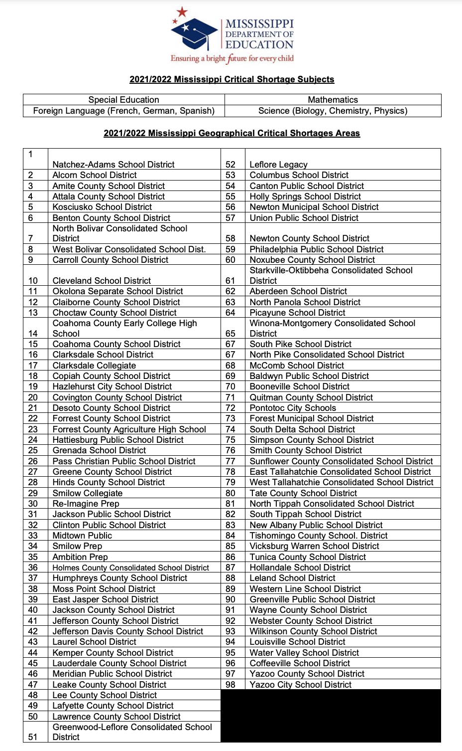

Amendment Number Two

NOTE: This amendment two is hereby made a part of the Mississippi Department of Education’s Request for Proposals. The Vendor acknowledges receipt of said amendment and is made aware of the changes contained therein. By signing this form, the Offeror accepts the changes as part of the contract requirement.

________________________________________ ___________________________
Authorized Signature Date

________________________________________
Printed Name

