Title 7 Education K-12
Part – 7

MISSISSIPPI
Kindergarten Guidelines

Carey M. Wright, Ed.D.
State Superintendent of Education

Nathan Oakley, Ph.D.
Chief Academic Officer

Revised 2018

The Mississippi State Board of Education, the Mississippi Department of Education, the Mississippi School for the Arts, the Mississippi School for the Blind, the Mississippi School for the Deaf, and the Mississippi School for Mathematics and Science do not discriminate on the basis of race, sex, color, religion, national origin, age, or disability in the provision of educational programs and services or employment opportunities and benefits. The following office has been designated to handle inquiries and complaints regarding the non‑discrimination policies of the above mentioned entities: Director, Office of Human Resources, Mississippi Department of Education, 359 North West Street, P.O. Box 771, Suite 203, Jackson, MS 39205‑0771, (601)359-3511.

Mississippi Department of Education
359 North West Street
P. O. Box 771
Jackson, Mississippi 39205-0771
(601) 359-3511
www.mdek12.org/EC

MISSISSIPPI
State Board of Education

Dr. Jason S. Dean,
Chair
Mr. Buddy Bailey,
Vice Chair
Dr. Carey M. Wright,
Executive Secretary
Mrs. Rosemary G. Aultman
Dr. Karen J. Elam
Mr. Johnny Franklin
Dr. John R. Kelly
Mr. Charles McClelland
Mrs. Brittney Rye
Mr. Sean Suggs

Tenette Smith, Ed.D.,
Director
Office of Elementary Education and Reading

Jill Dent, Ph.D.,
Director
Office of Early Childhood Education

Mississippi Kindergarten Guidelines Reviewers

Todd Boucher
Elementary Administrator
Biloxi Public School District
Angela Boutwell
Elementary Administrator
Starkville Consolidated School District
Tiffany Bradley
Kindergarten Teacher
Vicksburg-Warren School District
Barbara Brady
Kindergarten Teacher
Greenville School District
Christy Carroll
Elementary Administrator
Tupelo Public School District
Ava Conley
Kindergarten Teacher
Gulfport School District
Travis Creel
Elementary Administrator
Philadelphia Public School Distirct
Dr. Nikki Currey
Chapter President
American Academy of Pediatrics
Danielle Dishman
Kindergarten Teacher
Quitman County School District
Sharronda Evans
Kindergarten Teacher
Tupelo Public School District
Jennifer Foster
Kindergarten Teacher
Senatobia Municipal School District
Dr. John Gaudet
Chapter President-Elect
American Academy of Pediatrics
Dr. Kathleen Grigsby
Elementary Administrator
Jackson Public School District
Jacqueline Luckett
Kindergarten Teacher
Sunflower County Consolidated School District
Felicia Mann
Kindergarten Teacher
Natchez-Adams School District
LaToya Minor
Elementary Administrator
Vicksburg-Warren School District
Carmen Moor
Kindergarten Teacher
Hattiesburg Public School District
Pauly Oakes
Pre-Kindergarten Director
Grenada School District
Cambrea Paes
Kindergarten Teacher
Starkville Consolidated School District
Donna Pemberton
Kindergarten Teacher
Jackson Public School District
Kiana Pendleton
Curriculum Specialist
Hattiesburg Public School District
Reba Pree
Elementary Administrator
Greenville School District
Shannon Robins
Kindergarten Teacher
Oxford School District
Frederick Robinson
Elementary Administrator
Quitman County School District
Marie Roblin
Kindergarten Teacher
Pascagoula School District
Suzanne Ros
Elementary Administrator
Pascagoula School District
Suzanne Ryals
Assistant Superintendent
Lafayette County School District
Bridgette Sheridian
Kindergarten Teacher
Louisville Municipal School District
Stephanie Stokes
Kindergarten Teacher
Biloxi Public School District
Felicia Thomas
Elementary Administrator
McComb School District
Deidra Thompson
Kindergarten Teacher
Picayune School District
Tijuana Thompson
Kindergarten Teacher
Yazoo City Municipal School District
Terri Walls
Kindergarten Teacher
Starkville Consolidated School District
Shelley Whittington
Kindergarten Teacher
Meridian Public Schools
Kerri Wilder
Elementary Administrator
Picayune School District
Jessica Zettergren
Elementary Administrator
Senatobia Municipal School District

MDE Support Staff

Jill Dent
Bureau Director
Office of Early Childhood
Monica May
Assistant Director
Office of Early Childhood
Laura Dickson
Early Learning Collaborative Coordinator
Office of Early Childhood
Joyce Greer
Early Childhood Instructional Specialist
Office of Early Childhood
Candice Taylor
Early Childhood Instructional Specialist/619 Coordinator
Office of Early Childhood
Lydia Boutwell
Early Childhood Coach
Office of Early Childhood

TABLE OF CONTENTS

INTRODUCTION 7
Kindergarten Philosophy and Goals 7
Learning Principles 9
SECTION I 11
A. Entrance Age 11
1. Required Age 11
2. Required Documentation 11
3. Requirements for enrollment of children in public school 11
B. Compulsory-School-Age and Withdrawal 12
SECTION II 13
A. Guidelines for Curriculum 13
1. Curriculum 13
2. Learning Centers 13
B. Guidelines for Educational Materials 16
1. Requirement for Equipment and Educational Materials 16
2. Requirement for Instructional and Consumable Materials 16
C. Guidelines for Assessment 16
1. Requirement for Assessment and Screening 16
2. Recommended Screening 17
3. Requirement for Standardized Testing 17
4. Requirement for Individualized Assessments 17
5. Requirement for Documentation 17
SECTION III 19
A. Organization 19
1. Requirement for Teacher-Child Ratio 19
2. Requirement for Length of School Day and Term 19
3. Requirements for the Instructional Day 19
4. Requirements for Physical Activity 19
5. Recommendation for Quiet Time 19
6. SAMPLE Full Day Kindergarten Schedule 20
B. Staff 21
1. Required Certification for Kindergarten Teachers 21
2. Requirements for Assistant Teachers 22
3. Required Professional Development for Staff 22

SECTION IV 23
A. Guidelines for Family Engagement 23
1. Requirement for Handbook 23
2. Requirement for Family Communication 23
3. Recommendations for Volunteer Participation 23
B. Transportation 24
1. Requirement for Transportation 24
2. Requirement for School Bus Safety 24
SECTION V 25
A. Physical Settings 25
1. Guidelines for Structures Existing Prior to 2017 25
2. Guidelines for New Structures Constructed after July 2017 28
B. Outside Play Area 33
1. Guidelines for Outdoor Play Areas 33

INTRODUCTION
This manual has been prepared for use by administrators, counselors, teachers, and other authorized staff in the kindergarten programs of Mississippi and is to be used as a guide in facilitating kindergarten programs.

KINDERGARTEN PHILOSOPHY AND GOALS
The early childhood years are a critical time in the development for every child. The learning that takes place during the first eight years of life serves as the foundation for all later academic, social, emotional, physical and motor development. All children are capable of learning and meeting developmental milestones. Therefore, the Kindergarten Guidelines are proposed to assist all early childhood educators in their efforts to provide a high-quality evidence-based program serving kindergarten children to support school readiness.
School Readiness Definition
“Responsibility for school readiness lies not with children, but with the adults who care for them and the systems that support them,” (National Governors Association, 2005., p. 29)
School readiness is a multi-dimensional construct that goes beyond the skills, knowledge, and disposition of children as they enter kindergarten. Children are eligible for school when they have reached the chronological age established by the state, as described on page 11; however, school readiness is achieved through a combination of efforts involving children, families, schools, communities, and the state.
READY CHILDREN show an eagerness to explore, discover, engage, and learn.
They demonstrate interest and abilities in all dimensions of early learning and development: social and emotional development; language development; cognition and general knowledge; physical well-being and motor development; and approaches toward learning. Children are unique individuals, who do not develop at the same time or in the same way. Therefore, school readiness should be viewed as a continuum of behaviors rather than an inflexible or narrow set of proficiency skills. Any age-eligible child who is eager to attend kindergarten should be deemed “ready.”
READY FAMILIES recognize their role as their child’s first and most stable teacher and advocate while understanding their child’s current level of development. Families ensure a safe and consistent environment, promote good health, provide steady and supportive relationships, and understand their relationship with the school system to ensure a smooth transition.
READY SCHOOLS provide a welcoming and accepting environment for all and have professional educators who consistently advance growth and achievement for students with diverse backgrounds, experiences and abilities while working in partnership with families and communities.
READY COMMUNITIES include businesses, faith-based organizations, early childhood service providers, community groups, and local governments collaborating to support schools and children’s long-term success by providing families access to information, affordable services, and high-quality early learning opportunities.
READY STATES play a crucial part in supporting communities, schools, and families through developing appropriate policies; providing adequate funds; ensuring access to high-quality early development and learning opportunities; preparing and retaining a world-class early childhood workforce; ensuring an infrastructure to coordinate services, including data systems for accountability and demonstrating political leadership to make school readiness a state priority.
Adapted from National Governors Association. 2005. Building the foundation for bright futures: Final report of the NGA Task Force on School Readiness. Washington, DC: Author
All children attending a high-quality kindergarten programs will:
- improve their self-concept;
- increase their intellectual growth;
- enlarge their understanding of the world, people, experiences, ideas;
- increase competencies and skills in oral language, literacy, writing, listening, and thinking;
- increase their competencies and skills in mathematical reasoning and scientific exploration;
- increase their skills involved in physical coordination and gross and fine motor skills;
- increase their competence in dealing with emotions, feelings, and social situations;
- increase their self-direction and independence;
- develop cooperative, trusting relationships;
- develop their natural curiosity and creative potential; and
- develop a love of learning

LEARNING PRINCIPLES
The Kindergarten Guidelines outlined in this document are built on high-quality research and evidence-based principles. The following principles are required in the learning environment and curriculum in the classroom:
- Skills and concepts specific to developmental domains developed by the Mississippi Department of Education are foundational to all instruction.
  - English Language Arts
  - Mathematics
  - Social Studies
  - Science
  - Social and Emotional Development
  - Physical Development
  - The Arts
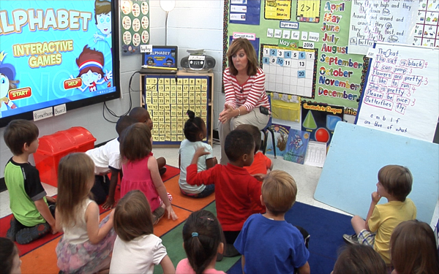
- Learning activities that acknowledge children’s individual rates of development are evident.
- Children are in an inclusive learning environment that embraces diversity.
- Children use their senses in the instructional process (seeing, hearing, touching, tasting, and smelling).
- Active engagement (exploring, playing, manipulating, and problem solving) is the primary strategy for delivering instruction.
- Children are taught using a combination of instructional strategies, which includes active engagement in integrated learning centers, speaking and listening, participating in large and small group,
and individual instructional settings.
- Attitudes and examples from teachers and in lesson content taught reflect a positive problem solving approach. Therefore, attention should be given to instructional methods, emotional climate, environment, peer-to-peer interaction, and educator-child interaction.
- Children have experiences that are sensitive to the value of play, for it is through play that children create their own meaning and learning.
Children need opportunities to engage in application of the principles being introduced through the curriculum. Therefore, one of the requirements for kindergarten classrooms is that the majority of the instructional delivery be organized around a variety of integrated learning centers with responsive interactions among children, their peers, and adults. These experiences provide opportunities for children to acquire skills and concepts through hands-on engaged learning while the teacher is facilitating appropriate language development through meaningful conversations with others.

SECTION I
Requirements for Voluntary Enrollment
- ENTRANCE AGE

Required Age
A child is eligible for a kindergarten program if they reach five years of age on or before September 1.

Required Documentation
A birth certificate and current immunization record (Form 121) are required for all kindergarten students and shall be presented to the proper school authority.

Requirements for enrollment of children in public school:
Mississippi Code Annotated § 37-15-9
(1) Except as provided in subsection (2) and subject to the provisions of subsection (3) of this section, no child shall be enrolled or admitted to any kindergarten which is a part of the free public school system during any school year unless such child will reach his fifth birthday on or before September 1 of said school year, and no child shall be enrolled or admitted to the first grade in any school which is a part of the free public school system during any school year unless such child will reach his sixth birthday on or before September 1 of said school year. No pupil shall be permanently enrolled in a school in the State of Mississippi who formerly was enrolled in another public or private school within the state until the cumulative record of the pupil shall have been received from the school from which he transferred. Should such record have become lost or destroyed, then it shall be the duty of the superintendent or principal of the school where the pupil last attended school to initiate a new record.
(2) Subject to the provisions of subsection (3) of this section, any child who transfers from an out-of-state public or private school in which that state’s law provides for a first-grade or kindergarten enrollment date subsequent to September 1, shall be allowed to enroll in the public schools of Mississippi, at the same grade level as their prior out-of-state enrollment, if:
        - The parent, legal guardian or custodian of such child was a legal resident of the state from which the child is transferring;
        - The out-of-state school from which the child is transferring is duly accredited by that state’s appropriate accrediting authority;
        - Such child was legally enrolled in a public or private school for a minimum of four (4) weeks in the previous state; and
        - The superintendent of schools in the applicable Mississippi school district has determined that the child was making satisfactory educational progress in the previous state.
SOURCES: Codes, 1942, Sec. 6225-03; Laws, 1953, Ex Sess, ch. 24, Sec. 3; 1976, ch. 390, Sec. 1; 1986, ch. 464; 1987, ch. 315; 1994, ch. 607, Sec. 19; Laws, 2003, ch. 397, § 2, SB 2394, eff from and after July 1, 2003.
- Compulsory-School-Age and Withdrawal
According to Mississippi Code Annotated § 37-13-91 (2) (f), "compulsory-school-age child" means a child who has attained or will attain the age of six (6) years on or before September 1 of the calendar year and who has not attained the age of seventeen (17) years on or before September 1 of the calendar year; and shall include any child who has attained or will attain the age of five (5) years on or before September 1 and has enrolled in a full-day public school kindergarten program.
SOURCES: Laws, 1977, ch. 483, Sec. 1; 1982, Ex Sess, ch. 17, Sec. 21; 1987, ch. 460, 1991, ch. 308, Sec. 1; 1991, ch. 539, Sec. 2; 1992, ch. 516, Sec. 1; 1992, ch. 524, Sec. 8; 1993, ch. 543, Sec. 3; 1994, ch. 604, Sec. 1; 1995, ch. 570, Sec. 1, eff from and after passage (approved April 7, 1995); Laws, 1998, Ch. 566, § 6, HB 1443, eff July 1, 1998. Amended by Laws 2000, Ch. 397, Sec. 1, SB3043; Laws, 2003, ch. 397, § 1, SB 2394, eff from and after July 1, 2003.

SECTION II
Curriculum, Materials, and Assessment
- GUIDELINES FOR CURRICULUM
  - Curriculum
Requirements for Curriculum Kindergarten programs use a research- and evidence-based (comprehensive, if available) curriculum that is aligned with the Mississippi College- and Career Readiness Standards. Mississippi Code Annotated § 27-103-159 defines “evidence-based program” as “a program or practice that has had multiple site random controlled trials across heterogeneous populations demonstrating that the program is effective for the population.” Additionally, the curriculum contains thematic units of activities and ideas designed to provide children the opportunities and experiences needed to master the performance standards in the Mississippi College- and Career Readiness Standards. Lesson planning documents should reflect Mississippi College- and Career Readiness Standards that are targeted through large and small group activities, individual instructional activities, and learning center activities that are used throughout the thematic unit. The curriculum shall include integrated language arts (reading, listening, thinking, speaking, writing, and viewing), music, art, math, social studies, science, dramatic play, and physical activities.
  - Learning Centers
- Daily Use Instructional delivery shall be organized primarily using learning centers. A minimum of four (4) different learning centers (**three primary centers and one teacher-led small group) shall be organized, arranged, and labeled so that they are accessible to all children for simultaneous use for a minimum of 120 minutes per day. The MDE recognizes the definition of learning centers as identified in literature as “distinct areas in a classroom that offer various materials and opportunities for hands-on learning at individually appropriate levels”. (Copple & Bredekamp, 2006). In addition, NAEYC (2007) publications state that learning centers:
  - Engage students in learning
  - Promote development of the whole child
  - Integrate multiple subject matters so that learning happens in a meaningful context
  - Assess student understanding and knowledge through observation and authentic assessment practices
  - Foster a love of learning
Copple, C., & Bredekamp. (2006) Basics of developmentally appropriate practice: An introduction for teachers of children 3 to 6. Washington, DC: NAEYC.
Stuber, G. (2007) Centering your classroom: Setting the stage for engaged learners. National Association for the Education of Young Children Beyond the Journal.
Learning centers provide children with hands-on opportunities to practice learning and thematic unit concepts. Learning relies heavily on experiential, hands-on activities. Each early learning classroom must include the following:
- Primary centers for each classroom contain a book/library center, math/manipulative center, and creative art center.**
- Additional integrated learning centers are added to accommodate the number of children enrolled and child interest; centers support current learning topics so that all children are engaged meaningfully.
- Available space in learning centers should be sufficient to accommodate simultaneous use by the number of children enrolled in the classroom while maintaining appropriate numbers of children in each learning center.
    - Children have access to a wide range of interesting, developmentally appropriate reading materials from all genres including fiction and non-fiction books, poetry, magazines, newspapers, and writing materials during learning center time and throughout the day.
    - Consistent use of worksheets is inappropriate at this developmental level and should not be a primary part of the curriculum.
    - Learning centers should offer a variety of activities and materials for simultaneous use by children.

In addition to the three (3) primary learning centers identified in this section (book/library center, math/manipulative center, and creative art center.**), additional learning centers may include those from the list below to meet the minimum requirement of four (4) integrated learning centers per classroom. Except for the three (3) primary centers identified previously, the remaining learning centers shall be rotated and changed throughout the year. The following is a list of possible learning centers.
- Oral Language/Phonemic Development Center
- Creative Arts Center**
- Science Center
- Math Center**
- Language Arts Center
- Cooking Center
- Blocks, Wheel toys, and Construction Center
- Sand and/or Water Center
- Woodworking Center
- Music Center
- Library Center**
- Listening Center
- Dramatic Play
- Creative Writing Center
- Social Studies Center
- Technology Center
- Motor Development Center
** Designates a primary center in each classroom

- Space Limitations If space is limited, some of the centers may be combined.
- Use of Classroom Technology Computers and similar technological devices are only to be used in the classroom as instructional tools.
- Resource Materials Teachers use, at a minimum, the resources developed by the Mississippi Department of Education in curriculum planning such as the Kindergarten Developmental Checklist and the Kindergarten Readiness Assessment: Next Steps for Districts. These materials can be found at www.mdek12.org/ec.

GUIDELINES FOR EDUCATIONAL MATERIALS
  - Requirement for Equipment and Educational Materials
The initial expenditure for any new equipment, instructional materials and consumable supplies shall be adequate to equip a classroom of a maximum of 27 five-year-old children. Classroom teachers should select instructional materials that are most suited for their classrooms and the developmental needs of their students.

  - Requirement for Instructional and Consumable Materials

The school district shall spend a minimum of $1,000 per kindergarten classroom to replenish the consumable supplies and instructional materials at least once per year. This money is in addition to the Educational Enhancement Fund monies allocated to each teacher. Educational materials shall reflect the instructional needs and implementation of learning activities described for kindergarten. It is recommended that teachers are able to indicate the needs for classroom educational materials. Students should have access to technology in the classroom on a regular basis.

GUIDELINES FOR ASSESSMENT

Requirement for Assessment and Screening
A continuous evaluation through a variety of techniques, procedures, and tools is used to determine each child’s needs. Information obtained from ongoing assessments is reflected in lesson plans to address children’s needs collectively, as well as individually.
- All schools conduct vision and hearing screenings for all kindergarten students within the first 45 days of school enrollment.
- All physical or developmental screening results are reviewed and all necessary education or developmental referrals made within 45 days of the initial screening.
- It is recommended that students who show deficits on developmental screenings be given an intervention, which may be administered and documented by the classroom teacher. The student can then be given a follow-up screener to determine if the intervention was successful. If the student has not made sufficient progress, an additional intervention may be put in place, or the student may be referred for an evaluation for special education services, if data collected support the suspicion of a disability. When making a referral, districts should follow their Child Find procedures.

    - Recommended Screening
It is recommended that all entering kindergarten students receive a comprehensive health screening, such as (1) the Early and Periodic Screening, Diagnosis, and Treatment (EPSDT), (2) a Bright Futures checkup, or (3) a standard physical conducted by a child’s health care provider or health department. If no documentation of a current comprehensive health screening or standard physical is available from within the last year, screenings/standard physicals should be conducted within 45 days of the beginning of school by either a private health care provider of the parents’ choosing, or through school resources such as school nurses, or the local Department of Health. Parents are strongly encouraged to attend screenings conducted at the school. A standard physical form is to be submitted for all screenings conducted by a private health care provider.

    - Requirement for Standardized Testing
All kindergarten students shall be administered the state-approved kindergarten readiness assessment. Paper and pencil standardized tests are not appropriate testing measures and shall not be used alone. However, standardized test sections that assess developmentally appropriate writing skills (e.g., sentence structure, writing form) are permissible and may be used. Any technology-based assessment should be administered using touch-based technology devices. Children should also know how to use a mouse. Therefore, multiple opportunities to practice using a mouse must be given.

    - Requirement for Individualized Assessments
A continuous evaluation through the use of a variety of techniques, procedures, and tools shall be used to determine individual student’s social, emotional, and academic enrichment needs. The evaluation shall be based on the learning outcomes in the required curriculum standards.

    - Requirement for Documentation
It is recommended that assessment of kindergarten skills be documented through use of a variety of techniques and procedures to include: checklists, performance scales, portfolios of children's work, anecdotal records, observational reports, video and audio tape recordings, experience charts, photographs, and informal tests.
It is recommended that at a minimum, each kindergarten classroom develop a transition folder to follow each child to first grade. The folder must contain the following:
- End-of-year Kindergarten Readiness Assessment Score/Summary Sheet
- End-of-year developmental screening results (if the classroom completes a spring or end-of-term screening).
- End-of-year results from other assessments used in the classroom
- A school-issued final report card/skills checklist
- A child information sheet containing some or all of the following (a sample sheet is located at www.mdek12.org/EC):
  - Child’s name, date of birth, preferred name, photo, languages spoken
  - Parents’ names (and/or other adults/caregivers), address, phone, and
preferred time and way to contact (in accordance with school policy)
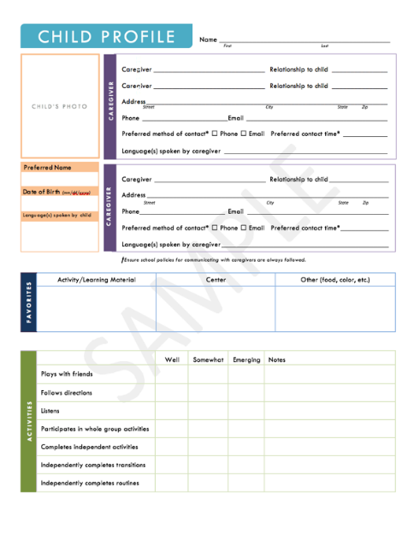
  - Child’s favorite things (activity, toy, food, color, book, center, etc.)
  - Child’s play and learning styles
  - Child’s skills and proficiencies
  - Child’s areas of growth and what they do not like to do
  - Child’s personality/temperament traits
- Work samples (2 or 3 samples that demonstrate the child’s capabilities). May include:
  - Free art
  - Guided art
  - Writing sample
  - Learning center products
(e.g. photo of block construction)

SECTION III

Organizational Procedures and Staff

ORGANIZATION

Requirement for Teacher-Child Ratio
The teacher-child ratio shall be 1:22 maximum. If a full-time assistant teacher is assigned to the kindergarten classroom, the teacher-child ratio shall not exceed 2:27.

Requirement for Length of School Day and Term
The length of the school day and school term shall be the same as that of the other grades of the elementary school.

Requirements for the Instructional Day
The instructional day includes all aspects of the child’s day (e.g. learning center activities, large and small group activities, individual instruction, and guided physical activity). At a minimum, the instructional day in a full-day program includes 330 instructional minutes, to include 30 minutes of physical activity and 120 minutes of learning centers; 30 minutes of quiet/rest time is recommended.

  - Requirements for Physical Activity
Children shall engage in physical activity for a minimum of 30 minutes and a maximum of 60 minutes during a full-day program. The minutes assigned to physical activity do not have to occur continuously. Weather permitting, physical activity takes place outside. Outdoor play experiences will occur unless a weather advisory is in effect or the play space is unsafe due to damp or wet conditions. If outdoor play is not possible per one or more of these conditions, teachers provide 30 minutes of indoor physical activity documented in lesson plans.
  - Reccomendation for Quiet Time
It is recommended that kindergarten students engage in a minimum of 30 minutes of quiet time daily. Activities during quiet time may include individual activities, looking at books/reading, listening to books on tape (audio books), drawing, or resting, as appropriate for each individual student.

- SAMPLE Full Day Kindergarten Schedule
TIME | ACTIVITY | MINUTES
7:00 – 7:30 | Arrival/Free Choice Centers/Breakfast | 30 Minutes
7:30 – 7:50 | Morning Routine/Do-Now | 20 Minutes
7:50 – 8:00 | Morning Exercise | 10 Minutes
8:00 – 8:25 | Whole Group 1 | 25 Minutes
8:25 – 9:30 | Small Groups and Learning Centers | 65 Minutes
9:30 – 10:15 | Extension Class/Teacher Planning (music, library, computer, art, physical education) | 45 Minutes
10:15 – 10:40 | Whole Group 2 | 25 Minutes
10:40 – 11:05 | Lunch | 25 Minutes
11:05 – 12:25 | Small Group/Learning Centers | 80 Minutes
12:25 – 1:00 | *Recess/P.E. | 35 Minutes
1:00 – 1:30 | Whole Group 3/ Quiet Time | 30 Minutes
1:30 – 2:00 | Small Groups/Learning Centers | 30 Minutes
2:00 – 2:20 | Health Lesson/Snack | 20 Minutes
2:20 – 2:35 | Closure/Review of the Day | 15 Minutes
2:35 – 2:45 | Dismissal | 10 Minutes
2:45 – 3:30 | Teacher Planning | 45 Minutes

REQUIRED MINUTES |  |  | SAMPLE SCHEDULE MINUTES
Instructional Time | 330 Minimum |  | Instructional Time | 455 minutes
Center Time | 120 Minimum |  | Center Time | 205 minutes
Quiet Time | (Recommended only) |  | Quiet Time | 30 minutes
Physical Activity | 30 Minimum -  60 Maximum |  | Physical Activity | 45 minutes
Health | 45 Minimum (per week) |  | Health | 20 minutes (per day)
*Due to physical education extension class, physical activity may be more than 30 minutes on certain days.

STAFF

Required Certification for Kindergarten Teachers
General Education Teachers are required to follow one of the pathways listed below:

GENERAL EDUCATION KINDERGARTEN CLASSROOMS
Hold a Pre-K/K (153) License
OR
Hold a K-3 (116) License or
Hold a K-4 (152) License
OR
Hold a K-6 (120) License
OR
Other Pathways | AND | Completion of an approved Licensure pathway degree program to obtain  116 (K-3), 120 (K-6), 152 (K-4),  or 153 (Pre-K/K) endorsement  AND  Any additional requirements  needed for licensure

***Kindergarten teachers seeking an initial elementary education license must make a passing score on the Pearson Foundations of Reading Assessment in accordance with Mississippi Code Annotated § 37-3-2.

  - Requirements for Assistant Teachers
Assistant teachers are required to follow one of the pathways listed below:

Hold an Associate’s Degree or higher
OR
Two Years or 48 College Credit Hours
(transcript verification required)
OR
High School Diploma/GED
AND
Verification of WorkKeys® Scores****

**** To meet WorkKeys® requirements, Assistant Teachers must meet the following criteria: (1) a Reading for Information score of 4, an Applied Mathematics score of 4, and a Writing or Business Writing score of 3; OR WorkKeys® Silver Level certification.

  - Required Professional Development for Staff
All teaching staff (teachers and assistant teachers) and program administrators must complete at least eight (8) contact hours of professional development annually related to principles and methods of early childhood education and reading instruction. Training should reflect appropriate best practices for early childhood (Pre-K through Grade 3) and should be evidence- or research-based.

SECTION IV

Family Engagement and Transportation

GUIDELINES FOR FAMILY ENGAGEMENT
Families are viewed as partners and their child’s first teacher. Teachers should assist families with information and resources that could help their children. Families should have the opportunity to volunteer in the classroom and participate in enrichment opportunities.

Requirement for Handbook
Each school district shall develop and distribute a parent handbook.
The handbook should include information that addresses the kindergarten philosophy, goals, and information unique to a kindergarten program
(e.g. curriculum, credentials, and assessments).

Requirement for Family Communication
Parent/teacher conferences are conducted two times during the kindergarten school year to inform parents or guardians of the child’s progress. If documented attempts to meet with parents or other responsible persons fail, telephone conferences can be substituted.

Communication should be conducted on a regular basis. Communication between school and home could consist of notebooks/folders, newsletters, conferences, emails, phone calls, etc.

Regular parent involvement is recommended through such activities as orientation, open house, teacher/parent conferences, and ongoing collaboration between parents and school to enhance the learning process.

Recommendations for Volunteer Participation
Parents, guardians, and community members should be encouraged to participate in various activities such as developing learning games for home or classroom use, sharing information with the class about their work skills or profession, or sharing their talents with the children through varied activities. Volunteers are not in the classroom without a teacher or assistant teacher present and cannot be used to meet the minimum adult-to-child ratio. Volunteers that serve in a school more than 120 hours per school year will participate in an orientation session, sign a confidentiality agreement, and consent to a background check that is conducted by the district.

TRANSPORTATION

Requirement for Transportation
All transportation is optional except for children who have it listed as a service on their Individualized Education Programs (IEPs). Transportation requirements regarding children with IEPs are determined by the IEP Committee.

- Requirement for School Bus Safety
All kindergarten programs must abide by Mississippi Code Annotated § 37-41-3 and the National Highway Transportation Safety Association (NHTSA) Guidelines. It is recommended that a safety monitor be appointed on each school bus to board and de-board the bus. School bus drivers should promote a safe and positive environment through appropriate interaction with the students.

SECTION V

Physical Settings and Outside Play

PHYSICAL SETTINGS

Guidelines for Structures Existing Prior to 2017
  - Existing Classrooms
- Requirements for Existing Classrooms
- The classroom consists of no less than 35 square feet per child with a minimum of 600 square feet.
- Kindergarten classrooms are to be located at ground level.
- Every closet latch is such that children can open the door from the inside.
- The maximum distance to an exit from any point in the building does not exceed 150 feet. The maximum distance from the classroom door at the corridor to an exit does not exceed 100 feet.
- All electrical outlets accessible to children should be a type called “tamper-resistant electrical outlets.” These types of outlets look like standard wall outlets but contain an internal shutter mechanism that prevents children from sticking objects like hairpins, keys, and paperclips into the receptacle. This spring-loaded shutter mechanism only opens when equal pressure is applied to both shutters such as when an electrical plug is inserted. In existing facilities that do not have “tamper-resistant electrical outlets,” outlets should have “safety covers” that are attached to the electrical outlet by a screw or other means to prevent easy removal by a child. “Safety plugs” should not be used since they can be removed from an electrical outlet by children. All newly installed or replaced electrical outlets that are accessible to children should use “tamper-resistant electrical outlets.” In areas where electrical products might come into contact with water, a special type of outlet called Ground Fault Circuit Interrupters (GFCIs) should be installed. A GFCI is designed to trip before a deadly electrical shock can occur. To ensure that GFCIs are functioning correctly, they should be tested at least monthly. GFCIs are also available in a tamper-resistant design. (Source: Caring for Our Children 5.2.4.2, www.cfoc.nrckids.org)
  - Recommendations for Existing Classrooms
- Where multiple kindergarten units occur within a school or building, they are grouped adjacent to one another for teacher and child interaction and for optimum use of common facilities.
- Each kindergarten classroom has a work counter of at least 12 feet with at least one sink. The sink is stainless steel or porcelain, standard with gooseneck fitting on one side and a drinking bubbler on the other. The sink has cold water only. A paper towel dispenser accessible to students and a trash receptacle should be located near the sink.
- 110-volt wall plugs should be located every 10 feet to 15 feet around the classroom.

  - Existing Bathrooms
- Requirements for Existing Bathrooms
- Classrooms are located no more than 125 feet from a bathroom.
- Every toilet room door lock is designed to permit opening of the locked door from the outside in an emergency, and the opening device is readily accessible to the staff.
- For children with disabilities who are not yet toilet trained, a changing table is provided in the bathroom or classroom.
- All bathrooms are adequately stocked with toilet tissue.
- No items other than toilet tissue or bathroom supplies are stored in bathrooms. Cleaning supplies may be kept in the bathroom only if out of reach of children.
    - Recommendations for Existing Bathrooms
- A toilet room in the classroom is available for kindergarten children.
- Toilet seats in bathrooms are 10 to 13 inches from the floor.
- Lavatories are 24 inches from the floor.

  - Existing Furniture
- Requirements for Existing Furniture
        - Furniture is of an appropriate height for young children.
        - Tables and chairs are provided rather than desks.
        - At least one small bookcase or book display shelf is provided per classroom for children to access literature in the classroom.
    - Recommendations for Existing Furniture
- At least two small bookcases or book display shelves are provided to allow children access to literature in the classroom.
- A desk, chair, file cabinet and/or personal area is provided within the classroom for teachers, providing these items do not significantly diminish space for use by children.

        - Existing Floors
- Requirements for Existing Floors
    - Each classroom contains a 9 x 12-foot area rug or individual carpet squares, or similar material, to be used for large group meetings. Carpets or similar soft flooring surfaces are properly sanitized annually and replaced as needed.
ii. Recommendations for Existing Floors
- Classroom areas not carpeted are covered with resilient flooring or other easily cleaned material. Roll-type resilient flooring has the advantage of a minimum amount of jointing.
        - Building Codes for Existing Structures
- Requirements for Building Codes for Existing Structures
- All building construction conforms to the Southern Building Codes, the Americans with Disabilities Act (ADA), the Life Safety Codes, and any other city or county building codes.
- Recommendations for Building Codes for Existing Structures
- There are no recommendations for building codes.

        - Storage and Space in Existing Structures
- Requirements for Storage and Space in Existing Structures:
- Storage will be provided at the school for teaching and classroom supplies. Storage may not decrease classroom space available to students.
- Recommendations for Storage and Space in Existing Structures
- Base cabinets are installed below all counters. Doors are attached to some cabinets, while some are left open to serve as shelves. Open cabinets (18 x 24 inches and 24 x 36 inches) will accommodate large paper used for easel painting.
- Cabinets, 12 inches deep, are installed over the entire counter area for general storage.
- Open storage units (cubbies) are available for every student. Each unit is four feet high and two feet wide with coat hanging space at the bottom and a storage area at the top. Coat hooks should be installed 36 inches from the floor.
- Adequate storage space should be provided. The storage units may include one wall of built-in cabinets or moveable storage sections. Most storage units are accessible to children to facilitate independence and responsibility within the classroom. Storage space, above the reach of the children, is available for use by teachers.
- Adequate space for display of children's work is provided. Bulletin boards can be located on walls and/or fastened to the backs of cabinets and bookcases.
- A teacher work area of 180 to 200 square feet is allocated for use by every two to three kindergarten teachers. This area is needed for individual assessment of children, conferencing with parents, making classroom materials, and planning meetings.

Guidelines for New Structures Constructed after July 2017
- New Classrooms
  - Requirements for New Classrooms
- The classroom is a minimum of 1,000 square feet.
- The minimum classroom width is 24 feet, except in pod-type structures. The classroom is free from excess storage that prevents full usage of classroom square footage.
- Classrooms contain operable lighting with area controls that ensure adequate lighting throughout the room. Switches within reach of the children are located at the doors. Toilet rooms contain lighting fixtures.
- The maximum distance to an exit from any point in the building does not exceed 150 feet. The maximum distance from the interior classroom door at the corridor to an exit does not exceed 100 feet.
- Kindergarten classrooms are located at ground level.
- Every closet latch is such that children can open the door from the inside.
- All newly installed electrical outlets accessible to children should be tamper-resistant electrical outlets. These types of outlets look like standard wall outlets but contain an internal shutter mechanism that prevents children from sticking objects like hairpins, keys, and paperclips into the receptacle. This spring-loaded shutter mechanism only opens when equal pressure is applied to both shutters such as when an electrical plug is inserted. In existing facilities that do not have tamper-resistant electrical outlets, outlets should have safety covers that are attached to the electrical outlet by a screw or other means to prevent easy removal by a child. Safety plugs should not be used since they can be removed from an electrical outlet by children. All newly installed or replaced electrical outlets that are accessible to children should use tamper-resistant electrical outlets. In areas where electrical products might come into contact with water, a special type of outlet called Ground Fault Circuit Interrupters (GFCIs) should be installed. A GFCI is designed to trip before a deadly electrical shock can occur. To ensure that GFCIs are functioning correctly, they should be tested at least monthly. GFCIs are also available in a tamper-resistant design. (Source: Caring for Our Children 5.2.4.2, www.cfoc.nrckids.org)
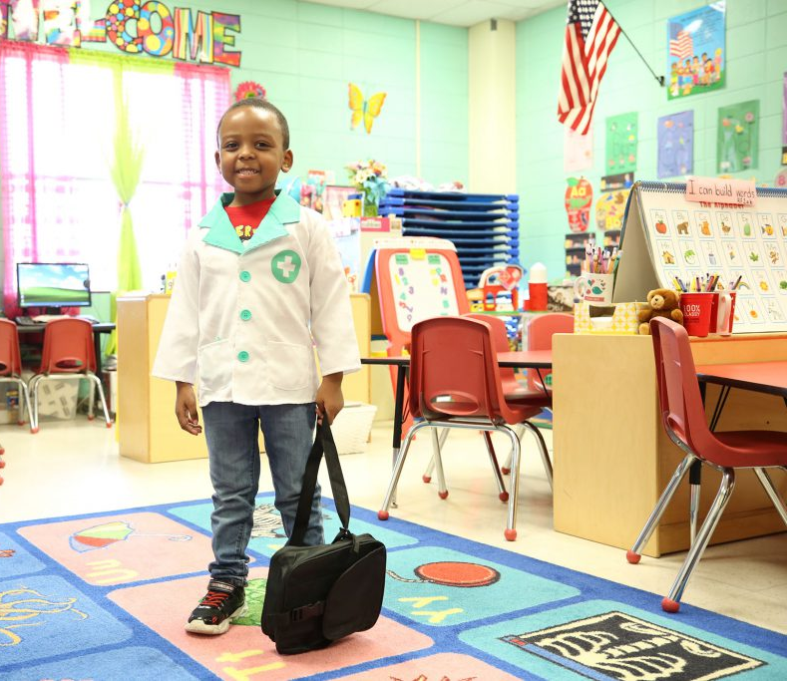
- Recommendations for New Classrooms
- All kindergarten units within one school or building are grouped in the same general vicinity for optimum use of
common facilities.
- A classroom clock is in each classroom.
- 110-volt wall plugs are located every 10 to 15 feet around
the classroom.
- A minimum of 50 square feet of window
area per unit is available in each classroom. Windows are located no more than two feet from the floor. Windows are able to be opened from the inside for ventilation purposes. A generous glass window area
is in place to overlook the playground and promote an indoor-outdoor atmosphere. Roofing overhang and installation of blinds or shutters are provided to combat excessive sunlight.
- Careful consideration is given to the location of kindergarten units in new structures.
Each classroom has a door opening onto the playground or other attractive outdoor space. A six-foot roof overhang makes the outdoor area usable on a rainy day as an outdoor learning center.
- New Bathrooms
          - Requirements for New Bathrooms
- Each classroom contains a minimum of one bathroom that consists of a toilet and lavatory, or at the district's option the lavatory may be omitted if the work counter area is equipped with a sink and is in close proximity to the toilet room door. The toilet paper holder is placed within a child's reach from the toilet. In classrooms where children are not yet toilet trained, a changing table is installed.
- Individual toilet rooms are required to accommodate the physically handicapped and follow ADA regulations.
- Every toilet room door lock is designed to permit opening of the locked door from the outside in an emergency, and the opening device is readily accessible to the staff.
          - Recommendations for New Bathrooms
- One bathroom/shower combination is provided for every eight kindergarten units.

- Furniture in New Classrooms
    - Requirements for Furniture in New Classrooms
- Tables and chairs are provided rather than desks.
- Chairs in the kindergarten classroom adjust from 8 to 14 inches so that all children's feet will touch the floor.
- All tables adjust from 20 inches to 24 inches in height.
- Furniture is of an appropriate height for young children.
- At least one small bookcase or book display shelf is provided per classroom for children to access literature in the classroom.

    - Recommendations for Furniture in New Classrooms
- A body-length, shatter-proof wall or floor mirror is in the dramatic play/housekeeping center area or near the toilet area.
- At least two small bookcases or book display shelves, designed to display book covers/titles, are provided to allow children access to literature in the classroom.
- A desk, chair, file cabinet and/or personal area be provided within the classroom for teachers, providing these items do not significantly diminish space for use by children.
- A teacher work area of 180 to 200 square feet minimum is allocated for use by every two to three kindergarten teachers. A proportionately larger space shared by all kindergarten teachers in a school would suffice. This room is made inviting through use of carpeting and appropriate furniture. Recommended items in the space include a four-drawer file cabinet, two chairs, a work counter, or table storage shelving.

- Floors in New Classrooms
    - Requirements for Floors in New Classrooms
- Classroom areas are covered with resilient flooring or other easily cleaned material. Roll-type resilient flooring has the advantage of a minimum amount of jointing.
- Each classroom contains a 9 x 12-foot area rug or individual carpet squares, or similar soft flooring surface, to be used for large group meetings. Carpets or similar soft flooring surfaces will be properly sanitized annually and replaced as needed.

    - Recommendations for Floors in New Classrooms
- There are no recommendations for floors in new classrooms.

- Building Codes for New Classrooms
    - Requirements for Building Codes for New Classrooms
    - All building construction conforms to the Southern Building Codes, the Americans with Disabilities Act (ADA), the Life Safety Codes, and any other city and county building codes.

    - Recommendations for Building Codes for New Classrooms
    - There are no recommendations for building codes in new structures.
- Storage and Space in New Classrooms
    - Requirements for Storage and Space in New Classrooms
    - Open storage units (cubbies) are provided for each student.
    - Wall receptacles are placed 10 feet to 15 feet apart in each classroom. Any receptacle in the counter area should not be located near a sink. A minimum of six outlets is installed.
    - Every closet latch is such that children can open the door from the inside.
    - Built-in cabinets or portable storage areas are constructed to promote accessibility of materials to the child to encourage the selection of activities and to facilitate room clean-up and to serve as learning center dividers. The height of cabinets and storage furnishings does not diminish teachers’ ability to visually supervise children.

    - Recommendations for Storage and Space in New Classrooms:
  - Base cabinets are installed below all counters. Doors are attached to some cabinets, while some are left open to serve as shelves. Open cabinet (18 x 24 inches and 24 x 36 inches) will accommodate the large paper used for easel painting.
  - Cabinets, 12 inches deep, are installed over the entire counter area for general storage.
  - Open storage units (cubbies) are available for every student. Each unit is four feet high and two feet wide with coat hanging space at the bottom and a storage area at the top. Coat hooks are installed 36 inches from the floor.
  - Adequate storage space is provided. The storage units include one wall of built-in cabinets or moveable storage sections. Most storage units are accessible to children to facilitate independence and responsibility within the classroom. Storage space, above the reach of the children, is available for use by teachers.
  - Adequate space for display of children's work is provided. Bulletin boards can be located on walls and/or fastened to the backs of cabinets and bookcases.

OUTSIDE PLAY AREA

Guidelines for Outdoor Play Areas
- Outdoor Play Areas
- Requirements for Designated Outdoor Play Areas
- A designated area for supervised outside periods during the kindergarten day is provided. Kindergarten students do not simultaneously share an area with children in third grade or older during designated outside periods.
- To allow for all children to engage in outdoor play together, a fully accessible outdoor play space is provided for children requiring adaptive equipment. Activities are provided to allow for and encourage inclusive play.
- Appropriate playground equipment and landscape design is provided to facilitate learning and ensure safety.
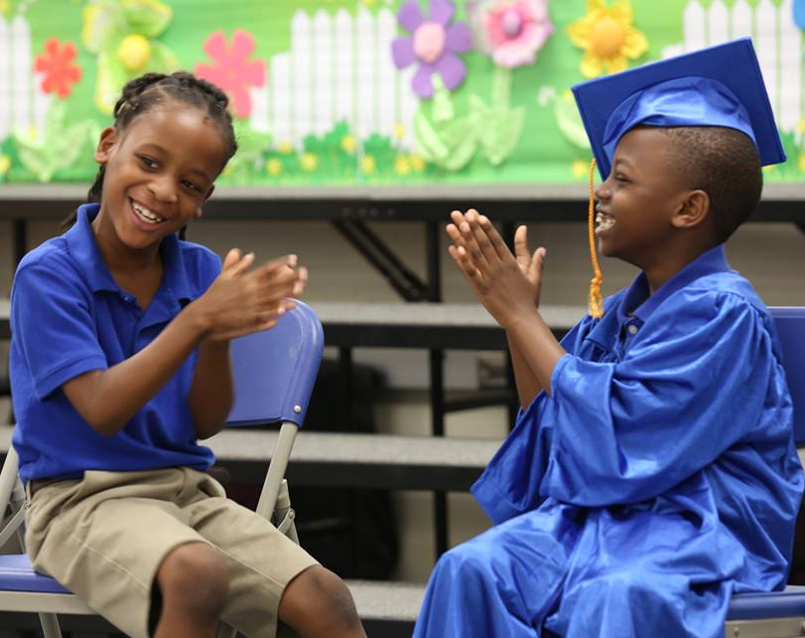
- Playground equipment and landscape design is developmentally appropriate for five-year-old children according to National Standards adopted by the Mississippi Department of Health.
- The outside play area has defined boundaries to protect children from environmental hazards. Boundaries are sufficient to prevent vehicles and other hazards from entering the play area as well as prevent children from exiting the play area alone.

- Recommendations for Outdoor
Play Areas
    - The outdoor play area is a
minimum of 4,300 square feet for two kindergarten classes. For each additional class, another 1,400 square feet is added.
    - A covered area is located on the playground to allow children refuge from the sun and to serve as a play area during inclement weather. This area is 225 to 300 square feet for each kindergarten class, with a sloped concrete surface to shed water.

Source code: Section 37-21-7 (Adopt)

