

***2019***

***Teacher Resource Guide for Alternate***

***Biology Elements***



2019

Teacher Resource Guide for

Mississippi Alternate Academic Achievement Standards­–

Alternate Biology Elements

Carey M. Wright, Ed.D., State Superintendent of Education

Nathan Oakley, Ph.D., Chief Academic Officer

Robin Lemonis, State Director, Office of Special Education

Mississippi Department of Education

Post Office Box 771

Jackson, Mississippi

39205-0771

Office of Special Education

601-359-3498

[www.mdek12.org/ose](http://www.mdek12.org/ose)

The Mississippi State Board of Education, the Mississippi Department of Education, the Mississippi School for the Arts, the Mississippi School for the Blind, the Mississippi School for the Deaf, and the Mississippi School for Mathematics and Science do not discriminate on the basis of race, sex, color, religion, national origin, age, or disability in the provision of educational programs and services or employment opportunities and benefits. The following office has been designated to handle inquiries and complaints regarding the nondiscrimination policies of the above-mentioned entities:

Director, Office of Human Resources

Mississippi Department of Education

**Table of Contents**

Acknowledgements 5

Introduction 6

Support Documents and Resources 7

Structure of the Teacher Resource Guide for Alternate Biology Elements Document 8

Structure of the Teacher Resource Guide for Alternate Biology Elements Document (graphic) 9

Levels of Support (LOS) 10

Teacher Resource Guide for Alternate Biology Elements 11

References 22

# 

# Acknowledgements

The Mississippi Department of Education gratefully acknowledges the hard work of the following individuals for their involvement in developing the *Teacher Resource Guide for Mississippi Alternate Academic Achievement Standards for Science*.

Sharon Coon Mississippi Department of Education

Margaret Ellmer, Ph.D. Mississippi Department of Education

Kellie Fondren Mississippi State University

Madelyn Harris Mississippi Department of Education

Myra Pannell, Ph.D. Mississippi State University Research and Curriculum Unit

Allison Paige Pigott Mississippi Department of Education

Bobby L. Richardson Mississippi Department of Education

Jackie Sampsell, Ed.D. Mississippi Department of Education

Denise Sibley Mississippi State University Research and Curriculum Unit

Stacey Todd Ocean Springs School District

Tiffany Withers Rankin County School District

# Introduction

**Mission Statement**

The Mississippi Department of Education (MDE) is dedicated to student success, which includes improving student achievement in science and establishing communication skills within a technological environment. The *Mississippi Alternate Academic Achievement Standards (MS AAAS) for Science* provides a consistent, clear understanding of what students are expected to know and be able to do by the end of the course. The purpose of the *Alternate Academic Achievement Standards* is to build a bridge from the content in the general education science framework to academic expectations for students with the most significant cognitive disabilities. The standards are designed to be rigorous and relevant to the real world, reflecting the knowledge and skills that students need for success in postsecondary settings.

**Purpose**

In an effort to closely align instruction for students with significant cognitive disabilities who are progressing toward postsecondary settings, the *MS AAAS for Science* includes course-specific standards for science. This document is designed to provide a resource for special education teachers in Grades 9-12 with a basis for curriculum development and instructional delivery.

The *Teacher Resource Guide for Alternate Biology Elements* contains prioritized content which is presented as a matrix to show the continuum of the concept across complexity levels. The matrix shows varying access points to the prioritized content. A student’s progression through content contained in the matrix is intended to be fluid. It is not the intent, nor should it be practice, for a student to be exposed to content in a straight vertical line through one of the columns. Every student, regardless of disability, comes to the learning environment with a different set of prior knowledge and experience. For this reason, a student may be able to access some content from the middle complexity level and access other concepts at the more complex level. Teachers should evaluate a student’s ability in relation to the content and select the entry point based on that evaluation. Students should not be locked into receiving exposure to all content at the same entry point.

# Support Documents and Resources

The MDE Office of Special Education aims to provide local districts, schools, and teachers supporting documents to construct standards-based instruction and lessons, allowing them to customize content and delivery methods to fit each student’s needs. The teacher resource guide includes suggested resources, instructional strategies, sample lessons, and activities. Additional sample activities and resources for selected standards may be added; this shall be a living document with ongoing updates based on educator feedback. The intent of these activities is to assist teachers in linking their instruction to the prioritized content. The teacher resource guide includes activity adaptations for students with a varying range of abilities within the classroom. The activities and adaptations provided are intended to serve as a model of how students participating in the Mississippi Academic Assessment Program–Alternate may receive academic instruction in science. There are many ways in which skills and concepts can be incorporated based on a student’s individual learning styles and needs. Professional development efforts are aligned to the *Mississippi Alternate Academic Achievement Standards (MS AAAS) for Science* and delivered in accord with teacher resources to help expand expertise in delivering student-centered lessons.

# Structure of the Teacher Resource Guide for Alternate Biology Elements Document

Mississippi Alternate Academic Achievement content standard: The *MS AAAS for Science* is a general statement of what students with significant cognitive disabilities should know and be able to do because of instruction.

Performance Objectives: Statements that describe in precise, measurable terms what learners will be able to do at the end of an instructional sequence.

I Can Statement(s): Includes the Performance Objective(s) as the *Most Complex* and scaffolds the performance objectives two additional levels (B) and (C) to *Least Complex*. This matrix demonstrates the continuum of the concept across complexity levels. The purpose is to assist teachers in modifying to meet the unique, diverse needs of learners with significant cognitive disabilities.

Real-World Connections: One way to facilitate learning that is meaningful to students and prepares them for their professional lives outside of school. When teachers move beyond textbook or curricular examples and connect content learned in the classroom to real people, places, and events, students are able to see a greater relevance to their learning. Real-world connections are used to help students see that learning is not confined to the school, allow them to apply knowledge and skills to real-world situations, and personalize learning to increase and sustain student engagement.

Vocabulary:Includes a list of difficult or unfamiliar words.

Resources:Includes suggested resources, instructional strategies, lessons, and activities. Additional sample activities and resources for selected standards may be added; this shall be a living document with ongoing updates based on educator feedback. The intent of these activities is to assist teachers in linking their instruction to the prioritized content.

# Structure of the Teacher Resource Guide for Alternate Biology Elements Document (graphic)

Vocabulary

Real-World Connections

Mississippi Alternate Academic Achievement Standard (MS AAAS)

Performance Objective(s)

Resources

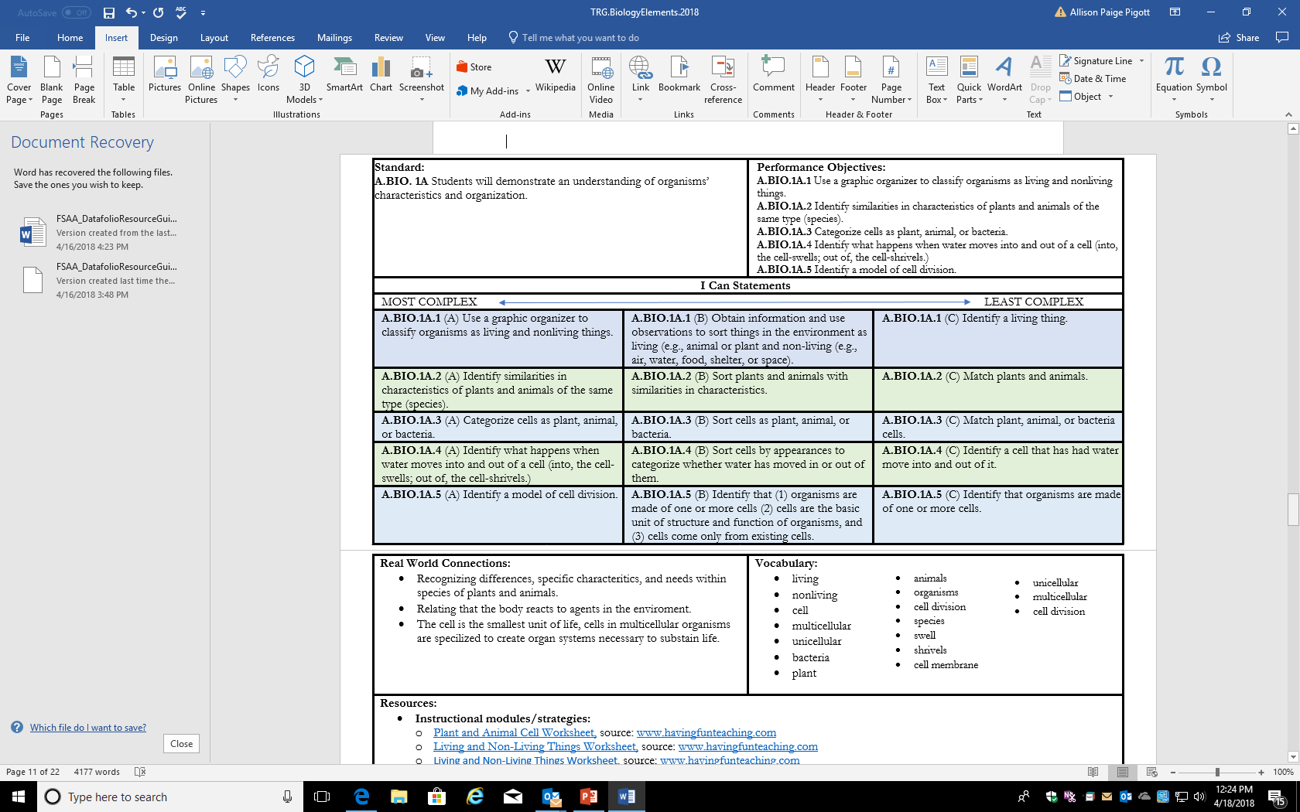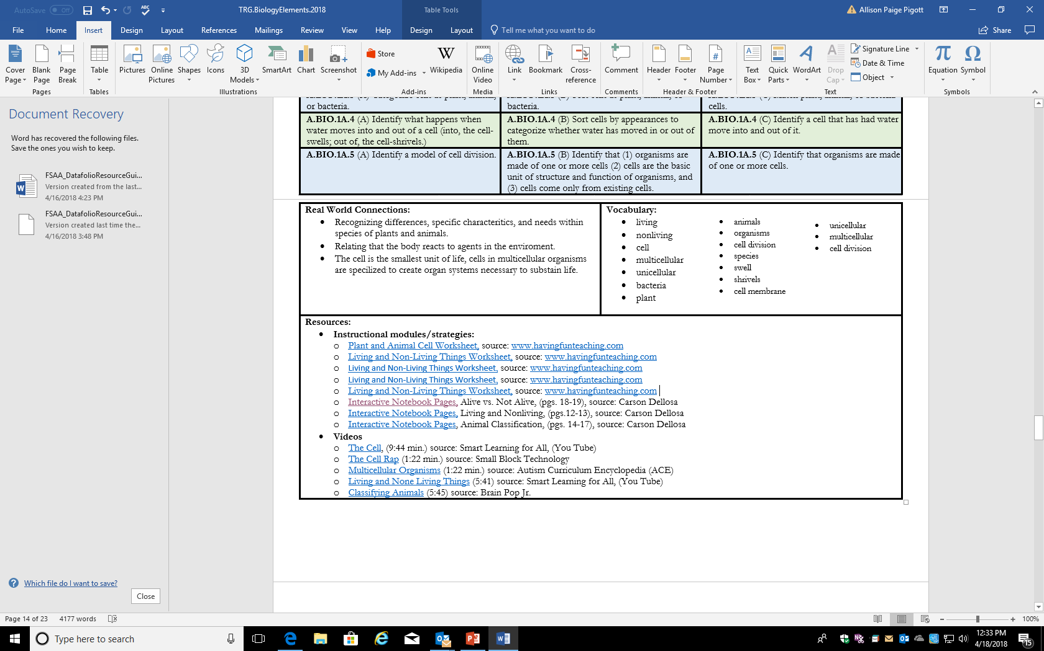

I Can Statements

# Levels of Support (LOS)

Students with significant cognitive disabilities require varying LOS to engage in academic content. The goal is to move the student along the continuum of assistance toward independence by decreasing the LOS provided and increasing student accuracy within the context of content to demonstrate progress.

The following chart describes the continuum of LOS. Appropriate LOS are important to increase student engagement and student independence and to track student achievement and progress.

|  |  |  |  |
| --- | --- | --- | --- |
| **Level of Assistance** | **Definition** | **Example** | **Non-Example** |
| **Non-**  **Engagement (N)** | The student requires assistance from the teacher to initiate, engage, or perform; however, the student actively refuses or is unable to accept teacher assistance. | The student resists the teacher’s physical assistance toward the correct answer. | The student does not look at the activity. |
| **Physical**  **Assistance (P)** | The student requires physical contact from the teacher to initiate, engage, or perform. | The teacher physically moves the student’s hand to the correct answer. | The teacher taps the correct answer and expects the student to touch where he/she tapped. |
| **Gestural**  **Assistance (G)** | The student requires the teacher to point to the specific answer. | When presenting a choice of three pictures and asking the student which picture is a triangle, the teacher will point to or tap on the correct picture to prompt the student to indicate that picture. | The teacher moves the student’s hand to gesture toward the right answer. |
| **Verbal**  **Assistance (V)** | The student requires the teacher to verbally provide the correct answer to a specific item. | The teacher says, “Remember, the main character was George. Point to the picture of the main character.” | The teacher says “Who is the main character?” without providing the information verbally. |
| **Model**  **Assistance (M)** | The student requires the teacher to model a similar problem/opportunity and answer prior to performance. | The teacher models one-to-one correspondence using manipulatives and then asks the student to perform a similar item. | The teacher completes the exact same activity as the student is expected to perform. |
| **Independent (I)** | The student requires no assistance to initiate, engage, or perform. The student may still require other supports and accommodations to meaningfully engage in the content but does not require assistance to participate and respond. | The teacher asks the student, “Who is the main character of the book?” and the student meaningfully responds without any prompting or assistance. | The teacher asks the student, “Who is the main character?” and points to the picture of the main character. |

# 

# Teacher Resource Guide for Alternate Biology Elements

|  |  |  |  |
| --- | --- | --- | --- |
| **Standard:**  **A.BIO.1A.** Students will demonstrate an understanding of organisms’ characteristics and organization. | | **Performance Objectives:**  **A.BIO.1A.1** Use a graphic organizer to classify organisms as living and nonliving things.  **A.BIO.1A.2** Identify similarities in characteristics of plants and animals of the same type (i.e., species).  **A.BIO.1A.3** Categorize cells as plant, animal, or bacteria.  **A.BIO.1A.4** Identify what happens when water moves into and out of a cell (into, the cell swells; out of, the cell shrivels).  **A.BIO.1A.5** Identify a model of cell division. | |
| **I Can Statements** | | | |
| MOST COMPLEX LEAST COMPLEX | | | |
| **A.BIO.1A.1 (A)** Use a graphic organizer to classify organisms as living and nonliving things. | **A.BIO.1A.1** **(B)** Obtain information and use observations to sort things in the environment as living (e.g., animal or plant and nonliving [e.g., air, water, food, shelter, space]). | | **A.BIO.1A.1 (C)** Identify a living thing. |
| **A.BIO.1A.2 (A)** Identify similarities in characteristics of plants and animals of the same type (i.e., species). | **A.BIO.1A.2 (B)** Sort plants and animals with similarities in characteristics. | | **A.BIO.1A.2 (C)** Match plants and animals. |
| **A.BIO.1A.3 (A)** Categorize cells as plant, animal, or bacteria. | **A.BIO.1A.3 (B)** Sort cells as plant, animal, or bacteria. | | **A.BIO.1A.3** **(C)** Match plant, animal, or bacteria cells. |
| **A.BIO.1A.4 (A)** Identify what happens when water moves into and out of a cell (e.g., into, the cell swells; out of, the cell shrivels). | **A.BIO.1A.4 (B)** Sort cells by appearance to categorize whether water has moved in or out of them. | | **A.BIO.1A.4 (C)** Identify a cell that has had water move into and out of it. |
| **A.BIO.1A.5 (A)** Identify a model of cell division. | **A.BIO.1A.5 (B)** Identify that (1) organisms are made of one or more cells (2) cells are the basic unit of structure and function of organisms, and (3) cells come only from existing cells. | | **A.BIO.1A.5 (C)** Identify that organisms are made of one or more cells. |
| **Real-World Connections:**   * Recognizing differences, specific characteritics, and needs within species of plants and animals * Relating that the body reacts to agents in the enviroment * The cell is the smallest unit of life; cells in multicellular organisms are specialized to create organ systems necessary to sustain life | | **Vocabulary:**   * Animals * Organisms * Cell Division * Species * Swell * Shrivel * Cell membrane * Living * Cell division      * Nonliving * Cell * Multicellular * Unicellular * Bacteria * Plant | |
| **Resources:**   * **Instructional modules/strategies:**   + [Plant and Animal Cell Worksheet,](http://files.havefunteaching.com/free-worksheets/grade/fourth/science/animal-plant-cells-worksheet.pdf) source: [www.havefunteaching.com](http://www.havefunteaching.com)   + [Interactive Notebook Pages,](https://images.carsondellosa.com/media/cd/pdfs/Activities/Samplers/104904_sb.pdf) Alive vs. Not Alive, (pp. 18-19), source: Carson Dellosa   + [Interactive Notebook Pages,](https://images.carsondellosa.com/media/cd/pdfs/Activities/Samplers/104908_sb.pdf) Living and Nonliving, (pp.12-13), source: Carson Dellosa   + [Interactive Notebook Pages](https://images.carsondellosa.com/media/cd/pdfs/Activities/Samplers/104908_sb.pdf), Animal Classification, (pp. 14-17), source: Carson Dellosa * **Videos**   + [The Cell](https://www.bing.com/videos/search?q=elementary+video+water+in+and+out+of+cell&&view=detail&mid=5C1E665FFB1DDDCB04235C1E665FFB1DDDCB0423&&FORM=VRDGAR), (9:44 min.), source: Smart Learning for All, [YouTube]   + [The Cell Rap](https://www.bing.com/videos/search?q=elementary+video+water+in+and+out+of+cell&&view=detail&mid=DD48534016D8405A539EDD48534016D8405A539E&&FORM=VDRVRV) (1:22 min.), source: Small Block Technology   + [Multicellular Organisms](https://www.bing.com/videos/search?q=multicellular+organisms&&view=detail&mid=C7B507CCD0F76D92D23AC7B507CCD0F76D92D23A&&FORM=VRDGAR) (1:22 min.), source: Autism Curriculum Encyclopedia (ACE)   + [Living and None Living Things](https://www.bing.com/videos/search?q=teaching+living+and+nonliving+things+videos&view=detail&mid=345C98D846C2F00818BC345C98D846C2F00818BC&FORM=VIRE) (5:41), source: Smart Learning for All, [YouTube]   + [Classifying Animals](https://www.bing.com/videos/search?q=Living+Non-Living+BrainPOP+Jr.&&view=detail&mid=65734D9A21B955F10F0B65734D9A21B955F10F0B&&FORM=VRDGAR) (5:45), source: Brain Pop Jr. | | | |

|  |  |  |  |
| --- | --- | --- | --- |
| **Standard:**  **A.BIO.2.** Demonstrate a basic understanding that plants use light from the sun to convert to energy. | | **Performance Objectives:**  **A.BIO.2.1** Identify that the sun is the main source of energy for plants.  **A.BIO.2.2** Classify parts of plants, such as leaf, stem, root, seed, and flower, to the functions of food production, support, water transport, and reproduction.  **A.BIO.2.3** Demonstrate the exchange to show that oxygen produced by plants is used by animals and carbon dioxide produced by animals is used by plants.  **A.BIO.2.4** Identify why photosynthesis is important. | |
| **I Can Statements** | | | |
| MOST COMPLEX LEAST COMPLEX | | | |
| **A.BIO.2.1** **(A)** Identify that the sun is the main source of energy for plants. | **A.BIO.2.1** **(B)** Recognize that plants grow toward light, roots grow down, and stems grow up. | | **A.BIO.2.1** **(C)** Use pictures to recognize that plants grow toward the light. |
| **A.BIO.2.2** **(A)** Classify parts of plants, such as leaf, stem, root, seed, and flower, to the functions of food production, support, water transport, and reproduction. | **A.BIO.2.2** **(B)** Classify plants into two groups—vascular or nonvascular—based on the internal structures used to transport food and water. | | **A.BIO.2.2** **(C)** Identify the parts of plants that humans eat. |
| **A.BIO.2.3 (A)** Demonstrate the exchange to show that oxygen produced by plants is used by animals and carbon dioxide produced by animals is used by plants. | **A.BIO.2.3 (B)** Identify that oxygen is produced by plants and carbon dioxide is produced by animals. | | **A.BIO.2.3 (C)** Identify that a characteristic of all living organisms is that they respond to stimuli. |
| **A.BIO.2.4 (A)** Identify why photosynthesis is important. | **A.BIO.2.4 (B)** Identify the components of photosynthesis: light (sun or artificial), water, and air (for carbon dioxide), which are necessary for plant survival. | | **A.BIO.2.4 (C)** Recognize that light and water are necessary for green plants’ survival to make food (i.e., photosynthesis). |
| **Real-World Connections:**   * Basic needs of plants to successfully garden and grow food * How to appropriately recognize houseplants’ needs * Recognize parts of plants that people eat | | **Vocabulary:**   * Water * Photosynthesis * Energy * Carbon Dioxide * Oxygen      * Water Transport * Food Production * Vascular * Nonvascular * Light * Sun * Leaf * Stem * Root * Seed * Flower * Plant | |
| **Resources:**   * **Instructional modules/strategies:**   + [Parts of Plants We Eat Worksheet](https://www.havefunteaching.com/resource/fifth-grade/plant-parts-eat-worksheet/), source: [www.havefunteaching.com](http://www.havefunteaching.com)   + [Interactive Notebook Pages,](https://images.carsondellosa.com/media/cd/pdfs/Activities/Samplers/104904_sb.pdf) What Plants Need (pp. 20-21), source: Carson Dellosa Publishing   + [Interactive Notebook Pages](https://images.carsondellosa.com/media/cd/pdfs/Activities/Samplers/104906_sb.pdf), Parts of a Plant, (pp.16-17), source: Carson Dellosa Publishing   + [Interactive Notebook Pages](https://images.carsondellosa.com/media/cd/pdfs/Activities/Samplers/104907_sb.pdf), Plant Parts, (pp. 12-13), source: Carson Dellosa Publishing   + [Interactive Notebook Pages](https://images.carsondellosa.com/media/cd/pdfs/Activities/Samplers/104907_sb.pdf), Plant Adaptations, (pp. 14-15), source: Carson Dellosa Publishing   + [Interactive Notebook Pages](https://images.carsondellosa.com/media/cd/pdfs/Activities/Samplers/104909_sb.pdf), Making Energy, (p. 21), source: Carson Dellosa Publishing * **Videos**   + [Parts of a Plant](https://www.bing.com/videos/search?q=parts+of+a+plant+brainpop+jr&&view=detail&mid=42060D1DC2B46DB9F55742060D1DC2B46DB9F557&&FORM=VRDGAR) (2:30), source: Smart Learning for All, [YouTube]   + [Photosynthesis](https://www.bing.com/videos/search?q=oxygen+is+produced+by+plants+video&view=detail&mid=9DDF91A3E2984678822A9DDF91A3E2984678822A&FORM=VIRE) (5:52), source: Small Learning for All, [YouTube]   + [Parts of Plants](https://www.youtube.com/watch?v=xO8hrqDuMmY) (7:38), source: [www.makemeagenius.com](http://www.makemeagenius.com), [YouTube]   + [Parts of Plants Song](https://www.youtube.com/watch?v=-LGh7WEZe7k) (1:30), source: Appuseries, [YouTube] | | | |

|  |  |  |  |
| --- | --- | --- | --- |
| **Standard:**  **A.BIO.3A.** Students will demonstrate an understanding of sexual reproduction. | | **Performance Objectives:**  **A.BIO.3A.1** Recognize that sexual reproduction maintains the chromosome material of the species and is the combination of a female gamete (egg) and a male gamete (sperm).  **A.BIO.3A.2** Identify and provide examples of how genes can determine traits and characteristics of offspring.  **A.BIO.3A.3** Identify examples that illustrate how patterns of inheritance can affect multiple generations within families. | |
| **I Can Statements** | | | |
| MOST COMPLEX LEAST COMPLEX | | | |
| **A.BIO.3A.1 (A)** Recognize that sexual reproduction maintains the chromosome material of the species and is the combination of a female gamete (egg) and a male gamete (sperm). | **A.BIO.3A.1 (B)** Recognize that male and female organisms produce offspring by sexual reproduction. | | **A.BIO.3A.1 (C)** Identify male and female organisms. |
| **A.BIO.3A.2** **(A)** Identify and provide examples of how genes can determine the traits and characteristics of offspring. | **A.BIO.3A.2** **(B)** Match the traits of parents with their offspring (e.g., fur color, shape, hair type). | | **A.BIO.3A.2** **(C)** Identify individual traits. |
| **A.BIO.3A.3 (A)** Identify examples that illustrate how patterns of inheritance can affect multiple generations within families. | **A.BIO.3A.3 (B)** Identify offspring with recessive and dominant traits. | | **A.BIO.3A.3 (C)** Identify organisms with dominant traits. |
| **Real-World Connections:**   * Develop an understanding of how humans and other organisms reproduce * Relay health issues that may be inherited (e.g., heart disease and diabetes) to medical professionals | | **Vocabulary:**   * Female * Male * Recessive * Dominant * Chromosome * Female gamete (egg) * Species * Parents * Male gamete (sperm) * Heredity * Inheritance      * Sex * Sexual reproduction * Traits * Gene * Offspring | |
| **Resources:**   * **Instructional modules/strategies:**   + [Heredity Worksheets](http://printableworksheets.in/?dq=Heredity), source: Printable Worksheets * **Videos**   + [The Reproductive System](https://happylearning.tv/en/the-reproductive-system/), (3:51), source: Happy Learning, [YouTube]   + [Traits](https://www.youtube.com/watch?v=SldwzOJ23J8) (2:06), source: MooMoo Math and Science [YouTube]   + [Heredity](https://www.youtube.com/watch?v=6bWssRDAHW4) (2:04), source: MooMoo Math and Science [YouTube]   + [Punnett Square](https://www.youtube.com/watch?v=prkHKjfUmMs) (4:20), source: Mahalodotcom [YouTube] | | | |

|  |  |  |  |
| --- | --- | --- | --- |
| **Standard:**  **A.BIO.4.** Students will recognize the adaptations that, over time, have helped populations survive. | | **Performance Objectives:**  **A.BIO.4.1** Use a graphic organizer to identify organisms that were unable to adapt to changes in their environment and have become extinct**.**  **A.BIO.4.2** Identify the variations in a trait within a species that would increase survival in a given environment (e.g., giraffes with longer necks can reach leaves on higher branches).  **A.BIO.4.3** Compare the differences between organisms found as fossils and those that are alive today.  **A.BIO.4.4** Match groups of organisms with similar characteristics to demonstrate an understanding that they are related (e.g., select two species from an array that are most closely related: e.g., lion, tiger, and deer: lion and tiger are more closely related to each other than they are to deer). | |
| **I Can Statements** | | | |
| MOST COMPLEX LEAST COMPLEX | | | |
| **A.BIO.4.1 (A)** Use a graphic organizer to identify organisms that were unable to adapt to changes in their environment and have become extinct**.** | **A.BIO.4.1 (B)** Sort organisms that were unable to adapt in their environment and have become extinct from organisms that have survived due to beneficial traits. | | **A.BIO.4.1 (C)** Identify a trait that would give an organism a better chance of survival (e.g., bright colors in flowers, echolocation in bats, white fur in polar bears). |
| **A.BIO.4.2 (A)** Identify the variations in a trait within a species that would increase survival in a given environment (e.g., giraffes with longer necks can reach leaves on higher branches). | **A.BIO.4.2 (B)** Recognize and sort variations in a trait within a species that would increase survival in a given environment (e.g., giraffes with longer necks can reach leaves on higher branches). | | **A.BIO.4.2 (C)** Identify a trait that helps a species survive (e.g., runs fast, has camouflage). |
| **A.BIO.4.3 (A)** Compare the differences between organisms found as fossils and those that are alive today. | **A.BIO.4.3 (B)** Match a fossil with its living counterpart through the use of pictures, picture symbols, or concrete objects. | | **A.BIO.4.3 (C)** Identify a fossil as an organism that lived a long time ago. |
| **A.BIO.4.4 (A)** Match groups of organisms with similar characteristics to demonstrate an understanding of their relationship. For example, select two species from an array that are most closely related, such as lion, tiger, and deer (Lion and tiger are more closely related to each other than they are to deer). | **A.BIO.4.4 (B)** Identify similar characteristics between two types of organisms (e.g., alligators and dogs both have four legs; eagles and robins both have feathers). | | **A.BIO.4.4 (C)** Sort different types of organisms based on similar characteristics (e.g., sort real pictures of animals into groups that have feathers or fur). |
| **Real-World Connections:**   * Help protect endangered animals * Take care of the local habitat by cleaning up and properly disposing of garbage | | **Vocabulary:**   * Adapt * Variations * Traits      * Extinct * Environment * Fossils * Species * Survival * Beneficial | |
| **Resources:**   * **Instructional modules/strategies:**   + [Animal Adaptation Worksheet](https://www.havefunteaching.com/resource/writing/adaptation-worksheet/), source: www.havefunteaching.com   + [Extinction Worksheet](https://www.havefunteaching.com/resource/writing/extinction-worksheet/), source: www.haveteaching.com   + [Endangered Species Worksheet 1](https://www.havefunteaching.com/resource/science/endangered-species-worksheet/), source: www.havefunteaching.com   + [Endangered Species Worksheet 2](https://www.havefunteaching.com/resource/writing/endangered-species-worksheet-2/), source: www.havefunteaching.com   + [Interactive Notebook Pages](https://images.carsondellosa.com/media/cd/pdfs/Activities/Samplers/104907_sb.pdf), Animal Adaptations, (p. 19), source: Carson Dellosa Publishing * **Videos**   + [Fossils](https://www.youtube.com/watch?v=sgPnnzou0og), (1:50), source: MonkeySee, [YouTube]   + [Fossils for Beginners](https://www.youtube.com/watch?v=PTQRY8i4HgY) (2:49), source: MooMoo Math & Science [YouTube]   + [Endangered Animals](https://www.youtube.com/watch?v=7k8CcAU2Lt0) (4:18), source: SciShow Kids [YouTube]   + [Endangered Species](https://www.youtube.com/watch?v=2iu8bbntr80) (6:16), source: Cosmo’s World [YouTube] | | | |

|  |  |  |  |
| --- | --- | --- | --- |
| **Standard:**  **A.BIO.5.** Students will relate the interdependence of living organisms and their environment. | | **Performance Objectives:**  **A.BIO.5.1** Predict how a habitat could change as a population changes (e.g., availability of resources).  **A.BIO.5.2** Identify the effect that a change in nonliving environmental factors could have on particular populations (e.g., too little rain would prevent most plants from growing, and animals would have to leave the environment to find water).  **A.BIO.5.3** Categorize human activities as positive or negative on the basis of their effect on the Earth. | |
| **I Can Statements** | | | |
| MOST COMPLEX LEAST COMPLEX | | | |
| **A.BIO.5.1 (A)** Predict how a habitat could change as population changes (e.g., availability of resources). | **A.BIO.5.1 (B)** Identify whether a population would increase or decrease as a result of a change in the ecosystem (e.g., because the weather is colder, many birds moved away; as a result, consider whether the bird population would increase or decrease). | | **A.BIO.5.1 (C)** Identify factors that can impact the survival of a population. |
| **A.BIO.5.2 (A)** Identify the effect that a change in nonliving environmental factors could have on particular populations (e.g., too little rain would prevent most plants from growing, and animals would have to leave the environment to find water). | **A.BIO.5.2 (B)** Identify nonliving environmental factors that could change and affect a population (e.g., coastal erosion resulting in a loss of dry land, wildfires depleting food sources and disrupting the food chain). | | **A.BIO.5.2 (C)** Identify a nonliving environmental factor (e.g., water) that could change (e.g., flooding) and affect a population (e.g., organisms would have to seek a new environment). |
| **A.BIO.5.3 (A)** Categorize human activities as positive or negative on the basis of their effect on the Earth. | **A.BIO.5.3 (B)** Match human activities with their effect on Earth (e.g., littering and polluting bodies of water result in the extinction of aquatic organisms). | | **A.BIO.5.3 (C)** Identify human activities that can affect Earth (e.g., cutting trees can eliminate habitats; recycling can save resources). |
| **Real-World Connections:**   * Advocate for the preservation of the environment * Take steps to preserve Earth * Apply the best practices for conserving resources * Sort and recycle materials | | **Vocabulary:**   * Ecosystem * Community * Food Source * Wildfire * Habitats * Recycle * Litter * Pollution * Erosion * Human * Environment * Population * Food Chain * Positive * Negative * Earth | |
| **Resources:**   * **Instructional modules/strategies:**   + [Interactive Notebook Pages](https://images.carsondellosa.com/media/cd/pdfs/Activities/Samplers/104908_sb.pdf), Food Chains and Webs, (pp. 20-12), source: Carson Dellosa Publishing   + [Interactive Notebook Pages](https://images.carsondellosa.com/media/cd/pdfs/Activities/Samplers/104909_sb.pdf), Ecosystems, (pp. 12-19), source: Carson Dellosa Publishing   + [Taking Care of Earth Worksheets](http://printableworksheets.in/?dq=Taking%2520Care%2520Of%2520Earth), source: Printable Worksheets * **Videos**   + [Components of an Ecosystem](https://www.bing.com/videos/search?q=changes+in+nonliving+factors+that+affect+a+habitat+videos&&view=detail&mid=96613B14ABCF668C903D96613B14ABCF668C903D&&FORM=VDRVRV) (19:58), source: Ikenstore.com, [YouTube]   + [Care for Our Environment](https://www.youtube.com/watch?v=V0lQ3ljjl40) (8:33), source: Turtlediary, [YouTube]   + [Save Our Earth](https://www.youtube.com/watch?v=bn8R_XqjjI0) (3:00), source: robinlittlewood, [YouTube] | | | |

# References

ACT. (2014). *ACT college and career readiness standards—Science.* Retrieved from

http://www.act.org/content/dam/act/unsecured/documents/CCRS-ScienceStandards.pdf

Alabama State Department of Education. (2015). *Alabama course of study: Science.* Montgomery, AL: Author.

Alabama State Department of Education (2016). *Alabama extended standards: Science.* Manuscript in

preparation. Montgomery, AL: Author.

Florida Department of Education, Special Education. (2016). *FSAA datafolio teacher resource guide.* FL:

Florida Department of Education.

Indiana Department of Education. (2016). *Indiana’s academic standards for science—2016*. Retrieved from http://www.doe.in.gov/standards/science-computer-science

Massachusetts Department of Elementary and Secondary Education. (2016). *2016 Massachusetts science*

*and technology/engineering curriculum framework*. Malden, MA: Author.

Mississippi Department of Education. (2010). *2010 Mississippi science framework*. Jackson, MS: Author.

Mississippi Department of Education. (2018). *2018 Mississippi college- and career-readiness standards for*

*science.* Jackson, MS: Author.

Mullis, I. V. S., & Martin, M. O. (Eds.). (2015). *TIMSS 2015 assessment frameworks.* Chestnut Hill, MA: TIMSS & PIRLS International Study Center, Boston College.

National Assessment Governing Board. (2015). *Science framework for the 2015 National Assessment of*

*Educational Progress* (Contract No. ED-04-CO-0148). Washington, DC: U.S. Government

Printing Office.

National Research Council. (2012). *A framework for K-12 science education: Practices, crosscutting concepts, and core ideas.* Washington, DC: The National Academies Press.

National Science Teachers Association. (2013). *Safety in the science classroom, laboratory, or field sites.* Retrieved from http://www.nsta.org/docs/SafetyInTheScienceClassroomLabAndField.pdf

Next Generation Science Standards Lead States. (2013). *Next Generation science standards: For states, by states.* Washington, DC: The National Academies Press.

Schrock, K. (2013, Nov. 9). Resources to support the SAMR model [Blog post]. Retrieved from http://www.schrockguide.net/samr.html

South Carolina Department of Education. (2014). *South Carolina academic standards and performance indicators for science.* Columbia, SC: Author.

South Carolina Department of Education. (n.d.) *The South Carolina Alternate Assessment (SC-Alt): Science*

*assessment and instructional support guide.* Columbia, SC: Author.

Virginia Department of Education. (2010). *Science standards of learning for Virginia public schools.* Richmond, VA: Author.