EXTENDED SCHOOL YEAR (ESY) FACT SHEET

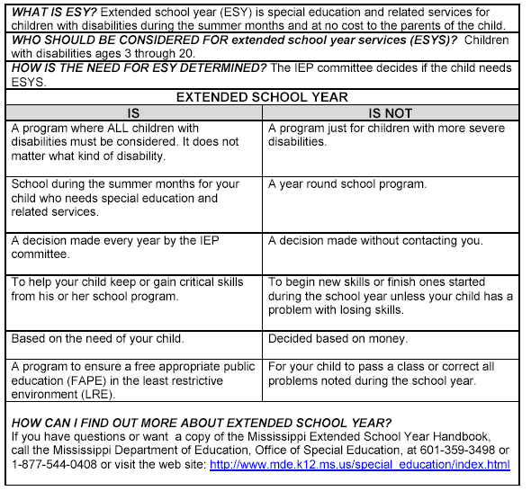

Things you should not be told about ESY:

1. We do not have any staff who want to work this summer.
2. We do not ever contract with physical therapists, occupational therapists and
speech/language pathologists in the summer.
3. We did not keep any data to see if your child needs ESY.
4. We will have to wait and see if there is any money for it.
5. The state does not approve that.
6. None of our students need it.
7. I have made the decision we are not having ESY.
8. We only have a set number of weeks for ESYS.
9. Your child has not met any goals.
10. We have never had any students get ESY.

ESY RECOMMENDATION FORM

Teacher’s Name________________________ School_________________________

Write the names of the students in your class who have been determined to need ESYS
according to the Mississippi Department of Education guidelines. Place a check (©) in
the applicable column to indicate the criterion used in determining eligibility.

Students’ Names | Regression-  Recoupment | Critical Point of Instruction | Extenuation Circumstances

Submit this form to the Supervisor of Special Education by _________________.

