Dyslexia Awareness Training
- What do you plan to gain from this session?

- List one thing you think of when you hear the word dyslexia?
Session #1

C. Where can you go to find if a student failed the dyslexia screener in kindergarten or first grade?

What foundational skill is necessary for learning to read and write?

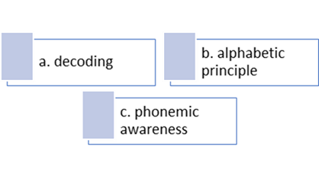
E. Think about a student that you have previously taught or are currently teaching that exhibits one of the cognitive behaviors mentioned. Pause the video to write down that student’s name, the behavior exhibited, and a strategy that could be put in place to support that student.
Student | Behavior | Strategy

6 | 4 | 2 | 3
1 | 9 | 5 | 8
3 | 7 | 4 | 2
5 | 6 | 9 | 4
F. Explain why it is important for our students to be able to name objects automatically and quickly.

G. Phonemic Awareness Activities
Segment words into syllables Segment words into sounds Sound deletion
Backpack | 2
Sidewalk | 2
Pencil | 2
sunglasses | 3
Sip | 3
Frog | 4
stop | 4
Say “shipment” without “ship” ment
Say “wonder” without “der” won
Say “safety” without “safe” ty

H. List two new strategies that you can implement I. We have discussed many ways to support your students.
with your students after watching this video. Take the next five minutes and reflect on students
1.

2.
that you have taught or are currently teaching that
could benefit from this specific instruction.

