DYSLEXIA AWARENESS

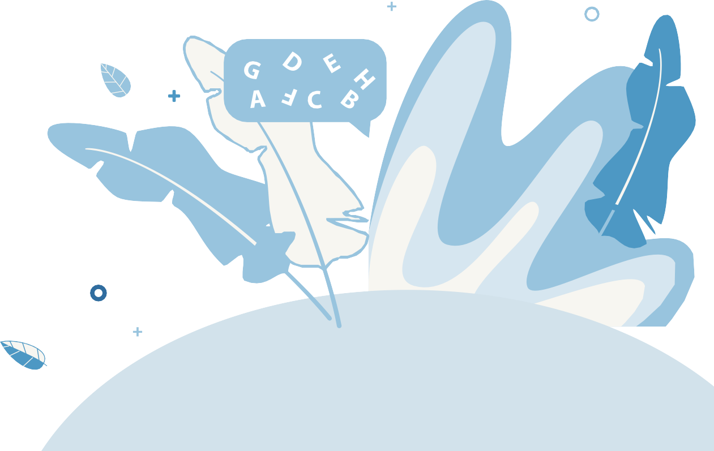

TRAINING

Instructional Guide

* Go to the Dyslexia Webpage

<https://mdek12.org/OAE/OEER/Dyslexia>

* Locate the 2021 Dyslexia Awareness Trainings
* Print the District Report Spreadsheet
* Print the Session Handout
* Click on the Session Videos
* Review the videos and complete the handout
* Sign the District Report Spreadsheet and document the dates each session was viewed
* Submit the spreadsheet to the Office of Intervention Services at [dyslexiadata@mdek12.org](mailto:dyslexiadata@mdek12.org) and keep a record for your files

