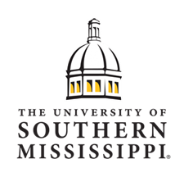  University of Southern Mississippi  Teacher Assistant Program (TAP)  Are you currently a teacher’s assistant? If so, you know what it takes to lead a K-6 classroom. In fact, you have probably thought about leading your own classroom one day. The fully online Teacher Assistant Program (TAP) at The University of Southern Mississippi is designed specifically to support you to achieve that goal.  The online meets the unique educational needs of teacher assistants who  desire to advance their knowledge and skills and become exemplary,  licensed teachers. Students enrolled in the TAP program have the  opportunity to complete all or part of their coursework online with highly  qualified and dedicated university faculty. The exciting and innovative  curriculum includes opportunities to apply new knowledge and skills  through clinical experiences that are completed while you are engaged in  your day-to-day responsibilities as a teacher assistant.  Graduates of the Elementary Education program are eligible to become certified teachers for grades K-6 with a reading endorsement and the choice of an endorsement in Math K-8, Math 9-12, Science, Social Studies, Foreign Language, or English. | Students enrolled in the TAP program at Southern Miss will major in Elementary Education.  For additional information regarding the Teacher Assistant Program at the University of Southern Mississippi, contact:  College of Education and Human Sciences Owings-McQuagge Hall (OMH), 116 118 College Drive, #5023Hattiesburg, Miss. 39406 Phone: 601.266.4568

