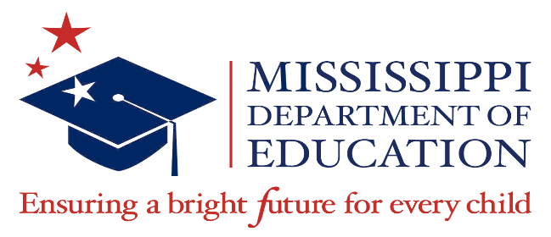

2022-2023

McKinney-Vento Education for Homeless Children and Youth Program Awards

School District | Award Amount
Corinth School District | $250,044.00
Jackson Public School District | $642,440.00
Starkville-Oktibbeha School District | $191,487.00
Tupelo Public School District | $275,620.00
TOTAL | $1,359,591.00

Funding Period: August 1, 2023 – September 30, 2024
(with a liquidation date of December 30, 2024)

