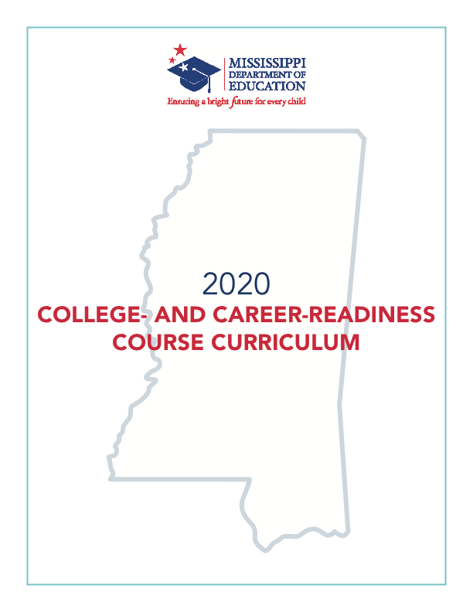

2020
Mississippi
College- and Career-Readiness
Course Curriculum

Carey M. Wright, Ed.D., State Superintendent of Education
Nathan Oakley, Ed.D., Chief Academic Officer
Wendy Clemons, Executive Director, Office of Secondary Education

Mississippi Department of Education
Post Office Box 771
Jackson, Mississippi 39205-0771
Office of Secondary Education
601.359.3461
www.mdek12.org

The Mississippi State Board of Education, the Mississippi Department of Education, the Mississippi School for the Arts, the Mississippi School for the Blind, the Mississippi School for the Deaf, and the Mississippi School for Mathematics and Science do not discriminate on the basis of race, sex, color, religion, national origin, age, or disability in the provision of educational programs and services or employment opportunities and benefits. The following office has been designated to handle inquiries and complaints regarding the non-discrimination policies of the above-mentioned entities:

Director, Office of Human Resources
Mississippi Department of Education

Table of Contents

Table of Contents 4
Acknowledgments 5
College- and Career-Readiness Task Force Members 6
Introduction 7
References and Resources 8
Research Synopsis 9
Unit 1: Introduction to College- and Career-Readiness 11
Unit 2: The Student Portfolio and Exhibit 13
Unit 3: College Selection and Transition 15
Unit 4: Applying for Financial Aid 17
Unit 5: Preparing for a Career and Internship 19
Unit 6: Financial Literacy 20
Unit 7: Community Service 23
Unit 8: Digital Literacy and Citizenship 24
Student Competency Profile 25
Pacing Guide 28
Appendix A: Unit References and Resources 30
Appendix B: Individual Success Plan (ISP) 36
Appendix C: Student Portfolio Guidelines and Resources 40
21st Century Skills and Objectives 40
Artifacts 42
Exemplary Artifact Check List 42
Digital Portfolio Assessment Rubric Sample 43
Student Artifact Reflection Sheet 47
Appendix D: 21st Century Skills 48
Appendix E: National Standards in K-12 Personal Finance 51
Appendix F: National Standards for Financial Literacy 53

Acknowledgments

Appreciation is expressed to the following professionals, who provided guidance and insight throughout the development process:

Cindy Ming, project manager for the Research and Curriculum Unit (RCU) at Mississippi State University (MSU)

Heather Morrison, director of P20 Partnerships, Office of Policy and Strategic Initiatives, Mississippi Institutions of Higher Learning

Jenny Campbell, project manager for the RCU at MSU

Brad Skelton, project manager for the RCU at MSU

Myra Pannell, associate director for the RCU at MSU

Betsey Smith, director for the RCU at MSU

College- and Career-Readiness Task Force Members

Amanda Tullos Literacy curriculum and intervention specialist, Starkville-Oktibbeha School District
Angela Payne, PhD Director of admissions, Meridian Community College
Audra Love Kimble Assistant executive director for academics and student affairs, Mississippi Community College Board
Casey C. Turnage, PhD Director of policy and strategic initiatives,
Mississippi Institutions of Higher Learning
Catherine Beasley Curriculum specialist, Rankin County School District
Chandrea Walker Director of counseling and support services,
Mississippi Department of Education
Charlotte Young Assistant superintendent, Meridian Public-School District
David Fava Career technical education director, Gulf Port School District
Debbie West-Terry Counselor, George County High School
Dee Randall Director of curriculum and instruction, Columbia School District
Emelia Nordan College savings plan and policy director, Office of the Mississippi Treasurer
Erron Flowers Director of admissions, University of Southern Mississippi
Helen Price Principal, Oak Grove High School
Janieth Adams Director of undergraduate admissions, Jackson State University
Jennifer Rogers Director of student financial aid, Mississippi Institutions of Higher Learning
Jennifer Trammell Office director of K-8 counseling programs, Mississippi Department of Education
Jessica Flynt Counselor, Covington County School District
Jessica Smith Counselor, Northwest Rankin High School
Juawice McCormick Coordinator of school counseling program, The University of Southern Mississippi
Kemi Ford Counselor, Amory School District
Kenya L. Horn Counselor, Mississippi School of the Arts
Keri Armstrong Counselor, Columbia High School
Kierstan Dufour Assistant director of Get2College, Woodward Hines Education Foundation
Lori Ball Director of undergraduate admissions and scholarships, Mississippi State University
Melissa Caperton Director of American College Application Campaign, American Council on Education
Rachel De Vaughan, PhD Director of special projects, Mississippi Community College Board
Selena Swartzfager President, Mississippi Council on Economic Education
Stephanie Bullock Project coordinator for Complete 2 Compete, MS Institutions of Higher Learning
Suzanne Oakley Counselor, Calhoun County High School
Theresa Conner Teacher, Northwest Rankin High School
Thomas Dudley III Assistant principal, Richland High School
Vickie Powell Senior vice president of foundations, Mississippi Economic Council

Introduction

Mission Statement
The Mississippi Department of Education (MDE) is dedicated to student success, which includes improving student achievement of 21st century skills. The Mississippi College- and Career-Readiness (CCR) course curriculum provides a consistent and clear understanding of what students are to be able to do at the end of each unit. The curriculum was designed to be relevant to the real world, reflecting the knowledge and skills needed for success in college, career and to compete in a global economy.

Purpose
The Mississippi CCR course was developed to support the vision and mission of the MDE that all students graduate from high school prepared for college, career, and active citizenship. The CCR course curriculum outlines what knowledge students should obtain and the types of skills that must be mastered upon completion of the course. These standards have been determined to be relevant for students’ successful transition to postsecondary and the workforce.

Implementation
The Mississippi CCR course was piloted during the 2018-2019 and 2019-2020 school years. This course was developed for students in 11th and 12th grades.

References and Resources

Get2College
Units for college and career planning were adapted by the Get2College program of the non-profit organization, Woodward Hines Education Foundation (WHEF). The Get2College mission is to help Mississippi students get to college and be successful there.
Get2college.org

Council for Economic Education
The unit on financial literacy was adapted from the National Standards for Financial Literacy published by the Council for Economic Education.
MSCEE

Jump$tart
The unit on financial literacy was also adapted from the National K-12 Standard for Personal Finance Education published by Jump$tart.
Jump$tart

ACT College- and Career-Readiness Standards
These standards are used to provide essential skills and knowledge needed for students to effectively prepare for college, a career, and life after high school.
ACT

Resources/References
A list of recommended references/resources is provided for each unit in Appendix A. Each list includes online instructional resources that may be used to teach or enhance each CCR unit. These resources are recommended and are not endorsed by the MDE or its partnering institutions. The list may be modified or enhanced based on the needs and abilities of students and available resources.

Research Synopsis

Introduction
High schools work to increase college- and career-readiness skills in order to prepare students for college, career, and life. These skills enable students to not only graduate high school but also pursue higher education. Eighty-six percent of high school students expect to attend college but lack the guidance and support needed to prepare for college enrollment and success. College- and career-readiness skills are measured through students’ mastery of four major components: key cognitive strategies, key content knowledge, academic behaviors, and contextual skills. Together, these four major components develop students who are fully prepared for postsecondary education.

In addition, most employers believe that employees lack the multidimensional skills needed to succeed in the workplace. These skills can be achieved through courses that emphasize college- and career-readiness skills, including the development of both cognitive and metacognitive capabilities. With analysis skills, interpretation, precision and accuracy, problem-solving, and reasoning skills, employers feel that employees are better prepared for success in the workforce. High schools focus on instilling these multidimensional skills in students in order to ensure that students are easily able to transition from high school to college and to the workplace.

Transition to Postsecondary Education
The Mississippi Articulation Transfer Tool (MATT) is the articulation agreement between Mississippi Community Colleges and the Mississippi Institutions of Higher Learning. High school counselors are highly encouraged to utilize the MATT during the advisement process of dual credit and dual enrollment. matttransfertool.com

Best Practices
Innovative Instructional Technologies
Recognizing that today’s students are digital learners, the classroom should be equipped with tools that will teach students in the way they need to learn. The high school teacher’s goal should be to include teaching strategies that incorporate current technology. To make use of the latest online communication tools, the classroom teacher is encouraged to use a learning management system that introduces students to education in an online environment and places the responsibility of learning on the student.

Differentiated Instruction
Students learn in a variety of ways. Some are visual learners, needing only to read information and study it to succeed. Others are auditory learners, thriving best when information is read aloud to them. Still, others are tactile learners, needing to participate actively in their learning experiences. Add the students’ backgrounds, emotional health, and circumstances, and a unique learner emerges. By providing various teaching and assessment strategies, students with various learning styles can succeed.

Cooperative Learning
Cooperative learning can help students understand topics when independent learning cannot. Therefore, one will see several opportunities in a high school curriculum for group work. To function in today’s workforce, students need to be able to work collaboratively with others and solve problems without excessive conflict.

Conclusion
Through this course, high school students may develop college- and career-readiness skills that will help them in the adaptation into college, career, and life. Students who complete this course will be well equipped for the workforce because they will have the cognitive and metacognitive skills needed to succeed in life after high school.
Unit 1: Introduction to College- and Career-Readiness

Throughout Unit 1, students will prepare a foundational knowledge of college- and career-readiness skills that will aid them in the transition into college, career, and life. Using the Individual Student Planning (ISP) tool to guide discussion throughout the year, students can begin or continue the process of preparing for life after high school.

Competencies and Suggested Objectives
- Explain what it means to be college- and career-ready.
- Define college- and career-readiness.
- Explain and illustrate what 21st century skills are and why they are needed to be college- and career-ready.
- Distinguish between hard skills and soft skills and how they apply to postsecondary and the workforce.
- Determine the college- and career-readiness skills needed for postsecondary college/university and/or a career.
- Create academic and personal S.M.A.R.T. goals for the current school year.
  - Discuss reasons for setting goals.
  - Identify and discuss each part of a S.M.A.R.T. goal.
  - Write S.M.A.R.T. goals for the current year and postsecondary that align with the current Individual Success Plan (ISP).
  - Identify action steps that will lead to the achievement of created S.M.A.R.T. goals.
  - Create a mission statement for the current school year that includes the items below.
    - Personal S.M.A.R.T. goals
    - Academic S.M.A.R.T. goals
    - How the personal and academic goals relate to 21st century skills
    - How the created goals represent the individual student
- Determine that all selected diploma requirements, based on the chosen career, are current and postsecondary plans are developed.
- Schedule a meeting with the high school counselor to complete the items below.
      - Revise/complete an ISP to ensure requirements for the selected diploma are current and on track for graduation.
      - Create a collaborative school year calendar of dates for student conferences/important deadlines for college, scholarship, and financial aid applications and portfolio artifacts.
- Evaluate postsecondary programs to determine progress towards meeting postsecondary/career goals.
- Create or revise a student résumé that includes the items below.
          - Work experience (e.g., internships, job shadowing experiences, summer jobs, part-time work)
          - Volunteering/community service projects
          - School information
          - Leadership activities
          - Extracurricular activities
- Determine which college/university program of study or career pathway best meets the completed ISP.
  - Discuss the differences between private, public, and religious colleges and universities regarding cost and requirements for admittance.
  - Research to identify the top three potential colleges and universities for the programs of study that align with the ISP.
  - Schedule college/university campus tours (in person or virtual) with staff or a counselor.
  - Complete an individual career assessment using an online resource (e.g., O*NET online).
  - Research online resources for career exploration options to prepare for a career, internships, and/or college or university (e.g., Get2College, MATT, and Big Future).

Unit 2: The Student Portfolio and Exhibit

The following unit provides all students with an opportunity to develop a portfolio that uniquely demonstrates the culmination of their proficiency in academics, 21st century skills (i.e., critical thinking, creativity, collaboration, and communication), and citizenship. Reflecting on who they are while showing what they want to do, the portfolio allows students to communicate and demonstrate 21st century skills and knowledge of postsecondary and career interests.

The final portfolio exhibit should affirm students’ abilities to think critically and creatively, to solve practical problems, to make reasoned and ethical decisions, and to communicate effectively. This portfolio will require cooperation and collaboration among faculty members to ensure students have the resources needed to complete the project (i.e., an administrator, an academic teacher, a counselor, and/or media specialists).

Competencies and Suggested Objectives
- Discuss the purpose and development of a student portfolio.
- Explain the purpose of a student portfolio.
- Identify and explain each component of a student portfolio.
- Assess ways a student portfolio will demonstrate 21st century skills and knowledge from across curricula.
- Determine the requirements for the portfolio based on the assessment rubric. (Sample rubric can be found in Appendix B.)
- Demonstrate how to collect and organize exemplary artifacts into the student portfolio.
- Collect and identify individual exemplary artifacts for the portfolio (e.g., academic assignments, writing samples, collaborative projects, job shadowing experiences, etc.) that will measure intended outcomes of 21st century skills and citizenship across subject areas and disciplines.
- Write a reflection for each artifact that will be included in the final portfolio. (Sample reflection form can be found in Appendix B.)
- Create a collaborative calendar with teachers, counselors, and staff to determine when artifacts and written assignments for the portfolio are due throughout the year.
- Evaluate progress for the completion of the final portfolio.
- Evaluate each artifact to ensure it demonstrates proficiency of 21st century skills.
- Complete reflections on selected artifacts.
- Schedule a date and time with the counselor and staff for the final portfolio exhibit.
- Write and prepare formal invitations to send to the selected/designated portfolio review panel.

- Present the final portfolio for evaluation.
- Make strategic use of digital media (e.g., textual, graphical, audio, visual, and interactive elements) in presentations to enhance understanding of findings, reasoning, and evidence and to add interest.
- Communicate effectively how selected artifacts demonstrate the items below.
  - Proficiency of 21st century skills based on the portfolio rubric
  - Proficiency in academic standards
  - Preparedness for the chosen career pathway/postsecondary program of study
- Communicate effectively how selected artifacts demonstrate the items below.
  - Evidence of self-reflection
  - Academic and social growth
  - Leadership
- Write and address formal thank you notes to mail/hand deliver to the portfolio exhibit panel members.

Unit 3: College Selection and Transition
Competencies and Suggested Objectives
- Investigate potential colleges/universities or military branches based on the ISP and career interests.
      - Create a student profile at Big Future or other selected resource to use in the college search.
      - Select colleges/universities or military branches to research based on the ISP and career interests.
      - Compare admissions requirements for selected military branches or selected colleges/universities (e.g., ACT score, grade point average (GPA), essay, and recommendation requirements).
      - Determine “cost of attendance” (COA) for each college/university selected (myintuition).
      - Write emails to potential college/university admissions counselors to introduce the student and their interests as well as request information on scheduled events and activities.
      - Create a calendar of application deadlines for selected colleges/universities.
      - Create a calendar of dates for enlistment/enrollment requirements for a selected military branch or ROTC.
- Demonstrate the ability to complete college admissions applications.
- Identify the documents needed to complete a college application (e.g., ACT scores, transcripts, admissions essays, résumés, recommendations).
- (Juniors ONLY) Complete a mock application for review by a faculty member.
- Utilize admissions counselors from selected colleges to provide information on the application process and selection.
- (Seniors Only) Complete an official application for selected colleges/universities. (It is recommended that students complete three applications—a reach, match, and safety.)
- (Seniors Only) Review the process required to request official documents that will be required and sent to selected colleges/universities (e.g., transcript, ACT score, fee waiver, etc.).
- (Applications that require essays) Develop a written essay to meet college admissions, program entry, and/or scholarship requirements.
- Identify the requirements of selected college/university admissions, program entry, and/or scholarship essay (e.g., relevant topics, word count, double spaced, font, header, and footer notes).
- Research and choose a relevant essay prompt.
- Create a draft of the college essay to be reviewed and edited by a faculty member or counselor.
- Create a final draft of the essay for submission to the selected college/university.
- (Juniors Only) Prepare for a transition to college.
- Research college academic programs offered in the summer that align with interests and career paths.
- Register for college/university campus visits.

Units for college and career planning were adapted by the Get2College program of the non-profit organization, Woodward Hines Education Foundation (WHEF). The Get2College mission is to help Mississippi students get to college and be successful there.

Unit 4: Applying for Financial Aid
Competencies and Suggested Objectives
      - Develop a college financial plan that identifies funding sources for, and sustainability for, each year required for a degree or certification in a selected academic or technical program.

The following objectives can be met by following the College Planning Guide found in the online resource Get2College.
- Explain the difference between a scholarship, a student loan, a work-study program, and a Pell Grant as financial aid options and what order they should be used when applying to a college/university. Explore financial aid options that will apply for each selected college/university (e.g., scholarships, grants, the G.I. Bill, etc.).
- Calculate the amount of financial aid needed for selected colleges/universities using the financial aid calculators on each college/university website.
- Research available scholarships that will apply to selected academic or technical programs (e.g., outside scholarships, university or college scholarships, Mississippi aid).
- Explore military options for college financial aid.
- Investigate the types of student loans, loan amounts, interest rates, repayment options, etc. (studentloans.gov)
- Complete applications for financial aid.
              - Explore Free Application for Federal Student Aid (FAFSA) resources to gain an understanding of what it is, what it is used for, and why it is important. (FAFSA)
              - Create a Federal Student Financial Aid username and password (FSA ID) to be used for all Federal Student Aid applications such as, FAFSA, and Federal student loans.
              - Determine eligibility for the Mississippi HELP grant and other scholarships (e.g., Mississippi Scholars) based on information obtained from a revised/completed ISP.
(Juniors Only)
              - Use the EFC (Expected Family Contribution) calculator (Get2College) to determine eligibility for financial aid.
              - Apply for available private scholarships (national or local).
(Seniors Only)
              - Complete the FAFSA between October 1 and March 31. (fafsa.gov)
              - Complete the Mississippi Aid Application between October 1 and March 31. (msfinancialaid.org)
- Complete an application worksheet, including scholarship/financial aid deadlines and requirements to maintain each.
- Participate in mock scholarship and academic interviews.
  - Identify and examine questions that may be asked during a scholarship/academic interview.
  - Participate in a mock scholarship interview with peers or instructor.
  - Write a reflection of the interview process and determine strengths and areas of growth.
- Understand the financial aid award letter process.
- Complete any verification required from the college/university or the Mississippi Office of Student Financial Aid.
- Review financial aid packages the semester prior to attending a college/university.
- Review the “Cost of College” resources from Get2College. Complete the resources based on the chosen college/university.
- Accept a financial aid package for a college/university through an online student account.

Units for college and career planning were adapted by the Get2College program of the non-profit organization, Woodward Hines Education Foundation (WHEF). The Get2College mission is to help Mississippi students get to college and be successful there.

Unit 5: Preparing for a Career and Internship
Competencies and Suggested Objectives
            - Research a selected career path based on interests and program of study in a completed ISP (e.g., O*Net Online, Bureau of Labor Statistics Occupational Outlook Handbook).
- Determine the skills, education, and training that will be needed for this career/profession.
- Explore the technology used in this career/profession.
- Identify potential salary and employee benefits/compensations.
- Research current and future job availability for the chosen career path based on location.
- Determine the return on investment for the chosen career.
- Create a spreadsheet or flow chart showing the advancement of the chosen career path and track the cost of any additional education/certifications that could be required throughout this career or other related options.
- Participate in an internship, career interview, or job shadowing experience in person or online that is related to a researched career field.
- Distinguish between an internship, a career interview, and a job shadowing experience.
- Discuss the purpose of an internship, a career interview, and job shadowing experience and how participating can provide purposeful exposure to a researched career path.
- Schedule a meeting with designated school staff to plan and schedule internship/job shadowing hours and expectations.
- Identify skills (technical, transferable, and/or “soft”) that are needed for the selected career field.
- Explain what this career looks like daily.
- Determine the current salary scale for the desired career.
- List the advantages and disadvantages of entering the selected career field.
- Identify work experiences that are beneficial to this selected career.
- Complete and document internship/job shadowing hours within the chosen career field.
- Request a letter of recommendation from the internship or job shadowing experience.
- Submit internship or job shadowing experience evaluation forms.
- Write a reflection that gives an overview of the internship or job shadowing experience. The reflection should also answer the questions below.
        - How will this experience influence the selected career pathway?
        - How did this experience compare to previous ideas or views of the chosen career?
        - How did this experience help identify personal strengths and opportunities for growth?

Unit 6: Financial Literacy
Competencies and Suggested Objectives
- Compare sources of personal income and compensation and analyze factors that affect net income.
  - Analyze the monetary and non-monetary value of employee benefits in addition to wages and salaries.
  - Identify non-income factors that influence career choice.
  - Compare the unemployment rates of workers with different levels of education.
  - Describe the relationship between gross and net income.
  - Identify the parts of a paycheck stub and describe the purpose of deductions.
  - Explain the purpose of income tax and how it impacts net income.
  - Complete a W-4 form, Mississippi Employee’s Withholding Exemption Certificate, and Form I-9.
- Apply reliable information and systematic decision making to personal financial decisions.
  - Explain how personal financial decisions affect oneself as well as others.
  - Evaluate reliable resources for financial advice or representation when making financial decisions, including consulting attorneys, tax advisors, and/or financial planners.
  - Investigate sources of up-to-date information regarding consumer rights and responsibilities.
  - Describe how inflation affects financial decisions, including the price of goods and services.
  - Explain the process of resolving identity theft problems as recommended by the Federal Trade Commission and relevant financial institutions.
  - Develop a definition of wealth based on personal values, priorities, and goals.
  - Discuss the importance of having a personal financial plan, including goals, a spending-and-savings plan, an investing plan, an insurance plan, a net worth statement, and an estate plan.
- Analyze strategies to monitor income and expenses, plan for spending, and save for future goals.
  - Compare the features and costs of personal checking/savings accounts offered by different financial institutions.
  - Investigate account management services that financial institutions provide (e.g., banking apps, websites, mobile alerts, online bill pay, direct deposit, etc.).
  - Identify ways to deposit and withdraw funds from a personal checking and/or savings account.
  - Discuss various banking activities used to make a purchase, make a deposit, and/or pay a bill (e.g., written check, ATM withdrawal, debit, person-to-person transaction, prepaid card, etc.).
  - Write a check.
  - Reconcile a checking account.
  - Compare the costs of cashing a check with various third parties, such as banks or credit unions, check-cashing services, and retail outlets.
  - Compare the advantages and disadvantages of owning a house versus renting.
  - Identify common monthly bills and demonstrate how to schedule and manage bill payments.
  - Develop a budgeting plan to manage spending and saving.
- Develop strategies to control and manage credit and debt.
  - Discuss the benefits and costs of using credit and debt.
  - Explain the effect of debt on net worth and the ability to borrow money.
  - Compare and contrast debit and credit cards.
  - Examine a credit card statement and identify the interest rate and fees charged.
  - Analyze credit reports and credit scores.
  - Discuss the relationship between compound interest and debt and its effect on wealth building.
  - Differentiate among various types of student loans and alternatives as a means of paying for postsecondary education.
  - Determine the most cost-effective option for purchasing a vehicle.
- Explain how investing helps build wealth and meet financial goals.
  - Describe the differences between saving and investing and when to utilize each.
  - Describe the importance of various sources of income on retirement, including Social Security, employer-sponsored retirement savings plans, and personal investments.
  - Compare various types of investments and give examples of how employer-matching contributions to employer-sponsored retirement savings plans and vesting schedules affect participating employees.
  - Explain how compound interest works, its benefits to savers, and how to calculate it using an online calculator.
  - Illustrate how the concept of time value of money applies to retirement planning.
  - Compare the advantages of taxable, tax-deferred, and tax-advantaged investments for new savers, including Roth IRAs and employer-sponsored retirement vehicles.
  - Define asset allocation and diversification and explain why they are key strategies for successful investing.
  - Compare the consequences of delaying investment for retirement and the benefits of investing early.
  - Explain the stock market, including the basics of how it functions, how investors interact with the stock exchange, and how investors make money in it.
- Analyze appropriate and cost-effective risk management strategies.
  - Identify and discuss the basic types of insurance available to consumers and determine the appropriate time to utilize each.
  - Evaluate the costs and benefits of extended warranties.
  - Differentiate among the main types of auto insurance coverage and determine the legal minimum amounts of auto insurance coverage required in Mississippi as well as the recommended optimal amounts.
  - Identify the factors that influence the cost of homeowner’s and renter’s insurance.
  - Explain the fundamentals of health insurance and identify various types of health insurance coverage.
  - Analyze the conditions under which it is appropriate for young adults to have life, health, disability, and long-term care insurance and identify sources to obtain each.
  - Explain premiums, deductibles, copays, and out-of-pocket expenses.

This unit was developed, in part, by the Mississippi Council on Economic Education. The competencies and Suggested Objectives are based on the Council for Economic Education’s National Standards for Financial Literacy and the Jump$tart National Standards for K-12 Personal Finance Education.

Competencies and Suggested Objectives
- Determine a service project that will meet a need within the local school/community.
  - Define community service.
  - Discuss what a community service project is and why it is important.
  - Explain the purpose of a service project and how it can impact a school or local community.
  - Analyze potential service projects that would meet a need within the local school/community (e.g., children and schools, senior citizens, military, animals, environment, hungry or homeless, reducing crime, promoting safety, promoting community involvement or enhancement, maternal and child health, adult literacy, disease prevention and treatment, financial literacy).
  - Determine how the selected service project or projects will be implemented within the local school/community (e.g., the whole class/grade, an individual student, groups of students, etc.).
- Write and present a proposal for the selected service project to peers and selected staff.
  - Explain how the project will benefit and create a positive environment for the local school/community involved in the project.
  - Create a project work plan that details how the project will be fully implemented within a school/community.
If funding is required…
  - Develop a budget that includes expenditures (e.g., marketing, transportation, materials, and supplies), income (e.g., donated goods/services, funds raised, and grants), and how all monies will be reported.
  - Explore external organizations/donors who can support and fund parts of the project.
  - Create a fundraising plan that will meet the fundraising needs for the project.
- Implement a student-led service project into the school/community.
  - Determine the roles and responsibilities of the service project work plan.
  - Establish a consistent form of communication with volunteers, project participants, and staff involved in the project.
  - Collect informational data on the progress of the project.
  - Maintain financial documentation of all aspects of the service project.
- Evaluate the success of the student service project.
  - Evaluate to determine if the project benefitted and created a positive environment for the local school/community.
  - Write a report that includes a summary, key points, visuals, challenges, and recommendations for the service project.
- Present the final overall report to the selected portfolio committee (e.g., make a video, write an article, create a slideshow, etc.).
Unit 7: Community Service

Unit 8: Digital Literacy and Citizenship
Competencies and Suggested Objectives
- Explain the role that digital media plays in an individual’s daily life.
  - Discuss different types of media and how each is used to inform society (e.g., print, newspaper, broadcast, television, radio, talk radio, internet, etc.).
  - Compare the similarities and differences between digital communities and non-digital communities.
  - Analyze how digital media influences and impacts society.
  - Explore the different ways individuals interact and integrate media into their daily lives.
  - Evaluate the advantages and disadvantages of various forms of media.
  - Explain the purpose of a professional email account and how to create one.
- Demonstrate proper etiquette when collaborating, communicating, and using digital media.
  - Identify cyberbullying, cyberstalking, and other inappropriate online behaviors.
  - Analyze how cyberbullying, cyberstalking, and other inappropriate online behaviors can affect individuals and groups of people.
  - Research state and national laws and policies concerning cyberbullying, cyberstalking, and other inappropriate online behaviors.
  - Discuss strategies that can be used to protect an individual’s online privacy.
  - Explain the importance of respecting other people’s opinions online.
  - Identify the responsible use of social media and how to apply it to individual social media accounts.
- Evaluate the impact of social media on digital communities.
  - Explore how social media sites/apps contribute to building online communities.
  - Analyze the advantages and disadvantages of social media sites/apps.
  - Investigate the impact personal social media accounts can have on college and career options.
- Analyze copyright and plagiarism laws.
  - Evaluate copyright and plagiarism laws on one’s own creative work.
  - Evaluate copyright and plagiarism laws on others’ creative work.
  - Identify resources that can assist with recognizing different types of licenses and copyright uses (e.g., Creative Commons).
- Explore the various facets of internet privacy.
  - Identify ways in which websites collect personal data on its users.
  - Compare the advantages and disadvantages of websites collecting personal data.
  - Compare private versus public information.
  - Demonstrate how to set privacy settings and update them on a regular basis.
  - Explore the impact of an individual’s digital footprint.
  - Explain how a digital footprint can impact college and career choices.
  - Investigate security measures that can be taken to protect an individual’s identity.
  - Discuss the characteristics and purpose of a strong password.
  - Identify security measures that websites take to protect their users’ identities.
- Create a presentation that applies knowledge and understanding of an aspect of digital literacy/digital citizenship.

Student Competency Profile
Student’s Name: ___________________________________________

This record is intended to serve as a method for either the instructor or student to update as each unit/competency is completed. It can be duplicated for each student.

This document is recommended, however, instructors of the CCR course may develop or revise this record based on the context of their district/school’s scheduling of this course and/or digital availability.

Unit 1: Introduction to College- and Career-Readiness
Date Completed
 | 1. | Explain what it means to be college- and career-ready.
 | 2. | Create academic and personal S.M.A.R.T. goals for the current school year.
 | 3. | Determine that all selected diploma requirements, based on the chosen career, are current and postsecondary plans are developed.
 | 4. | Determine which college/university program of study or career pathway best meets the completed ISP.
Unit 2: The Student Portfolio and Exhibit
 | 1. | Discuss the purpose and development of a student portfolio.
 | 2. | Demonstrate how to collect and organize exemplary artifacts into the student portfolio.
 | 3. | Evaluate progress for the completion of the final portfolio.
 | 4. | Present the final portfolio for evaluation.
 | 5. | Write and address formal thank you notes to mail/hand deliver to the portfolio exhibit panel members.
Unit 3: College Selection and Transition
 | 1. | Investigate potential colleges/universities or military branches based on the ISP and career interests.
 | 2. | Demonstrate the ability to complete college admissions applications.
 | 3. | (Applications that require essays) Develop a written essay to meet college admissions, program entry, and/or scholarship requirements.
 | 4. | (Juniors Only)Prepare for transition to college.
Unit 4: Applying for Financial Aid
 | 1. | Develop a college financial plan that identifies funding sources for, and sustainability for, each year required for a degree or certification in a selected academic or technical program.
 | 2. | Complete applications for financial aid.

Date Completed
 | 3. | Complete an application worksheet, including scholarship/financial aid deadlines and requirements to maintain each.
 | 4. | Participate in mock scholarship and academic interviews.
 | 5. | Understand the financial aid award letter process.
Unit 5: Preparing for a Career and Internship
 | 1. | Research a selected career path based on interests and program of study in a completed ISP.
 | 2. | Participate in an internship, career interview, or job shadowing experience in person or online that is related to a researched career field.
 | 3. | Request a letter of recommendation from an internship or job shadowing experience.
 | 4. | Submit internship or job shadowing experience evaluation forms.
 | 5. | Write a reflection that gives an overview of the internship or job shadowing experience.
Unit 6: Financial Literacy
 | 1. | Compare sources of personal income and compensation and analyze factors that affect net income.
 | 2. | Apply reliable information and systematic decision making to personal financial decisions.
 | 3. | Analyze strategies to monitor income and expenses, plan for spending, and save for future goals.
 | 4. | Develop strategies to control and manage credit and debt.
 | 5. | Explain how investing helps build wealth and meet financial goals.
 | 6. | Analyze appropriate and cost-effective risk management strategies.
Unit 7: Community Service
 | 1. | Determine a service project that will meet a need within the local school/community.
 | 2. | Write and present a proposal for the selected service project to peers and selected staff.
 | 3. | Implement a student-led service project into the school/community.
 | 4. | Evaluate the success of the student service project.
 | 5. | Present the final overall report to the selected portfolio committee (e.g., make a video, write an article, create a slideshow, etc.).
Unit 8: Digital Literacy and Citizenship
 | 1. | Explain the role that digital media plays in an individual’s daily life.
 | 2. | Demonstrate proper etiquette when collaborating, communicating, and using digital media.
 | 3. | Evaluate the impact of social media on digital communities.
 | 4. | Analyze copyright and plagiarism laws.
 | 5. | Explore the various facets of internet privacy.
 | 6. | Create a presentation that applies knowledge and understanding of an aspect of digital literacy/digital citizenship.

Pacing Guide

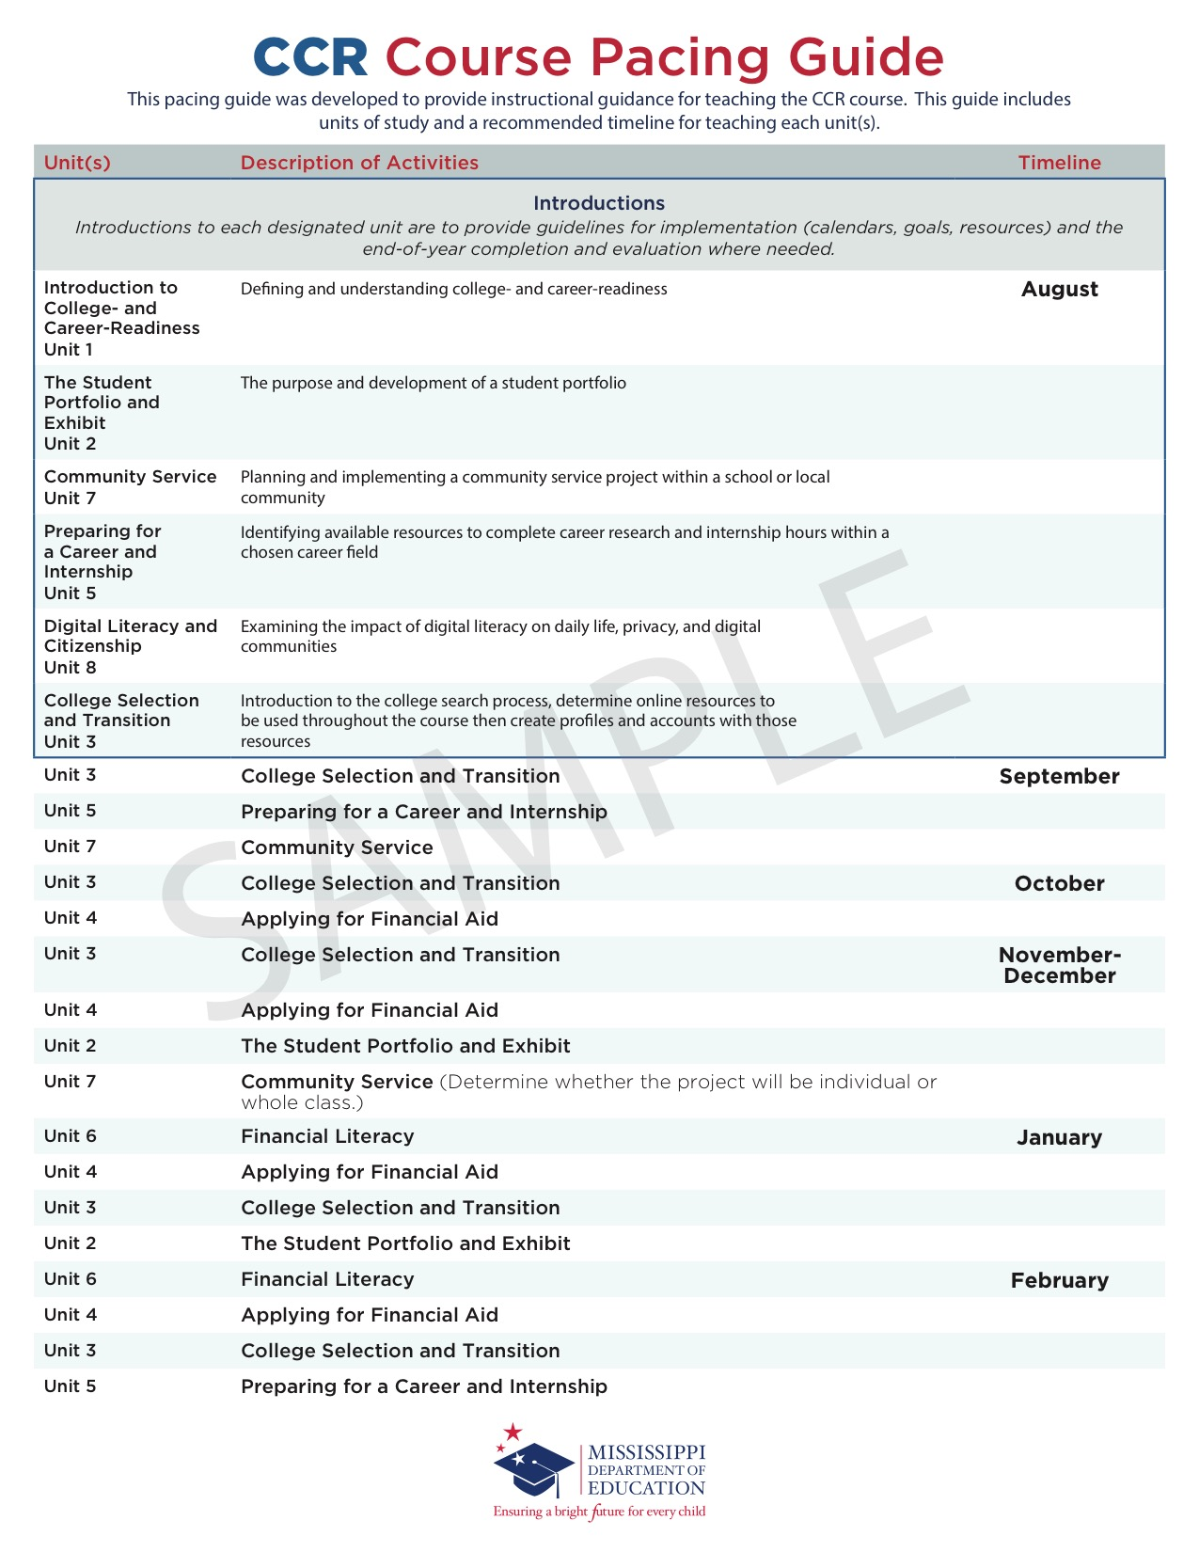
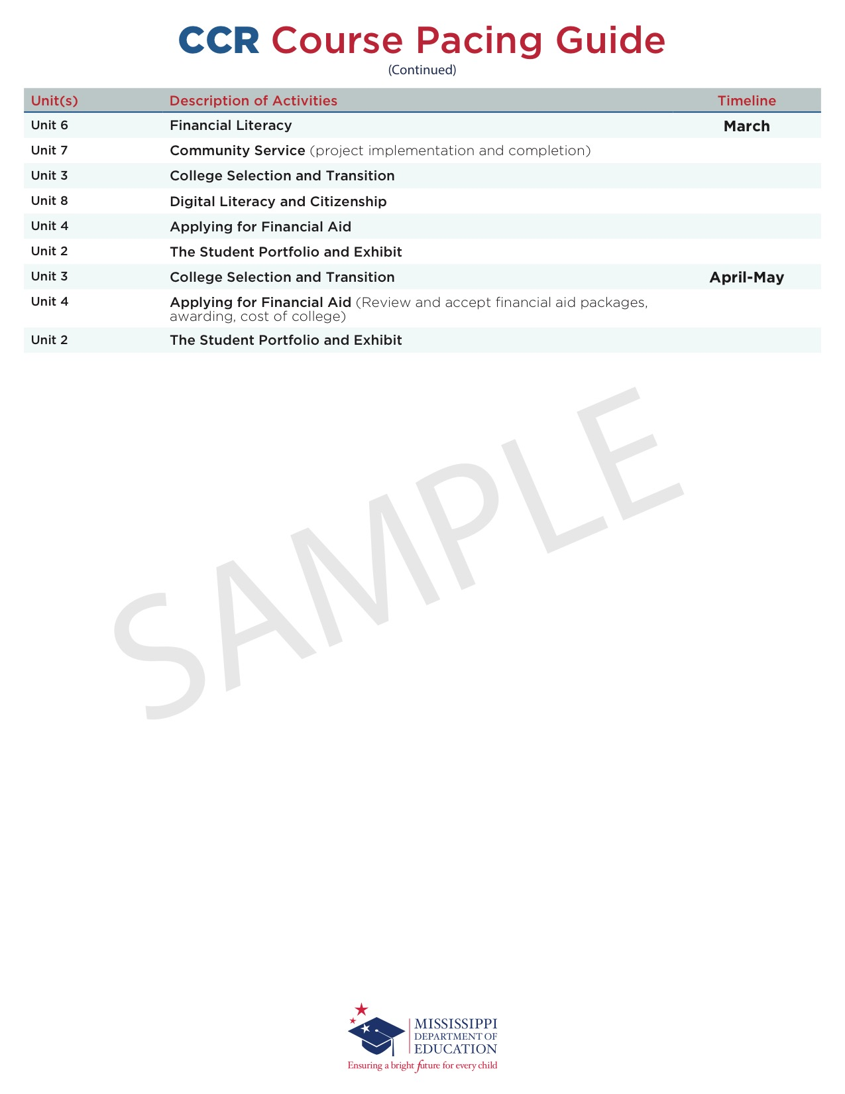
Appendix A: Unit References and Resources
References and resources listed below were recommended by members of the CCR taskforce, teachers, and counselors who contributed to the development of this document. Any resource listed below is not to be conveyed as an endorsement of any organization or company.

Unit 1: Introduction to College- and Career-Readiness
College resume guidance, worksheet, templates. Retrieved from get2college.org/resumes

Components of a high school résumé [Video]. Retrieved from youtube.com/watch?v=VMw1vKv3YsY

College navigator from the National Center for Education Statistics (n.d.). Retrieved from nces.ed.gov/collegenavigator/

Unit 2: The Student Portfolio and Exhibit
Step-by-step on how to develop a student portfolio. Los Angeles Student Portfolio Defense. (n.d.). Retrieved from lausdportfoliodefense.weebly.com/
Guymon, Dave. 4 free web tools for student portfolios (2014, May 2), Edutopia. Retrieved from edutopia.org/blog/web-tools-for-student-portfolios-dave-guymon
Hiles, Heather (2016, July). Digital portfolios position students for success in the workforce. Retrieved from edsurge.com/news/2016-07-06-digital-portfolios-position-students-for-success-in-the-workforce

Mississippi Scholars. (n.d.). Retrieved from msmec.com/what-is-mississippi-scholars/

Mississippi Scholars Tech Master. (n.d.). Retrieved from msmec.com/mississippi-scholars-tech-master-information/

Teaching Channel (Producer). (2016, October). Student profile: Portfolio defense [Vide]. Retrieved October 28, 2016, from teachingchannel.org/videos/success-portfolio-defense-eed

Palmer-Fuechsel, Virginia. (2015, August). High school essential skills portfolio guide. Retrieved from newschoolva.com/files/Portfolio_Guide.pdf

American Psychological Association. (2010). Publication Manual of the American Psychological Association [PDF] (4th ed.). Washington D.C.: American Psychological Association.

Unit 3: College Selection and Transition
College Board BigFuture—Get started. (n.d.). Retrieved from bigfuture.collegeboard.org/get-started
(Begin here in developing your lesson plans. Begin with the “Get Started” drop-down menu to introduce topics and interactive resources to students for the course. Make sure to utilize the Educator Resources Center, which includes lesson plans among other resources, as you get started.)

Get2College (Producer). (2017, August 18). College planning and financial aid 101 [Video file]. Retrieved from youtube.com/watch?v=_rv82IYqQLM

Get2College (Producer). (2017, July 12). Recorded webinar on college search and financial aid [Video file]. Retrieved from youtube.com/watch?v=ujlDz9G7Fi4

College countdown Mississippi. (n.d.). Retrieved from get2college.org/collegecountdownmsresearch-info/
(May want to consider holding an “Application Day” at your school for all seniors or just a smaller version in your class.)

ACT prep Get2College workshops. (n.d.). Retrieved from get2college.org/what-we-do/act-prep-workshops/
(List of ACT workshops and tips for students)

ACT prep resources from ACT. (n.d.). Retrieved from act.org/content/act/en/products-and-services/the-act/test-preparation/act-academy.html
(Free ACT prep for students from ACT)

ACT prep classroom resources. (n.d.). Retrieved from resources.opened.com/okact/
(Classroom focused ACT prep for students and educators)

College Board BigFuture—Getting in. (n.d.). Retrieved from bigfuture.collegeboard.org/get-in
(Information to have students research admissions rates and different types of admissions selection processes.)

College scholarship or admissions essay guidance. (n.d.). Retrieved from get2college.org/essays/
(Guidance on essay writing for either scholarship or admissions purposes with link to other guides and examples.)

Get2College (Producer). (2016, July 19). Your essay, your voice [Video file]. Retrieved from youtube.com/watch?v=sHvZ7whkO9M

Get2College (Producer). (2016, July 12). Your essay: Catch the reader’s attention [Video file]. Retrieved from youtube.com/watch?v=waZXXyO_taU

How to choose the right college. (n.d.). Retrieved from get2college.org/choosing-a-college/
(Things to consider when researching and selecting the right college for students.)

Get2College (Producer). (2016, July 5). Visit campus [Video file]. Retrieved from youtube.com/watch?v=81lOGeRjaRw

ACT Career Ready 101. (2018). Retrieved from run2.careerready101.com/cr-main/login

Get2College (Producer). (2016, August 2). Connect with recruiters [Video file]. Retrieved from youtube.com/watch?v=4K6DaVP8AR8

Unit 4: Applying and Planning for Financial Aid
Get2College (Producer). (2017, September 22). Scholarships and the four types of financial aid [Video file]. Retrieved from youtube.com/watch?v=DvY-yC2Qyn0

HELP grant information. (n.d.). Retrieved from get2college.org/planforcollege/help-grant/
(Share with students when educating on the Mississippi Financial Aid options that are available.)

Scholarship search resource. (n.d.). Retrieved from get2college.org/student-tools/scholarships/
(Get2College website with lists of local and national scholarship searches)

Expected family contribution calculator. (n.d.). Retrieved from https://get2college.org/efc-calculator
(Get2College website with the Expected Family Contribution Calculator)

College Board BigFuture—Pay for college. (n.d.). Retrieved from bigfuture.collegeboard.org/pay-for-college
(This is a great starting point for expanding on financial aid options from here.)

Get2College (Producer). (2017, November 8). Why should I fill out FAFSA (Free Application For Federal Student Aid) [Video file]. Retrieved from youtube.com/watch?v=vCqbw31w4kE

Get2College (Producer). (2017, December 18). State aid in Mississippi. Retrieved from youtube.com/watch?v=o3zjVKn94MY

Federal Student Aid (Producer). (2017, June 15). How to create your FSA ID [Video file]. Retrieved from youtube.com/watch?v=K7ihhGk8mCY

FAFSA website. (n.d.). Retrieved from studentaid.ed.gov/sa/fafsa

Mississippi Financial Aid application website. (n.d.). Retrieved from msfinancialaid.org//state-aid/

Scholarship interview questions/guide. (n.d.). Retrieved from get2college.org/interviews/
(Use for mock scholarship interviews. These questions are compiled from universities within the state and questions they have used for scholarship interviews in the past.)

commonapp.org/ready
(This website answers or guides general questions about the Common App. Common App is only used by a certain number of colleges, and those are listed on the website. This is a toolkit of resources if students need to complete the Common App.)

The SmartStudent guide to financial aid. (2010). Retrieved from finaid.org

Your connection to scholarships, colleges, financial aid, and more. (n.d.). Retrieved April 29, 2016, from fastweb.com

The College Board. (n.d.). Retrieved April 29, 2016, from collegeboard.org

The College Board student home page. (n.d.). Retrieved April 29, 2016, from student.collegeboard.org/css-financial-aid-profile

The College Board: Sample questions—Writing and language. (n.d.). Retrieved April 29, 2016, from collegereadiness.collegeboard.org/sample-questions/writing⁻language

Interactive virtual tours and campus maps. (n.d.). Retrieved April 29, 2016, from campustours.com

Filling out college applications. (n.d.). Retrieved April 29, 2016, from universitylanguage.com/guides/applying-to-college/

The Common App website. (2015). Retrieved April 29, 2016, from commonapp.org

Universal College Application. (n.d.). Retrieved April 29, 2016, from universalcollegeapp.com

What to do before and after your college interview. (n.d.). Retrieved April 29, 2016, from bigfuture.collegeboard.org/get-in/interviews/what-to-do-before-and-after-your-college-interview-admissions

Get ready for college—College planning, financial aid, educator resources. (n.d.). Retrieved May 2, 2016, from bigfuture.collegeboard.org/

Career resources, career guide, online education, and degree directory. (n.d.). Retrieved May 2, 2016, from careers.org/

U.S. Bureau of Labor Statistics. (n.d.). Retrieved May 2, 2016, from bls.gov/

Classroom materials. (n.d.). Retrieved from bls.gov/k12/teachers.htm

Today's Military. (n.d.). Retrieved May 2, 2016, from todaysmilitary.com

Unit 5: Preparing for a Career and Internship
O*Net interest profiler. (n.d.). Retrieved from the My Next Move website: mynextmove.org/explore/ip
O*Net—Online resources for researching and searching careers. (n.d.). Retrieved from onetonline.org/
(Gives information on job titles, related careers, and potential earnings based on the U.S. Bureau of Labor Statistics and current job openings.)

Explore careers. (n.d.). Retrieved from bigfuture.collegeboard.org/explore-careers.
(Resource point for preparing for a career/internship)
Career interest survey. (n.d.). Retrieved from get2college.org/choosing-a-career/

Grier, Emily. (2013, May 16). 10 things to do before you start your internship. Retrieved October 28, 2016, from hercampus.com/career/job-advice/10-things-do-you-start-your-internship

Investopedia. (2013, June 24). 7 tips to help land that internship. Retrieved October 28, 2016, from forbes.com/sites/investopedia/2013/06/24/7-tips-to-help-land-that-internship/#5a0edfa657ee

The ultimate guide to internships. (n.d.). Retrieved October 28, 2016, from educations.com/internships/how-to-apply-for-internships-8689

Smith, Jacquelyn. (2013, March 20). Turn your internship into a full-time job. Retrieved October 28, 2016, from forbes.com/sites/jacquelynsmith/2013/05/20/turn-your-internship-into-a-full-time-job/#61987bb6483c

About C'reer. (n.d.). Retrieved from creer.us/

High school career development lessons. (n.d.). Retrieved from okcareertech.org/educators/career-and-academic-connections/career-information-resources/high-school-career-development-lessons

Unit 6: Financial Literacy
About Everfi. (n.d.). Retrieved from everfi.com

National standards for financial literacy. (n.d.). Retrieved from councilforeconed.org/resource/national-standards-for-financial-literacy/#sthash.giM65Epl.dpbs

Jump$tart Coalition for Personal Financial Literacy (2017). National standards in K-12 personal finance education (4th ed.). Washington, D.C. Retrieved from jumpstart.org/what-we-do/support-financial-education/standards/

Unit 7: Community Service
Sarikas, Christine. (n.d.). 129 great examples of community service projects. Retrieved April 29, 2016, from blog.prepscholar.com/129-examples-of-community-service-projects

Social change volunteer opportunities (n.d.). Retrieved May 2, 2016, from dosomething.org/us/campaigns

Unit 8: Digital Literacy
Australian government: Office of the children's eSafety commissioner. (2016, October 10). Classroom resources. Retrieved from esafety.gov.au/education-resources/classroom-resources

Common Sense Media. (n.d.). K-12 digital citizenship curriculum. Retrieved October 11, 2016, from commonsensemedia.org/educators/digital-citizenship

Childnet International. (n.d.). Retrieved October 11, 2016, from digizen.org/

Cybrary Man. (n.d.). Cybrary Man's educational web sites. Retrieved October 11, 2016, from cybraryman.com/digcit.html

SWGfL Digital Literacy. (n.d.). Digital literacy & citizenship from the South West Grid for Learning. Retrieved October 11, 2016, from digital-literacy.org.uk/Home.aspx

Cable Impacts. (2016, October 11). Teaching digital citizenship. Retrieved from teachinctrl.org/

Appendix B: Individual Success Plan (ISP)

Student Planning Tool for the Traditional Diploma
I. STUDENT INFORMATION
Student Name: |  |  |  |  |  | MSIS#:
Career Cluster:  (select one) Refer to  guidance document for additional information |  | ☞ Agriculture, Food, and Natural Resources   Architecture and Construction   Arts, A/V Technology, and Communications   Business, Management, and Administration |  | ☞ Education and Training   Finance   Government and Public Administration   Health Science |  |  | ☞ Hospitality and Tourism   Human Sciences   Information Technology   Law, Public Safety,  Corrections, and Security |  |  | ☞ Manufacturing   Marketing   STEM  Transportation,  Distribution, and Logistics
II. TRADITIONAL DIPLOMA AND ENDORSEMENT OPTIONS (select at least one)
Academic Endorsement (26 Credits) Date Selected: |  |  | Career and Technical (CTE) Endorsement (26 Credits) Date Selected: |  |  |  |  | Distinguished Academic Endorsement (28 Credits) Date Selected:
 | Earn an overall GPA of 2.5. |  |  |  | Earn an overall GPA of 2.5. |  |  |  | Earn an overall GPA of 3.0.
 | Courses must meet MS IHL College Preparatory Curriculum (CPC) requirements. |  |  |  | Must complete a four-course sequential program of study. |  |  |  | Earn four additional Carnegie units for a total of 28 (four science and four social studies credits)
 | Earn MS IHL and community college-readiness benchmarks (ACT sub scores of 17 in English and 19 in math as approved by postsecondary for non-remediation at most community colleges and IHL college-ready courses in senior year or the equivalent SAT score as defined by IHL). |  |  |  | Earn two additional Carnegie units for a total of 26. |  |  |  | Courses must meet MS IHL CPC recommended requirements.
 | Earn two additional Carnegie units for a total of 26. |  |  |  | Earn silver level on ACT WorkKeys. |  |  |  | Earn national college-readiness benchmarks on each subtest established by ACT (18 in English and 22 in math or SAT equivalency as established by College Board and IHL).

Must successfully complete one of the following: |  |  | Must successfully complete one of the following: |  | Must successfully complete one of the following:
 | One AP course with a C or higher and take the appropriate AP exam |  |  | One CTE dual credit or earn articulated credit in the high school CTE course |  | One AP course with a B or higher and take the appropriate AP exam
 | One Diploma Program-IB course with a C or higher and take the appropriate IB exams |  |  | Work-based learning experience or career pathway experience |  | One Diploma Program-IB course with a B or higher and take the appropriate IB exams
 | One academic dual-credit course with a C or higher in the course |  |  | Earn a State Board of Education-approved national credential |  | One academic dual-credit course with a B or higher in the course
III. REQUIREMENTS AND RECOMMENDATIONS
Date Met |  | Requirements
 |  | Student identifies an endorsement prior to entering ninth grade. Endorsement requirements can only be changed with parental permission. (Refer to Section VI for parent signature.)
For early release, student must have met college- or career-readiness benchmarks (ACT sub scores of 17 in English and 19 in math or earned a Silver level on ACT WorkKeys or SAT equivalency sub scores). Alternately, a student must meet ALL of the following:
- Have a 2.5 GPA
- On track to meet diploma requirements
- Passed or met all MAAP assessment requirements for graduation
- Concurrently enrolled in Essentials of College Math or Essentials of College Literacy
Date Met |  | Recommendations
 |  | For early graduation, a student should successfully complete an area of endorsement.
 |  | Student should take a math or math equivalency senior year.
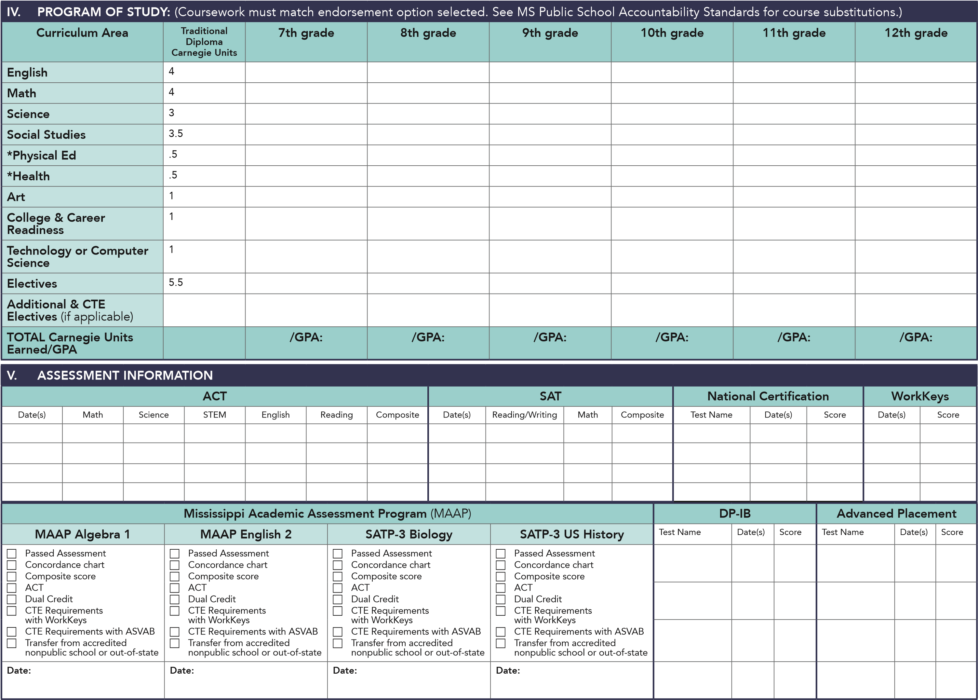

VI. DOCUMENTATION OF REVIEW OF INDIVIDUAL SUCCESS PLAN (ISP):
Requirement at exit of seventh grade (pending accreditation approval)
Signatures are only required in the second semester
Grade | Date of Review | Supervising Educator | Parent/Guardian Signature and Date | Student Signature and Date
7th
8th
9th
10th
11th
12th
VII. NOTES

Appendix C: Student Portfolio Guidelines and Resources

The student portfolio provides students an opportunity to demonstrate knowledge, skills, and attributes of college- and career-readiness through exemplary artifacts that answer the question “How am I prepared for college, career, and life?”. The portfolio is individualized, in that it will uniquely demonstrate the culmination of students’ aptitude in academics, 21st century skills (listed below), and personal growth. Reflecting on who they are while showing what they want to do, the portfolio allows students to communicate their preparedness of 21st century skills and knowledge of postsecondary and career interests.

The final portfolio presentation should affirm students’ ability to think critically and creatively, to solve practical problems, to make reasoned and ethical decisions, and to communicate effectively. This portfolio will require cooperation and collaboration among faculty members to ensure students have the resources needed to complete the portfolio (i.e., administrator, academic teacher, counselor, and/or media specialists).

21st Century Skills and Objectives
These skills and objectives are to be used as a reference when developing the portfolio and in determining a rubric for grading. (A sample rubric has been provided)
- Critical Thinking
  - Use various types of reasoning (e.g., inductive, deductive, etc.) as appropriate to the situation.
  - Analyze how parts of a whole interact with each other to produce overall outcomes in complex systems.
  - Effectively analyze and evaluate evidence, arguments, claims, and beliefs.
  - Analyze and evaluate major alternative points of view.
  - Synthesize and make connections between information and arguments.
  - Interpret information and draw conclusions based on the best analysis.
  - Reflect critically on learning experiences and processes.
  - Solve different kinds of unfamiliar problems in both conventional and innovative ways.
  - Identify and ask significant questions that clarify various points of view and lead to better solutions.
- Communication¹
  - Articulate thoughts and ideas effectively using oral, written, and nonverbal communication skills in a variety of forms and contexts.
  - Listen effectively to decipher meaning, including knowledge, values, attitudes, and intentions.
  - Use communication for a range of purposes (e.g., to inform, instruct, motivate, and persuade).
  - Use multiple media and technologies and know how to assess their impact and effectiveness.
  - Communicate effectively in diverse environments (including multilingual and multicultural).
- Creativity¹
  - Use a wide range of idea creation techniques (such as brainstorming).
  - Create new and worthwhile ideas (both incremental and radical concepts).
  - Elaborate, refine, analyze, and evaluate original ideas to improve and maximize creative efforts.
  - Develop, implement, and communicate new ideas to others effectively.
  - Be open and responsive to new and diverse perspectives; incorporate group input and feedback into the work.
  - Demonstrate originality and inventiveness in work and understand the real-world limits to adopting new ideas.
  - View failure as an opportunity to learn; understand that creativity and innovation are part of a long-term cyclical process of small successes and frequent mistakes.
  - Act on creative ideas to make a tangible and useful contribution to the field in which the innovation will occur.
- Citizenship
  - Participate in activities that benefit the community in some way.
  - Recognize the emotional benefits of participating in community service.
  - Identify how communities determine and fulfill needs.
  - Explore different service activities and projects that can benefit the community.
  - Recognize that every person is a part of multiple communities.
- College- and Career-Readiness
  - Demonstrate flexibility in various situations.
  - Manage time wisely in order to complete goals in a timely manner.
  - Complete tasks and assignments independently and in group settings.
  - Act responsibly to oneself and towards others.
  - Follow through with assignments or responsibilities until they are completed.
  - Recognize the importance of being a self-directed learner.
  - Act as a leader to guide others to success.
- Collaboration
  - Demonstrate the ability to work effectively and respectfully with diverse teams.
  - Exercise flexibility and a willingness to help make the necessary compromises to accomplish a common goal.
  - Assume a shared responsibility for collaborative work, and value the individual contributions made by each team member.

Artifacts
The following list is examples of areas from which students can select exemplary artifacts. This list should not be considered all inclusive. The recommended number of artifacts is 10. However, the total number of artifacts included is up to individual schools/districts.

- Classwork (e.g., assignments, papers, tests/quizzes, essays, projects, written work, journal entries, artwork, etc.)
- Photographs and videos
- Documentation from community service projects
- College essays
- Scholarship applications
- ACT scores
- PSAT scores
- WorkKeys scores
- Professional résumés
- Mock interview videos
- Internship notes and reflections
- Other

Exemplary Artifact Check List
Use the following statements to determine if the artifact chosen could be an exemplary artifact.
- I worked on this artifact for more than one week, either independently or in class.
- I played a significant role in creating this artifact.
- I revised this artifact based on received feedback.
- I was challenged while working on this artifact.
- I can demonstrate my understanding of content standards through this artifact.
- I can explain what 21st century skills I learned or developed through this artifact.
- I can explain how this artifact connects to life outside of school and/or my future.
- I grew as a student and as an individual through this artifact.

Examples and other resources to help guide the process of developing this unit can be found at the following link: lausdportfoliodefense.weebly.com.

Digital Portfolio Assessment Rubric Sample
A portfolio review panel should be selected. This panel may consist of staff, school counselors, administration, and student collaborators. It is recommended that the portfolio review panel meet prior to presentations to review and discuss the scoring rubric. A sample scoring rubric has been provided below.
Individual students should meet with their staff/school counselor to schedule the date and time of their portfolio presentation. This presentation will showcase selected artifacts, self-reflections, and other assigned items that demonstrates a student’s ability to meet the demands of postsecondary/a career.
 | Level 4 | Level 3 | Level 2 | Level 1
Artifacts Support the Following 21st Century Skills:  Critical thinking  Collaboration  Communication  Creativity  Citizenship  College- and career-readiness | Artifacts included in the portfolio clearly connect and support the objectives under each of the 21st century skills.  A thoughtful and thorough explanation is given for the selection of each of the chosen artifacts and how they support 21st Century Skills. | Artifacts included in the portfolio sufficiently connect and support the objectives under each of the 21st century skills.  An adequate explanation is given for selection of each of the chosen artifacts and how they support 21st century skills. | Artifacts included in the portfolio partially connect and support the objectives under each of the 21st century skills but others do not.  A limited explanation is given for the selection of each of the chosen artifacts and how they support 21st century skills. | Artifacts included in the portfolio do not connect and support the objectives stated under each of the 21st century skills.  An explanation is not given for the selection of each of the chosen artifacts and how they support 21st century skills.

 | Level 4 | Level 3 | Level 2 | Level 1
Evidence of  Growth | Through the selected artifacts and written explanations, the student demonstrated an extraordinary level of academic and personal growth from the beginning of the school year to the end of the year. | Through the selected artifacts and written explanations, the student demonstrated a moderate level of academic and personal growth from the beginning of the school year to the end of the year. | Through the selected artifacts and written explanations, the student demonstrated a minimal amount of academic and personal growth from the beginning of the school year to the end of the year. | Through the selected artifacts and written explanations, the student demonstrated no growth from the beginning of the year to the end of the year.
Evidence of Self-Reflection | There is extensive evidence of self-reflection of each artifact woven throughout the entire portfolio.  The reflection demonstrates higher-level thinking, and great consideration has been factored into the connections between the reflections and artifacts. | There is some evidence of self-reflection woven throughout the entire portfolio.  The student has demonstrated some consideration of the connections between the reflections and the artifacts. | There is minor evidence of self-reflection throughout the portfolio.  The student has made some connections between the reflections and the artifacts. | There is no evidence of self-reflection in any part of the portfolio.  The student has not made any connections between the reflections and the artifacts.

 | Level 4 | Level 3 | Level 2 | Level 1
Variety of Artifacts | There is a variety of 10 or more artifacts included in the portfolio. The artifacts were creatively chosen to show academic and personal growth while reflecting 21st century skills. | There is a variety of less than 10 and more than six artifacts included in the portfolio. Some creativity was used, with artifacts chosen to show academic and social growth while reflecting 21st century skills. | There is a variety of six or less artifacts selected. Minimal creativity was used to show how each artifact reflects 21st century skills. | There is a variety of five or less artifacts included in the portfolio. No creativity was used in choosing artifacts to show academic and personal growth while reflecting 21st century skills.
Visual Appeal and Organization | The portfolio is professional and well-organized and there is extensive evidence the student carefully planned the appearance of the portfolio. The portfolio is organized to where the audience can easily identify significant connections between artifacts, explanations, and reflections without any confusion. | The portfolio is aesthetically pleasing and organized. There is some evidence that the student carefully planned the appearance of the portfolio. The portfolio is organized so that the audience can identify some connection between artifacts, explanations, and reflections with minimal confusion. | The portfolio is limited in aesthetically pleasing characteristics. There is little evidence the student sufficiently planned the portfolio. The portfolio is arranged in sections that may not have a specific order or organization. The audience has moderate difficulty identifying some connection between artifacts, explanations, and reflections. | The portfolio is not aesthetically pleasing in any way. There is no evidence that thought was put into planning the appearance of the portfolio. The portfolio has no order or organization. The audience is unable to identify a connection between artifacts, explanations, and/or reflections.
Presentation Preparation | All aspects of the presentation are well prepared, and the student demonstrates a complete grasp of the portfolio’s purpose. | Most aspects of the presentation are well prepared. Most aspects of the portfolio’s purpose are completely understood by the student. | Most aspects of the presentation are well prepared. Some major aspects of the portfolio’s purpose are not completely understood by the student. | Some aspects of the presentations were not well prepared. Some aspects of the portfolio’s purpose were not completely understood by the student.

 | Level 4 | Level 3 | Level 2 | Level 1
Public Speaking Skills | The student has good voice inflection and does an outstanding job in the speaking aspect of the presentation. | The student has generally good voice inflection and makes very few errors in speaking or communicating | The student has some voice inflection and does attempt to communicate clearly, making a few errors in communicating. | The student has very few changes in voice inflection and makes some major errors in communicating.
Balance of Product and Process | The student has been highly engaged with the entire portfolio process throughout the whole year. It is evident that the student took optimal pride in selecting the artifacts. | The student has been engaged with the portfolio process throughout the year. There is evidence that the student took pride in selecting the artifacts. | The student has been somewhat engaged with the portfolio process throughout the year. | The student has not been engaged with the portfolio process throughout the year.

Student Artifact Reflection Sheet

Which one of the 21st century skills does this artifact address?
Critical thinking Collaboration Communication
Creativity Citizenship College- and career-readiness

Describe the artifact that you have chosen. Where and when is it from? If applicable, describe the assignment or activity. ______________________________________________________________________________________________________________________________________________________________________________________________________________________________________________________________________________________________________________________________________________________________________________________________________________________________________________________________________________________________________________________________________________________________________________
How does this artifact support the objectives under the identified 21st century skill?
______________________________________________________________________________________________________________________________________________________________________________________________________________________________________________________________________________________________________________________________________________________________________________________________________________________________________________________________________________________________________________________________________________________________________________
How can this skill be applied in college, career, and/or life?
______________________________________________________________________________________________________________________________________________________________________________________________________________________________________________________________________________________________________________________________________________________________________________________________________________________________________________________________________________________________________________________________________________________________________________

Appendix D: 21st Century Skills

 | Unit 1 | Unit 2 | Unit 3 | Unit 4 | Unit 5 | Unit 6 | Unit 7 | Unit 8
21st Century Standards
CS1
CS2 |  |  |  |  |  | X
CS3 |  |  |  |  |  |  |  | X
CS4
CS5
CS6 |  | X
CS7 | X | X |  |  |  | X | X | X
CS8 | X | X | X | X | X | X | X | X
CS9 | X | X | X | X | X | X | X | X
CS10 |  | X | X | X |  |  |  | X
CS11 | X | X | X | X | X | X | X | X
CS12 | X | X | X | X | X | X | X | X
CS13 | X | X | X | X | X | X | X | X
CS14 | X | X | X | X | X | X | X | X
CS15 | X | X | X | X | X | X | X | X
CS16 | X | X |  |  |  |  | X | X

CSS1-21st Century Themes
CS1 Global Awareness
- Using 21st century skills to understand and address global issues
- Learning from and working collaboratively with individuals representing diverse cultures, religions, and lifestyles in a spirit of mutual respect and open dialogue in personal, work, and community contexts
- Understanding other nations and cultures, including those that speak non-English languages
CS2 Financial, Economic, Business, and Entrepreneurial Literacy
- Knowing how to make appropriate personal economic choices
- Understanding the role of the economy in society
- Using entrepreneurial skills to enhance workplace productivity and career options
CS3 Civic Literacy
- Participating effectively in civic life through knowing how to stay informed and understanding governmental processes
- Exercising the rights and obligations of citizenship at the local, state, national, and global levels
- Understanding the local, state, national and global implications of civic decisions

CS4 Health Literacy
- Obtaining, interpreting, and understanding basic health information and services and using such information and services in ways that enhance health
- Understanding preventive physical and mental health measures, including proper diet, nutrition, exercise, risk avoidance, and stress reduction
- Using available information to make appropriate health-related decisions
- Establishing and monitoring personal and family health goals
- Understanding national and international public health and safety issues
CS5 Environmental Literacy
- Demonstrating knowledge and understanding of the environment and the circumstances and conditions affecting it, particularly as it relates to air, climate, land, food, energy, water, and ecosystems
- Demonstrating knowledge and understanding of society’s impact on the natural world (e.g., population growth, population development, resource consumption rate, etc.)
- Investigating and analyzing environmental issues and making accurate conclusions about effective solutions
- Taking individual and collective action toward addressing environmental challenges (e.g., participating in global actions, designing solutions that inspire action on environmental issues, etc.)

CSS2-Learning and Innovation Skills
CS6 Creativity and Innovation
- Think creatively.
- Work creatively with others.
- Implement innovations.
CS7 Critical Thinking and Problem Solving
- Reason effectively.
- Use systems thinking.
- Make judgments and decisions.
- Solve problems.
CS8 Communication and Collaboration
- Communicate clearly.
- Collaborate with others.

CSS3-Information, Media, and Technology Skills
CS9 Information Literacy
- Access and evaluate information.
- Use and manage information.
CS10 Media Literacy
- Analyze media.
- Create media products.
CS11 ICT Literacy
          - Apply technology effectively.

CSS4-Life and Career Skills
CS12 Flexibility and Adaptability
- Adapt to change.
- Be flexible.
CS13 Initiative and Self-Direction
- Manage goals and time.
- Work independently.
- Be self-directed learners.
CS14 Social and Cross-Cultural Skills
- Interact effectively with others.
- Work effectively in diverse teams.
CS15 Productivity and Accountability
- Manage projects.
- Produce results.
CS16 Leadership and Responsibility
- Guide and lead others.
- Be responsible to others.

Appendix E: National Standards in K-12 Personal Finance

The following standards were obtained from Jump$tart. These standards, which were used in the development of Unit 6: Financial Literacy, can be found at the following link: jumpstart.org/what-we-do/support-financial-education/standards/.

Spending and Saving
- Apply strategies to monitor income and expenses, plan for spending, and save for future goals.
  - Standard 1. Develop a plan for spending and saving.
  - Standard 2. Develop a system for keeping and using financial records.
  - Standard 3. Describe how to use different payment methods.
  - Standard 4. Apply consumer skills to spending and saving decisions.

Credit and Debt
- Develop strategies to control and manage credit and debt.
  - Standard 1. Analyze the costs and benefits of various types of credit.
  - Standard 2. Summarize a borrower’s rights and responsibilities related to credit reports.
  - Standard 3. Apply strategies to avoid or correct debt management problems. Standard 4. Summarize major consumer credit laws.

Employment and Income
- Use a career plan to develop personal income potential.
- Standard 1. Explore job and career options.
- Standard 2. Compare sources of personal income and compensation.
- Standard 3. Analyze factors that affect net income.

Investing
- Implement a diversified investment strategy that is compatible with personal financial goals.
  - Standard 1. Explain how investing may build wealth and help meet financial goals.
  - Standard 2. Evaluate investment alternatives.
  - Standard 3. Demonstrate how to buy and sell investments.
Standard 4. Investigate how agencies protect investors and regulate financial markets and products.

Risk Management and Insurance
- Apply appropriate and cost-effective risk management strategies.
  - Standard 1. Identify common types of risks and basic risk management methods.
  - Standard 2. Justify reasons to use property and liability insurance.
  - Standard 3. Justify reasons to use health, disability, long-term care, and life insurance.

Financial Decision-Making
- Apply reliable information and systematic decision-making to personal financial decisions.
  - Standard 1. Recognize the responsibilities associated with personal financial decisions.
  - Standard 2. Use reliable resources when making financial decisions.
  - Standard 3. Summarize major consumer protection laws.
  - Standard 4. Make criteria-based financial decisions by systematically considering alternatives and consequences.
  - Standard 5. Apply communication strategies when discussing financial issues.
  - Standard 6. Analyze the requirements of contractual obligations.
  - Standard 7. Control personal information.
  - Standard 8. Use a personal financial plan.

Appendix F: National Standards for Financial Literacy

The following standards were obtained from the Council of Economic Education. These standards, which were used in the development of Unit 6: Financial Literacy, can be found at the following link: councilforeconed.org/wp-content/uploads/2013/02/national-standards-for-financial-literacy.pdf.

Summary of the Standards
- Earning Income
Income for most people is determined by the market value of their labor, paid as wages and salaries. People can increase their income and job opportunities by choosing to acquire more education, work experience, and job skills. The decision to undertake an activity that increases income or job opportunities is affected by the expected benefits and costs of such an activity. Income also is obtained from other sources such as interest, rents, capital gains, dividends, and profits.

- Buying Goods and Services
People cannot buy or make all the goods and services they want; as a result, people choose to buy some goods and services and not others. People can improve their economic well-being by making informed spending decisions, which entails collecting information, planning, and budgeting.

- Saving
Saving is the part of income that people choose to set aside for future uses. People save for different reasons during their lives. People make different choices about how they save and how much they save. Time, interest rates, and inflation affect the value of savings.

- Using Credit
Credit allows people to purchase goods and services that they can use today and pay for those goods and services in the future with interest. People choose among different credit options that have different costs. Lenders approve or deny applications for loans based on an evaluation of the borrower’s past credit history and expected ability to pay in the future. Higher-risk borrowers are charged higher interest rates; lower-risk borrowers are charged lower interest rates.

- Financial Investing
Financial investment is the purchase of financial assets to increase income or wealth in the future. Investors must choose among investments that have different risks and expected rates of return. Investments with higher expected rates of return tend to have greater risk. Diversification of investment among several choices can lower investment risk.

- Protecting and Insuring
People make choices to protect themselves from the financial risk of lost income, assets, health, or identity. They can choose to accept risk, reduce risk, or transfer the risk to others. Insurance allows people to transfer risk by paying a fee now to avoid the possibility of a larger loss later. The price of insurance is influenced by an individual’s behavior.

National Education Association. (n.d.). Preparing 21st Century Students for a Global Society: An Educator’s Guide to the “Four Cs.” Retrieved June 30, 2016, from nea.org/tools/52217.htm

