Mississippi Department of Education

Understanding the Mississippi
Statewide Accountability System

This document begins with a brief description of the current accountability system and a concise history of accountability in Mississippi. It covers the Achievement Model, Growth Model, and High School Completion components of the system and explains how those components are used to assign an Accountability Status to schools and school districts.
There are examples showing calculations for the Quality of Distribution Index (QDI) in the Achievement Model and calculations for predictions, raw residuals, standardized residuals, and the growth composite in the growth model.
The appendix includes an explanation of Full Academic Year (FAY), tables showing the prediction coefficients and standardization constants used in the 2011 Growth Model, and examples of the accountability reports that were provided to school districts in 2009.

Office of Research and Statistics
2011 Edition
July 22, 2011

Table of Contents

 | Page
Introduction | 1
Historical Perspective – Accountability in Mississippi | 1
Measures Used in the statewide Accountability System | 2
Assessment Results | 2
School Completion Information | 2
How the Statewide Accountability System Works | 3
The Achievement Model | 5
Assignment of Student Scores to Schools and Districts | 5
Special Procedures for Using Algebra I and Biology I Scores in the Achievement Model | 5
The QDI | 7
Examples of Different Score Distributions and Associated QDI Values | 7
Calculation of the QDI Value | 8
The Growth Model | 9
Predictions, Calculation of Residuals, and Standardization for a Hypothetical Student | 10
Calculation of the Growth Composite | 12
The Growth Status | 12
High School Completion | 13
Tracking a Cohort of Students over Five Years | 13
Graduation Rate and HSCI Calculations | 13
The Accountability Status | 14
Appendix:
- Full Academic Year | 15
- 2011 Growth Model Prediction Coefficients and Constants | 16
- 2011 Growth Model Residual Standardization Constants | 17
- Accountability Reports (Note: Example reports are from 2008/2009) | 18
- Where to Find Additional Information | 23

Understanding the Mississippi Statewide Accountability System

Introduction

The Mississippi Statewide Accountability System provides an annual estimate of instructional effectiveness for each school district and most of the schools in the state. The system uses results from statewide assessments (tests) administered at certain grades and in certain high school courses. For most districts and for some schools, the system also uses information about high school completion.

Accountability systems in Mississippi are mandated by state law. Generally, the overall system characteristics and consequences for district and school performance are covered in the law while specific technical characteristics of the accountability models are developed and tested under the guidance of the Mississippi Department of Education and the Commission on School Accreditation. The accountability models are subjected to the state’s Administrative Procedures Act (public comment) process and must be approved by the State Board of Education. Preliminary results from the accountability system are presented to school district personnel and are subject to a review process. After any data corrections, the final annual accountability results are approved by the State Board of Education and the results are published.

The annual accountability results can be accessed by the public through the Mississippi Assessment and Accountability Reporting System (MAARS) at http://orshome.mde.k12.ms.us/ors.

Newspapers, television stations, and many radio stations throughout the state cover the statewide or regional accountability results using information provided by the Department of Education.

The current accountability system was developed over a period of three years. The statewide language arts and mathematics curriculum frameworks were revised in 2006 and 2007 and were implemented during the 2007-2008 school year. New assessments in language arts and mathematics were developed, and pilot tested. The assessments (MCT2 for grades 3-8, Algebra I, English II) were implemented during the 2007-2008 school year. The current accountability system (based on the revised curriculum and new assessments) was developed in 2008 and 2009 and implemented for the first time during fall 2009.

Note: Changes in the accountability system that were approved by the State Board of Education for 2010 (QDI ranges and re-calculation of prediction equations) and 2011 (accountability labels, HSCI credit values, and a one-year exclusion of Biology I scores) are indicated by footnotes in this edition.

Historical Perspective – Accountability in Mississippi

The current accountability system is actually the fourth comprehensive accountability system to be used in Mississippi. Following the Education Reform Act of 1982, the state developed new curriculum frameworks and several new assessment programs. The first statewide administration of the assessments occurred in the spring of 1987. The Mississippi Performance-Based Accreditation System was then developed and tested. The first accountability results were released in October 1988. That accountability system was the first in Mississippi and one of the first in the country. The system used data from the statewide assessments and assigned accreditation levels to each of the state’s school districts. The system yielded results only at the district level – there were no school level results. Although envisioned as a system with five performance levels, the original model classified districts into only three levels (Level 1 through Level 3) due to the nature of the initial minimal competency assessment programs. The first accountability system was used from 1988 through 1994.

In 1994, state legislation required that the accountability system be revised based on more rigorous curriculum guidelines and assessments. After the new curriculum and assessments were in place, the accountability model was revised and tested. The revised system again yielded results only at the district level. However, it classified districts into five accreditation levels (Level 1 through Level 5) and the system included a performance index ranging from 1.0 through 5.0 providing information on how a district performed within its assigned accreditation level. The second accountability system was used from 1995 through 1999.
In 1999, state legislation again required that the accountability system be revised. The curriculum was revised in 1999 and 2000 and new criterion-referenced assessments were developed. The new assessments were piloted in 2000, and administered live in 2001. A new accountability system was developed that produced results at the school level -- there were no district level results. Each school was classified into one of five accountability levels (Level 1 through Level 5). The system included two separate components – an achievement model and a growth model. In addition to its level, each school was assigned an Accountability Level Index ranging from 100 to 600 that provided information on how the school performed within its assigned accountability level. The third accountability system was used from 2003 through 2007.

No statewide accountability results were available in 2008 because the current accountability system was being developed. This document provides a basic description of the current system. More detailed information regarding the development of the accountability system can be found in documents listed in Appendix E.

Measures Used in the Statewide Accountability System

The accountability system uses two kinds of student level information – results from statewide assessments (the student testing programs) and data on school completion for a cohort of students tracked over five years.

Assessment Results

Results from the following assessments are used in the statewide accountability system. Additional information on the assessment programs can be found on Office of Student Assessment web page at http://www.mde.k12.ms.us/ACAD/osa.

Mississippi Curriculum Test – 2nd Edition (MCT2). The MCT2 is based on the revised statewide language arts and mathematics curricula. Tests in language arts and mathematics are administered each year in May to students enrolled in grades 3 through 8. The results include a numeric scale score and a proficiency level. The proficiency levels represent standards based on cut scores established by committees of Mississippi teachers and approved by the State Board of Education. The proficiency levels are Advanced, Proficient, Basic, and Minimal.
Subject Area Testing Program (SATP). The SATP includes end-of course tests in Algebra I, English II, Biology I, and U.S. History. The results from the SATP multiple-choice tests include a numeric scale score, a proficiency level, and a pass/fail status. Students take these tests when they complete the course and must achieve a passing score in order to obtain a high school diploma. Students who fail one of the tests can continue to take the test until they pass it. The accountability system uses the score from each student’s first attempt on the multiple-choice tests. The English II writing assessment (essay) is not used in the accountability system.
Note: The Biology I test was being revised and was not used in the accountability system in 2011 -- it will be included again beginning in 2012.
Mississippi Alternate Assessment of the Extended Curriculum Frameworks (MAAECF). The MAAECF is a set of assessments designed for students with disabilities who cannot take the regular statewide assessment even with allowable accommodations and modifications. According to Federal law, the MAAECF can be administered only to students with significant cognitive disabilities (SCD). The MAAECF includes assessments in Language Arts, Mathematics, and Science. There are several levels of the assessments with separate scoring tables for students in each grade 3-8 plus high school. MAAECF results are reported only as proficiency levels.

School Completion Information

The state developed procedures for tracking cohorts of students using data in the Mississippi Student Information System (MSIS) -- the statewide student level database. The procedures allow the state to track selected cohorts (groups of students) over different periods of time. For each student in the cohort, the procedures determine whether the student graduated with a regular high school diploma, completed all requirements for a regular diploma except for a passing score on one or more of the SATP tests, completed school with an occupational diploma or a (special education) certificate of attendance, obtained a GED through an approved program, or dropped out before completing school. The accountability system uses school completion data for a cohort of students beginning in 9th grade tracked over five years. Additional information on the use of school completion information in the accountability system is presented later in this document. Comprehensive information on the procedures for tracking student cohorts can be found on the Office of Dropout Prevention web page at http://www.mde.k12.ms.us/Dropout_Prevention.

How the Statewide Accountability System Works

The figure on the next page illustrates how the Statewide Accountability System works.

The Achievement Model provides a measure of overall school or district level performance during the previous school year. A Quality of Distribution Index (QDI) value is calculated using data from the MCT2 language arts and mathematics tests; SATP data from the Algebra I, Biology I [not used in 2011 -- see note below], English II, and U.S. History tests; and results from the language arts and mathematics sections of the MAAECF. The QDI value ranges from 0 (100% of students scoring in the lowest proficiency level on the assessments) to 300 (100% of the students scoring in the highest proficiency level on the assessments). The formula for calculating the QDI is discussed in the Achievement Model section of this document.

Note: Biology I was not included in the 2011 accountability model because the test was being revised.

The Growth Model provides a measure of the degree to which a school or district met its expected performance during the previous school year. A Growth Composite value is calculated using data from the last three school years. Student performance on the MCT2 is used to predict student performance on the MCT2 the following year and student performance on the SATP tests in subsequent years. The 2011 Growth Model results used 2010 MCT2 data to predict student performance on the 2011 MCT2 and results from MCT2 administrations in 2008, 2009, and 2010 to predict student performance on SATP tests administered during the 2010/2011 school year (see the note below). The Growth Composite value ranges from small negative values (e.g., -3) through small positive values (e.g., +3). A value of 0 or higher indicates that the school or district met its performance expectation and results in a Growth Status of “Met.” A negative value indicates that the school or district did not meet its performance expectation and results in a Growth Status of “Not Met.” The prediction equations and the formula used for calculating the Growth Composite are discussed in the Growth Model section of this document.

Note: Grade 8 Algebra I scores are predicted using the 7th grade MCT2 from the previous year, grade 9 Algebra I and Biology I scores are predicted using the 8th grade MCT2 from the previous year, and grade 10 Algebra I and, Biology I scores are predicted using the 8th grade MCT2 from two years earlier. English II scores are predicted using the 8th grade MCT2 from two years earlier and U.S. History scores are predicted using 8th grade MCT2 scores from three years earlier. Biology I was not included in the growth model in 2011 because the test was being revised.

The High School Completion component of the accountability system provides a measure of the degree to which students completed high school. This component of the accountability system applies only to schools and districts that have a graduating class (i.e., a 12th grade). Two separate measures are used – the High School Completion Index (HSCI), and the Graduation Rate. The measures are calculated by tracking a cohort of students beginning in 9th grade and continuing for five years (although most of the students complete school within four years, some take longer). HSCI values range from -300 (100% of students dropping out of school) through 300 (100% of students graduating with a standard high diploma within five years). The graduation rate is the percentage of students in the cohort graduating with a standard diploma within five years (0% through 100%).

The achievement, growth, and high school completion components are combined to yield an Accountability Status (sometimes called a label or rating). The method used for assigning accountability statuses is discussed in the Accountability Status section of this document.

Achievement Model
The overall school or district level academic performance.
Measure:
QDI (Quality of Distribution Index)
Data: MCT2 (3-8), SATP & MAAECF

The Mississippi Statewide
Accountability System

Accountability Status
(Accountability Label)
(Accountability Rating)
The annual designation assigned to a school or district based on achievement, growth, and (if appropriate), high school completion.
Labels are listed below.
Growth Model
The degree to which a school or district met its expected performance.
Measure: Growth Status
(Based on Growth Composite Value)
Data: MCT2 (4-8) & SATP
Predictors: MCT2 (3-8)

High School Completion
The degree to which students successfully completed high school.
Measures:
HSCI (High School Completion Index) & Graduation Rate
Data: 5-Year Cohort Tracking Information

Star School / Star District
High Performing
Successful
Academic Watch
Low Performing
At Risk of Failing
Failing

Note: Prior to 2011, the label “Low Performing”
fell below the label “At Risk of Failing” in the
Accountability Status hierarchy (see “The
Accountability Status” on page 14).

The Achievement Model

The Achievement Model provides a measure of overall school or district level performance during the previous school year. A Quality of Distribution Index (QDI) value is calculated using data from the MCT2 language arts and mathematics tests; SATP data from the Algebra I, Biology I, English II, and U.S. History tests; and results from the language arts and mathematics sections of the MAAECF.

Note: Throughout this section, there are references to the Biology I test. Since the Biology I test was being revised, it was not used in the accountability system in 2011 -- it will be included again beginning in 2012.

Assignment of Student Scores to Schools and Districts

Scores used for calculating QDI are the MCT2, SATP, and MAAECF scores from test administrations during the previous school year. The student scores used for calculating QDI for a particular school or district are selected as follows.

- Scores count at the school and/or district in which the student was enrolled for a Full Academic Year (FAY). A student who moved from one school to another during the school year may satisfy the FAY criteria at the district, but not at either school. In that case, the student’s test scores will be included for calculating the district QDI, but will not be included when calculating QDI for either school.
- Scores for FAY students taking the Algebra I or Biology I test may also count at a high school for which the current school is a “feeder.” This is explained in more detail below.
- Scores for FAY students taking the Algebra I or Biology I test at a high school may also count at a different school in which they satisfied FAY earlier. This is explained in more detail below.

In all of the above cases, if a special education student has a resident school code or resident district code (see special education screen in MSIS), his/her score(s) will be re-assigned to the corresponding resident school or district.

Special Procedures for Using Algebra I and Biology I Scores in the Achievement Model

Special procedures are used to encourage middle schools, 9th grade schools, and high schools to work collectively to ensure that students take Algebra I and Biology I when they are ready to take the course.

A student’s Algebra I and/or Biology I score(s) are be assigned to all higher level schools (i.e., schools containing higher grade levels) on the student’s forward feeder pattern. In most cases, this will be one school. In some cases it will be two schools (e.g., 8th grade Algebra I score assigned to a stand-alone 9th grade school plus a 10-12 high school. This is called “forward-mapping.”

A student’s Algebra I and/or Biology I score(s) will be assigned to a maximum of one other school for each earlier school year. Full academic year status is used for assignment purposes and it is impossible for a student to satisfy FAY in more than one school during any school year. This is called “back-mapping.”

For students taking Algebra I in a stand-alone 9th grade school, the score may be back-mapped to a different school where he/she was as an 8th grader and forward-mapped to the grade 10-12 high school.

The forward-mapping and back-mapping procedures are described in more detail beginning on the next page.

For Algebra I:

Current-Year School. If a student satisfies the definition of “Full Academic Year” (FAY) at the school in which he/she took the Algebra I test for the first time, the student’s Algebra I score will be included when calculating QDI for that school. This is the same logic used in the previous achievement model.

Forward-Mapping. This procedure counts a student’s Algebra I score at a school that the student may attend in the future.
- If a school containing grade 8 feeds a 9-12 high school, the eighth grade Algebra I scores for students meeting FAY will also be counted in the high school accountability results.
- If a stand-alone 9th grade school feeds a 10-12 high school, the ninth grade Algebra I scores for students meeting FAY will also be counted in the high school accountability results.
- If a school containing grade 8 feeds a stand-alone 9th grade school which feeds a 10-12 high school, the eighth grade Algebra I scores for students meeting FAY will be counted in the accountability results for both the 9th grade school and the 10-12 high school.
Note: The implementation logic for “forward-mapping” requires an accurate linking table containing all feeder/receiving schools within the 8-12 and 9-12 grade spans throughout the state.

Back-Mapping. This procedure counts a student’s Algebra I score at one or more schools in which the student met FAY during earlier school years.
- For an FAY student in a 9-12 high school, an Algebra I test score will also be counted at the school where the student was enrolled as an eighth grader if (1) the student met FAY as an eighth grader AND (2) both schools are in the same school district.
- For an FAY student in a 10-12 high school, an Algebra I test score will also be counted
  - at the school where the student was enrolled as a ninth grader if (1) the student met FAY as a ninth grader AND (2) both schools are in the same school district.
  - at the school where the student was enrolled as an eighth grader if (1) the student met FAY as an eighth grader AND (2) both schools are in the same school district

Note: The implementation for “back-mapping” does not require information concerning actual feeder/receiving school patterns. The appropriate back-mapping of test results is accomplished using FAY/enrollment and grade assignment data for students during earlier school years.

For Biology I: [Note: Not Applicable in 2011]

Current-Year School. If a student satisfies the definition of “Full Academic Year” (FAY) at the school in which he/she took the Biology I test for the first time, the student’s Biology I score will be included when calculating QDI for that school. This is the same logic used in the previous achievement model.

Forward-Mapping. This procedure counts a student’s Biology I score at a school that the student may attend in the future.
- If a school containing grade 9 feeds a 10-12 high school, the ninth grade Biology I scores for students meeting FAY will also be counted in the high school accountability results.

Back-Mapping. This procedure counts a student’s Biology I score at a school in which the student met FAY during an earlier school year.
- For an FAY student in a 10-12 high school, a Biology I test score will also be counted at the school where the student was enrolled as a ninth grader if (1) the student met FAY as a ninth grader AND (2) both schools are in the same school district.

The QDI

QDI (Quality of Distribution Index) represents an overall measure of student performance on statewide assessments during the previous school year. The QDI is based on a relatively simple concept – if more students score in the higher proficiency levels on the test, the distribution of scores is more “positive”.
QDI = (1 X %Basic) + (2 X %Proficient) + (3 X %Advanced)

No credit is given for students scoring in the Minimal (lowest) proficiency level and the greatest credit is given for students scoring in the Advanced (highest) proficiency level. The QDI value can range from 0 (100% of students scoring Minimal) through 300 (100% scoring Advanced).

Examples of Different Score Distributions and Associated QDI Values

(MIN=Minimal, BAS=Basic, PRO=Proficient, ADV=Advanced)

ADV
100%

QDI = 0 + (2 X 0) + (3 X 100) = 300
MIN BAS PRO
0% 0% 0%

0 150 300

PRO
50%
ADV
50%
MIN BAS
0% 0% QDI = 0 + (2 X 50) + (3 X 50) = 250

0 150 300

PRO
100%

MIN BAS ADV
0% 0% 0% QDI = 0 + (2 X 100) + (3 X 0) = 200

0 150 300

BAS
100%

MIN PRO ADV
0% 0% 0% QDI = 100 + (2 X 0) + (3 X 0) = 100

0 150 300

BAS
50%
MIN
50%
PRO ADV
0% 0% QDI = 50 + (2 X 0) + (3 X 0) = 50

0 150 300

Calculation of the QDI Value

Under the Mississippi Achievement Model, a QDI is calculated for each school with assessment data and for each school district.

Once student level scores have been assigned to each school and district (including forward-mapped and back-mapped scores), computer programs calculate percentages of students scoring in each proficiency level separately by test/grade and across all tests/grades. Full precision/unrounded percentage values are used for calculating QDI. The percentage values are then rounded for reporting purposes. The full-precision calculated QDI is then rounded to one decimal place for certain reporting purposes and it is rounded to a whole number as the official QDI value for the school or district.

Note: The assignment of scores to a particular school is complex (requiring determination of FAY, back-mapping, forward mapping, and consideration of resident district and resident school codes). Therefore, any QDI value calculated using percentages from testing company reports or from the assessment results displayed in the Mississippi Assessment and Accountability Reporting System (MAARS) is only a rough approximation of the official QDI.

QDI Calculation Example:

Total number of test scores assigned to the school 105
Number scoring Minimal 12 11.4285714%
Number scoring Basic 27 25.7142857%
Number scoring Proficient 46 43.8095238%
Number scoring Advanced 20 19.0476190%

QDI = 25.7142857 + (2 X 43.8095238) + (3 X 19.0476190) =
= 25.7142857 +87.6190476 + 58.142857
= 170.4761903

The full precision QDI value rounds to 170.5 for reporting.
The full precision QDI value rounds to 170 as the official QDI value for the school.

Note: The official QDI is determined by rounding the full precision value; not by rounding the (already rounded) reporting value.

The Growth Model

The Growth Model provides a measure of the degree to which a school or district met its expected performance during the previous school year. A Growth Composite value is calculated using data from the last three school years. Student performance on the MCT2 is used to predict student performance on the MCT2 the following year and student performance on the SATP tests in subsequent years. The 2011 Growth Model results used 2010 MCT2 data to predict student performance on the 2011 MCT2 and results from MCT2 administrations in 2008, 2009, and 2010 to predict student performance on SATP tests administered during the 2010/2011 school year (see the note below).

Note: Grade 8 Algebra I scores are predicted using the 7th grade MCT2 from the previous year, grade 9 Algebra I and Biology I scores are predicted using the 8th grade MCT2 from the previous year, and grade 10 Algebra I and, Biology I scores are predicted using the 8th grade MCT2 from two years earlier. English II scores are predicted using the 8th grade MCT2 from two years earlier and U.S. History scores are predicted using 8th grade MCT2 scores from three years earlier. Biology I was not included in the growth model in 2011 because the test was being revised.

The predictions are based on equations derived by running multiple regression analyses on student level assessment data. A multiple regression prediction equation with two predictors has the form

Y’ = (b1 * X1) + (b2 * X2) + c where,

Y’ is the predicted score,
b1 is the regression (prediction) coefficient for the first predictor variable,
X1 is the numeric value of the first predictor variable,
b2 is the regression (prediction) coefficient for the second predictor variable,
X2 is the numeric value of the second predictor variable, and
c is a numeric constant.

In the Mississippi growth model, scale scores (SS) on the MCT2 language arts (LA) and mathematics (MA) tests are the predictor variables. The equation is used to predict the scale score on a subsequent test. For example,

Predicted 2011 Grade 4 MCT2 SS_{MA} = (b1 * 2010 Grade 3 MCT2 SS_{LA}) + (b2 * 2010 Grade 3 MCT2 SS_{MA}) + c
or
Predicted 2011 Grade 9 Algebra I SS = (b1 * 2010 Grade 8 MCT2 SS_{LA}) + (b2 * 2010 Grade 8 MCT2 SS_{MA}) + c

The regression equations predict performance at the student level. Although the predictions are not accurate enough for use at the student level, the positive and negative prediction errors tend to cancel each other, so average residual values for groups of students within a school or district are much more accurate.

There is a separate and unique prediction equation for each test. Once the prediction equations are developed, they are applied to the student level data to yield raw residuals (actual scale score minus predicted scale score). A residual value of 0 means the student performed exactly as expected based on his/her earlier performance. Negative residual values indicate performance that was below expectation – positive residual values indicate performance that was above expectation.

Standardization of the student level residual values is required in order to combine the results across tests for different grades and subjects. Student level residuals are standardized based on the statewide distribution of raw residuals.

Predictions, Calculation of Raw Residuals, and Standardization for a Hypothetical Student

1. Collect assessment data.

John Smith has an MCT2 data record from 2010.
He took the grade 3 level of the test and scored as follows.
Language Arts Scale Score = 149
Mathematics Scale Score = 151

John also has an MCT2 data record from 2011.
He took the grade 4 level of the test and scored as follows.
Language Arts Scale Score = 152
Mathematics Scale Score = 148

2. Determine the student’s cohort.

Since John had MCT2 data from both 2010 and 2011 and the 2011 test was one level higher than the 2010 test, he can be included in the growth model.
He is part of the cohort called, “MCT2 Grade 3 to Grade 4.”

3. Keep student only if FAY at the district level both years.

In 2009/2010, John satisfied Full Academic Year in the Green Hills school district. He moved between schools in the district during the year and did not satisfy FAY at either school.

In 2010/2011, John satisfied FAY in the South Bay School District. He remained at one school all year satisfying FAY at Jefferson Elementary.

Note: John’s data record is kept since he satisfied FAY at the district level both school years. His performance will be included in the 2011 district level accountability results for South Bay and the 2011 school level accountability results for Jefferson Elementary. Had he moved within South Bay School District during 2010/2011 and failed to satisfy FAY at a school, he would have been included in only the South Bay district level results for 2011.

4. Run multiple regression analysis for each prediction group.

Note: The growth model prediction equations are not re-calculated each year. The following section describes how John’s scores were used when the MCT2 Grade 3 to Grade 4 prediction equations were established in 2009 and how his scores are used for making 2011 predictions.

John’s data record containing his 2008 and 2009 MCT2 scores were used in two multiple regression analyses as follows (for establishing the prediction equations in 2009).
- Cohort MCT2 Grade 3 to Grade 4 Predicting 2009 Language Arts Scale Score
- Cohort MCT2 Grade 3 to Grade 4 Predicting 2009 Mathematics Scale Score

The language arts (LA) prediction equation used in 2011 has the form
Predicted 2011 SS_{LA} = (b₁ X 2010 SS_{LA}) + (b₂ X 2010-SS_{MA}) + c

The mathematics (MA) prediction equation used in 2011 has the form
Predicted 2011 SS_{MA} = (b₁ X 2010 SS_{LA}) + (b₂ X 2010-SS_{MA}) + c

The regression coefficients (b₁, b₂) and the constant values for LA and MA are different.

The actual 2011 prediction equations for cohort “MCT2 Grade 3 to Grade 4” were
2011-SS_{LA} = (0.66740 X 2010 SS_{LA}) + (0.19352 X 2010 SS_{MA}) + 20.23434
2011-SS_{MA} = (0.35175 X 2010 SS_{LA}) + (0.44978 X 2010 SS_{MA}) + 30.64508

5. Predict 2011 scale scores and calculate residuals.

John’s data record containing his 2010 and 2011 MCT2 scores is used to calculate his predicted values and raw residuals as follows.

Predicted 2011 Language Arts Scale Score:
(0.66740 X 149) + (0.19352 X 151) + 20.23434 =
99.4426 + 29.22152 + 20.23434 = 148.89846

Predicted 2011 Mathematics Scale Score:
(0.35175 X 149) + (0.44978 X 151) + 30.64508 =
52.41075 + 67.91678 + 30.64508 = 150.97261

Language Arts Raw Residual:
Actual 2011 SS_{LA} – Predicted 2011 SS_{LA} =
152 – 148.89846 = +3.10154 (about 3 SS points above prediction)

Mathematics Raw Residual:
Actual 2011 SS_{MA} – Predicted 2011 SS_{MA} =
148 – 150.97261 = -2.97261 (about 3 SS points below prediction)

6. Determine standardization constants for each test.

Note: The standardization constants are not re-calculated each year -- they reflect the year that the corresponding prediction equations were established. The MCT2 Grade 3 to Grade 4 standardization constants were established in 2009.

The following are the standardization constants (means and standard deviations) calculated from the 2009 student level raw residual data distributions.

Language Arts Raw Residuals for Cohort “MCT2 Grade 3 to Grade 4”
N-Count = 32,669
Mean = ~0 (this is the expected value)
Standard Deviation = 7.5930178

Mathematics Raw Residuals for Cohort “MCT2 Grade 3 to Grade 4”
N-Count = 32,730
Mean = ~0 (this is the expected value)
Standard Deviation = 7.1603189

7. Calculate standardized residual values.

John’s raw residuals are standardized using the means and standard deviations from the statewide distributions for Cohort “MCT2 Grade 3 to Grade 4.” A raw residual is standardized by subtracting the statewide mean and dividing by the statewide standard deviation (SD).

Standardized Residual = (Raw Residual – Statewide Mean) / Statewide SD

Language Arts Standardized Residual:
(+3.10154 – 0) / 7.5930178 = +0.40847264 (about 4/10 SD above prediction)
Note: This value will be averaged with the standardized residuals for other students in this cohort to produce school and district level Mean Standardized Residual values.

Mathematics Standardized Residual:
(-2.97261 – 0) / 7.1603189 = -0.4151505 (about 4/10 SD below prediction)
Note: This value will be averaged with the standardized residuals for other students in this cohort to produce school and district level Mean Standardized Residual values.

Calculation of the Growth Composite

The standardized student level residuals for each test are averaged to yield mean standardized residual values for each school and school district. The standardization procedure produces values that can be combined across the tests for different grade levels and subject areas.

Each school has some combination of mean standardized residual values depending on the grade configuration and the SATP courses (if any) taught at the school. Most districts have mean standardized residual values for all of the tests.

Since the mean standardized residual values are directly comparable, they can be weighted (for the number of students contributing data toward the standardized value) and summed to yield a single Growth Composite value for the school or district.

The Growth Composite ranges from small negative values (e.g., -3) through small positive values (e.g., +3). A growth composite of zero (0) indicates that the typical student in the school “just met” his/her predicted performance. Growth composite values above and below zero represent distances from the predicted value in student-level standard deviation units.

The Growth Status

The growth composite values are used to assign each school and district a Growth Status. A growth composite value of 0 or higher indicates that the school or district met its performance expectation and results in a Growth Status of “Met.” A negative value indicates that the school or district did not meet its performance expectation and results in a Growth Status of “Not Met.”

Continued on Next Page

High School Completion

The High School Completion component of the accountability system provides a measure of the degree to which students completed high school. This component of the accountability system applies only to schools and districts that have a graduating class (i.e., a 12th grade). Two separate measures are used – the High School Completion Index (HSCI), and the Graduation Rate. The measures are calculated by tracking a cohort of students beginning in 9th grade and continuing for five years.

Tracking a Cohort of Students over Five Years

Year 1 |  | Year 2 |  | Year 3 |  | Year 4 |  | Year 5
Gr 09 |  | Gr 09 |  | Gr 09 |  | Gr 09 |  | Gr 09
Notes: |  | Gr 10 |  | Gr 10 |  | Gr 10 |  | Gr 10
¹Most students finish
school in four years.
²Some students fall behind one
year and take five years
to complete school.
³Some students fall behind more
than one year and are still enrolled
at the end of five years.
This assumes that students do not
drop out of school before finishing.
 |  |  |  | Gr 11 |  | Gr 11 |  | Gr 11³
 |  |  |  |  |  | Gr 12¹ |  | Gr 12²
Graduation Rate and HSCI Calculations

The graduation rate is the percentage of students in the cohort graduating with a standard diploma within five years (0% through 100%).

The High School Completion Index (HSCI) uses the same 5-year student cohort, but it assigns partial credit for students who complete school but do not earn a regular high school diploma and students who are still enrolled at the end of five years. The HSCI formula assigns the following numeric values to different school completion conditions.

Standard Diploma¹ | 300
GED | 200²
Occupational Diploma | 175²
Certificate of Attendance | 150
Met Requirements Except Graduation Test | 150
Still Enrolled | 50
Dropout | -300
¹Standard Diploma means a high school diploma that meets the state’s minimum graduation requirements. Many school districts have graduation requirements that exceed the state minimums (e.g., a higher number of course credits and completion of specific courses for earning the district’s regular diploma and additional credits and certain advanced courses for earning an advanced diploma).
²Prior to 2011, the credit value for GED was 125 and the credit value for Occupational Diploma was 150.

HSCI values range from -300 (100% of students dropping out of school) through 300 (100% of students graduating with a standard high school diploma within five years).

The Accountability Status

The achievement, growth, and high school completion components are combined to yield an Accountability Status (sometimes called a label or rating). The figure below shows how values on the separate components are used for assigning an accountability status to a school or district.

- The school or district is placed in a row based on its QDI value.
- The school or district is placed in a column based on its Growth Status.
- If the school or district is in the top two rows (two highest QDI ranges) and it has a graduating class, the High School Completion Index is used to differentiate between two possible labels.

Mississippi Statewide Accountability System Status Labels

QDI Range  (2010 Values)¹ |  | Growth Status² |  |  |  | High School Completion Variables
 |  | Not Met | Met
200-300 |  | High Performing | Star School/District³ |  |  | HSCI >= 230 or  Grad Rate >= 80%
 |  |  | High Performing |  |  | HSCI < 230 and  Grad Rate < 80%
166-199 |  | Successful | High Performing³ |  |  | HSCI >= 200 or  Grad Rate >= 75%
 |  |  | Successful |  |  | HSCI < 200 and  Grad Rate < 75%
133-165 |  | Academic Watch | Successful
100-132 |  | Low Performing | Academic Watch |  |  | Note: The labels “Low Performing” and “At Risk of Failing” switched positions in the table in 2011.
Below 100 |  | Failing | At Risk of Failing

¹The QDI ranges for the top three achievement levels will increase between 2009 and 2012.
(Note: The QDI ranges for 2010 through 2012 were revised to be the same as the 2009 ranges).
QDI Range | Year 2009 | Year 2010 | Year 2011 | Year 2012
Top Range | 200-300 | 200-300 | 200-300 | 200-300
 | 166-199 | 166-199 | 166-199 | 166-199
 | 133-165 | 133-165 | 133-165 | 133-165
 | 100-132 | 100-137 | 100-137 | 100-137
Bottom Range | Below 100 | Below 100 | Below 100 | Below 100
²Met indicates a growth composite of 0 or above; Not Met indicates a negative growth composite value.

³Note: Schools and districts without a graduating class are assigned this label.

Appendix A
Full Academic Year

In order for a student’s test data to be included in the accountability system, the student must have received instruction in the target school and/or district for a certain period of time – called a Full Academic Year (FAY). FAY is defined separately for test scores reflecting instruction during a traditional year and for scores from fall-only and spring-only courses taught at some high schools.

The information used to determine a student’s FAY status comes from the monthly data transmissions in the Mississippi Student Information System (MSIS). If a student is enrolled in a public school district for any length of time during a monthly reporting period, the district’s student data management package sends a record for the student to MSIS. If a student moves from one public school district to another during a reporting period, both districts will send a record to MSIS.

There are nine MSIS reporting periods for each school year. The first monthly data are transmitted at the end of September. That transmission covers the period from the opening of school in the district (generally, early- to mid August) through September 30. The first reporting period is called “Month 1.” The other eight reporting periods end on the last day of each subsequent month – October through May.

The computer programs that determine each student’s FAY status use the last district and school in which the student was enrolled during each reporting period. For every student, there are nine data records each containing a district and school code (or blanks if the student was enrolled in no public school district during the reporting period). The following is an example of the data records for a student who was not enrolled in a public school district during August or September (Month 1), enrolled in Popps Ferry Elementary School (044) in Biloxi (2420) during the middle of October (Month 2) and moved to Gorenflo Elementary (024) – also in Biloxi – during April (Month 8).

Month 1 <blank> Month 6 2400044
Month 2 2400044 Month 7 2400044
Month 3 2400044 Month 8 2400024 (note change in school code)
Month 4 2400044 Month 9 2400024
Month 5 2400044

A student’s test data will be included for accountability purposes at a school if

- MCT2, MAAECF and Spring SATP data for students on a traditional schedule:
- Month 8 school =
same school on 6 of the 7 earlier monthly records (Month 1 through Month 7).
- Month 7 school =
same school on all 6 of the earlier monthly records (Month 1 through Month 6).
- Fall SATP data for students on a semester/block schedule:
- Month 3 school =
same school on Month 1 and Month 2 records.
- Spring SATP data for students on a semester/block schedule:
- Month 8 school =
same school on Month 5, Month 6, and Month 7 records

The same procedure is used to determine if a student met FAY at the district level.

The sample data record above reflects a student who met Full Academic Year at the district level (2400), but did not meet FAY at any school. The student’s test scores would be included in Biloxi’s accountability results, but they would not be included in the accountability results for any school.

Appendix B
2011 Growth Model Prediction Coefficients and Constants
Important! Predictions made for individual students using the coefficients in this table are useful ONLY when the residuals are combined with those from a sufficient number of other students to yield a reliable school or district level mean residual value. Use of predictions for individual students for ANY other purpose constitutes an INVALID use of these equations.
Cohort | b₁  (predictor 1 = SS_{LA}) | b₂  (predictor 2 = SS_{MA}) | Constant
For Predicting 2011 MCT2 Language Arts Scale Score
Grade 3 >> Grade 4 | 0.66740 | 0.19352 | 20.23434
Grade 4 >> Grade 5 | 0.56645 | 0.28808 | 20.95114
Grade 5 >> Grade 6 | 0.61304 | 0.23745 | 22.16681
Grade 6 >> Grade 7 | 0.50552 | 0.34008 | 22.40117
Grade 7 >> Grade 8 | 0.50192 | 0.34635 | 22.24909
For Predicting 2011 MCT2 Mathematics Scale Score
Grade 3 >> Grade 4 | 0.35175 | 0.44978 | 30.64508
Grade 4 >> Grade 5 | 0.27038 | 0.58263 | 22.22587
Grade 5 >> Grade 6 | 0.32465 | 0.55164 | 19.05126
Grade 6 >> Grade 7 | 0.23739 | 0.56952 | 30.21002
Grade 7 >> Grade 8 | 0.22812 | 0.59003 | 28.21435
For Predicting 2010/2011 SATP Scale Score
Grade 7 >> Algebra 1 Grade 8 | 0.40050 | 0.66937 | 491.80214
Grade 8 >> Algebra 1 Grade 9 | 0.21497 | 0.65138 | 523.83792
Grade 8¹ >> Algebra 1 Grade 10 | 0.18985 | 0.40028 | 566.16779
Grade 8 >> Biology 1 Grade 9 | NA until 2012 | NA until 2012 | NA until 2012
Grade 8¹ >> Biology 1 Grade 10 | NA until 2012 | NA until 2012 | NA until 2012
Grade 8¹ >> English II MC | 0.58406 | 0.29868 | 518.22355
Grade 8² >> US History | 2.11827 | 1.32225 | -150.60750
Note: The prediction equations for MCT2 and for grade 8 and 9 SATP scores were developed in 2009 using test data from 2008 and 2009. The prediction equations for grade 10 SATP (and English II MC) scores were developed using test data from 2008 and 2010. The prediction equation for U.S History scores was developed using test data from 2008 and 2011. Note: Biology I was not used in 2011.
¹These MCT2 scores are from two years earlier (when current 10th graders were in 8th grade).
²These MCT2 scores are from three years earlier (when current 11th graders were in 8th grade).

Appendix C
2011 Growth Model Residual Standardization Constants
Important! Predictions made for individual students are useful ONLY when the standardized residuals are combined with those from a sufficient number of other students to yield a reliable school or district level mean standardized residual value. Use of predictions for individual students for ANY other purpose constitutes an INVALID use.
Cohort | Standardization Constant¹
For Standardizing 2011 MCT2 Language Arts Raw Residuals
Grade 3 >> Grade 4 | 7.5930178
Grade 4 >> Grade 5 | 7.2360555
Grade 5 >> Grade 6 | 6.9665475
Grade 6 >> Grade 7 | 7.9015985
Grade 7 >> Grade 8 | 7.3824539
For Standardizing 2011 MCT2 Mathematics Raw Residuals
Grade 3 >> Grade 4 | 7.1603189
Grade 4 >> Grade 5 | 7.3118151
Grade 5 >> Grade 6 | 7.0806733
Grade 6 >> Grade 7 | 6.5080958
Grade 7 >> Grade 8 | 7.7447762
For Standardizing 2010/2011 SATP Raw Residuals
Grade 7 >> Algebra 1 Grade 8 | 8.3427013
Grade 8 >> Algebra 1 Grade 9 | 7.7274918
Grade 8 >> Algebra 1 Grade 10 | 8.1074930
Grade 8 >> Biology 1 Grade 9 | NA until 2012
Grade 8 >> Biology 1 Grade 10 | NA until 2012
Grade 8 >> English II MC | 7.0768335
Grade 8 >> US History Grade 11 | 34.4100212
Note: The standardization constant is the standard deviation for the student level distribution of raw residual values. A student’s raw residual is standardized by dividing it by the value shown in this table. The standardized residual will be in “z-score” format where 0 indicates that the student’s raw residual was the same as the statewide mean value. Non-zero values indicate how far above (positive values) or below (negative values) the statewide mean the student’s residual value fell (in standard deviation units).
Note: Standardization constants for MCT2 and for grade 8 and 9 SATP are based on 2008/2009 student residual distributions. Standardization constants for grade 10 SATP (and English II MC) are based on the 2009/2010 residual distributions. The standardization constant for U.S. History was based on the 2010/2011 residual distribution.
Appendix D
Accountability Reports

Publicly-Accessible Reports

Once the final accountability results are approved by the Mississippi State Board of Education, they are published. The results are accessible by the public through the web-based Mississippi Assessment and Accountability Reporting System (MAARS). The Office of Research and Statistics posts a list of district and school level accountability results in MAARS. Accountability results for a particular district or school can also be accessed using the MAARS “Search for…” feature.

Access MAARS from the Mississippi Department of Education’s main web page or, directly, at
http://orshome.mde.k12.ms.us/ors

A. Accessing a Complete List of District and School Level Accountability Results

From the MAARS Main Page, click on “Accountability Information” and select the desired year.
Click “Accountability Results” to see links to the available reports.

Under “State Achievement and Growth Models,” the District and School Level Results links will download a file (Microsoft Excel 2007 spreadsheet or PDF) containing a record for each district and school. The accountability results appear in the following columns.
Distsch 4-digit district code plus 3-digit school code (000 for a district record)
District Name
School Name
Accreditation Status Assigned by the Office of Accreditation (not covered in this document)
Accountability Status
QDI
Growth Status
Graduation Rate
HSCI

B. Accessing the Accountability Results for a Particular District or School

From the MAARS Main Page, click on “Search for State, District, or School Data”
A page appears containing the most recent state level data (If the displayed page is for a school or school district, go to the DISTRICT: field near the top of the page and select “Mississippi” from the drop down list). Drop down lists allow the user to select the school year, any school district, and any school. Accountability results can be displayed for the selected district or school by clicking on the data tab labeled “Accountability.”

Secure District Reports

District personnel can access secure reports and data on the web using an assigned userid and password. Preliminary accountability reports are posted for districts to review. After a formal review and correction of any data errors, the Mississippi State Board of Education approves the final accountability results and the Office of Research and Statistics posts the publicly accessible reports in MAARS (see above) and makes the final secure accountability reports available to districts.

Beginning on the next page are samples of the secure 2008/2009 accountability reports. Reports for later years may contain additional variables or fewer variables reflecting changes in the accountability system.

Sample School Level Report for the Achievement Model (QDI Calculation Report)
Sample School Level Report for the Growth Model (Growth Report)
Sample School Level High School Completion Index Report (HSCI Report)
Sample School Performance Report (reports the Accountability Label)

Sample School Level Report for the Achievement Model (QDI Calculation Report)

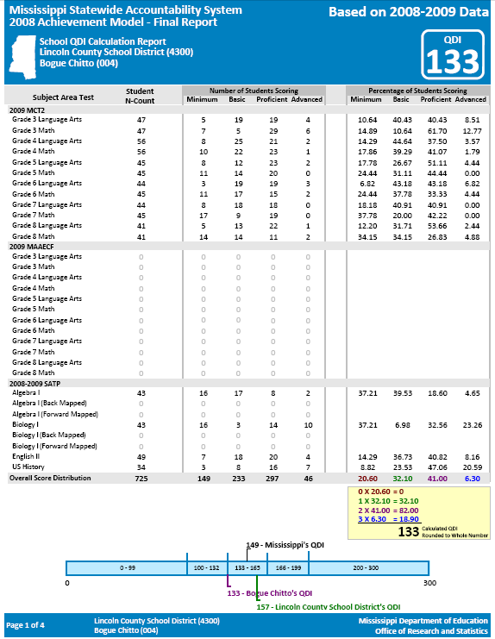

School & District Name & ID
The school level and district level reports are formatted the same. Data are displayed only for variables on which the school or district had data.
This is a secure report provided to school districts. This report is not publicly available because it could identify individual students (particularly the MAAECF section).

Sample School Level Report for the Growth Model (Growth Report)

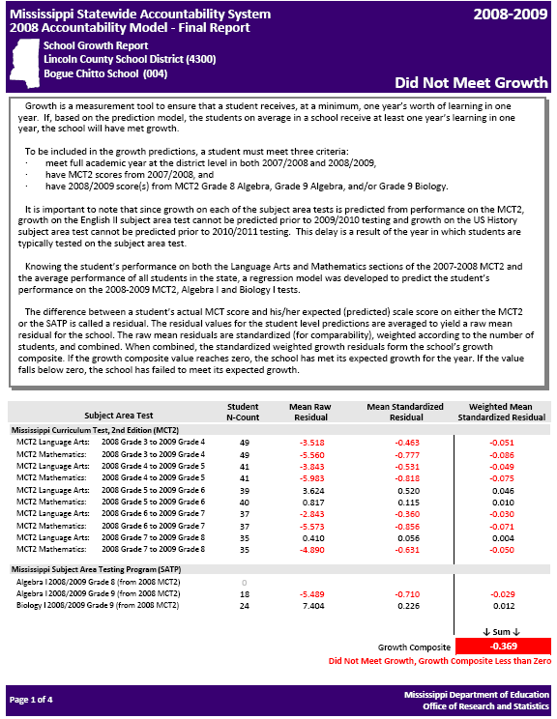
School & District Name & ID
The school level and district level reports are formatted the same. Data are displayed only for variables on which the school or district had data.
This is a secure report provided to school districts. This report is not publicly available because it could identify individual students.

Sample School Level High School Completion Index Report (HSCI Report)

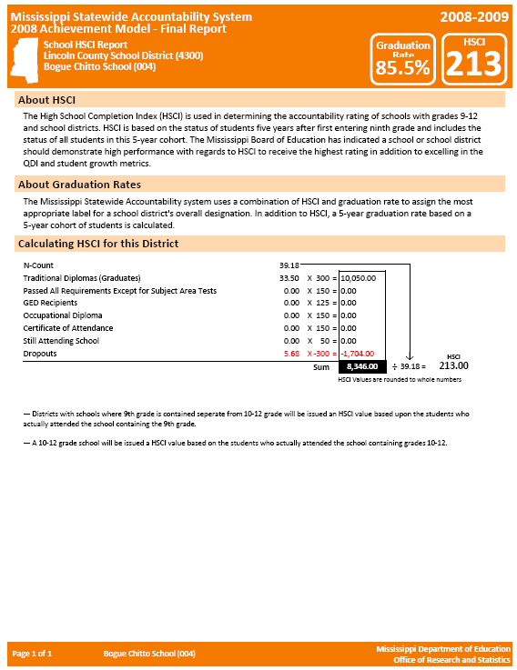

School & District Name & ID

The school level and district level reports are formatted the same.

Sample School Performance Report (reports the Accountability Label)

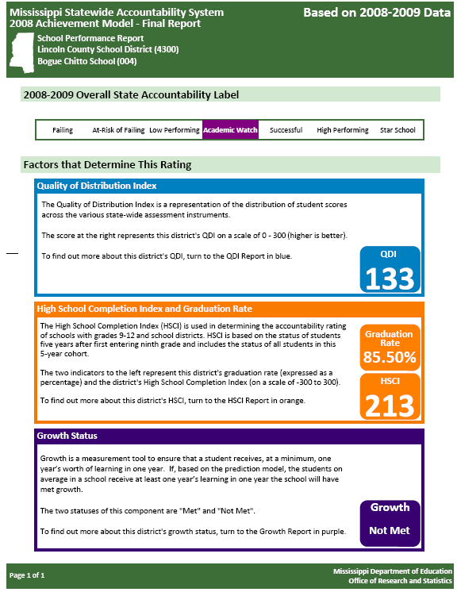
School & District Name & ID

The school level and district level reports are formatted the same.

Appendix E
Where to Find Additional Information

Information about the Statewide Accountability System

Mississippi’s Accountability System: A New Challenge [Media Briefing]. November 19, 2009, Office of Instructional Programs and Services, Mississippi Department of Education. This is a PDF containing slides from a PowerPoint presentation.
http://orshome.mde.k12.ms.us/ors/Accountability%20System%20Media%20Briefing%20%2811-19-09%29.pdf

Mississippi Statewide Accountability System / Development of the New Models for Achievement and Growth: Report #1. November 26, 2008 (Revised). Office of Research and Statistics, Mississippi Department of Education. This PDF describes the development of the current achievement model.
http://research.mde.k12.ms.us/pub/docs/MSAS_New_Report_1.pdf

Approval to revise the State Accountability Rating System. Office of Accreditation, Mississippi Department of Education. This PDF contains the text from the State Board of Education agenda item where the new accountability system was approved (details for the growth model were established later – see below).
http://www.mde.k12.ms.us/accred/2009_Board%20Accountability-1.pdf

Development of a Growth Model for the 2009 Statewide Accountability System: Report #2. September 21, 2009. Office of Research and Statistics, Mississippi Department of Education. This PDF describes the development of the current growth model.
http://www.mde.k12.ms.us/accred/Growth%20Model%20Development%20-%20Report%202.pdf

Procedures for Calculating Graduation, Completion and Dropout Counts and Rates by Tracking Cohorts of Students in MSIS. March 28, 2007 (Revised). Mississippi Department of Education. This PDF describes the approved procedures for calculating the graduation rate used in the statewide accountability system.
http://research.mde.k12.ms.us/pub/docs/GCD%20for%20APA%20Revised%2003282007.pdf

Mississippi Assessment and Accountability Reporting System (MAARS)

The following link points to the main web page for MAARS – the web portal operated by the Department of Education – Office of Research and Statistics. http://orshome.mde.k12.ms.us/ors

Information about the Statewide Curriculum Frameworks

The following link points to the main web page for the Mississippi Department of Education – Office of Curriculum and Instruction. http://www.mde.k12.ms.us/acad/id/curriculum/Curr.htm

Information about the Statewide Assessment Programs

The following link points to the main web page for the Mississippi Department of Education – Office of Student Assessment. http://www.mde.k12.ms.us/ACAD/osa/

Accreditation Policies and Procedures

The following link points to the main web page for the Mississippi Department of Education – Office of Accreditation. http://www.mde.k12.ms.us/accred/accred.html

Note: Documents pertaining to proposed and approved changes to the statewide accountability system can usually be found on the Office of Accreditation web page.

