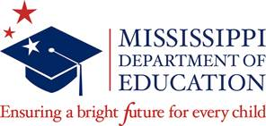
For Office Use Only
Date Certification Received: _______
Received by: __________________

OFFICE OF SPECIAL EDUCATION
SPEECH-LANGUAGE THERAPY PROGRAM/SCHOLARSHIP
CERTIFICATION FOR SCHOOL YEAR 2021-2022

DISTRICT NAME: ________________________________DISTRICT CODE: __________

ASSURANCES
As superintendent of this district, I certify by my signature that:
- As required by MS Code Ann. §37-175-3 all students have been screened before the end of Grade 1 for school year 2021-2022;

- The screener was administered by a 215-licensed Speech-Language Pathologist who is not 100% funded by IDEA;

- The screener addressed speech, language, voice and fluency;

- Parents were notified if their child failed the screener;

- Documentation is on file.

Please indicate the number of students screened for the 2021-2022 school year.

_____________________________________
Printed Name of Superintendent

_____________________________________ _________________________________
Signature of Superintendent Date

Return this form via email by June 30, 2022 to:
Teresa Laney
tlaney@mdek12.org

