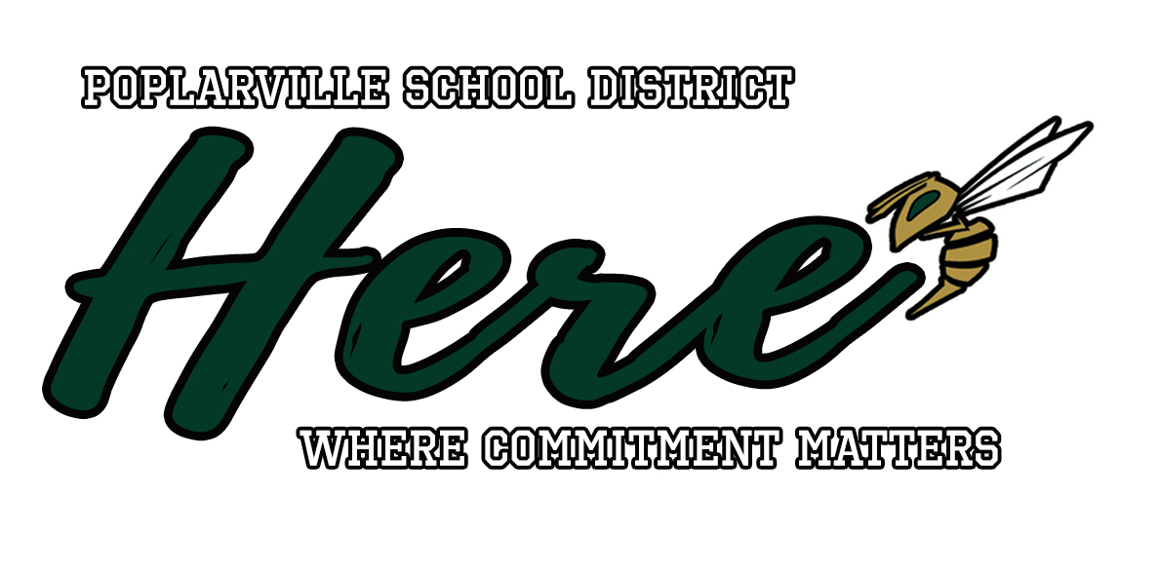
Poplarville School District Restart Plan
2022 - 2023
The Poplarville School District will offer the traditional classroom model for the 2022 - 2023 school year The traditional model requires students to be physically present at school. A medical homebound option will be available for students with severe medical conditions.

PSD will consider guidance from The Mississippi Department of Health and follow any mandates from the governor. Safety protocols to support the health and well being of the staff and students will be practiced. Changes to this plan could be altered due to local school board decisions or executive orders.

Schedule and Calendar
The bell schedules for each school and the school calendar can be found on the district website at www.poplarvilleschools.org.

Health and Hygiene
- Masks are recommended but optional for students and staff. Masks will be required if PSD or a particular school reaches a Covid positivity rate of 12%.
- Health and safety practices such as regular hand sanitizer use and classroom disinfecting will be observed. Hand sanitizer will be available at all school entrances and in every classroom.

Health Services
- Parent/Guardian close contact options:
- Continue to attend classes as normal
- 5 Day Quarantine
- Each school is staffed by a full time registered nurse. Nurses will provide services for student and staff sickness. Questions regarding student attendance following illness should be directed to the school nurse.
- Parents should not send their child to school if they are ill. Any student or staff member with a fever of 100.0 degrees or greater should not be present in school.

Transportation
- Hand sanitizer will be available on every bus.
- Drivers will disinfect the buses daily at the end of the bus route.
- Drivers and students can wear masks or face coverings while on the bus as long as they meet the dress code requirements.

Child Nutrition
- Each school cafeteria will be open and fully functional.
- Covered or individually wrapped items will be offered when feasible.
- Touchless hand sanitizer will be available at each serving line.

Activities/Athletics
- Mississippi High School Activities Association guidelines will be followed for activities and athletics.

