MISSISSIPPI DEPARTMENT
OF EDUCATION
MISSISSIPPI SCHOOL SAFETY MANUAL

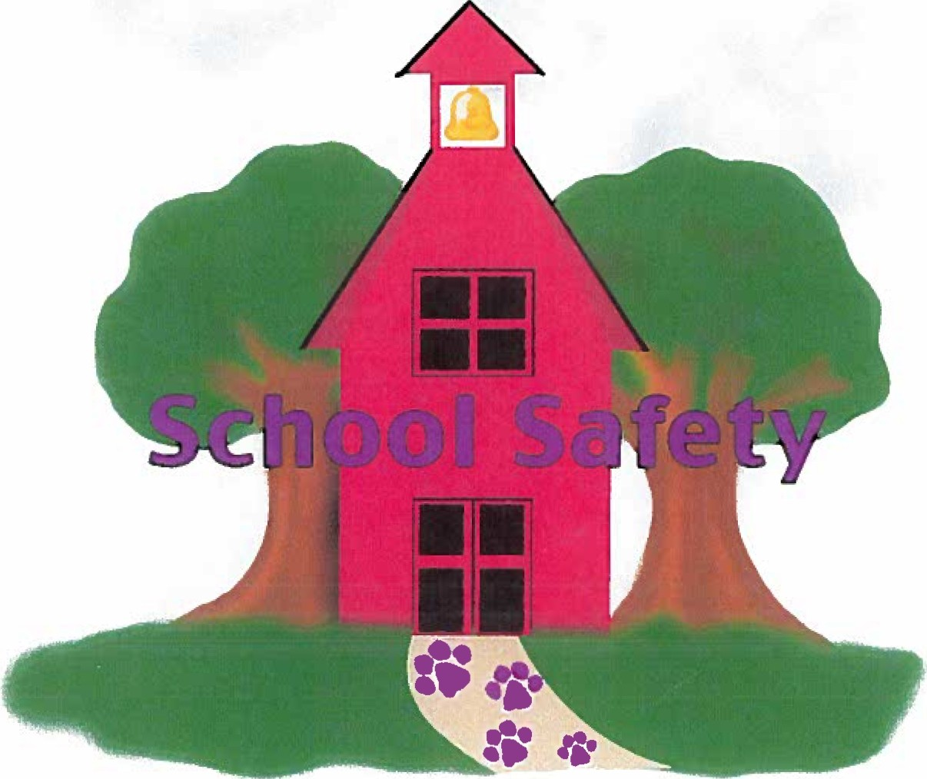

Office of Safe and Orderly Schools Division of School Safety

Table of Contents
Table of Contents i
Introduction 1
The School Safety Concept 2
Background 2
Operational Approach 2
Programmatic Approach 3
Accreditation Standards and the School Safety Plan 3
Assessment 4
Types of Assessments 5
Site Assessment 5
Culture and Climate Assessment 5
School Threat Assessment 5
Capacity Assessment 6
School Safety Plan Components 6
District and School Policies and Procedures Manual 6
Programs that Promote Compliant Behavior and Reduce Prohibited Conduct 6
Crisis Response Plan 7
School Safety Personnel 7
School Resource Officer (SRO) 7
Campus Enforcement Officer (CEO) 8
School Safety Officer 8
Safety Policy/Guidelines for Consideration 9
Operational Policies 9
Programs Implemented 9
Safety Concerns 10
Policy Planning 10
Expand the Partnership 10
The School Board 10

Administrators 11
Teachers 11
Students 11
Parents 11
Law Enforcement 11
Emergency Services 11
The District Attorney/Youth Court Prosecutor 11
Other 12

Introduction

Comprehensive school safety is fundamental to student success and achievement. This resource guide was designed to provide the reader with resources that enable school districts to establish and maintain safe and orderly schools through the development of comprehensive school safety plans.
The intent of this resource guide is to serve as an easy referral document for the administrator, School Resource Officer (SRO), and School Safety Officer (SSO) when confronted with routine problems of daily operations. Additionally, it is hoped the reader will better understand how to develop school safety plans and procedures appropriate for their individual school and community environments.
This resource guide provides both generally accepted standards of school safety as well as accreditation standards. Safe schools are a whole community responsibility including administrators, teachers, support staff, students, and parents. The information contained in this document is meant to be a guide for emergency planning and is not all-inclusive.
There is a separate document that includes many of the criminal, educational and juvenile statutes of the Mississippi Code of 1972, Annotated. The Mississippi Department of Education (MDE) does not issue legal opinions. Any official legal opinion regarding any statute must come from the Office of the Mississippi Attorney General.

The School Safety Concept
Background
School safety planning remains an ever-present priority for providing a safe and orderly school environment. It first became an issue in Mississippi with the recognition that schools may be safer with the utilization of security and emergency management methodology.
The MDE identified this need and created the Office of Safe and Orderly Schools. The Division of School Safety was established within this office to furnish technical assistance, consulting services, training, and to serve as the primary state school safety center for school safety to all K-12 school districts, law enforcement agencies, emergency responders, and community members.
MDE has developed a model wherein school safety requires a broad-based commitment from the entire community. This commitment must promote a comprehensive approach to school safety that focuses on prevention, mitigation, response, and recovery. The security and safety process must complement the education process and support an environment free of fear, harassment, and danger. Each method of approach is equally important and necessary as the other.

Operational Approach
Mississippi has selected a combination of the programmatic and operational approaches to school safety. If a school does not have control of the school environment and the student population by sound daily operating procedures there will be such a level of disruption, or lack of confidence by participants, the education process will be hampered at all levels. Students, parents, and staff must feel safe to reach the maximum level of student achievement.
MDE is focusing on the school safety plan as the primary foundation instrument by which schools can evaluate their status as well as design and implement changes to policies, procedures, and emergency protocols based on research results. MDE has established broad principles of student intervention, discipline, and management. Implementing these principles daily, as part of normal routine, will ensure schools are maintaining a safe environment. Operational approaches deal with routine procedures and typically yield an almost immediate safe school environment when rigorously implemented. A safe environment requires the support from all levels, starting with the school board and working down through the superintendent, principals, teachers, and students to implement the school safety as well as disciplinary policies and procedures. This includes student monitoring, implementation of student codes of conduct, properly utilized disciplinary procedures, deployment of School Resource Officers (SRO) and School Safety Officers (SSO), proper enforcement procedures, compliance with state statutes as well as liaison with law enforcement, emergency services, youth court, and community service agencies.

Programmatic Approach
Programmatic approaches include character education, crime prevention programs, aggression management, peer counseling, DARE, GREAT, ROTC and similar programs. Schools shall only implement those programs that can demonstrate they have been proven successful in statistically reducing student violence, narcotics usage or alcohol usage. These programs shall be periodically evaluated for effectiveness and efficiency with a view towards discontinuing those programs that are ineffective or not cost effective.

Accreditation Standards and the School Safety Plan
The School Safety Plan is essentially the foundation the school uses to maintain a safe and secure educational environment. The existence of a comprehensive school safety plan is a generally accepted standard of school safety, as well as a mandatory requirement of Miss. Code Ann. § 37-3-83, and Mississippi Public School Accountability Standards, 2017 (Process Standard 31). Specific accreditation standards for school safety include:
- The school must have a crisis response plan that includes specific staff response protocols for: (Crisis Plan Review)
  - Fire
  - Bomb Threat/Explosion
  - Tornado/Hurricane/Inclement Weather
  - Armed/Unarmed Intruder
  - Earthquake
  - Interior/Exterior Hazardous Materials
  - Threats unique to the geographical location of the school
- Staff member roles and responsibilities must be identified, and they must be familiar with the crisis response plan. (Staff interviews)
- Staff Crisis (Emergency) Response Team identified as well as contact information
- Drills must be documented in accordance with the following schedule: (Drill File)
  - Fire Drills-Monthly
  - Tornado Drills- twice per year
  - Lockdown/Intruder- twice per year
- The school must have two (2) family reunification points designated to include maps to these locations. (Crisis Plan Review)
- The school must have two (2) evacuation locations designated to include maps to these locations.
- The school must be compliant with all pertinent Mississippi Codes: (District Policy and Procedure Manual Review)
  - Miss. Code Ann. § 37-11-53 - Dissemination of the Student Code of Conduct
  - Must possess and enforce the Student Disciplinary Plan
  - Must report all crimes in accordance with the provisions of Miss. Code Ann. § 37-11-29.
  - Must have a restraint policy.
  - Must have a search policy for students, personal property, and vehicles that is enforced.
  - Must have an enforced visitor control procedure.
  - School Safety Personnel:
- SROs and SSOs must be certified by MDE within 2 years of appointment to the school if employed by the school district.
- All school safety personnel must be supervised by the superintendent or designee, excluding principals.
- SROs must be certified full-time police officers.
- SROs must be armed and deployed in accordance with the generally accepted standards of police practice. They must qualify with firearms bi-annually.
- SROs must attend Active Shooter Training (ALERRT) every third year.
- All school safety personnel must receive a minimum of 40 hours service training as approved by MDE each year.

Assessment
Evaluating school safety procedures and practices is an ongoing process. One of the first steps in designing a School Safety Plan is the evaluation of the school’s current safety status and statistics. When drafting a school safety plan, a safety committee shall be formed with representatives of all elements of the school and community responders. This plan shall be reviewed by all involved and signed off on by each entity involved. The plan shall be reviewed/revised annually during the summer and submitted for board approval. The school safety plan must have annual board approval.
The purpose of this assessment is to increase district knowledge of gaps or areas of needed improvement, evaluate the procedures for legality and consistency, and to initiate new policies based on assessment findings. It is recommended that a comprehensive school safety assessment be conducted by either MDE’s Division of School Safety, a certified SRO, or a School Safety Administrator that uses MDE standards for assessment.
It is also recommended the assessment instruments be used to assess perceptions of school safety on the part of staff, faculty, and students. It should be remembered that perceptions do not necessarily reflect facts regarding school safety. The Division of School Safety will assist in these areas upon request.
Types of Assessments
- Site Assessment: A site assessment examines the safety, accessibility, and emergency preparedness of the school’s buildings and grounds. This assessment includes, but is not limited to, a review of building access and egress control measures, visibility around the exterior of the building, compliance with applicable architectural standards for individuals with disabilities and others with functional and access needs, and emergency vehicle access.

Purpose and Results
- Increased understanding of the potential impact of threats and hazards on the school buildings and grounds.
- Increased understanding of risk and vulnerabilities of the school buildings and grounds when developing the plan.
- Knowledge of which facilities are physically accessible to students with disabilities, staff, parents, volunteer workers, and emergency response personnel.

- Culture and Climate Assessment: In schools with positive climates, students are more likely to feel connected to adults and their peers. This fosters a nurturing environment where students are more likely to succeed, feel safe, and report threats. A school culture and climate assessment evaluates student and staff connectedness to the school and help identify problem behaviors. For example, this assessment may reveal a high number of bullying incidents, indicating the
need to implement an anti-bullying program.
Purpose and Results
- Knowledge of students, and staff perceptions as to their safety.
- Knowledge of problem behaviors that should be addressed to improve school climate.
- School Threat Assessment: A school threat assessment analyzes communication and behaviors to determine whether a student, staff, or other person may pose a threat. These assessments must be based on fact, must comply with applicable privacy, civil, and other laws. The threat assessment team is separate from the planning team and meets on its own regular schedule.
Purpose and Results
Students, staff, or other persons that may pose a threat are identified before a threat develops into an incident and are referred for services, if appropriate.

- Capacity Assessment: The planning team should understand what resources are at their disposal. A capacity assessment examines the capabilities of the students and staff as well as the services and material resources of community partners. This assessment is used to identify people in the building with certain skills (e.g., first aid, search and rescue training, counseling and mental health expertise, etc.). Equipment and supplies shall be inventoried. The inventory shall include an evaluation of equipment and supplies used for people with disabilities, such as sign language interpreters, evacuation chairs, accessible transportation, and consumable and durable medical supplies.
Purpose and Results
- An increased understanding of available resources.
- Knowledge of staff capabilities will help planners assign roles and responsibilities in the plan.

School Safety Plan Components
There are three (3) components to a School Safety Plan.
- District and School Policies and Procedures Manual
Policies and procedures that are clearly communicated and consistently enforced to afford a safe school operating environment. A listing of policies, procedures, and regulations the district and/or school has enacted are typically those items listed in:
  - Employee handbook: Monitoring duties, intruder policies, and evacuation procedures.
  - Parent/Student Handbook: Uniform policies, code of conduct policies, etc.
  - Discipline Code: Hearing procedures and prohibited conduct.
  - District Policies and Procedures: Safety policies, campus security policy, assessments conducted, needs identified, alternative school/detention policy.
  - Maintenance Policies: Athletic procedures and transportation policy.
  - Programs and staff training the school uses to reduce violence or non-compliant behavior such as DARE, GREAT, Youth Crime Watch, ROTC, Teen Court, etc.

- Programs that Promote Compliant Behavior and Reduce Prohibited Conduct
A listing of those programs that have been implemented to encourage a safe and secure school environment and compliant behavior. The program shall:
- Be statistically proven to promote good character and encourage compliant behavior.
- Have a means of objectively measuring the success of the program.

- Crisis Response Plan
In accordance with Miss. Code Ann. § 37-3-101 the school safety plan must include a comprehensive listing of Crisis Response Protocols to include all staff actions and a protocol for the following events at a minimum:
- Fire
- Tornado/Inclement weather
- Hurricane
- Bomb Threat/Explosion
- Intruder (armed and unarmed)
- Earthquake
- Threats unique to the school such as nuclear incidents, hazardous materials spills, train derailment, etc.

Each classroom shall contain emergency packs that include color cards for outside evacuations only (Red – have an emergency issue, Yellow – need assistance from an Administrator, Green – no issues), class roster with emergency student contacts, emergency procedures checklist, whistle, and list of any specific special needs (medications, dietary needs, or other medical issues pertaining to students).

School Safety Personnel
Assignment of personnel shall be based on the school safety assessment, threat profile, needs of the district, and funding availability. In accordance with Miss. Code Ann. § 37-7-321, all security or law enforcement personnel assigned to a school district on a full-time basis (greater than 75%) must be certified by MDE within 2 years of appointment if employed directly by a school district. The School Resource Officer (or SSO/CEO) shall be an integral part of all safety planning areas since this individual is responsible for safety planning and response.

School Resource Officer (SRO)
- Definition: An officer, commissioned by a local law enforcement agency or school district, who has at least three (3) years of full time commissioned law enforcement service and is a graduate of the Basic Law Enforcement Officer Training Program and the Mississippi Department of Education (MDE) School Resource Officer Basic Course. This officer shall be supervised by the superintendent or their designee, excluding principals. The officer typically spends 40% of their time in enforcement and security administration, 30% teaching character related education subjects, and 30% mentoring at-risk students.
- Duties/Qualifications: Must be at least 24 years of age and have at least three (3) years of law enforcement experience prior to assignment. The SRO is assigned to a school district on a full-time basis. Duties include school safety planning, enforcement, teaching, and mentoring. It is recommended that the SRO have an assigned office space, computer, and phone line. This allows the SRO to have a location to write reports, maintain intelligence logs, communicate with surrounding Law Enforcement for situational awareness, and research items that may provide safety and security to schools. The SRO is expected to be armed and maintain qualifications with the issued weapon every six (6) months. Officers shall be screened for intelligence, ability to teach subjects within their area of expertise, and their ability to interact with students. The SRO is not merely an armed security guard.
- Minimum Training Standard:
- Completion of the Police Officer Basic Course (reserve basic is not acceptable).
- Completion of the MDE School Resource Officer Basic Course within two (2) years of appointment (See MS Code 37-7-321).
- 40 hours per year of MDE sanctioned in-service training.
Campus Enforcement Officer (CEO)
- Definition: An officer, commissioned by a local law enforcement agency or local school district in accordance with Miss. Code Ann. § 37-7-321 who is a graduate of the Reserve Police Officer Basic Course and is assigned enforcement, security, and safety duties.
- Duties/Qualifications: The Campus Enforcement Officer (CEO) is a School Safety Officer that is commissioned by a local law enforcement agency that has law enforcement authority. The CEO has authority to carry a weapon and make arrests. The officer is responsible only for enforcement and safety related activities. The Campus Enforcement Officer is not trained in school safety, planning, classroom teaching, or counseling related duties.
- Minimum Training Standard:
- Completion of the Reserve Police Officer Basic Course
- 40 hours per year of MDE sanctioned in-service training is recommended.

School Safety Officer (SSO)
- Definition: A security and safety specialist, employed by the school district or private security company, who has been contracted by the district to provide routine safety and security duties.
- Duties/Qualifications: The School Safety Officer (SSO) is assigned routine duties of safety and physical security under the supervision of a School Resource Officer, Campus Enforcement Officer, or school administrator. The SSO does not have authority to carry a weapon or make arrests. The SSO conducts routine patrols, secures buildings, and checks for safety hazards.
- Minimum Training Standards:
- Completion of the MDE School Safety Officer Basic Course
- 40 hours per year of MDE sanctioned in-service training

Safety Policy/Guidelines for Consideration
Operational Policies
The following list is not exhaustive but provides a starting point for the issues/policies that shall be considered. All school safety related plans and programs shall be based on a comprehensive assessment and state statutes relating to school safety.
- Discipline Plan  - Code of Conduct Policies  - Playground Policies  - Duty Rosters  - Traffic Policies  - Visitor Policies and  Procedures  - Search Policies  - Dress Code  - Electronic Communication/Cell Phone Policies  - Internet Policies | - Field Trip/Special Event Policies  - Plain Language Commands (NIMS Compliance)  - Parking & Automobile Policies  - Evacuation Procedures  - Medication Dispensing Policy  - Shop Safety Policy  - Juvenile Court Liaison Policy  - Alarm Systems  - Posting of Signs  - Hazardous Material Policy  - Inclement Weather Procedures
Programs Implemented
- Drug Abuse Resistance Education (DARE) - to be taught by an SRO or other
Law Enforcement
- Gang Reduction Education and Training
- Teen SERT
- Campus Safety Council
- Teen Court
- Youth Crime Watch
- Boys and Girls Clubs
- Civil Air Patrol Aerospace Leadership course
- JROTC
- 4-H

Safety Concerns
Safety concerns include:
- School location and age: The neighborhood, age of the school, maintenance
level, and attendance.
- Communication Systems: Shall have two-way communication between office
and key personnel (Administrators, Janitorial Staff, School Safety Personnel,
etc.) as well as an emergency phone system.
- Surveillance Systems (if needed): System shall be monitored and/or recorded.
Policies shall specify if the system is being used as a deterrent or monitoring
tool.
- Shut-off valves to utilities shall be located and noted on the school map.
- Fire drills shall be conducted monthly and documented.
- Tornado drills shall be conducted twice per year at a minimum and
documented.
- Lockdown drills shall be conducted twice per year at a minimum and
documented.
- Building Accessibility: Perimeter doors allowing ingress and egress from public
areas shall be one-way or monitored.
- Classrooms shall have interior door locks (or method to secure the door for a
lockdown), a copy of the room level crisis plan, and classroom emergency packs.
- Parent and bus traffic shall be segregated and controlled.
- Emergency lighting shall be present and checked.
- Custodial closets, electrical, plumbing, and gas equipment areas shall be
locked. Storage areas shall be neat and free of flammable or hazardous
material.
- Science labs shall have safety equipment and emergency protocols. Chemicals
shall be segregated and tagged with expiration dates.

Policy Planning
Expand the Partnership
Policies and programs require community based collaborative efforts to be effective, and shall include students, parents, teachers, administrators, staff, social and mental health professionals, law enforcement, emergency response personnel, school board members, and the business community. The district shall have a multi-disciplinary team in place to assess the credibility and response to resolving threat issues.
The School Board
The School Board is responsible for adopting and implementing policies and procedures that will create and maintain a safe environment for the learning process as well as reflect consistency with all relevant statutes.
Administrators
Administrators have the inherent authority and responsibility to conduct administrative investigations regarding possible violation of policies, procedures, and statutes. Administrators need only a reasonable suspicion of a violation to question and search a student. The Administrators have the authority to file criminal charges, pursuant to Miss. Code Ann. 1972, on behalf of the school district for crimes committed on school property.
Teachers
Teachers must be directly involved, trained, and supported in all stages of developing programs for safer schools. Teachers are the first line of defense in school safety because of the direct contact with students. Teacher insight into potential problems with students and the school is important in the planning process.
Students
Students can be a crucial component to violence prevention. Students provide an essential perspective on how to promote school safety and shall be included in all efforts to create and maintain a safe and orderly school. Non-compliant behavior is a choice on the student’s part and shall be handled appropriately.
Parents
Parents are a key player in the school safety process. Parents are responsible for their child’s behavior at all times.
Law Enforcement
Law Enforcement Officers (LEO), including SROs, County/City Police Officers, State, and Federal partners can provide vital information in the planning process for safer schools. LEOs understand trends within the communities they serve and have the capability to obtain resources not typically available to those outside the law enforcement area.
Emergency Services
Emergency services consists of Fire Services, Emergency Management, Law Enforcement, Emergency Medical Services, and other emergency response entities. Emergency Services shall be included in the safety planning process, exercises and evaluations.
The District Attorney/Youth Court Prosecutor
The District Attorney/Youth Court Prosecutor may help educate school personnel on legal and criminal issues regarding school safety.
Other
Using a community-based approach to policy planning could include many other entities than the ones listed above. Other possibilities to consider are:
      - Community business partners (Walmart, Lowe’s, Home Depot, etc.)
      - Volunteer Services (American Red Cross, Salvation Army, local service groups, etc.)
      - Local hospital(s)
      - Area Specific Threat Entities (Railroad Authority, Airport Authority, local transportation entities, etc.)

