SUGGESTED
INSTRUCTIONAL
PLANNING GUIDE
for the Mississippi College- and Career-Readiness Standards
q Literacy/English
Language Arts
Grades 9-10

The Mississippi State Board of Education, the Mississippi Department of Education, the Mississippi School for the Arts, the Mississippi School for the Blind, the Mississippi School for the Deaf, and the Mississippi School for Mathematics and Science do not discriminate on the basis of race, sex, color, religion, national origin, age, or disability in the provision of educational programs and services or employment opportunities and benefits. The following office has been designated to handle inquiries and complaints regarding the non‑discrimination policies of the above-mentioned entities: Director, Office of Human Resources, Mississippi Department of Education, 359 North West Street, P.O. Box 771, Jackson, MS 39205‑0771, (601) 359-3513.

Mississippi Department of Education
359 North West Street
P. O. Box 771
Jackson, Mississippi 39205-0771
(601) 359-3513
www.mdek12.org

MISSISSIPPI DEPARTMENT OF EDUCATION
Carey M. Wright, Ed.D.
State Superintendent of Education
Nathan Oakley, Ph.D.
Chief Academic Officer
Wendy Clemons  Executive Director, Offices of Secondary  Education/Dropout Prevention and Professional Development | Tenette Smith, Ed.D.  Executive Director, Office of Elementary  Education and Reading
Marla Davis, Ph.D.  State Director of Curriculum and Instruction | Kristen Wynn  State Literacy Director (K-12)
Natalie Crowder  English Language Arts Content Director | Jill Hoda  Assistant State Literacy Coordinator | Lori Stringer  Assistant State Literacy Coordinator
 | Melissa Beck  Assessment Coordinator (K-3) | LeighAnne Cheeseman Assistant State Literacy/English Learner Coordinator (K-3)

Special Acknowledgements
Bailey Education Group
Barksdale Reading Institute
The Kirkland Group

INTRODUCTION
The unprecedented, nationwide school closures in the spring of 2020 due to the COVID-19 pandemic have created a shift in how districts plan for school re-entry. Instead of the traditional brick-and-mortar planning, administrators are now identifying models that will support a variety of instructional delivery scenarios as they plan for school reopening. The traditional methods of planning and delivery are nearly impossible to implement as a stand-alone model; instead, innovative educators are developing and identifying strategies and resources to support a variety of distance learning scenarios as part of their plans. When using new models of delivery, it is important to recognize that the traditional approach to remediation—providing work better suited for earlier grades—may be insufficient. Instead, the conventional approach to remediation will likely compound the problem educators are trying to correct. According to a 2018 study, The Opportunity Myth,, the approach of “meeting students where they are”, while often well-intended, only widens the achievement gap. Instead of remediation, teachers and administrators are encouraged to look toward acceleration methods to support student growth and close the gaps.

PURPOSE
This document is intended to provide guidance to schools and districts as they develop instructional plans to address unfinished learning. It includes recommendations to assist educators as they diagnose learning loss and create an instructional plan to put every student on track to mastering grade-level standards. In addition, this guide is intended to compliment resources released by various organizations, including Student Achievement Partners (SAP), EdReports, The New Teacher Project (TNTP), and the Council of Chief State School Officers, that also address the challenges of prioritizing instruction, addressing unfinished learning, and meeting the social-emotional and mental health needs of students.
Recommendations for Addressing Unfinished Learning and Acceleration in ELA/Literacy

RECOMMENDATION 1 u | Focus on grade-level content and learning through the use of  High-Quality Instructional Materials (HQIM)
Since time is a scarce commodity in classrooms—made more limited by anticipated closures and distance or hybrid learning models in the fall of 2020—strategic instructional choices about which content to prioritize must be made. More importantly, educators must make deliberate instructional choices that allow all students to effectively engage with grade-level work.  For students to develop the integrated, holistic, and flexible literacy skills necessary to participate in the world around them, they need and deserve regular access to grade-level complex texts. They also need lots of time to independently explore particular topics, suited to students’ varied interests, through reading multiple texts that are at a range of complexity levels. Focusing solely on simple, below-level texts won’t teach readers how to deal with complicated concepts, syntax, or subtle cohesive links in texts.  Simple texts lack the critical rich vocabulary knowledge only available to students reading complex on-grade-level texts. In the words of Professor Alfred Tatum, Dean of the College of Education of the University of Illinois, “Leveled texts lead to leveled lives” (Fisher & Frey, 2014). |  | #MATERIALSMATTER  When teachers don’t have access to great  materials, they spend valuable time searching for them online or create content themselves. A 2017 RAND analysis found that 96 percent of teachers use Google and 75 percent of teachers use Pinterest to find lessons and materials. These materials are mostly unvetted and of varying quality. Inconsistent access to aligned materials impacts student learning in schools across the country, but particularly hits schools that have a higher proportion of low income and students of color the most, perpetuating inequities and opportunity gaps.
RECOMMENDATION 2 u | Prioritize content and learning
Focus Instruction  Focus on Standards That Represent the Major Work of ELA/literacy Instruction: Learning to Read, Close Reading of Complex Texts, and Volume of Reading to Build Knowledge  Some standards require greater emphasis than others based on the literacy research about what matters most and the time and practice that they take to develop. These two literacy components of a text-centered, rich ELA/literacy classroom experience lead the way to identifying the Major Work of ELA/literacy instruction across the grades:  In grades 4–12, these instructional practices are best exemplified by 14 MS-CCR standards (and the research that supports them). They cross the domains of Reading, Writing, Speaking and Listening, and Language. |  |  | LOOK CLOSELY AT THE STANDARDS  Review the MS CCRS Scaffolding Document, the ELA Vertical Progression Document, and the MS CCRS for ELA to identify how the ELA Standards progress from year to year and how the skills and content students are expected to learn develop in a larger scope.  - Identify which standards are priority for each grade– standards introduced for the first time, or standards established as the foundation for continued learning in the next grade.  - Study grade-specific standards alongside the year-long scope and sequence provided within the adopted curriculum to identify:  - what standards and topics will be covered, and when;  - how students will apply their knowledge of the standards once it is taught; and  - how students will show their knowledge.
RECOMMENDATION 3 u | Plan your approach to diagnosing students’ unfinished learning
Universal Screeners  Universal screeners are valid and reliable data collection tools and processes used to assess students’ current level of performance in relation to grade- level benchmarks, identifying students who need intervention and those who do not. Because screening takes place multiple times per year with all students, screeners are typically designed to be easy, quick, and repeatable.  Diagnostic Assessments  Diagnostic Assessments are used to assess specific skills or components of reading such as phonemic awareness, phonics skills, and fluency. The results of diagnostic assessments inform instruction and intervention. Diagnostic assessments can be formal standardized tests of children’s component reading and language abilities or informal measures such as criterion-referenced tests and informal reading inventories. Not all children need this kind of in-depth reading assessment, which is most important for struggling and at-risk readers.  Teachers should use assessment results to alert them to the fact that students have unfinished learning. But it is ultimately up to the teacher to identify where the gaps in essential learning exist, and what additional scaffolding and support is required.  Strong, attentive instruction, with embedded formative assessment, thus enables teachers to respond to student needs in real-time, and in the context of grade-level standards, rather than defaulting to wholesale remediation.  Moreover, this type of attention and responsiveness, particularly among teams of different types of teachers (such as special education teachers, bilingual education teachers, etc.) working together, provides a more complete picture of the educational needs of diverse learners. For English learners in particular, educators working to address unfinished learning while delivering grade-level instruction need to discern whether learning challenges are due to gaps in the understanding of content, language acquisition, or both. |  |  |  | APPROVED LIST OF  READING SCREENERS  State statute requires that the Mississippi Department of Education shall select early literacy and numeracy screening assessment instrument or instruments to be used throughout the state in the screening of students in Kindergarten through Grade 3. (Mississippi Code § 37-23-16; Mississippi Code § 37-177-5) The Mississippi Department of Education, in collaboration with Mississippi Reading Panel, has established an approved list of reading screeners to be used by local school districts in grades K-3. The following universal screeners are approved for use in Mississippi schools:  - FAST: Adaptive Reading, CBMReading, and earlyReading English (suite of three administered together) (Grades K-12)  - iReady® (Grades K-12)  - Measures of Academic Progress (MAP) Growth (Grades K-2), MAP (Grades 2-10)  - STAR Reading (Grades 1-12)
Schools and districts should prioritize gathering information about students’ unfinished learning by using assessments from high-quality adopted materials as often as possible. Designing assessments is truly challenging, so using the assessments provided by the high-quality instructional materials you’ve adopted is the best way to diagnose gaps that students might have in their learning.

RECOMMENDATION 4 u | Promote social and emotional development through literacy instruction
As we narrow the focus and recommit to what matters most academically, research also tells us that four learning mindsets are particularly important in supporting students’ academic development. They focus on students’ sense of 1) belonging and safety, 2) efficacy, 3) value for effort and growth, and 4) engagement in work that is relevant and culturally responsive (Aspen Institute, 2019).

Within classrooms, within schools, attention must be given to restoring relationships and a sense of community, so students feel safe, fully engage and work hard. We need to help students know that we believe they can succeed and that their ability and competence will grow with their effort. And more than ever, students need to see value and relevance in what they are learning to their lives and their very beings. Investing in students' social-emotional development is done by the entire system of adults in schools. This investment is key to promoting engagement in—not a substitute for—teaching academic content; it represents a change in how academic content is taught.
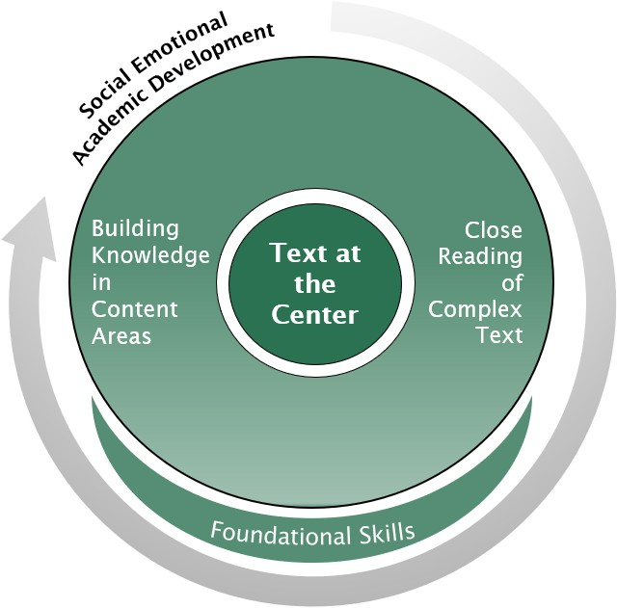
Instructional Practices adopted from CASEL
For example, through ELA, educators can support students to:
- See the connections between current tasks and their personal goals and interests; reflect on their personal aspirations, goals, and objectives in writing assignments (self-awarenes).
- Develop skills for focusing attention, managing stress anxiety, and accomplishing goals in order to effectively participate in classroom or remote learning environments (self-management).
- Develop empathy and perspective-taking in their thinking, reading, and writing processes (social awareness).
- Develop speaking and listening skills for presentations and learn to collaborate in groups where they are encouraged to consider the perspectives and thought processes of their peers (relationship skills).
- Use writing to reflect on choices and goals as a way of developing strong decision-making skills (responsible decision-making).
Specific Considerations for Transitioning to Grade Nine
“As with the transition to middle school, the transition from middle into high school is typically marked by mixed feelings of excitement and anxiety. Not only must students take on greater responsibility for their own learning and deal with higher academic expectations, they also have to find their way in new social and physical environments that are initially intimidating and confusing. Such a transition is a big challenge in ordinary times and will likely prove even more challenging after extended and unexpected school closures. This transition and the unfinished learning students will have from grade eight may take a toll on students’ academic agency and self-confidence. Students will require not only instructional support, but social-emotional support from teachers, parents, and peers. At the same time, students will also enter high school with newfound knowledge and skills from having to navigate a difficult time during the pandemic, as well as new ways of engaging with school.”- Council of the Great City Schools

SUGGESTED
INSTRUCTIONAL
PLANNING GUIDE
for the Mississippi College- and Career-Readiness Standards
Grades 9-10

Prioritizing Instructional Content and Practices in ELA/Literacy (9-10)
Adopted from Student Achievement Partners: ELA/Literacy Considerations (2020-2021)
At this level, students are expected to understand more from and make fuller use of written materials, including using a wider range of text evidence to support their inferences. As they address different aspects of the same topic, students make more connections about how complex ideas interact and develop within (and across) books, essays, articles, or other resources. Students learn to evaluate intricate arguments and surmount the challenges posed by complex written materials and other resources independently and confidently. Through wide and deep reading of literature and literary nonfiction of steadily increasing sophistication, they expand their literary and cultural knowledge and better understand references and images. They also work to develop the flexibility, concentration, and fluency to produce logical, well-reasoned writings and presentations that are supported by evidence. By writing and participating in a variety of conversations, they will practice asserting and defending claims and showing what they know about a subject using appropriate examples and evidence. These literacy practices that allow students to gain knowledge and skills through the careful study of texts and topics are not only left to ELA, but should also find their rightful place as practices required by the disciplines in science, technical subjects, history, and social studies.
*Reading and writing standards that vary by grade level are shown in charts below. This allows teachers to see how the standard was covered in past years as well as what they will be learning in the future. The bolded sections of each standard indicate new skills for that standard/year.

Keep Grade-Level Complex Text at the Center
of Reading, Writing, Speaking and Listening, and Language Instruction
PRIORITY u | Regular Close Reading of Grade-Level Complex, Anchor Texts
9-10 STANDARDS
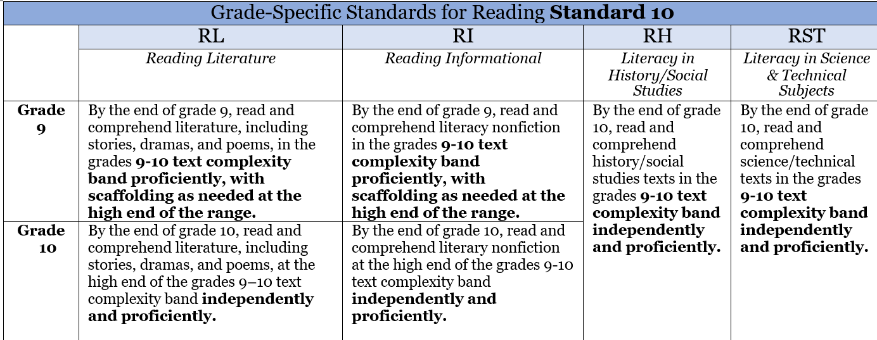
RL.9-10.10 and RI.9-10.10

RECOMMENDED INSTRUCTIONAL PRACTICES
- Routinely focus all students on rich, grade-level anchor texts:
  - Grade Band: 9-10
  - Lexile Range: 1050-1335
  - When selecting anchor texts, also consider qualitative features of texts (such as meaning, structure, language, and knowledge demands).
- Organize units around conceptually related topics and content-rich themes.
- Focus on building knowledge through anchor texts.
- Provide instructional scaffolds such as building knowledge about a topic, providing access to texts read aloud, shared reading, and think-aloud.
Resource:
Supporting All Learners with Complex Texts

PRIORITY u | Sequences of Text-Specific Questions and Task to Support Close Reading
9-10 STANDARDS
RL 9-10.1 and RI 9-10.1
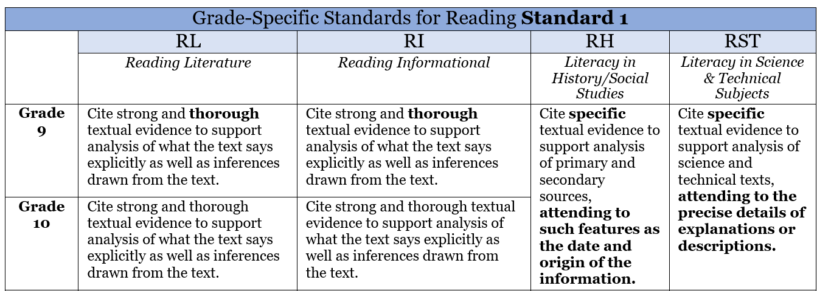
Additional Guidance for Grades 9-10 Reading Standards should be identified through the use of a high-quality, standards-aligned curriculum.
RECOMMENDED INSTRUCTIONAL PRACTICES
- Provide sequences of questions that engage students deeply with the text.
- Design instruction to cultivate every student’s ability to read carefully and grasp information—both what the text says explicitly and when drawing inferences from texts.
- Encourage students to cite specific text evidence (quotes and examples) when supporting their own points in writing and speaking, making their reasoning clear to the reader or listener and constructively evaluating others’ use of evidence.
- Provide students time to read and reread portions of the anchor text.
Resource:
Text-Dependent Questions

PRIORITY u | Systematic Work with Text-Based Vocabulary
9-10 STANDARDS
RL 9-10.4 and RI 9-10.4

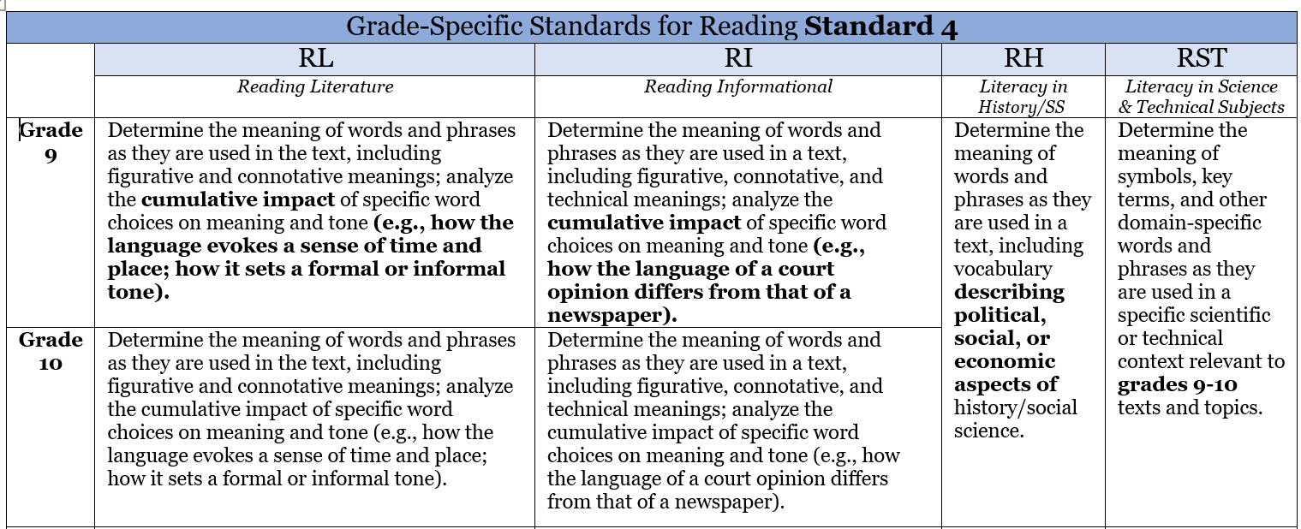

CCR.L.4 Determine or clarify the meaning of unknown and multiple-meaning words and phrases by using context clues, analyzing meaningful word parts, and consulting general and specialized reference materials, as appropriate. (See grade specific guidance for standards for L.4 a-d)
CCR.L.5 Demonstrate understanding of figurative language, word relationships, and nuances in word meanings. (See grade specific guidance for standards L.5 a-c)
CCR.L.6 Acquire and use accurately a range of general academic and domain-specific words and phrases sufficient for reading, writing, speaking, and listening at the college and career readiness level; demonstrate independence in gathering vocabulary knowledge when encountering an unknown term important to comprehension or expression.
Additional Guidance for Grade 9-10 Reading and Language Standards should be identified through the use of a high-quality, standards-aligned curriculum.

RECOMMENDED INSTRUCTIONAL PRACTICES
- Use text-based questions and tasks; focus on academic and domain-specific words that are critical for understanding the text or part of large word families.
- Provide supplemental practice on text-based vocabulary through games, exercises, and focus on word parts and their morphology.
- Encourage the use of the targeted words from the anchor text throughout discussions and writing assignments.
- Regularly—and daily, if possible—choose one complex and compelling sentence from the anchor text to deconstruct and reconstruct with students.
Resources:
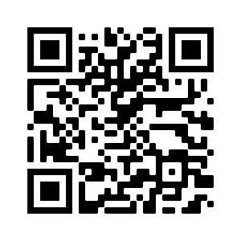
Academic Word Finder Selecting and Using Academic Vocabulary Instruction
PRIORITY u | Frequent Evidence-Based Discussion About Anchor Text
9-10 STANDARDS
SL.1 Prepare for and participate effectively in a range of conversations and collaborations with diverse partners, building on others’ ideas and expressing their own clearly and persuasively. (See grade specific guidance for standards SL.1 a-d)

RECOMMENDED INSTRUCTIONAL PRACTICES
- Design daily opportunities for students to process and extend their learning through collaborative, small-group, or partner text-based discussions.
- Strategically use peer partnerships to promote as much productive talk as possible.
- Have students reflect on each other’s thinking using evidence, as well as considering and challenging others’ perspectives.
- Teach the language of argumentation to facilitate students taking positions on what they’re reading and hearing from others.
Resources:
PBS Sample Lesson Effective Classroom Discussions
PRIORITY u | Regular Evidence-Based Writing About Anchor Text
9-10 STANDARDS
W 9-10.9 Draw evidence from literary or informational texts to support analysis, reflection, and research.
Additional Guidance for Grades 9-10 Writing Standards should be identified through the use of a high-quality, standards-aligned curriculum.
RECOMMENDED INSTRUCTIONAL PRACTICES
- Connect writing to what students are reading to deepen comprehension, check for understanding, and ensure all students have equal access to the topic on which they’re writing.
- Include writing assignments connected to the literary texts students are reading that target perspective-taking and exploring the emotions and motivations of characters as an on-ramp to self-exploration and reflection.
- Reserve non-text-based writing prompts to advance specific goals rooted in social-emotional learning (reflect on feelings, foster artistic expression, write personal stories).
- Vary writing assignments (short on-demand pieces or longer multi-day pieces) throughout the week, if possible.
Resource:
Designing High-Quality Writing Tasks

PRIORITY u | Fluency Practice with Grade-Level Anchor Texts
9-10 STANDARDS
Extend RF.4.4 Read with sufficient accuracy and fluency to support comprehension.
RECOMMENDED INSTRUCTIONAL PRACTICES
- Engage in fluency exercises—daily, if possible—through regular and repeated readings of texts. (This includes all students except those who demonstrate oral fluency with grade-level texts.)
- Attend to prosody (pitch, stress, and timing) as students read aloud.
- Fulfill public speaking demands by having students select grade-level seminal texts and speeches to practice and perform with peers.
- Ensure students have time to discuss the meaning of the text and address text-based vocabulary as needed, even when improving fluency is the focus.
Resources:
Increasing Reading Fluency 9-10 Fluency Packet
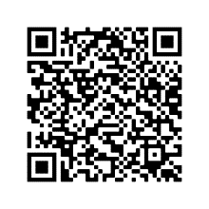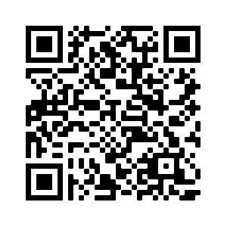

BUILDING KNOWLEDGE THROUGH LITERACY About Topics Across Content Areas
PRIORITY u | Regular Reading of Multiple Text and Media on a Range of Conceptually Related Topics
9-10 STANDARDS
W. 9-10.8
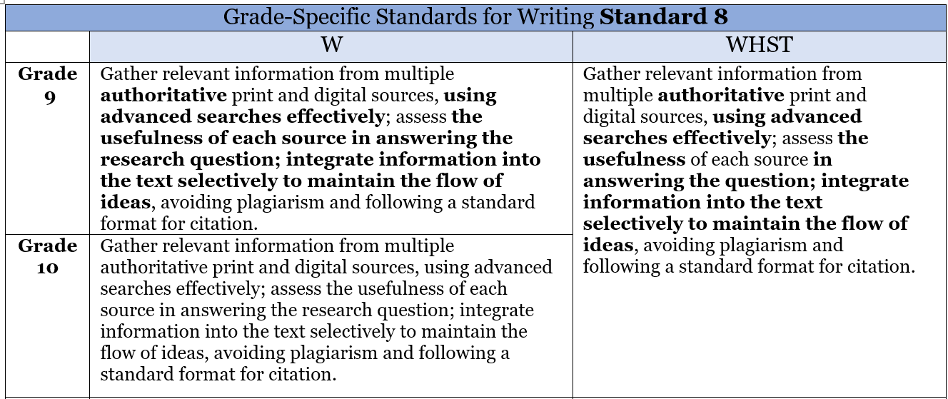
SL.1 Prepare for and participate effectively in a range of conversations and collaborations with diverse partners, building on others’ ideas and expressing their own clearly and persuasively. (See grade specific guidance for standards SL.1 a-d)
Additional Guidance for Grade 9-10 Writing Standards should be identified through the use of a high-quality, standards-aligned curriculum.
RECOMMENDED INSTRUCTIONAL PRACTICES
- Choose content-rich informational texts that are topically connected to the anchor texts or topic under study to build students’ knowledge about the topic and maximize their breadth of exposure to academic vocabulary.
- Offer students texts that span a range of complexity levels so they can read the texts independently, with peers, or with modest support. This should include a balance of literature and informational texts across content areas of ELA, science, history, the arts, and technical subjects.
  - Grade Band: 9-10
  - Literary: 30%
  - Informational: 70%
PRIORITY u | Regular Research, Discussion and Writing About Topics
9-10 STANDARDS
W 9-10.8

RI 9-10.9
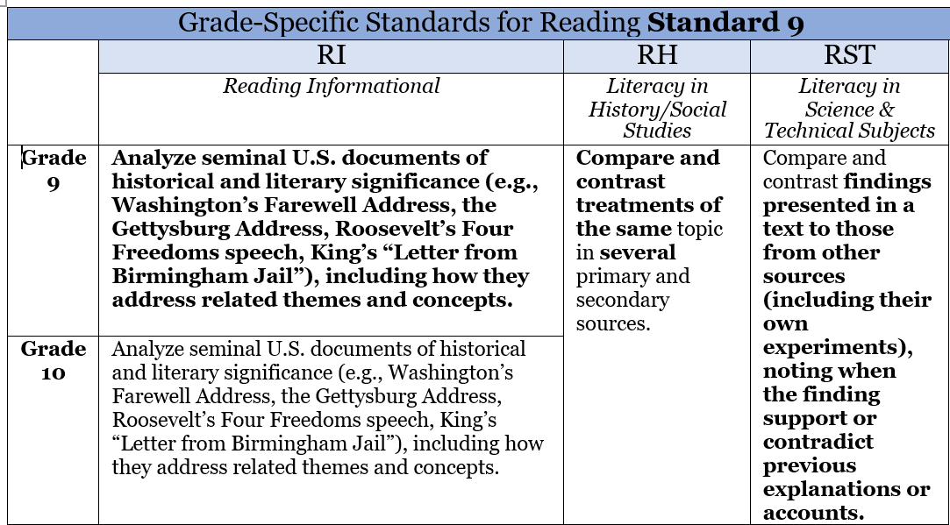

SL.1 Prepare for and participate effectively in a range of conversations and collaborations with diverse partners, building on others’ ideas and expressing their own clearly and persuasively. (See grade specific guidance for standards SL.1 a-d)
Additional Guidance for Grades 9-10 Reading and Language Standards should be identified through the use of a high-quality, standards-aligned curriculum.
RECOMMENDED INSTRUCTIONAL PRACTICES
- Ask students regularly to research, then express—orally and in writing—information gained from multiple texts and auxiliary resources (e.g., illustrations, video clips, maps) to build knowledge on a topic.
- Promote independent reading, by providing options for students to choose topically connected texts. (These can be driven by student interest, topic of anchor text, and course content.)
- Integrate what students have just read (and learned) with what they have previously read (and learned) to build a more coherent understanding of a topic. Design collaborative, small-group, or partner discussions on topics for students to process and extend their learning.
- Add lightweight student accountability for regularly engaging in a volume of reading both assigned (related to the topics and themes being studied) and chosen by students.
Resource:
3 Steps to Engage Students in Research Writing
PRIORITY u | Modify Instruction Based on Student Progress
RECOMMENDED INSTRUCTIONAL PRACTICES
- Administer brief screeners at the beginning of the year and at periodic checkpoints throughout the school year
- Ensure frequent opportunities to formatively assess:
  - Fluency with grade-level text
  - Students’ knowledge of the topics of the complex texts under study to determine how to bring students into the unit of study

Use Additional Standards to Support the Major Work of ELA/Literacy Instruction
PRIORITY u | Intentionally Include Supporting Standards
RECOMMENDED INSTRUCTIONAL PRACTICES
- Using high-quality, standards-aligned curriculum, plan instruction that intentionally includes supporting standards—represented by the more than two dozen remaining standards in each grade level—to engage students more fully in the Major Work of the Grade. The supporting standards can be incorporated into instruction in service of the major 14 standards. Promote independent reading, by providing options for students to choose topically connected texts. (These can be driven by student interest, topic of anchor text, and course content.)
- For instance, in close reading lessons, supporting standards can help generate an effective sequence of text-specific questions that target central ideas, text structure, author’s purpose, and the like, to guide students in exploring and extracting the key ideas of texts.
- Likewise, when devising writing assignments, the supporting standards can help guide the quality of explanations or arguments that students should be reaching for in one grade or another.

ELA/Literacy K-12 Instructional Planning Guides (IPG) References

Collaborative for Academic, Social, and Emotional Learning. (2017). Examples of Social and Emotional Learning in High School English Language Arts Instruction. Retrieved from https://www.casel.org/wp-content/uploads/2017/08/SEL-in-High-School-ELA-8-20-17.pdf

Council of the Great City Schools. (2020). Addressing unfinished learning after COVID-19 school closures . Washington, DC: Author. www.cgcs.org

Gough, P. and Tunmer, W. (1986). Decoding, reading, and reading disability. Remedial and Special Education, 7, 6–10.

Kilpatrick, D. A. (2015). Essentials of Assessing, Preventing, and Overcoming Reading Difficulties. Hoboken, New Jersey: John Wiley & Sons.

“Micro-Apartments Hope to Ease Living Costs for Young City Residents.” PBS LearningMedia, PBS NewsHour, 21 June 2020, Retrieved from mpb.pbslearningmedia.org/resource/6624c308-5a2c-4551-9f94-c8927a058be2/micro-apartments-hope-to-ease-living-costs-for-young-city-residents/.

Moats, L., & Tolman, C. A. (2019). LETRS 3rd Edition: Language essentials for teachers of reading and spelling. Boston, MA: Sopris West.

Nagy W., Herman P., & Anderson R. C. (1985). Learning words from context. Reading Research Quarterly, 20(2), 233–253.

Student Achievement Partners, 2020-21 Priority Instructional Content, https://www.achievethecore.org/2020-2021_PriorityInstructionalContent

Student Achievement Partners. (n.d.). Academic Word Finder. https://achievethecore.org/page/1027/academic-word-finder

Student Achievement Partners. (n.d.). Increasing Reading Fluency for Middle and High School Students. https://achievethecore.org/page/3254/increasing-reading-fluency-for-middle-and-high-school-students

Student Achievement Partners. (n.d.). Selecting and Using Academic Vocabulary in Instruction. Retrieved from https://achievethecore.org/content/upload/Selecting%20and%20Using%20Academic%20Vocabulary%20in%20Instruction.pdf

Student Achievement Partners. (n.d.). Supporting All Learners with Complex Texts. https://achievethecore.org/aligned/supporting-all-learners-with-complex-texts/

Student Achievement Partners. (n.d.). Text Complexity. https://achievethecore.org/category/1206/ela-literacyfoundational-skills

Student Achievement Partners. (n.d.). Text Dependent Questions. https://achievethecore.org/category/1158/elaliteracy-text-dependent-questions

Student Achievement Partners. (n.d.). 3 Steps to Engage Students in Research Writing. http://achievethecore.org/aligned/3-steps-engage-students-in-research-writing/
Wassermann, Selma. “Effective Classroom Discussions.” Effective Classroom Discussions - Educational Leadership, 2010, Retrieved from www.ascd.org/publications/educational-leadership/feb10/vol67/num05/Effective-Classroom-Discussions.aspx.

https://tntp.org/assets/documents/TNTP_The-Opportunity-Myth_Web.pdf
https://mdreducation.com/reports/classroom-trends-teachers-buyers-instructional-materials-users-technology/
https://www.rand.org/pubs/research_reports/RR1529-1.html
https://fordhaminstitute.org/national/research/supplemental-curriculum-bazaar
https://journals.sagepub.com/doi/pdf/10.3102/0013189X15603982
https://mdek12.org/ese/ccr
https://mdek12.org/secondaryeducation/englishlanguage
https://mdek12.org/secondaryeducation/englishlanguage
https://www.mdek12.org/sites/default/files/Offices/MDE/OA/OSA/Universal%20Screener%20and%20Diagnostic%20Assessment/screener-guidance-april-2018-04-18_20180419134804_279631.pdf
https://www.casel.org/wp-content/uploads/2017/08/SEL-in-High-School-ELA-8-20-17.pdf

