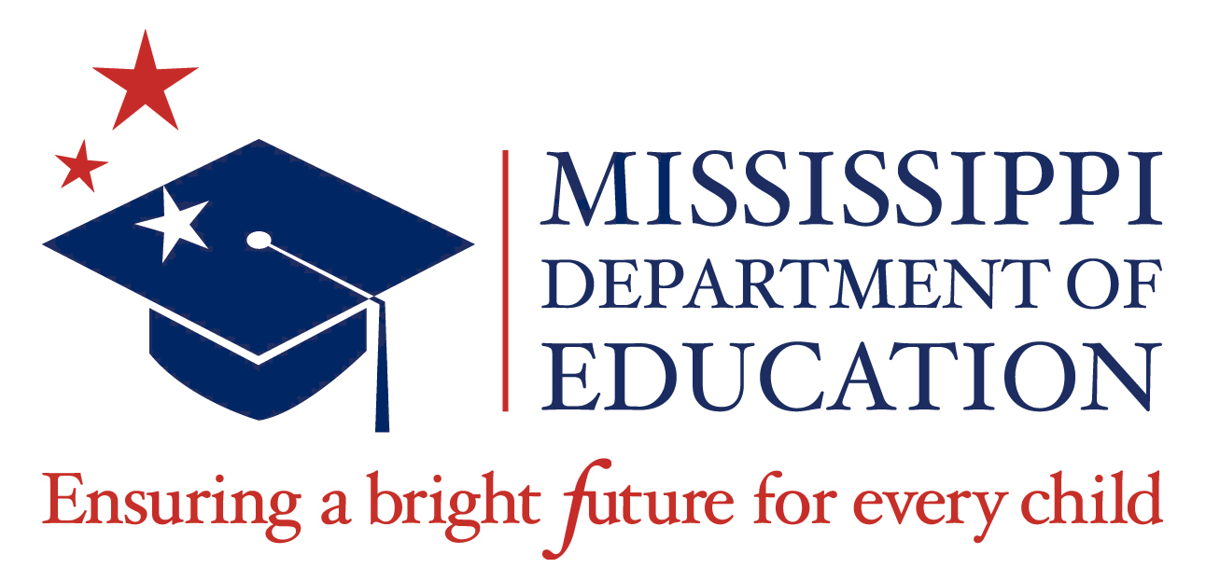

FY21 McKinney-Vento Homeless RFP Webinar FAQs

- Is the PowerPoint available already?
Yes. The McKinney-Vento Homeless RFP presentation is posted in MCAPS, MDE Document Library, Homeless Education->FY21->Homeless FY21 RFP Webinar Presentation or click here for a copy of the presentation.

- Is there a required number of homeless students to receive funding?
No. There is no required number of homeless students to receive funding.

- Are children living in foster care and group homes considered homeless for the purpose of providing educational services using McKinley-Veto grant funds?
Unfortunately, children living in foster care and group homes are not considered homeless according to most recent guidance.

- I am interested in the FY21 McKinney-Vento Homeless RFP. Where can I find more information?
The FY21 McKinney-Vento Homeless RFP is available on the MDE’s website at https://www.mdek12.org/PN/RFP under Grants, RFP-McKinney Vento Education for Homeless Children and Youth Program. The FY21 McKinney-Vento Homeless RFP webinar is also available for viewing at https://attendee.gotowebinar.com/recording/135275521673856770

