Mississippi Department of Education
Office of Special Education

INDIVIDUALIZED
EDUCATION
PROGRAM (IEP)
DEVELOPMENT
GUIDANCE
Creating a Program to Benefit
Children with Disabilities

Table of Contents

Chapter 1: Overview of the Individualized Education Program (IEP) 1
Project Forum’s Seven-Step Process to Creating a Standards-Based IEP 1
IEP Implementation Requirements 2
IEP Committee 3
Signature Page For IEP 4
Chapter 2: Seven Steps to Creating a Standards-Based IEP 12
Steps 1-3: Present Levels of Academic Achievement and Functional Performance (PLAAFP) 12
Step 1: Consider Grade-Level Standards 13
Step 2: Examination of Classroom and Student Data 14
Step 3: Develop the PLAAFP Using the Information Gathered 15
Important PLAAFP Considerations 15
Tips for PLAAFP Writing 15
Guiding Questions for PLAAFP Student’s Strengths, Preferences, and Interests 16
Guiding Questions for PLAAFP Impact of Disability and Student Needs 18
Prioritizing the Areas of Concern Included in the PLAAFP 19
Annual Goal Baseline Data 20
Steps to Determining the Baseline 21
Area of Annual Goal 22
Step 4: Developing Measurable Annual Goals and Short-Term Instructional Objectives and Benchmarks (STIO/Bs) 23
Develop Measurable Annual Goals Aligned with Grade-level Academic Content Standards 24
Writing Measurable Goals and Objectives 26
Examples of Measurable Annual Goals 27
Write STIO/Bs 28
Academic Measurable Annual Goals and STIO/Bs 29
Functional Measurable Annual Goals and STIO/Bs 30
Step 5: Assessing and Reporting Student Progress 33
Determine Current Level of Performance (CLP) and Sufficient vs. Insufficient Progress 35
Special Considerations 38
Special Considerations for Communication 38
Special Considerations for Assistive Technology 39
Special Considerations Services for Students Who Are Blind or Visually Impaired 40
Special Considerations Services for Students Who Are Deaf or Hearing Impaired 41
Special Considerations for Behavior Intervention 42
Special Considerations Services for Students with Limited English Proficiency 43
Step 6: Identifying Specially Designed Instruction 44
Related Services 45
Instructional/Functional Accommodations 46
Program Modifications 47
Supports for Personnel 47
Step 7: Determining Appropriate Participation in Statewide Assessments 50
Disability Preclusion for the English Language Proficiency Test (ELPT) 52
Statewide Testing Accommodations 60
Setting Accommodations 60
Timing/Scheduling Accommodations 61
Presentation Accommodations 61
Response Accommodations 61
Chapter 3: Additional Planning for Students with Disabilities 64
Individual Transition Plan 64
Postsecondary Goals 64
Secondary Transition Services 67
Placement Considerations and Least Restrictive Environment (LRE) Determination 76
Placement Considerations for ESY 81
Chapter 4: Itinerant Services 86
Early Childhood Special Education Services 86
Regular Early Childhood Program Services 87
Preschool Itinerant Services 87
ECSE IEP’s IDEA Requirements 88
ECSE IEP Goals 89
Appendix A: Guided Questions for Areas of Academic Achievement and Functional Performance 90
HEALTH, VISION, HEARING, AND MOTOR ABILITIES 91
COMMUNICATION STATUS 92
ACADEMIC PERFORMANCE 93
SOCIAL, EMOTIONAL, AND BEHAVIORAL STATUS 96
SECONDARY TRANSITION NEEDS 97
FUNCTIONAL VISION AND LEARNING MEDIA ASSESSMENT 99
Appendix B: Indicator 13 Checklist 100
Indicator 13 Checklist 101
Instructions for Completing the Indicator 13 Checklist 102

Chapter 1: Overview of the Individualized Education Program (IEP)
The Individuals with Disabilities Education Act (IDEA) and State Board Policy Chapter 74, Rule 74.19 have established the Individualized Education Program (IEP) as the structure for planning and implementing goals and objectives for students with disabilities. It is a collaboratively written plan created by a parent, the student with a disability (if appropriate), district personnel, and other IEP Committee members to describe the unique needs of the student and to develop a program that meets those needs. The IEP is a legally binding document that describes specially designed instruction, related services, and accommodations and modifications needed to provide students with disabilities a Free Appropriate Public Education (FAPE).

The IEP must be designed to:
- Indicate what the student is expected to be able to achieve within one (1) year
- Provide high expectations and the educational benefit for students with disabilities
- Ensure access to the general education curriculum and standards in the general classroom to the maximum extent possible
- Provide effective transition services to promote successful postsecondary experiences, including college and career, to prepare students with disabilities to lead productive and independent adult lives

Project Forum’s Seven-Step Process to Creating a Standards-Based IEP
The Mississippi Department of Education (MDE) recommends a Standards-Based IEP process based on Project Forum’s Seven-Step Process to Creating a Standards-Based IEP.
Step 1: Consider the grade-level content standards for the grade in which the student is enrolled or would be enrolled based on age.
Step 2: Examine classroom and student data to determine where the student is functioning in relation to the grade-level standards.
Step 3: Develop the present level of academic achievement and functional performance.
Step 4: Develop measurable annual goals aligned with grade-level academic content standards.
Step 5: Assess and report the student’s progress throughout the year.
Step 6: Identify specially designed instruction, including accommodations and/or modifications, needed to access and progress in the general education curriculum.
Step 7: Determine the most appropriate assessment option.

IEP Implementation Requirements
To provide FAPE to all students with disabilities, public agencies are required to have an IEP in effect for each student ages three (3) through twenty (20) years with a disability:
- Immediately upon the development of the IEP for the initial provision of services
- Immediately upon the adoption of an IEP for a student who transfers into the school
- At the beginning of each school year
- By the student’s third birthday for his or her transitioning from Part C (First Steps) services

See State Board Policy Chapter 74, Rule 74.19 for regulatory IEP requirements. See “Procedures for State Board Policy 74.19 Volume II: Free Appropriate Public Education, Individualized Education Program, Least Restrictive Environment, and Extended School Year Services” for guidance in the development of an IEP, determining IEP Committee members, and conducting IEP meetings.

IEP Section: Heading Section (appears on every page of the IEP form)
- School Year: Record the school year for which you are writing the IEP.
- Public Agency/School District: Record the public agency or school district responsible for completing the IEP.
- Student’s Name: Record the student’s legal name: first, middle, and last. Do not use nicknames.
- MSIS Number: Record the student’s Mississippi Student Information System Identification (MSIS) number.

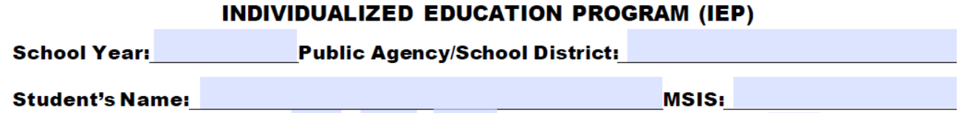
1
2
3
4

IEP Section: Timeline Information, Demographic Data, and Parent Information
- IEP Committee Meeting Date: Record the date of the initial or annual IEP meeting. This is the annual date and should only be changed when an annual review has been conducted.
- Projected Annual Review Date: Record the projected date of the annual review. This is no more than one year from the IEP Committee meeting date.
- IEP Implementation Date: Record the date on which the IEP services will begin.
- Projected End Date: Record the date on which the IEP services will end.
- Date of Birth: Record the student’s date of birth.
- Age: Record the student’s current age.
- Primary Eligibility Category: Record the student’s primary eligibility category.
- Gender: Record the student’s gender.
- Ethnicity: Record the student’s ethnicity as identified by the student’s family and district policy.
- Secondary Eligibility Category: Record the student’s secondary eligibility category.
- Grade: Record the student’s current grade.
- School: Record the name of the school the student currently attends.
- Current Eligibility Date: Record the date of the student’s most recent eligibility determination.
- Projected Re-evaluation Date: Record the projected date of the next evaluation. This date must be no more than three years from the date of the last evaluation or, for a student who is Developmentally Delayed (DD), before the student’s 10th birthday.
- Parent/Guardian Name(s): Record the legal name (first and last) of the parent/guardian(s). Do not use nicknames. NOTE: Space is provided to record two names.
- Address: Record the parent’s current address (or the student’s current residence).
- Phone Number: Record the parent’s current phone number.
- Email: Record the parent’s current email address.
6
5
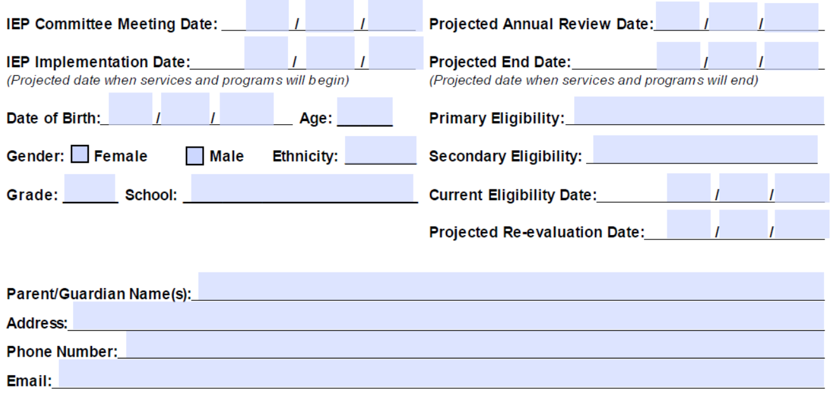
12
20
21
10
15
16
9
13
17
14
11
18
8
7
19
22

IEP Committee
The IEP Committee is a team of individuals who work collaboratively to develop, review, or revise the educational program to meet the needs of a student with a disability in his or her Least Restrictive Environment (LRE). The IEP Committee must include the parent, the student (whenever appropriate), at least one general educator of the student, at least one special educator or service provider of the student, and a representative of the public agency. At the discretion of the parent and/or the public agency, other individuals with knowledge or special expertise regarding the student may serve as IEP Committee members. Representatives of other public or private agencies may be invited to participate on the IEP Committee as appropriate. At least one member of the IEP Committee must be able to interpret the instructional implications of evaluation results. This person may be a member of the student’s Multidisciplinary Evaluation Team (MET) or one of the other members of the IEP Committee.

NOTE: For preschool-age students, the general education teacher must be an individual qualified to teach students of that age in a regular education program, including Head Start, public or private preschool classes, public or private kindergarten, pre-K in the public school, and child development/childcare centers.

Signature Page For IEP
(NOTE: The IEP signature page is located at the back of the IEP.)

All signatures for the parent/guardian are on the signature page of the IEP. Present the page at the beginning of the meeting, and signatures should be obtained with the date as each section is discussed. Signatures are not needed for areas considered not applicable, so “NA” may be written, or the space may be left blank.

When revisions are made to the IEP, attendance must be documented on the revision page. However, if the changes are in the areas of exit options or transfer of rights, parent and/or student’s signatures must also be on the signature page.

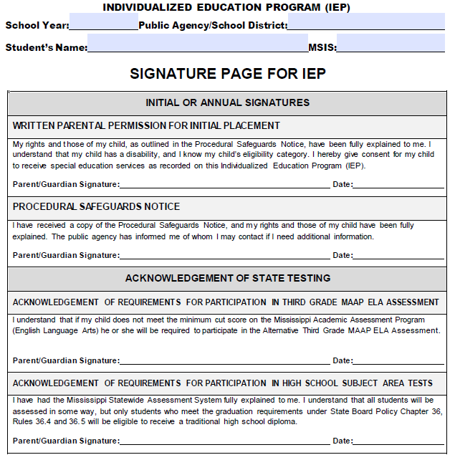

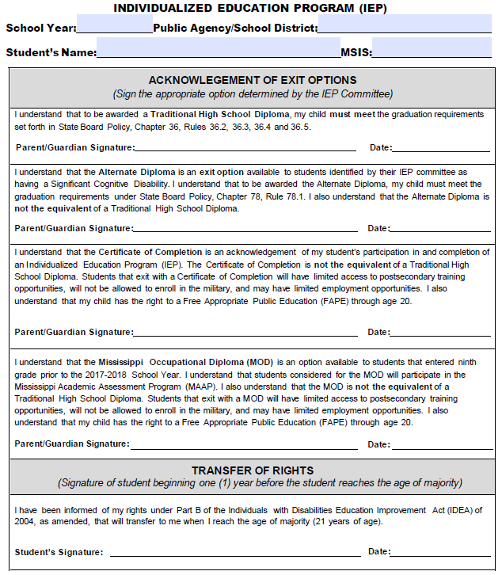

IEP Section: IEP Committee Participants for the Initial/Annual Meeting
The IEP Committee Participants section on the first page is completed during an initial IEP meeting or an annual review.

In considering who to include on the IEP Committee, ask:
- Is the student in the general education setting?
- Does the student have any special concerns that require experts?
- Is there another agency or facility that should be represented?

- Purpose of the IEP Meeting: Select either “Initial” or “Annual” IEP meeting. Please note that if this meeting is the student’s initial IEP meeting, the parent must sign the “Written Parental Permission for Initial Placement” before implementing the IEP. This signature section is located at the end of the document on the IEP signature page.
- Names and Positions of IEP Committee Members: Record the names and positions of participants attending the IEP meeting. Signatures are not required. The agency representative, general educator, special educator, parent(s), and student (if appropriate) are all required members of the IEP Committee.
- Names and Positions of Excused IEP Committee Members: Record the name and position of any IEP Committee member who has been excused from the IEP meeting, in whole or in part. Attach the following required written documentation: (a) a written agreement signed by the parent and/or adult student and the school district excusing the IEP Committee member from attending the meeting (see the Procedures for State Board Policy 74.19 Volume II: Appendix IEP.B: Excusal of IEP Committee Member) and (b) if applicable, any written input provided by the excused IEP Committee member prior to the meeting. Written input must include substantive data (e.g., based on assessment, providing meaningful guidance to the team, regarding the purpose of the meeting, reflecting on general education curriculum, etc.).
- IEP meeting was conducted via alternate means of technology: Select any alternate means of technology used by IEP Committee members, including the parent, to participate in the meeting or N/A for not applicable.
- IEP meeting was recorded: Check yes or no to document whether or not the meeting was recorded.
- Evaluations: Check or list any future evaluations or assessments needed to determine special education or related services needs of the student.

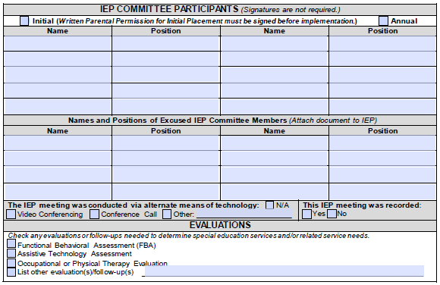
6
4
5
3
2
1
Procedural Safeguards Notice: This signature section is located at the end of the document on the IEP signature page. Provide the parent a copy of the Procedural Safeguards Notice and fully explain the parent’s and student’s rights. Have the parent sign and date the statement indicating receipt of the Procedural Safeguards Notice. Parents should be provided a copy of the Procedural Safeguards at least once a year or as required.

Written Parental Permission for Initial Placement: (This signature section is located at the end of the document on the IEP Signature Page.)
The parent/guardian must provide written consent for special education services for the student before any initial services may be provided. The other members of the IEP Committee should assist the parent in understanding their student’s rights under the IDEA as well as his or her disability status and category for eligibility. The IEP Committee, of which the parent is a member, must develop the student’s IEP collaboratively. In addition, the other members of the IEP Committee should assist the parent in understanding the services, supports, and other provisions in the IEP before obtaining permission for initial placement. If this is the student’s initial IEP, have the parent sign and date the statement indicating consent for the initial provision of special education services. A signature is required. This section may be left blank for all future IEPs.

NOTE: A copy of the Procedural Safeguards Notice must be provided only one time each school year, with the following exceptions:
- Upon initial referral or a request for an evaluation or re-evaluation
- Upon receipt of the first MDE state complaint in a school year
- Upon receipt of the first request for a due process hearing in a school year
- In accordance with the discipline procedures when a change in placement occurs
- Upon the student’s initial IEP Committee meeting
- Upon the parent’s request to receive a copy

IEP Section: Additional IEP Meetings to Review, Revise, or Amend the IEP
- IEP Action: Select the purpose of the IEP meeting. Indicate “Review” when no significant changes are made to the IEP. Indicate “Revise” to make significant changes to the IEP, which requires an IEP meeting. Indicate “Amend” to make more limited changes (i.e., additions, deletions, and modifications) that do not require an IEP Committee meeting by agreement of the parent and school district.
- Date: Record the date of the IEP meeting or the date the IEP was revised or amended.
- Names and Positions of IEP Committee Members: Record the names and positions of IEP Committee participants who attended the IEP meeting, participated in the review or revision, or were informed of the amendments to the IEP. Signatures are not required.
- Names and Positions of Excused IEP Committee Members: Record the names and positions of any IEP Committee members excused from the IEP meeting, in whole or in part, if a meeting was conducted. Attach any written documentation required: (a) a written agreement signed by the parent and/or adult student and the district excusing the IEP Committee member from attending the meeting (see the Procedures Appendix IEP.B: Excusal for Required IEP Members) and, if applicable, (b) any written input provided by the excused IEP Committee member prior to the meeting. Written input must include substantive data (e.g., based on assessment, providing meaningful guidance to the team, regarding the purpose of the meeting, reflecting on general education curriculum, etc.).
- IEP meeting was conducted via alternate means of technology: Select any alternate means used by any IEP Committee members, including the parent, to participate in the meeting or N/A for not applicable.
- IEP meeting was recorded: Check “yes or no” if the meeting was recorded.
- Evaluations: Check or list any evaluations or assessments needed to determine special education or related services needs of the student. This does not satisfy the need for obtaining informed consent.
- Procedural Safeguards Notice: If a meeting is held, have the parent check the box of one of the statements: (a) the statement of receipt of the Procedural Safeguards Notice or (b) the statement indicating the wish not to receive another copy of the Procedural Safeguards Notice. Then, have the parent sign and date this page below the selected statement.
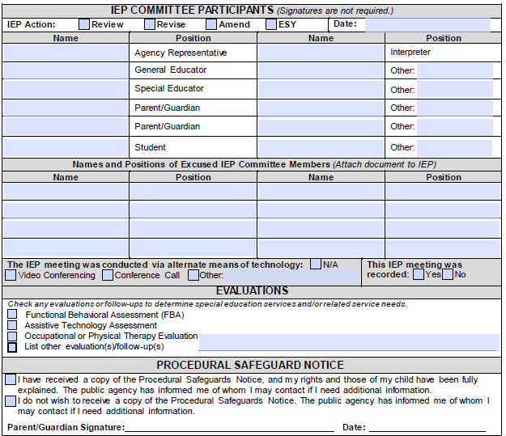
1
5
7
8
6
4
3
2

IEP Section: Summary of Revision
- Write a summary of any revisions, including additions, deletions, and modifications, made to the IEP form. Any change to the IEP summarized on this page must be included in the body of the IEP in its appropriate space.
- Check the box at the bottom after verifying these changes were made in the appropriate location on the IEP form.

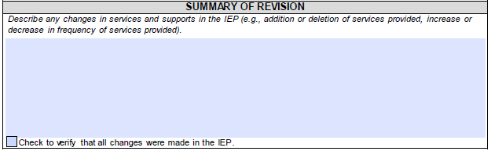
10
9

Chapter 2: Seven Steps to Creating a Standards-Based IEP
The National Association of State Directors of Special Education’s (NASDSE) Project Forum defined Standards-Based IEPs as a process and a document that is framed by the state standards and that contains goals aligned with, and chosen to facilitate, the student’s achievement of state grade-level academic standards. The Standards-Based IEP process is used to develop an educational program that links annual goals and instruction to the state general or modified standards. A Standards-Based IEP document is created to support the curriculum; it is NOT the curriculum. The annual goals resulting from this process do not restate the grade-level academic standards but rather address the knowledge and skills the student must learn to demonstrate mastery of the standards. The goal of a Standards-Based IEP is to develop an IEP that, when implemented, provides students access to the general curriculum and enables them to demonstrate academic achievement linked to grade-level content. This process is rooted in the IDEA, which emphasizes access to the general education curriculum for students with disabilities.

Steps 1-3: Present Levels of Academic Achievement and Functional Performance (PLAAFP)
IDEA and State Board Policy Chapter 74, Rule 74.19 require the IEP to have a statement of the student’s present levels of academic achievement and functional performance (PLAAFP). The PLAAFP must include how the student’s disability affects the student’s involvement and progress in the general education curriculum, or, for preschool-age students, how the disability affects the student’s participation in developmentally appropriate activities.

The U.S. Department of Education defines academic achievement and functional performance as follows:
- Academic achievement is marked by the academic subjects a student studies in school and the skills the student is expected to master in each subject area.
- Functional performance is defined as skills or activities that are not considered academic or related to the student’s academic achievement but are generally considered routine everyday activities. This includes, but is not limited to:
- Daily living skills (e.g., dressing, eating, going to the bathroom, etc.)
- Social skills (e.g., making friends, communicating with others, etc.)
- Behavior skills (e.g., knowing how to behave in various settings, etc.)
- Mobility skills (e.g., walking, navigating the community, etc.)

The PLAAFP is a clear description of (a) the student’s academic achievement and functional performance strengths, preferences, and interests; (b) how the student’s disability impacts the student’s involvement in the general education curriculum (or developmentally appropriate activities) and identification of areas of concern; (c) a summary of input from parents and the student; and (d) a synthesis of a variety of assessment data, including the student’s instructional levels in identified areas of concern and the student’s status on the prior IEP goals (if applicable). This information forms the foundation for all subsequent decisions for the IEP (e.g., setting annual goals, selecting appropriate accommodations, determining the type and frequency of special education and related services, etc.).

To start the process, begin with the end in mind and ask:
- What does the student expect to be doing or what do you expect the student to be doing in the next five (5) years? ten (10) years? fifteen (15) years?
- What skills and behaviors does the student need to move toward his or her vision?

Answering these questions first should help guide the Standards-Based IEP development process such that the IEP, when implemented, will ensure that the student can access and progress in the general education curriculum (or developmentally appropriate activities) in a manner that will allow the student to achieve his or her appropriate desired postsecondary outcome(s).

Step 1: Consider Grade-Level Standards
To write a student’s PLAAFP for a standards-based IEP, the first step is to consider the grade-level content standards for the grade in which the student is enrolled or would be enrolled for his or her age. The content standards describe the specific knowledge and skills students should attain (i.e., the what of what students should know and be able to do). These standards indicate the ways of thinking, working, communicating, reasoning, and investigating the important and enduring ideas, concepts, issues, dilemmas, and knowledge essential to a discipline.

In considering the grade-level standard, ask:
- What is the intent of the content standard?
- What does the content standard say the student must know and be able to do?

Step 2: Examination of Classroom and Student Data
The second step in developing a standards-based IEP is to examine classroom and student data to determine how the student is functioning in relation to grade-level standards and school/classroom expectations. Gather all of the necessary information and data about the classroom and student using a variety of data collection sources. NOTE: Multiple sources of data must be used to make decisions for students with disabilities.
Sample Data Sources
Formal and informal observations Curriculum-based assessments
Universal screeners Functional behavior assessment
Work samples Behavior intervention plan
Classwork State- and districtwide assessments
Criterion-referenced tests Transition assessments
Progress monitoring Interviews
Interventions Student and parent surveys

In considering the classroom and student data, ask:
- In what ways does the student’s academic performance differ from grade-level standards?
- In what ways does the student’s behavior differ from school/classroom expectations?
- In what ways does the students functional skills differ from school/classroom expectations?
- How has the student responded to evidence-based instruction and interventions designed to improve academic achievement and functional performance?

Step 3: Develop the PLAAFP Using the Information Gathered
Develop the present levels of academic achievement and functional performance using the information gathered in Steps 1 and 2. The PLAAFP includes data about the student’s strengths, preferences, interests, deficits, and disabilities as well as other parent input.

Important PLAAFP Considerations
- The PLAAFP contains educationally valuable information and is written in an easily understood manner.
- Multiple data sources are vital. One data source alone, such as a Standardized Test for the Assessment of Reading (STAR) report, may not give a clear picture of a student’s strengths and needs.
- Areas of need are those in which the student’s skills are not commensurate with those of typically developing peers.
- For areas of need, the PLAAFP must include relative strengths, needs or concerns, and baseline for each need.
- Baseline data provides a framework for true data-based progress monitoring and is related to expectations in the general education setting (norms are included).
- The PLAAFP contains information about the student’s ability to achieve grade-level proficiency.
- Any teacher would know where to begin instruction based on the information provided in the PLAAFP and the remainder of IEP.

Tips for PLAAFP Writing
- Use objective, measurable terms.
- Use current, relevant data that can be understood by teachers, parents, and students.
- When using scores, they should be self-explanatory. If not, be sure to include an explanation.

IEP Section: PLAAFP Student’s Strengths, Preferences, and Interests
- Student’s Strengths, Preferences, and Interests: Write a clear description of the student’s academic and functional strengths, areas of interest to inform differentiated instruction and/or behavioral intervention strategies, and preferences toward postsecondary outcomes.
  - Strengths are general things the student is good at doing.
  - Interests are things, events, or people that evoke the student’s curiosity. For preschool-age children, this may include interests associated with their daily activities.
  - Preferences are things, events, or people that the student chooses above others. These are not limited to the needs of the student in the school setting. For preschool-age children, this may include their choice of participation in centers or activities in the home.
The information recorded should relate to accessing and mastering the grade-level standards (or developmentally appropriate activities). Include specific feedback from the student and/or family. Also, identify significant personal attributes, personal accomplishments, and skills or behaviors the student has mastered as indicated by formal or informal assessments. Include the sources of data cited to describe the impact of the student’s disability and areas of need (e.g., interviews, formal assessments, informal assessments, etc.).

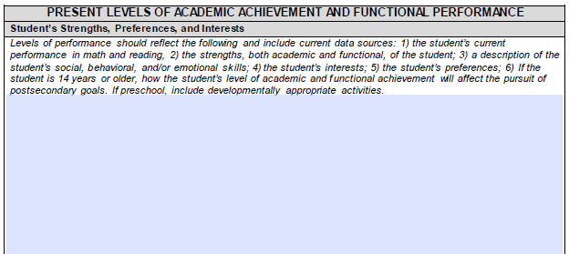

Guiding Questions for PLAAFP Student’s Strengths, Preferences, and Interests
- What is the student’s current performance in math and reading?
- What are the student’s strengths, both academic and functional?
- What are the student’s social, behavior, and/or emotional strengths and weaknesses?
- What are the student’s interests?
- What are the student’s preferences (e.g., being a small group auditory learner, reading with a peer, using a larger pencil, standing when completing a written assignment, etc.)?
- If in preschool, what are the student’s developmentally appropriate activities?
- If the student is age 14 or older, what are the student’s postsecondary expectations?

In considering the student’s strengths, preferences, and interests, ask:
- In what ways does the student meet or exceed expectations in academic, nonacademic, or extracurricular areas?
- What grade-level standards have the student mastered?
- In what activities or hobbies does the student consistently show an interest?
- In what subject areas or topics does the student consistently show an interest?
- In what careers has the student expressed an interest?
- What significant personal attributes does the student have that contribute positively to the student’s learning (e.g., persistence, curiosity, creativity, etc.)?
- What academic or functional knowledge or skills, including those listed on previous IEP goals, has the student mastered?

IEP Section: PLAAFP Impact of Disability and Student Needs
- Impact of Disability and Student Needs: Write a clear description of the impact of the student’s disability on the student’s involvement in and progress in the general education curriculum, movement toward participation in the general education curriculum or other developmentally appropriate activities. Include the impact on the student’s current level of achievement in reading and math, as well as the functional implications of the student’s skills. If the student is age 14 or older, describe the effect of the student’s disability on his or her pursuit of postsecondary expectations (e.g., education/training, employment, daily living, etc.). Clearly identify areas of concern to be addressed if the student is to meet state standards and expectations, including alternate standards. Current data and data sources should be cited to describe the impact of the student’s disability and areas of need (e.g., interviews, formal assessments, informal assessments, etc.).

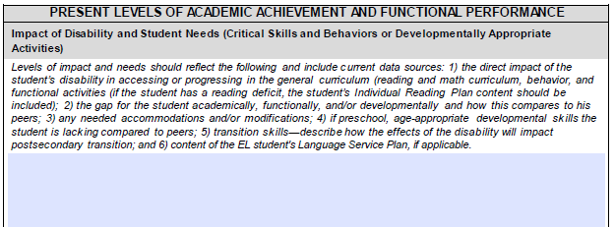

In considering the impact of the student’s disability, ask:
- What characteristics of the disability affect the student? Specifically, how does the student’s disability affect:
- academic performance,
- functional performance,
- behavioral functioning, and/or
- participation in developmentally appropriate activities?
  - What are the critical skills and behaviors required for the student to participate and make progress in the general curriculum, move towards participation in the general curriculum or other developmentally appropriate activities?
- What programs, classroom or testing accommodations, and/or interventions have been successful with the student?
- What support does the student need to gain the knowledge and attain the skills to progress in the general curriculum?

Guiding Questions for PLAAFP Impact of Disability and Student Needs
Levels of impact and needs should reflect the following and include current data sources:
- What is the direct impact of the student’s disability in access/progression in the general curriculum (e.g., reading and math curriculum, behavior, and functional activities) and how does this compare to peers? If the student has a reading deficit, the contents of his or her Individual Reading Plan (IRP) should be included here. (See below for further instruction)
- Where and what is the gap for the student academically, functionally, and/or developmentally?
- How does the student learn differently than his peers, which identifies the need for accommodations and/or modifications?
- If in preschool, what are the age-appropriate developmental skills, compared to peers, which the student is lacking?
- For transition skills, how will the effects of the disability impact the transition to postsecondary?

Individual Reading Plan (IRP) for Students with Reading Deficits
An IRP is not required if the student currently has an IEP with reading goals. However, if a student’s IEP does not currently address reading difficulties and the student later develops a deficit in reading, then the IEP Committee must determine whether goals need to be added to the IEP or if an IRP is most appropriate. If a student’s IEP only addresses math goals and the student later begins to struggle in reading, then an IRP must be written additionally for K-4 students.

Ultimately, the individual needs of the student should dictate the goals and the supports provided. The general education teacher and the special education teacher should work collaboratively to develop and implement the IEP and continue to progress monitor as indicated in the IEP.

IEP Section: PLAAFP Parent/Student Input
- Parent/Student Input: Write a summary of the concerns of the parent/student, including their ideas for supporting and/or enriching the education of the student that will be addressed in the IEP. Also, record the ways in which the parent reports the family will assist the student at home.

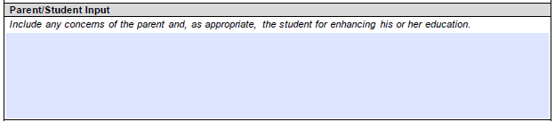

In considering the input of the parent/student, ask:
- What academic (e.g., reading, math, etc.) concerns do the parents have about their student’s education?
- What concerns do the parents have about their student’s life skills, social skills, emotional development, and/or behavior?
- What concerns do the parents have about their student’s future life after school?
- What strategies do the parents use at home to help their student learn?

Prioritizing the Areas of Concern Included in the PLAAFP
To complete the PLAAFP, you must first review all of the identified areas of concern.

- For students ages 3-5: The identified areas of concern must relate to one or more early childhood outcomes [Indicator 7]:
- Positive social-emotional skills and social relationships
- Acquisition and use of knowledge and skills, including early communication and early literacy/numeracy
- Use of appropriate behavior to meet needs including use of motor and adaptive skills for increasing independence in the world.

- For students ages 6-20: The identified areas of concern must relate to one of the following for the student:
- Academic achievement in reading or math
- The student’s functional performance in communication, social skills, emotional development, behavior, gross/fine motor abilities, career and technical education or employment skills, adaptive/daily living skills, or other areas specific to the student

While most students will have a few areas of concern, some students can have a multitude of deficits in many areas. In this situation, the IEP Committee will need to prioritize the areas of concern that are most significantly impacting the student’s ability to access and/or progress in the general curriculum (or developmentally appropriate activities), and that can reasonably be addressed within one year.

Annual Goal Baseline Data
(NOTE: A separate Baseline and Annual Goal Data page will be created for areas of critical need and prioritized areas of concern.)

For each area of concern, review the data examined in Step 2: Examination of Classroom and Student Data, including the results of the initial or most recent evaluation and the results of any interventions, progress monitoring, and gap analyses, as well as information about the student’s ability to generalize his or her learning, as they relate to this specific area of concern. This information will be used to develop the baseline of performance (i.e., the student’s current starting point).

The baseline should include:
- A data source
- A clear description of the observable “target” skill or behavior
- The condition under which the target skill can be observed
- The current rate of performance based on baseline data

Sample Data Sources
Formal and informal observations Curriculum-based assessments
Universal screeners Functional behavior assessment
Work samples Behavior intervention plan
Classwork State- and districtwide assessments
Criterion-referenced tests Transition assessments
Progress monitoring Previous year’s IEP goals
Interventions
Examples include:

- Given a second grade-level curriculum-based assessment, Jami can read aloud 50 words per minute with 75% accuracy. (RF2.4)
- Based on STAR assessments, when given 10 two-step word problems, Ashley is able to set up an equation to solve the problem using letters for unknown quantities with 30% accuracy. (4.OA.8)
- Sam remained in his seat with hands and feet to himself for 10 minutes, as documented on a behavior collection sheet, over three consecutive observations by school staff.

When summarizing the student’s performance, ask:
- What data do you have that describes the student’s performance in this area?
- What patterns can you identify in the data?
- What conditions are required for the student to perform the behavior?
- What is the student’s current rate of performance?
See “Appendix A: Guided Question for Areas of Academic Achievement and Functional Performance” for additional questions for the PLAAFP.

Steps to Determining the Baseline
- Identify all areas of need using several data sources such as STAR; interviews with parents, students, and general educators; and work samples.
- Determine areas of critical need (i.e., prioritized areas of need that can be reasonably addressed during the school year). These areas will become annual goals.
- Once these areas are identified, determine the baseline directly related to the annual goal.
- The baseline provides the starting point for progress monitoring.

IEP Section: Annual Goal Baseline Data
- Baseline Statement: The baseline statement should include a data source, an observable skill (e.g., behavior, etc.), condition (e.g., materials provided, setting, level of support, etc.) and criteria (e.g., how well the student currently performs the skill, etc.).
- Baseline data is the most specific information included in the PLAAFP. Baseline data is typically collected for needs that are considered the most significant. This data provides the starting point for measurable goals to be written for the student. Examples of baseline data would include words read correctly, percent of problems solved correctly, the number of times a behavior occurs, and the mean length of utterances.
- For information to be considered baseline data, it must meet four criteria:
  - Specific—It must be clear what is being measured.
  - Objective—You and a colleague should both be able to score/rate/measure it and come up with the same information.
  - Measurable—Something that can be measured and be able to show small increments of growth, not broad concepts.
  - Able to be given frequently—You need to be able to collect the information in the same way (at least as often as you send out progress reports) and able to show progress over those short periods of time.
- Anything that is specific, measurable, objective, and able to be given frequently to show growth can be used as baseline data. This is important when deciding whether something can be used as baseline data. Academic baseline data should relate to the skills found in the Mississippi College and Career Ready Standards (MS CCRS) or Mississippi Alternate Academic Achievement Standards (MS AAAS) for students with significant cognitive disabilities (SCD). If you are having difficulty identifying measures that are specific, measurable, and able to be given frequently, you may need to look at broad concepts or combinations of skills more narrowly. For example, reading is a broad concept that is made up of many skills. For baseline data for a measurable goal, a specific sub-skill such as phonics, fluency, or comprehension should be identified and measured.
- It is helpful if teachers try to use natural data collection methods for baseline data. There is no requirement that data be collected using a formal test. Try to use a method of data collection that accurately measures the skill being taught, but which does not require a significant time commitment. Consider how frequent progress monitoring of the student will be completed and use the same measurement for the baseline.

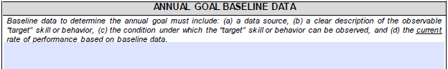

Area of Annual Goal
The IEP Committee should use the annual baseline data to identify the area to be addressed in the annual measurable goal.

IEP Section: Area of Annual Goal
Identify the specific area of concern that will be addressed on this individual page:
- Ages 3-5: Select from the social-emotional skills and relationships, knowledge and skills, or appropriate behavior to meet needs performance summary areas.

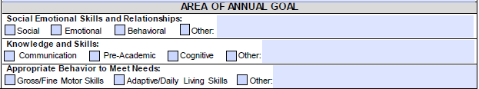

- Ages 6-20: Select from either the academic or functional performance summary area.

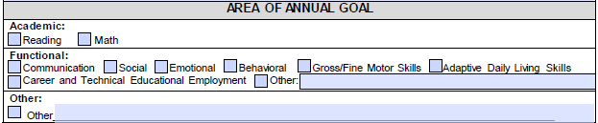

When prioritizing the student’s areas of concern, ask:
- How big is the gap between the student’s current skill level and grade-level expectations (or developmental expectations)?
- Are the needs related to “life-long” skills (e.g., communicating needs, self-care, reading, managing money, etc.)?
- Of all the critical needs identified, what are the most significant needs the student has in each subject area related to the grade-level standards?
- Of the critical needs identified, what are the most significant needs the student has in each functional skill area related to the behavioral standards?
- Will addressing these needs make a significant difference for the student in the coming year?

Step 4: Developing Measurable Annual Goals and Short-Term Instructional Objectives and Benchmarks (STIO/Bs)
Measurable annual goals are expectations of behaviors and skills the student must develop to be involved in and progress in the general education curriculum (or developmentally appropriate activities) and grade-level content, as appropriate. The measurable annual goals must be meaningful, understandable, and able to be accomplished within one year.

Academic and functional annual goals are connected to the PLAAFP, which describes the student’s strengths, is related to the specific areas of concerns that are impacted by the student’s disability, and uses the baseline performance as the starting point for the measurable annual goal.

Develop Measurable Annual Goals Aligned with Grade-level Academic Content Standards
Using the deficits identified and academic needs prioritized in the PLAAFP, identify the grade-level academic content standards (i.e., the MS CCRS or MS AAAS) that are impacted by the student’s deficits. From these, the IEP Committee must choose the most powerful one (i.e., the standard that, if mastered by the student, would provide the most benefit). The committee may select standards for foundational skills (i.e., basic language, literacy, and numeracy skills that are used broadly in many areas of academics, etc.), high-leverage skills (i.e., skills that provide access to additional skill sets), and/or skills necessary for achieving the student’s long-term outcomes (i.e., skills required for specific secondary transition goals). A student classified as having a SCD must have annual goals aligned to the MS AAAS. Students determined as SCD should also have annual goals addressing their functional needs (e.g., social skills, toileting, communication, daily living skills, etc.) that may not be tied to a standard.

Measurable annual goals have four components: (a) timeline, (b) condition, (c) behavior, and (d) criteria.
- Timeline: Specifies the amount of time it will take to attain the goal and answers the question: How long will it take the student to perform the behavior to that level? Typically, the timeframe is one year, but it can be less if a student is expected to achieve the necessary level of skill in less than one year (e.g., within 12 weeks).
- Condition: Specifies under what situations the behavior will occur, and answers the question: In what setting, using what materials, and/or with how much support will the behavior occur? For example:
- Given a second grade reading text….
- During transition time….
- During small group activities….
- With no more than three prompts….
- Behavior: Identifies the observable and measurable performance expected and answers the question: What will you see the student perform/do? For example:
- [The student will] read….
- [The student will] solve….
- [The student will] initiate interactions….
- [The student will] remain on-task….
- Criteria: Identifies how much of the behavior the student is expected to perform for the goal to be met, and answers the question: To what level does the student need to perform the behavior? The criteria can be addressed as a level of accuracy, a level of independence, and/or a rate of performance. For example:
- With 95% accuracy– or – with 15 of 20 items correct (level of accuracy)
- With prompting – or – independently (level of independence)
- 50 words per minute – or – 4 out of 5 occasions (rate)

Use scaffolding documents to unpack standards and determine which skills are embedded in the standards. (See the MS CCRS Scaffolding Documents)

Unpacking a standard is the process of identifying what students will know and be able to do when they have mastered the standard. Critical elements to the success of the unpacking process include:
  - Identifying reliable resources for determining depth and rigor
  - Scaffolding skills with level above and below
  - Using clear and concise language for students

For example:
  - Dissecting/determining what the standard says, EXACTLY
  - Determining the depth and rigor of each standard at a particular level
  - Matching essential questions with outcomes
  - Determining what proficiency looks like
  - Making a scoring guide
  - Determining the necessary steps to demonstrating proficiency
  - Determining prior knowledge

Writing Measurable Goals and Objectives
Timeline | Condition |  | Behavior |  | Criteria
- By the end of the 2019-20 school year  - By the end of the fourth nine weeks  - By the end of the second nine weeks  - By the end of the first semester  - By the end of the 2020-21 school year | - Independently  - With prompting  - Verbal  - Visual  - Physical  - Gestural  - Limited  - In the correct order  - With correct capitalization  - With correct punctuation of periods, question marks, commas, etc.  - With a main idea and # of supporting details  - Legibly  - Without assistance  - With minimal assistance  - Instantly and correctly  - On the first attempt  - At a level judged satisfactory by the teacher  - With no more than one redirection  - With a score of ___ from the __ grade writing rubric | Location  - During lunch  - In a large group  - In a small group  - In a 1:1 setting  - During free/play time  - Across environments  - During timed readings  - In a sharing routine  - In the community  Givens  - Given__ paragraphs  - Given pictures  - Given unfamiliar material  - Given words or letters  - Given a topic  - Given a story starter  - Given CVC words  Miscellaneous  - With typical peers  - With adults  - With __ software (do not use brand names)  - With __ grade vocabulary  - With two hands  - With L/R hand | - Alphabetize  - Answer  - Arrange  - Ask  - Bring  - Chart  - Choose  - Compare  - Compile  - Complete  - Compose  - Contrast  - Contribute  - Correct count  - Create  - Decode  - Define  - Demonstrate  - Describe  - Determine  - Differentiate  - Discriminate  - Does not____  - Edit  - Explain  - Generate  - Give  - Greet | - Identify  - Imitate  - Include  - Initiate  - Label  - List  - Maintain  - Make  - Match  - Name  - Organize  - Outline  - Paraphrase  - Point  - Pronounce  - Provide  - Read  - Record  - Retell  - Say  - Select  - Self-correct  - Share  - Solve  - Speak  - Spell  - Summarize  - Type  - Volunteer | Frequency  - __ X each day  - __ X in __ minutes each day  - __ consecutive days  - Fewer than __ minutes each week  - Whenever it appears  Duration  - For __ minutes  - For __ repetitions in __ (amount of time)  - For 1 class period in 4 out of 4 attempted classes  Accuracy  - __% of the time  - On __ out of __ trials  - No more than random error (define)  Latency/Speed  - __ words per minute  - __ letters per minute  - In less than __ minute(s)  - __ seconds or less  - Completes work in __ minutes  - Within __ minutes of a verbal prompt  Intensity  - With __ pounds of pressure/force

Examples of Measurable Annual Goals
MS CCRS:
By the end of the current school year, when given a fourth grade-level reading passage, Kimmie will read 108 words correctly in one minute on 4 out of 5 assessments (80%). (RL.3.4)
Timeline | Condition | Behavior | Criteria
By the end of the current school year | when given a fourth grade-level reading passage | Kimmie will read 108 words correctly in one minute | on 4 out of 5 assessments (80%).
Alternate Standards:
By the end of the 2019-20 school year, after a teacher read-aloud of a familiar illustrated literary text, Marcus will answer (by pointing to the answer choices) questions by retelling the beginning, middle, and end of a text with direct teacher comprehension support (guiding questions) for 4 out of 5 questions for 4 out of 5 texts. (MS AAAS.ELA-RL.K.1)
Timeframe | Condition | Behavior | Criteria
By the end of the 2019-20 school year | after a teacher read-aloud of a familiar illustrated literary text | Marcus will answer (by pointing to the answer choices) questions by retelling the beginning, middle, and end of a text with direct teacher comprehension support (guiding questions) | for 4 out of 5 questions for 4 out of 5 texts.
Behavior:
By the end of the fourth nine weeks, when participating in unstructured activities, Christopher will use at least 1 self-regulation strategy (e.g., 6-second pause, deep breathing, etc.) to keep hands to himself and refrain from hurtful physical contact (e.g., hitting, pushing, etc.) for 1 class period in 4 out of 4 attempted classes.
Timeframe | Condition | Behavior | Criteria
By the end of the fourth nine weeks | when participating in unstructured activities | Christopher will use at least 1 self-regulation strategy (e.g. 6-Second Pause, Deep Breathing, etc.) to keep hands to self and refrain from hurtful physical contact (hitting and/or pushing) | for 1 class period in 4 out of 4 attempted classes.
Early Childhood:
By the end of 36 weeks, when given an age-appropriate book, Sally will be able to identify 8 out of 10 common objects in the pictures by pointing on three consecutive attempts.

Timeline | Condition | Behavior | Criteria
By the end of 36 weeks | when given an age-appropriate book | Sally will be able to identify | 8 out of 10 common objects in the pictures by pointing on three consecutive attempts.

Write STIO/Bs
STIO/Bs are the intermediate steps between the student’s present level of performance and the measurable annual goal. Short-term instructional objectives and benchmarks should be general indicators of progress, not detailed instructional plans, that provide the basis to determine how well the student is progressing toward his or her annual goal and which serve as the basis for reporting to parents. STIO/Bs are only required for students determined to have SCDs. However, STIO/Bs may be developed for any student to demonstrate and mark progress toward the annual goal if the IEP Committee deems appropriate.

Generally, one annual goal would not include both short-term objectives and benchmarks. Whether short-term instructional objectives or benchmarks are used for a particular annual goal is at the discretion of the committee.

STIO/Bs are expectations of behaviors and skills the student must develop to master the measurable annual goal. Short-term instructional objectives are subskills developed in a sequence to achieve mastery of the behaviors or skills required in the annual goal. Short-term instructional benchmarks are major milestones that the student will demonstrate in marking his or her progress toward achieving the annual goal. STIO/Bs are written with the same components as goals: (a) timeline, (b) condition, (c) behavior, and (d) criteria.

When setting an appropriate goal for the student, ask:
- What steps must the student take to master the annual goal? The sequential steps that one student must demonstrate in order for him to reach the annual goal. These measurable progressive steps become the STIOs.
- What is the rate of learning of typical students the same age as the student?
- What is a realistic rate of learning or change in behavior for the student?
- What rate of learning or change in behavior would the student need?

Academic Measurable Annual Goals and STIO/Bs
Academic measurable annual goals and short-term instructional objectives must be aligned with either the MS CCRS or the MS AAAS unless they fall into the category of functional goals and STIOs covered in the next section.

Mississippi College- and Career-Ready Standards  MS CCRS.ELA. RF.4.3.a: Use combined knowledge of all letter-sound correspondences, syllabication patterns, and morphology (e.g., roots, affixes, etc. ) to read accurately unfamiliar multisyllabic words in context and out of context. | Annual Goal: In 36 weeks, given a fourth grade reading text, Dorian will use decoding skills to read unfamiliar words with prefixes and suffixes with 90% accuracy on three consecutive trials. MS CCRS.ELA.RF.4.3.a
 | STIO 1: In 9 weeks, given a fourth grade word list, Dorian will use decoding skills to read unfamiliar words with prefixes with 90% accuracy on three consecutive trials.
 | STIO 2: In 18 weeks, given a fourth grade word list, Dorian will use decoding skills to read unfamiliar words with suffixes with 90% accuracy on three consecutive trials.
 | STIO 3: In 27 weeks, given a fourth grade reading text, Dorian will use decoding skills to read unfamiliar words with prefixes and suffixes with 60% accuracy on three consecutive trials.

Mississippi Alternate Academic Achievement Standards  MS AAAS.ELA.RF.4.3.a: Apply letter-sound knowledge to use first letter plus context to identify unfamiliar words. | Annual Goal: In 36 weeks, when reading a picture book, Dorian will use context clues (e.g., the picture, other words in the sentence) to identify an unfamiliar word with 75% accuracy on 4 out of 5 attempts. MS AAAS.ELA.RF.4.3.a
 | STIO 1: In 6 weeks, given letter flash cards, Dorian will identify the sounds for each letter with 90% accuracy on 4 out of 5 attempts.
 | STIO 2: In 10 weeks, given a familiar word, Dorian will apply letter-sound knowledge to identify the beginning sound of the word with 90% accuracy on 4 out of 5 attempts.
 | STIO 3: In 14 weeks, given a sentence with one unfamiliar word, Dorian will apply letter-sound knowledge to identify the beginning sound of the word with 90% accuracy on 4 out of 5 attempts.
 | STIO 4: In 24 weeks, given a sentence with one unfamiliar word and a picture, Dorian will apply letter-sound knowledge and use the picture to identify the word with 50% accuracy on 4 out of 5 attempts.
 | STIO 5: In 30 weeks, given a sentence with one unfamiliar word and a picture, Dorian will apply letter-sound knowledge and use the picture or other words in the sentence to identify the word with 50% accuracy on 4 out of 5 attempts.

Functional Measurable Annual Goals and STIO/Bs
Other measurable annual goals and STIOs may focus on functional skills that will not be drawn directly from grade-level academic content standards but are skills necessary to enable the student to function in an academic environment.

Measurable annual goals and STIOs focusing on functional skills may focus on communication, social, emotional, behavioral, gross/fine motor, and adaptive/daily living needs as well as career and technical education and employment skills. Examples include:

Behavior | Annual Goal: In 36 weeks, when given independent assignments, Suzie will complete her assignments, solicit assistance appropriately when needed, and remain on task 95% of observed intervals with no more than one prompt as measured using a frequency chart.
 | STIO 1: In 9 weeks, when given independent assignments, Suzie will solicit assistance appropriately, when needed by raising her hand and waiting quietly for assistance 95% of instances observed with two or fewer prompts as measured using a frequency chart.
 | STIO 2: In 20 weeks, when given independent assignments, Suzie will remain on task 70% of observed intervals with two or fewer prompts as measured using a frequency chart.
 | STIO 3: In 30 weeks, when given independent assignments, Suzie will complete assignments 95% of the time with two or fewer prompts as measured using a frequency chart.
Daily Living Skills | Annual Goal: In 36 weeks, given a list of 20 bank transactions and a calculator, Jane will enter all transactions and balance her check register with 100% accuracy in 4 out of 5 trials.
 | STIO 1: In 4 weeks, given a sample check register, Jane will correctly identify the information to be listed under each heading with 90% accuracy in 9 out of 10 trials.
 | STIO 2: In 10 weeks, given a list of 20 bank transactions (including checks, deposits, ATM withdrawals, and debit transactions), Jane will determine where the transaction should be recorded in the check register (i.e., under withdrawal or deposit) with 90% accuracy on 9 out of 10 trials.
 | STIO 3: In 20 weeks, given a list of 20 bank transactions (including checks, deposits, ATM withdrawals, and debit transactions), Jane will fill-out a check register listing information under the correct heading with 100% accuracy in 9 out of 10 trials.
 | STIO 4: In 22 weeks, given the terms withdrawal and deposit Jane will identify what operation (subtraction or addition) will be used to calculate the balance with 100% accuracy in 9 out of 10 trials.
 | STIO 5: In 30 weeks, given a list of 20 bank transactions (including checks, deposits, ATM withdrawals, and debit transactions) and a calculator, Jane will calculate the balance of her check register with 80% accuracy in 9 out of 10 trials.

IEP Section: Measurable Annual Goals and STIO/Bs (Ages 3-5)
- Goal Number (#): Assign a number to each goal.
- Measurable Annual Goal: Write the measurable annual goal specifying the (a) timeline, (b) condition, (c) behavior, and (d) criteria.
- Method of Measurement (MOM): Identify the method to be used to measure progress using the key provided. See guidance on measuring progress in the next section.
- Short-term Instructional Objectives/Benchmarks (STIO/Bs): Write the STIO/Bs necessary for achieving the measurable annual goal with each STIO/B specifying the (a) timeline, (b) condition, (c) behavior, and (d) criteria.

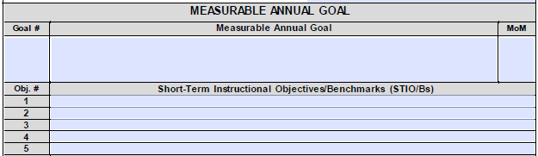
4
3
2
1

See Volume II: Free Appropriate Public Education / Individualized Education Program / Least Restrictive Environment / Extended School Year Services for additional information on writing measurable annual goals and STIO/Bs.

IEP Section: Measurable Annual Goals and STIO/Bs (Ages 6-20)

- Goal Number (#): Assign a number to each goal.
- Measurable Annual Goal: Write the measurable annual goal specifying the (a) timeline, (b) condition, (c) behavior, and (d) criteria.
- Transition Activity (TA) and Method of Measurement (MOM): Identify the transition activity and method to be used to measure progress using the key provided. See guidance on measuring progress in the next section.
- Short-term Instructional Objectives/Benchmarks (STIO/Bs): Write the STIO/Bs necessary for achieving the measurable annual goal with each STIO/B specifying the (a) timeline, (b) condition, (c) behavior, and (d) criteria.
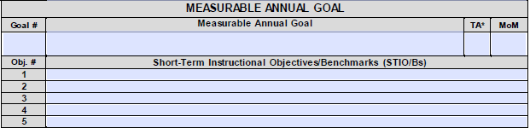
1
4
3
2

See Volume II: Free Appropriate Public Education / Individualized Education Program / Least Restrictive Environment / Extended School Year Services for additional information on writing measurable annual goals and STIO/Bs.

Step 5: Assessing and Reporting Student Progress
The IEP Committee must determine the most appropriate method for assessing and reporting on a student’s Current Level of Progress (CLP) toward his or her measurable annual goal. There are several assessment strategies that may be used to measure progress toward a measurable annual goal. Methods for informal assessment can be divided into two main types: unstructured (e.g., student work samples, journals, etc.) and structured (e.g., checklists, observations, etc.). The unstructured methods frequently are somewhat more difficult to score and evaluate, but they can provide a great deal of valuable information about the skills of the student, particularly in the areas of language proficiency and behavior. Structured methods can be both reliable and valid techniques when time is spent creating the scoring procedures. We usually observe students when they are involved in their everyday activities, but there may be occasions when we need to set up specific activities to support a specific observation. However, we look at observation and assessment as an integral part of reporting student progress. For example, in the case of a student with autism, while the teachers need to understand the effects and implications of autism, they should focus on the student’s current skills, strengths, weaknesses, likes, and dislikes, which will inform planning. The autism is secondary. By focusing on the student, we are considering each student individually and uniquely.

Examples include:
- Observation (OBS): The student’s behavior is recorded in a natural setting using an unstructured or structured format.
  - Unstructured Observation: Unstructured techniques for assessing students may include both written and oral activities. Examples of unstructured methods include work samples, homework, journals, participation in games and activities, etc. These unstructured methods are more subjective and may be difficult to quantify. However, these methods provide valuable information about the skills of students in specific areas. An unstructured observation is conducted by making a descriptive narrative of the environment and the student’s behavior during the observation period. The student’s behavior is typically reported as either occurring or not.
  - Structured Observation: A structured observation focuses primarily on a given observable activity. This requires that there are clearly defined goals and plans for these observations before the observation begins. The observer focuses selectively on any one given activity. The observation uses smaller, predetermined and more manageable pieces of information that have been obtained through the use of numerous techniques. There are varying levels of structure that these observations can be classified under. Highly structured observations have precise and exclusive ways to observe and break up information. Semi-structured observations do not have this level of control over what is being observed. A structured observation is conducted using specific rules about recording behavior for a specific setting and duration. Some examples include inventory or checklists, rating scales, questionnaires/interviews, ABC observations, event recording, time sampling, etc. Also, dynamic assessments measure how a student responds to intervention and the difference between what the student can learn unaided and what he or she can learn with assistance. These methods can help identify learning potential and eliminate bias for students with cultural and linguistic differences or socio-economic risk factors. The student’s behavior is reported as a frequency count, an amount of time, a rate of occurrence, etc.
- Criterion Referenced Test (CRT): The student’s knowledge and/or skills are measured using a written test consisting of items the student is expected to know or be able to perform. The student’s performance is typically reported as a percentage of the items completed correctly.
- Curriculum Based Measure (CBM): The student’s performance of a skill or subskill is measured utilizing probes administered using standardized procedures. For example, a student reads aloud from a reading probe/sample for one minute while the teacher scores the number of words read correctly. The student’s performance is typically reported as a rate of items performed correctly (e.g., words read correctly, digits written correctly, correct word sequences, correct letter sequences, etc.).
- Work Samples: Samples of the student’s work, including written assignments and other permanent products (e.g., drawings, charts/graphs, posters, models, etc.), are collected and/or assembled into a portfolio to make qualitative determinations if the student has met the criteria of expected standards. The student’s performance is typically rated using a rubric to determine the quality of the work completed against expected standards.
- Demonstration/Performance (D/P): The student’s performance is measured by giving the student a specific task to complete and making a qualitative determination if the student’s observed performance meets the expected criteria. The student’s performance is typically related as either meeting or not meeting the criteria.
- Other: Additional forms of assessment may be used. A clear description of other methods of measurement to be used should be explained to parents.

When considering how the student’s progress will be assessed, ask:
- Can the student demonstrate the knowledge/skill on a test or curriculum-based probe, or does the demonstration of the knowledge/skill create a work sample?
- Can the student’s behavior be observed during natural classroom/school activities or demonstrated/performed when provided a specific prompt or placed in a specific situation?
- Can you measure the behavior and, if so, which metric is the most meaningful to measure (e.g., frequency for out-of-seat behavior, duration for on-task behavior, etc.)? Four aspects of the occurrence of behavior can be useful: Frequency refers to the number of times a behavior occurs during a particular time period. Duration refers to how long a particular behavior lasts. Latency refers to how much time passes between a prompt of some kind and the occurrence of the behavior. Intensity refers to the force with which a behavior occurs. If the behavior is objectively described, we can study its occurrence and learn important additional information.
- Can a variety of assessments or assessment strategies be used to measure progress on the specific knowledge, skill, or behavior?

Determine Current Level of Performance (CLP) and Sufficient vs. Insufficient Progress
Once the method of measurement has been determined for each measurable annual goal and STIO/B, the expected Rate of Improvement (ROI) should be calculated to enable the student’s IEP Committee to determine how much improvement will be needed for the student to make sufficient progress to achieve the goal in a timely manner. To calculate the sufficient ROI, use the following formula:

Sufficient Rate of Improvement (ROI) = $\frac{(Outcome Behavior Rate-Baseline Behavior Rate)}{Timeframe from introduction to mastery of STIO/B}$

For example, the sufficient ROI for the following:
Baseline | Given a fourth grade word list, Dorian can use decoding skills to read unfamiliar words with prefixes with 36% accuracy in three consecutive trials.
Outcome &  Timeframe | STIO 1: In 9 weeks, given a fourth grade word list, Dorian will use decoding skills to read unfamiliar words with prefixes with 90% accuracy in three consecutive trials.

Sufficient ROI = $\frac{(90 \% accuracy-36\% accuracy}{9 weeks}$
= 54 percentage points of improvement / 9 weeks
= 6 percentage points of improvement per week

Once the sufficient ROI is known, ongoing progress monitoring data can be collected and examined to determine if the student has made sufficient progress or if changes in instruction, supports, and/or services are needed. To assist in interpretation, graphing of progress monitoring data is strongly recommended.

At the frequency specified in the Notification of Progress Provided to Parents/ Guardians, the student’s performance on all of the STIO/Bs must be assessed. The statement of the student’s CLP toward his or her measurable annual goal should identify (a) any STIO/Bs that have been mastered, (b) any STIO/Bs that have not been introduced, and (c) the student’s current level of performance on any STIO/Bs that have been introduced but not yet mastered. For example:
- Terry has mastered STIO #1 and currently identifies 2 of 4 steps of the strategy for solving equations correctly 80% of the time. STIOs #3, #4, and #5 have not been introduced.
- Suzie has mastered STIO #1 and currently remains on task for 47% of observed intervals and completes 72% of assignments with two or fewer prompts when given independent assignments.
- Conner has mastered STIOs #1 and #2 and currently reads 54 words correctly per minute with 5 or fewer errors on a third grade-level reading passage probe.

After the student’s CLP has been developed, the IEP Committee must determine the student’s progress toward meeting the annual goal by determining if the student has made sufficient progress on each of the STIO/Bs. If the student is making insufficient progress on one or more of the STIO/Bs, the student is making insufficient progress to meet the annual goal.

For example, the following progress monitoring data was collected for two students, Tamara and Judith, who both have a baseline of 36% accuracy and a sufficient ROI of 6 percentage points of improvement per week when measuring each student’s accuracy rate on a weekly criterion-referenced progress monitoring assessment.

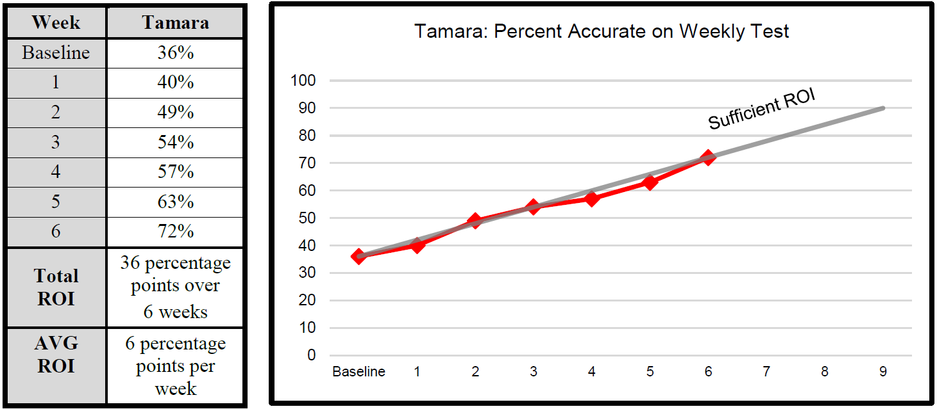

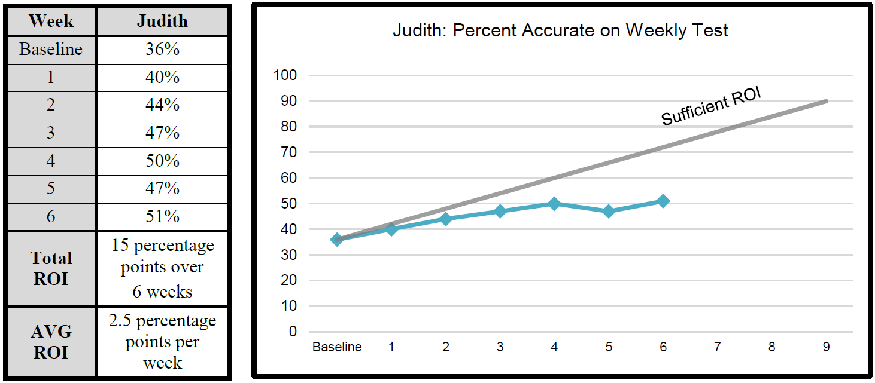

Tamara is making sufficient progress for achieving the STIO and the annual goal; however, Judith is making insufficient progress for achieving the STIO and is unlikely to meet the annual goal without changes in instruction, supports, and/or services.

IEP Section: Report of Progress
- Date of Report: Record the date for each reporting period.
- Current Level of Performance: Write a statement [2a] describing the student’s current level of performance on the annual goal based on progress on the STIO/Bs using the identified Method of Measurement (MOM) [2b]. Include performance on each unmastered objective in each report of progress. Example: Jan performed at 89% on Objective #1 during this 9-week period. Objectives #2, #3, and #4 were not introduced during this 9-week period.
- Progress on Annual Goal (PAG): In the column [3a], record the letter corresponding to the PAG statement [3b] that best describes the student’s progress on the annual goal. If the student is making insufficient progress on the annual goal, the IEP Committee must hold a meeting to consider revisions to the annual goal and/or to the supports and services provided to the student. If the student has met or exceeded the annual goal, the IEP Committee may hold a meeting to consider adding a new goal and/or revising the services provided to the student.
- Notification of Progress Provided to Parents/Guardians: Check the boxes to identify both the type of progress report and the frequency for reporting progress to the parent.

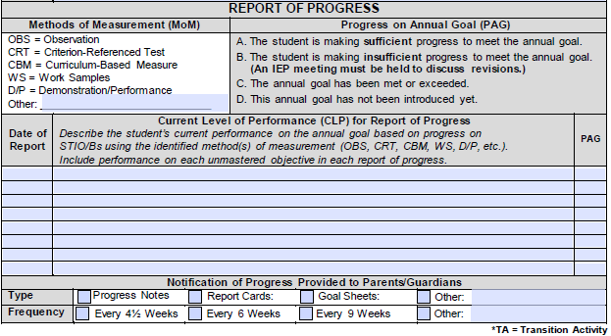
4
3b
2b
3a
2a
1

Special Considerations
State Board Policy Chapter 74, Rule 74.19 identifies five (5) circumstances the IEP Committee must take under special consideration when developing, reviewing, and/or revising an IEP. The IEP Committee must address any communication and assistive technology needs for all students with disabilities. Also, the IEP Committee must address the special needs of students who are blind, deaf, or visually/hearing impaired, who need behavior intervention, and/or who have limited proficiency with English.

Special Considerations for Communication
The IEP Committee must consider the communication needs of all students receiving an IEP.

When considering the student’s communication needs, ask:
- What communication demands and opportunities does the student have?
- Does the student have the skills and strategies necessary to meet those communicative demands and take advantage of communicative opportunities?
- Can the student fulfill his or her need to communicate in different settings?
- Does the student communicate appropriately and effectively? If not, why?
- How would the communication be described?

IEP Section: Special Considerations for Communication
- Question: Indicate if the student has any special communication needs.

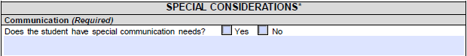

Special Considerations for Assistive Technology
The IEP Committee must consider the need for assistive technology devices and/or services for all students receiving an IEP.
- An assistive technology device is any item, piece of equipment, or product system, whether acquired commercially off the shelf, modified, or customized, that is used to increase, maintain, or improve the functional capabilities of a student with a disability. The term does not include a medical device that is surgically implanted, or the replacement of such device.
- An assistive technology service is any service that directly assists a student with a disability in the selection, acquisition, or use of an assistive technology device. The term includes:
  - The evaluation of the needs of a student with a disability, including a functional evaluation of the student in the student’s customary environment
  - Purchasing, leasing, or otherwise providing for the acquisition of assistive technology devices by students with disabilities
  - Selecting, designing, fitting, customizing, adapting, applying, maintaining, repairing, or replacing assistive technology devices
  - Coordinating and using other therapies, interventions, or services with assistive technology devices such as those associated with existing education or rehabilitation plans and programs
  - Training and/or technical assistance for a student with a disability or his or her family, if appropriate
  - Training and/or technical assistance for professionals (including individuals providing education or rehabilitation services), employers, or other individuals who provide services to, employ, or are substantially involved in the major life functions of that student

When considering the student’s assistive technology needs, ask:
- Does the student require an assistive technology assessment to determine if he or she would benefit from assistive technology?
- What type of assistive technology might increase the student’s participation in the general education curriculum, move towards participation in the general education curriculum, or participate in other developmentally appropriate activities?
- Is the student currently using any assistive technology device or services? If so, does the student’s assistive technology device work?

IEP Section: Special Considerations for Assistive Technology
- Question: Does the student need assistive technology services or devices? – AND – does the student need an assistive technology assessment?

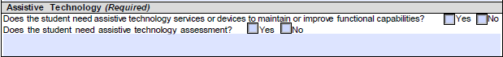

Special Considerations Services for Students Who Are Blind or Visually Impaired

The IEP Committee must describe any services for students who are blind or visually impaired.

When considering services for a student who is blind or visually impaired, ask:
- Has the student received a functional vision evaluation, learning media assessment, or clinical low vision assessment? If so, what are the results?
- Does the student require instruction in the use of a new reading and writing medium because the student can no longer effectively use the current medium?
- What are the current supports and instruction used to address the student’s needs as they relate to the student’s blindness or visual impairment?
- Which medium is most appropriate for the current visual limitations? Is the student receiving instruction in that medium?

IEP Section: Special Considerations Services for Students Who Are Blind or Visually Impaired

- Not Applicable: If the student is not blind or visually impaired, check “N/A” for not applicable and go to the next section.
- Questions: Indicate if the IEP Committee has considered providing instruction in braille – AND – if braille instruction was determined appropriate based on the evaluation.
- Evaluation Date: If an evaluation of the student’s reading and writing skills, needs, and media is conducted to determine if Braille inspection is appropriate, record the date of the evaluation.
- Question: Check if parents were provided information about the Mississippi School for the Blind.
1
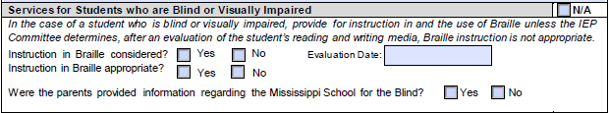
3
4
2

Special Considerations Services for Students Who Are Deaf or Hearing Impaired
The IEP Committee must describe any services for students who are deaf or hearing impaired. If applicable, the IEP Committee must consider the student’s (a) language and communication needs, (b) opportunities of direct communication with peers and professional personnel in the student’s language and communication mode, (c) academic level, and (d) full range of needs, including opportunities for direct instruction in the student’s language and communication mode.

When considering services for a student who is deaf or hearing impaired, ask:
- What is the student’s first or preferred language and mode of communication?
- Can the student use multiple modes to communicate (e.g., oral methods, manual methods, etc.)? Does the student need to learn a new mode of communication?
- What type of instruction has been provided or is needed to enhance the student’s ability to use his or her language and mode of communication?
- What are the current supports and instruction used to address the student’s needs as they relate to the student’s deafness or hearing impairment?
- What are the opportunities for direct communication with peers and professional personnel in the student’s language and communication mode?

IEP Section: Special Considerations Services for Students Who Are Deaf or Hearing Impaired
- Not Applicable: If the student is not deaf or does not have a hearing impairment, check “N/A” for not applicable and go to the next section.
- Language and Communication Mode: Record the student’s language and mode(s) of communication.
- Question: Indicate if instruction in the student’s language/mode of communication is needed.
- Question: Check if parents were provided information about the Mississippi School for the Deaf.
1
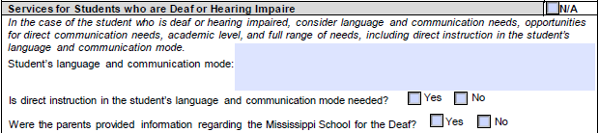
4
3
2

Special Considerations for Behavior Intervention
The IEP Committee must complete this section for a student who requires behavioral intervention. If any concerns about the student’s behavior have been noted (e.g., the student exhibits behavior(s) that impede his or her learning or the learning of others, etc.), the IEP Committee should consider the use of positive behavior intervention and supports to address the behavior(s), which may include conducting a Functional Behavioral Assessment (FBA) and/or developing a Behavioral Intervention Plan (BIP). In addition, the IEP Committee must conduct an FBA and implement a BIP if these are required as a result of the discipline provision of State Board Policy Chapter 74, Rule 74.19.

When considering the student’s need for behavior interventions, ask:
- Does the student’s behavior interfere with his or her learning or that of his or her peers?
- Has a formal FBA been completed? If so, what is the function of the student’s behavior?
- What supports (e.g., accommodations, modifications, supports for personnel, etc.) are currently used to address the student’s behavior(s)? Do these supports reduce problematic behavior and/or increase appropriate behavior?
- What other interventions are being used to address the behavior(s)? Do these strategies reduce problematic behavior and/or increase appropriate behavior?
- Has a formal BIP been created? Is the BIP being implemented with fidelity? Have the BIP strategies reduced problematic behavior and/or increased appropriate behavior?

IEP Section: Special Considerations for Behavior Intervention
- Not Applicable: If the student does not have any behavioral concerns requiring intervention, check “N/A” for not applicable and go to the next section.
- Questions: Check the box to answer the following questions:
- Indicate if the IEP Committee has developed goals and interventions to address specific behavior concerns.
- Indicate if a Functional Behavior Assessment (FBA) has been conducted. If yes, record the date of the most recent FBA.
- Indicate if a Behavior Intervention Plan (BIP) has been developed. If yes, record the date the BIP was developed and implemented. Also, record the date of the review or revision of the BIP, if applicable. The student must have a corresponding goal(s) to address all behavioral concerns.
1
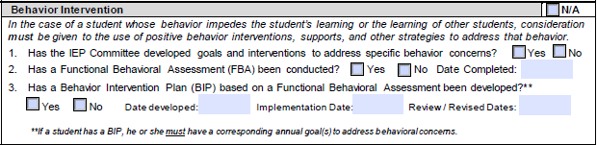
2

Special Considerations Services for Students with Limited English Proficiency
The IEP Committee must describe any services for students with Limited English Proficiency (LEP). If applicable, the IEP Committee must consider the student’s language needs.

When considering services for students with limited English proficiency, ask:
- What languages are spoken in the student’s home? What is the dominant language spoken in the student’s home?
- What languages does the student know and/or use? What is the student’s primary language at home and in the school setting?
- Have the cultural values and beliefs of the parents been considered in planning for the student’s education?

IEP Section: Special Considerations Services for Students with Limited English Proficiency
- Not Applicable: If the student does not have limited proficiency in English, check “N/A” for not applicable and go to the next section.
- If the student is an English Language (EL) student, answer the questions based on the student’s Language Service Plan. The EL Plan must be attached to the IEP.
1
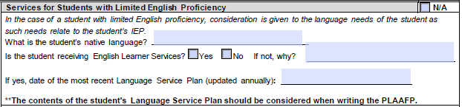
2

Access for All Guide
The Access for All Guide will aid in providing quality classroom instruction for all students, including general education students and students with disabilities who receive instruction in general education settings. Topics addressed in the guide are organized according to six deficit areas: academics, physical, speech/language, social/emotional, behavioral, and organizational skills. In each area, teachers are provided questions to ask that help determine students’ needs, suggested accommodations and/or modifications, and teaching strategies for implementation. The guide helps teachers keep the intent of the standards but change the delivery.

Step 6: Identifying Specially Designed Instruction
Identifying specially designed instruction, including accommodations and/or modifications needed to access and progress in the general education curriculum or in other developmentally appropriate activities, is the next consideration. Special education services are the specially designed instructional services provided to meet the unique needs of a student with a disability. Specially designed instruction includes, but is not limited to, the following provisions:
- Academic instruction
- Speech and/or language instruction
- Special and/or adapted physical education
- Vocational instruction
- Social skills instruction
- Organizational skills/strategies
- Behavioral training
- Training in functional living skills
- Special and/or adapted instruction in developmental and pre-academic skills

When determining which special education services to provide, ask:
- What are the student’s areas of concern and specific needs?
- How do the student’s deficits affect his or her achievement of grade-level content standards, functional skills, behavior, and/or developmentally appropriate activities?
- What type and amount of specially designed instruction does the student need to achieve the grade-level content standards, functional skills, appropriate behavior, and/or developmentally appropriate activities?
- When and in what location should these services be provided?

Related Services
Related services are developmental, corrective, and other supported services required to ensure a student with a disability benefits from special education. Related services include, but are not limited to, the following:
- Assistive technology services
- Audiology services
- Early identification and assessment of disabilities
- Interpretive services
- Medical services for diagnosis or evaluation purposes
- Orientation and mobility services
- Parent counseling and training
- Physical and/or occupational therapy services
- Psychological and/or counseling services
- Recreation and/or therapeutic recreation services
- Rehabilitation counseling
- School health services and school nurse services
- Social work services in schools
- Speech and/or language services
- Transportation services
NOTE: This list of services is not exhaustive. Other developmental, corrective, or supportive services may be required to assist a student with a disability to benefit from special education.

When selecting related services, ask:
- What are the student’s areas of concern and specific needs?
- What type and amount of developmental, corrective, and supportive services are needed to ensure the student benefits from general and special education?
- In what location and when should these services be provided?

Instructional/Functional Accommodations
Instructional/Functional accommodations are changes to the instruction and/or environment to enable students with disabilities to be successful learners and to actively participate with other students in educational activities or settings. Accommodations reduce the impact of the student’s disability, not the learning expectations. Accommodations can be grouped into four categories:
- Timing/Scheduling accommodations are changes to the total amount of time allowed or segmenting the task over a larger time frame.
- Setting accommodations are changes to the location/environment where a task is completed.
- Presentation accommodations are changes in the way instruction is provided, including changes to the instructional materials or equipment provided to the student.
- Response accommodations are changes in the way the student demonstrates acquisition of the skills being learned.

The IEP Committee must review any evaluation information to identify any accommodations the student may need to include in the IEP. Some instructional/functional accommodations cannot be used in state- and districtwide assessments. Refer to the Mississippi Testing Accommodations Manual to determine if the accommodations can be used for state- and districtwide assessments.

When selecting instructional/functional accommodations, ask:
- How do the student’s deficits affect his or her ability to participate in instruction?
- Does the student need changes to the learning environment?
- Does the student need changes to the timing or scheduling of learning activities?
- Does the student need changes to how he or she receives instruction?
- Does the student need changes to how he or she demonstrates learning?
See Statewide/Districtwide Testing Accommodations for additional guidance.

Program Modifications
Program modifications are changes to the environment and/or instruction that alter or change expectations for the student to enable him or her to be successful and to participate actively with other students in the general education classroom and in school-wide activities. Program modifications include, but are not limited to, the following:
- Curriculum modifications use a specialized curriculum that presents information using simplified vocabulary, content, and/or principles or leads to modified outcomes such as the General Educational Development (GED).
- Modified grading modifies the weights of assignments, projects, and tests.

The IEP Committee is cautioned about the use of modifications as they may increase the gap between the achievement of students with disabilities and grade-level expectations. Overreliance on modifications can negatively affect a student’s educational career as he or she may not progress at a rate that will enable the student to obtain a standard high school diploma.

When selecting program modifications, ask:
- How do the student’s deficits affect his or her ability to participate in instruction?
- Does the student need significant changes to assignments, texts, and/or curricula to be able to participate actively with other students in the general education environment or in developmentally appropriate activities?
- Does the student need individually designed behavioral interventions to be able to participate in the general education environment?

Supports for Personnel
Supports for personnel are services provided to personnel who work directly with a student with a disability to enable the implementation of special education and related services, instructional or functional accommodations and/or program modifications with the student. Supports for personnel include, but are not limited to:
- Providing training on disability characteristics or behavior management principles
- Providing consultation from specialists on implementing instruction and behavior strategies
- Having a paraprofessional as an assistant in the classroom
- Providing instruction to use special equipment (e.g., FM system, etc.) or teaching materials.

When selecting supports for personnel, ask:
- What specialized or individualized instructional and/or behavior support practices will be used with the student, and who will be implementing them?
- Does the student require specialized equipment or teaching materials?
- Does the student need continuous one-on-one support?
- Who will be responsible for monitoring the progress of the student?
See Procedures Volume II: FAPE, IEP, LRE, and ESY for additional guidance about special education and related services, accommodations, and modifications.

IEP Section: Special Education and Related Services
- Special Education Services: List all of the special education services to be provided.
- Area: Record the area(s) where the student will receive the services using the letter codes listed at the bottom of the page.
- Location: Record if the service will be located in special education or in general education classes. Any class with 50% or more students receiving special education service is considered a special education classroom.
- Start Date: Record the date on which the services will begin.
- End Date: Record the date on which the services will end.
- Duration/Frequency: Record the amount of time per day and the number of days per week the services will be provided (e.g., 30 minutes/3 times a week, etc.).
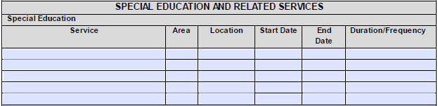
4
1
•
5
3
2

- Related Services: List all of the related services to be provided.
- Area: Record the area(s) where the student will receive the services using the letter codes listed at the bottom of the page.
- Location: Record if the service will be located in special education or in general education classes. Any class with 50% or more students receiving special education service is considered a special education classroom.
- Start Date: Record the date on which the services will begin.
- End Date: Record the date on which the services will end.
- Duration/Frequency: Record the amount of time per day and the number of days per week the services will be provided (e.g., 30 minutes/3 times a week, etc.).
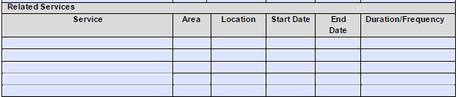
5
•
1
2
3
4

- Program Modifications:
- Area: Record the area(s) where the student will receive the services using the letter codes listed at the bottom of the page.
- Start Date: Record the date on which the services will begin.
- End Date: Record the date on which the services will end.
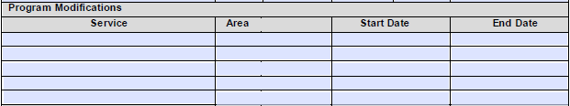
3
2
•
1

- Instructional/Functional Accommodations:
List all of the instructional or functional accommodations to be provided.
- Area: Record the area where the student will receive the services using the letter codes listed at the bottom of the page.
- Start Date: Record the date on which the services will begin.
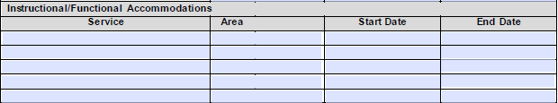
- End Date: Record the date on which the services will end.
1
3
2
•

- Supports for Personnel: List all of the supports for personnel to be provided.
- Area: Record the area where the student will receive the services using the letter codes listed at the bottom of the page.
- Location: Record if the service will be located in special education or in general education classes. Any class with 50% or more students receiving special education service is considered a special education classroom.
- Start Date: Record the date on which the services will begin.
- End Date: Record the date on which the services will end.
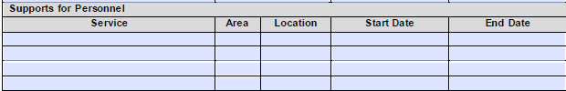
4
•
3
2
1

Step 7: Determining Appropriate Participation in Statewide Assessments
MS Code 37-16-3 requires that every pupil enrolled in a public school participate in the Statewide Assessment System and that the school district superintendent certify annually that all eligible pupils enrolled in the designated grade were tested. State Board Policy Chapter 74, Rule 74.19 requires the inclusion of students with disabilities in statewide assessments to the extent that students who are not disabled are included. In Mississippi, the following students with and without disabilities are expected to participate in statewide assessments:
- Students enrolled in kindergarten (K) or the third through eighth grades.
- Students who are ages 8-13 on September 1 of the current school year enrolled in a nongraded setting.
- Students enrolled in high school courses or secondary vocational programs, if included.
- Students enrolled in 12th grade who are age 18 on September 1 of the current school year, enrolled in a nongraded setting, and who have not enrolled in and/or been assessed on Algebra I, Biology I, English II, and U.S. History.

Step 7 of developing a standards-based IEP is to determine the most appropriate assessment option for the student. Mississippi, like all other states, is required under the Every Student Succeeds Act of 2015 (ESSA) and the Individuals with Disabilities Education Improvement Act of 2004 (IDEA) to provide high-quality alternate assessments for students with SCDs. These alternate assessments, like the general assessments, must be aligned to academic content standards that apply to all students in reading, writing, and mathematics in Grades 3–8 and, once in high school, in science and history in at least one grade in each of the 3–5, 6–8, and high school grade ranges. (ESSA of 2015).

However, for students with SCDs, the general assessments, even when administered with accommodations, do not provide these students with the opportunity to demonstrate what they know and can do. Therefore, alternate assessments based on Alternate Academic Achievement Standards (AAAS) are designed to measure the knowledge and skills of students with significant cognitive disabilities. Student performance explicated by the AAAS should show how eligible students demonstrate performance in relation to the academic content standards.

State testing for students with a significant cognitive disability has changed beginning with the 2016-17 school year. Dynamic Learning Maps (DLM) was replaced by the Mississippi Academic Assessment Program-Alternate (MAAP-A). Similar to MAAP, MAAP-A has been developed by Questar Assessment, Inc. and Mississippi educators. Beginning in the 2019-2020 school year, the MS AAAS for English Language Arts, Math, and Science will be used. Students with disabilities must participate in one or more of the following assessments of the Mississippi Statewide Assessment System as determined by their IEP Committee:

State- or Districtwide Assessments for Students with a SCD
MKAS2/Kindergarten Readiness Assessment
Third Grade MAAP ELA Assessment
MAAP-A (English Language Arts/Literacy)
MAAP-A (Mathematics)
MAAP-A (Science)
MAAP-A (English II)
MAAP-A (Algebra I)
MAAP-A (Biology I)
English Language Proficiency Test (ELPT)
ACT (American College Test)
Other
Other

State- or Districtwide Assessments for Students without a SCD
(MKAS²) Mississippi Kindergarten Readiness Assessment
Third Grade MAAP ELA Assessment
MAAP (English Language Arts/Literacy)
MAAP (Mathematics)
MAAP (Science)
MAAP-EOC (Algebra I)
MAAP-EOC (Biology I)
MAAP-EOC (English II)
MAAP-EOC (U.S. History)
(MS-CPAS2) Mississippi Career Planning and Assessment System, 2nd Edition
(ACT) American College Test
(ELPT) English Language Proficiency Test
Other

The IEP Committee must ensure students with disabilities have maximum access to the general curriculum, as appropriate, and must determine the most appropriate assessments for them. The standards used to determine appropriate learning goals [i.e., Mississippi College and Career Ready Standards (MS CCRS) or Mississippi Alternate Academic Achievement Standards (MS AAAS)] should also be used to determine the most appropriate assessments for students with disabilities.
- The Grade-Level/Subject Area Alternate Academic Assessments are designed to measure performance and growth based on the alternate content standards using collections of work samples, observations, pictures, and/or videos. The only students who should be assessed using alternate assessments are students who fall under the state’s definition of SCD.
- All other students should be assessed on grade-level standards using the general statewide assessments with any necessary allowable accommodations.

It is important for the IEP Committee to be fully informed about the state standards, including essential elements, and the statewide assessments. The IEP Committee needs to know about the demands, administration conditions, and response requirements of the general assessments and alternate assessments. The IEP Committee should consider any instructional accommodations and modifications the student has received and their implications for the administration of statewide assessments. All accommodations used for statewide testing must have been used during the student’s routine classroom instruction and assessments. Refer to Testing Students with Disabilities Regulations for additional guidance in determining appropriate assessments and to the current Mississippi Testing Accommodations Manual for information regarding testing accommodations.

Disability Preclusion for the English Language Proficiency Test (ELPT)

Under 34 C.F.R. §200.6(h)(4)(ii), if it is determined on an individualized basis that an English Learner (EL) has a disability that precludes assessment in one or more domains of the English Language Proficiency (ELP) assessment (speaking, listening, reading and writing), such that there are no appropriate accommodations for the affected domain or domains, a state educational agency (SEA) must assess the child’s English language proficiency based on the remaining domains in which it is possible to assess the student.

A determination that a disability precludes assessment in one or more domains must be made on an individualized basis by the child’s IEP team, the student’s 504 team, or, for students covered under Title II of the ADA, by the team or individual designated by the Local Education Agency (LEA) to make those decisions. Under the very rare circumstances when a student’s disability precludes assessment in one or more domains, the student may be exited under the state’s exit procedures based on a score of proficient on the remaining domains in which the student is able to be appropriately assessed. The U.S. Department of Education expects that only in very rare circumstances will children need to be assessed in fewer than four domains due to a disability that precludes assessment in a particular domain, and that the vast majority of ELs with disabilities will be able to be assessed in all four domains, with appropriate accommodations as needed, or by taking an alternate ELP assessment for ELs who are students with the most significant cognitive disabilities.

EXAMPLE provided in 34 C.F.R. §200.6(h)(4)(ii):
A nonverbal EL who, because of an identified disability, cannot take the speaking portion of the ELP assessment.
The EL is not precluded from the domain because he or she has a disability; rather, there is not an appropriate accommodation to enable the student to access the test.
The IEP team and the 504 team cannot exempt an EL from taking the English Language Proficiency Test (ELPT) or remove the EL designation.

Application of the Disability Preclusion: The domain(s) for which the student is precluded does not count for or against the student. The student’s overall score is calculated based on the remaining domains. For example, a student who is precluded from taking the Reading domain but takes the Speaking, Listening, and Writing domains will have the overall score calculated using only those three domains.

EXAMPLE 1
Jane has a disability preclusion for the Reading domain. She takes the Listening, Speaking, and Writing domains. Her proficiency levels in the three domains are as follows: L=5, S=4, W=4. Her overall proficiency level is four (4).
Does this student meet the Mississippi exit criteria? The answer is yes, this student meets the Mississippi exit criteria based on the following:
Proficiency Level 4 or 5 in Overall – Yes
Proficiency Level 4 or 5 in Reading – Disability Preclusion
Proficiency Level 4 or 5 in Writing – Yes

EXAMPLE 2
John has a disability preclusion for the Speaking domain. He takes the Listening, Reading, and Writing domains. His proficiency levels in the three domains are as follows: L = 4, R = 4, W = 2. His overall proficiency level is three (3).
Does this student meet the Mississippi exit criteria? The answer is no, this student does not meet the Mississippi exit criteria based on the following:
Proficiency Level 4 or 5 in Overall – No
Proficiency Level 4 or 5 in Reading – Yes
Proficiency Level 4 or 5 in Writing - No

When selecting appropriate statewide assessments, ask:
- To what extent does the student access the general statewide curriculum?
- Has the student been enrolled in the subject areas assessed for secondary students: Algebra I, Biology I, English II, and U.S. History?
- Can the student participate in the grade-level/subject area assessments if provided accommodations?

IEP Section: Exemption for Participating in Statewide Assessments
Students with disabilities are expected to participate in statewide assessments, beginning with the Kindergarten Readiness Assessment through the subject area assessments. However, the Mississippi K-3 Assessment Support System, including the Kindergarten Readiness Assessment and Third Grade MAAP ELA Assessment may not be appropriate for students who meet the criteria for a SCD.

In addition, students over age 18 may not need to participate in statewide assessments. For example, a 19-year-old student who intends to exit with a Certificate of Completion who has already taken all subject area assessments does not need to participate in statewide assessments. However, a 19-year-old student intending to exit with a standard high school diploma or alternate diploma who is enrolled in U.S. History and has not yet passed the U.S. History exam may participate in this subject area assessment. (See the Mississippi Public School Accountability Standards: Appendix A-11: Graduation Requirements Standard 14 – Certificate of Completion)

When determining if students who are ages 19-20 need to participate in the statewide assessments, ask:
- Is the student seeking a standard high school diploma? If so, has he or she already successfully completed each of the subject area courses and tests?
- Does the student meet the criteria for a SCD and intend to exit with a certificate?

Nonparticipation Statement: Check the box if either statement applies and the student will not participate in statewide assessments. (Note: If either box is checked, the student will count as “not tested” for accountability purposes.)

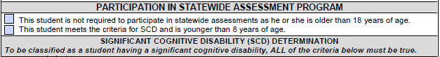

IEP Section: SCDs Determination
To determine the most appropriate assessment option for a student with a disability, the IEP Committee must first determine if the student meets the criteria for a SCD. The SCD designation is reserved for the few students who demonstrate significant cognitive deficits and poor adaptive skill levels that prevent participation in the standard academic curriculum or achievement of the academic content standards, even with accommodations and modifications, for reasons other than excessive or extended absences, visual disabilities, auditory disabilities, physical disabilities, emotional-behavioral disabilities, specific learning disabilities, or social, cultural, or economic differences. These students will also require extensive direct instruction in both academic and functional skills in multiple settings to accomplish the application and transfer of learned skills.

The IEP Committee must next determine the standards in which the student is instructed. The majority of students designated as having a SCD will receive all instruction using alternate standards (i.e., linked to the MS AAAS). However, a few students may display splinter skills such that, despite generally meeting the criteria for a SCD when considering performance in most areas, the student can perform at or above grade level in an area. For example, a student with autism with significant impairments in cognitive, language, social, and adaptive skills may perform at grade level in math and receive instruction using grade-level content standards. NOTE: This is not a common occurrence.

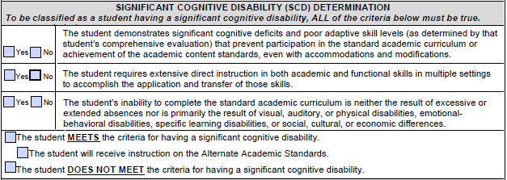
4a
4b
3
2
5
1

- Criteria Statements: Check the box for “Yes” or “No” to indicate the IEP Committee’s determination for each of the three criteria statements.
  - SCD Standard 1: The student demonstrates significant cognitive deficits and poor adaptive skill levels (as determined by that student’s comprehensive evaluation) that prevent participation in the standard academic curriculum or achievement of the academic content standards, even with accommodations and modifications.
    - The student has an IQ score or developmental level two or more standard deviations below the mean.
    - The student is not able to exhibit adaptive skills that would allow him or her to function independently and safely in daily life.
    - With accommodations/modifications in place, the student is not able to participate in and make progress in the standard academic curriculum.
    - The student meets the criteria for SCD Standard 1 (all statements must be true in order to mark “Yes”).
  - SCD Standard 2: The student consistently requires extensive direct instruction in both academic and functional skills in multiple settings to accomplish the application and transfer of those skills.
    - The student consistently requires extensive repeated, individualized instruction and support that is not of a temporary or transient nature, in both academic and functional skills, to gain educational benefits.
    - The student uses substantially adapted materials and individualized methods of accessing information in alternative ways to acquire, maintain, generalize, demonstrate, and transfer skills across multiple settings.
    - The student meets the criteria for SCD Standard 2 (all statements must be true in order to mark “Yes”).
  - SCD Standard 3: The student’s inability to complete the standard academic curriculum is neither the result of excessive or extended absences nor is primarily the result of visual, auditory, or physical disabilities, emotional-behavioral disabilities, specific learning disabilities, or social, cultural, or economic differences.
    - The student’s absences may be excessive and/or extended but are not the primary reason the student cannot complete the standard academic curriculum.
    - The student’s inability to complete the standard academic curriculum is not primarily due to one of the following: a Specific Learning Disability, an Emotional Disability, a Language/Speech Impairment, a Visual Impairment, a Hearing Impairment, an Orthopedic Impairment, and/or Other Health Impairment.
    - The student meets the criteria for SCD Standard 3 (all statements must be true in order to mark “Yes”).

- SCD Determination Statement: Select the appropriate statement:

4a. MEETS: Check if all three criteria statements are marked “Yes.” The student is considered as having a SCD. The student’s instruction should be based on the AAAS.
4b. Instructional Standards: If the student meets the criteria for a SCD, check the box to indicate the instructional standards for the student.
  - DOES NOT MEET: Check if one or more of the criteria statements are marked “No.” The student is not considered as having a SCD. The student’s instruction should be based on the MS CCRS.

Based on the SCD determination and the instructional standards for the student, the IEP Committee must determine which state- and districtwide assessments are appropriate for the student. The SCD designation or instruction using alternate standards does not prevent participation in the Mississippi Statewide Assessment System program. Rather, the IEP Committee must identify how – not if – the student will participate in statewide assessments for the student’s grade or age.

IEP Section: State and District Assessments for Students with a SCD
If a student has been determined to meet the criteria for a SCD and receives instruction using alternate standards, the student should be assessed using the Grade-Level/Subject Area Alternate Assessments. Statewide alternate assessments include the MAAP-A in Mathematics, Language Arts, and Science which assess progress on the MS AAAS. In addition, students who meet the criteria for a SCD, receive instruction using alternate standards and are English Language Learners (ELL) may be assessed using the ELTP. The IEP Committee may determine the need for additional assessments, including any appropriate districtwide assessments.

Assessments: Place an “X” in the box corresponding to the assessment in which the student will participate during the school year and the student’s grade level or, for nongraded students, the grade that matches the student’s age as of September 1 of the applicable school year. If any additional assessments are to be completed, record the name of the assessment and indicate the age/grade level.
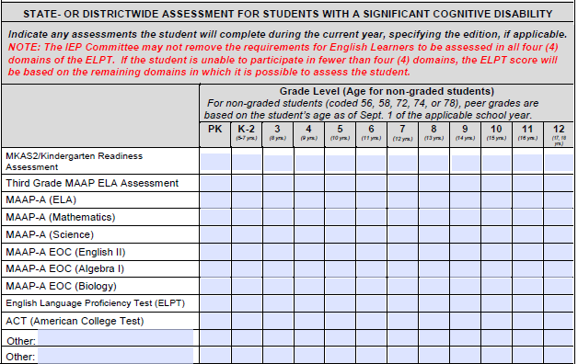

IEP Section: Acknowledgment of Requirements for Participation in Subject Area Tests
Parents must be informed of the requirements for participation in the Mississippi Statewide Assessment System and for earning a standard high school diploma, including the successful completion of subject area courses and end-of-course tests. Parents must also be notified of approved alternate measures that fulfill the subject area end-of-course testing requirements.
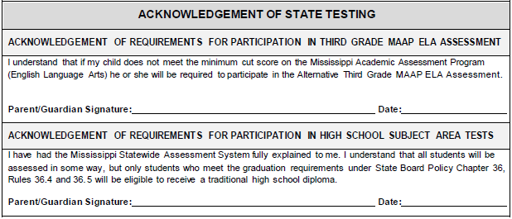
Signature and Date: Have the parent sign and date the appropriate statement. A signature is required. This signature section is located at the end of the document on the IEP Signature Page.

IEP Section: State and District Assessments for Students without a SCD
All students without a SCD should be assessed on grade-level standards using the general statewide assessments. Statewide assessments include grade-level assessments in primary grades and subject area assessments in secondary grades. The grade-level assessments include the Mississippi Pre K-3 Assessment Support System (MKAS²), the MAAP, the Subject Area Testing End-of-Course (MAAP-EOC in Algebra I, Biology I, English II, and U.S. History).

Additional assessments are used in the secondary grades to determine college and career readiness. The Mississippi Career Planning and Assessment System, 2nd Edition (MS-CPAS2) is used for students who participate in career and technical education. The American College Test (ACT) will be administered to all students classified as juniors starting in the 2014-2015 school year to assess the students’ academic readiness for college. See the MS-CPAS2 Frequently Asked Questions for more information about the assessment and students with disabilities (located online at https://www.rcu.msstate.edu/Assessment/FAQs.aspx).

Additional assessments may be used in any grades depending upon the needs of the student or the district policy. Students with disabilities who are English Language Learners (ELL) may be assessed using the ELPT to determine if they continue to need services. The IEP Committee may determine the need for additional assessments, including any appropriate districtwide assessments. Contact the MDE’s Office of Student Assessment for additional information on statewide assessments and students with disabilities.

- Assessments: Place an “X” in the Grade Level box corresponding to the assessment in which the student will participate during the school year and the student’s grade level. If any additional assessments are to be completed, record the name of the assessment and indicate the student’s grade level. All students must be enrolled in the subject area course before taking the end-of-course assessment (i.e., MAAP-EOC) or enrolled in career and technical education courses before taking the end-of-year or end-of-course assessment (i.e., MS-CPAS2).
- Administration Date: If the student has already taken a subject area or career and technical education assessment, record the most recent administration date in the Grade Level box. This information is intended to assist the IEP Committee in planning for a student who is participating in assessments that may need to be administered multiple times over multiple years depending upon the student’s performance.

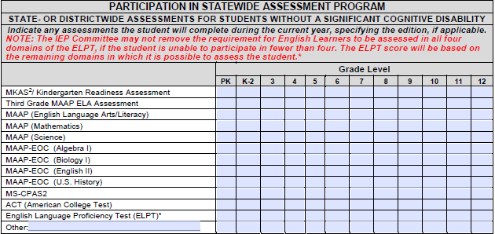

Statewide Testing Accommodations
Statewide Testing Accommodations enable students with disabilities to demonstrate their learning on statewide assessments by reducing the effect of the student’s disability—not the learning expectations. Each statewide assessment will have a list of allowable testing accommodations. The IEP Committee must list the accommodations necessary for the student to participate in the statewide assessment program. All accommodations used for statewide assessments must also be used during the student’s routine classroom instruction and assessments. Testing accommodations can be grouped into four categories: (a) setting accommodations, (b) timing/scheduling accommodations, (c) presentation accommodations, and (d) response accommodations.

Setting Accommodations
Setting accommodations are changes to the location or environment where the assessment will be administered. Setting accommodations are intended to ensure the test taker is comfortable and focused. Students who need familiar settings for staff, special lighting, smaller groups, special equipment, and/or limited visual distractions may benefit from setting accommodations.

When selecting setting accommodations for assessments, ask:
- Is the student easily distracted in large groups?
- Is the student easily distracted or made uneasy by new surroundings?
- Does the student have trouble staying on task?
- Does the student need special lighting or equipment?

Timing/Scheduling Accommodations
Timing/Scheduling accommodations are changes to the total amount of time allowed or segmenting the assessment over multiple sessions or days. Timing/Scheduling accommodations are intended to ensure the test taker is focused and not fatigued. Students who need frequent breaks, fatigue easily, cannot concentrate for extended periods of time or certain times of day, and/or require special diets or medications necessitating regular breaks may benefit from timing/scheduling accommodations.

When selecting timing/scheduling accommodations for assessments, ask:
- Does the student tire easily because of health impairments?
- Can the student work continuously during the entire time allocated for test administration or does the student need frequent breaks?
- Does the student perform better at a specific time of day (e.g., morning, etc.)?

Presentation Accommodations
Presentation accommodations are changes to the test materials or directions provided to the student. Presentation accommodations are intended to ensure the student can access the test materials and can understand the purpose of the test items and the expected response. Students who have difficulties with printed materials (e.g., texts, graphics, or symbols), difficulties with reading or an inability to read, and/or who have sensory or cognitive disabilities (including difficulties with memory, sequencing, directionality, and organization) may benefit from presentation accommodations.

When selecting presentation accommodations for assessments, ask:
- Does the student have a sensory disability that requires a special medium for reading (e.g., braille, large print, etc.)?
- Does the student need hearing aids to be able to understand spoken directions?
- Does the student need memory aids, resource sheets, or problem-solving tools?
- Can the student read independently and understand directions?
- Does the student need directions repeated or explained?

Response Accommodations
Response accommodations are changes to the way the student demonstrates learning for the assessment. Response accommodations are intended to ensure the student can demonstrate his or her knowledge of the test content. Students who have difficulties with written or verbal communication, difficulties transcribing responses, and/or physical disabilities may benefit from response accommodations.

When selecting response accommodations for assessments, ask:
- Does the student need special equipment for written or verbal communication (e.g., a communication board, a speech generating device, a braille printer, etc.)?
- Can the student use a pencil or other writing instrument?
- Can the student dictate a response to a scribe or into a tape recorder?
- Does the student need an English language or spelling dictionary?
- Does the student have trouble with tracking from one page to another?

Refer to the current Mississippi Testing Accommodations Manual for information regarding allowable testing accommodations for each assessment included in the Mississippi Statewide Assessment System.

IEP Section: Statewide/Districtwide Test Accessibility/ Accommodations
- Presentation Accommodations: List all of the presentation accommodations to be provided.
- Code: Record the codes for the accommodations as listed in the current version of the Mississippi Testing Accommodations Manual.
- Test(s): Record the letter for the test(s) for which the accommodations will be used found in the key at the bottom of the page.
- Other Test: Record the name of any other tests that are listed in B.
- Response Accommodations: List all of the response accommodations to be provided.
- Code: Record the codes for the accommodations as listed in the current version of the Mississippi Testing Accommodations Manual.
- Test(s): Record the letter for the test(s) for which the accommodations will be used found in the key at the bottom of the page.
- Other Test: Record the name of any other tests that are listed in B.
- Timing/Scheduling Accommodations: List all of the timing/scheduling accommodations to be provided.
- Code: Record the codes for the accommodations as listed in the current version of the Mississippi Testing Accommodations Manual.
- Test(s): Record the letter for the test(s) for which the accommodations will be used found in the key at the bottom of the page.
- Other Test: Record the name of any other tests that are listed in B.
- Setting Accommodations: List all of the setting accommodations to be provided.
              - Code: Record the codes for the accommodations as listed in the current version of the Mississippi Testing Accommodations Manual.
              - Test(s): Record the letter for the test(s) for which the accommodations will be used found in the key at the bottom of the page.
              - Other Test: Record the name of any other tests that are listed in B.
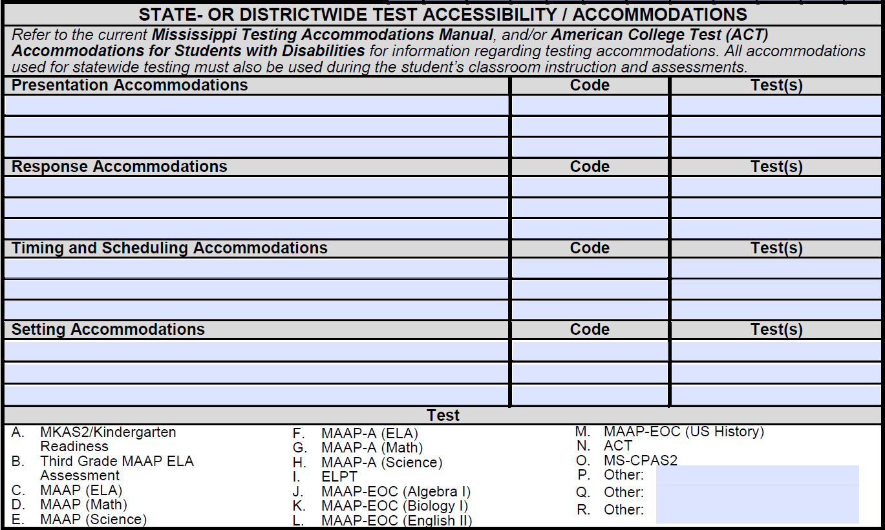
1,2,3,4c
1b
3b
4b
2b
1a
2a
3a
4a
2
4
1
3

Chapter 3: Additional Planning for Students with Disabilities
The IDEA and State Board Policy Chapter 74, Rule 74.19 require the inclusion of additional information in the IEP, including the planning and programming for postsecondary outcomes, the determination of the student’s LRE, and/or the determination of need for and, if necessary, the programming for Extended School Year (ESY) services.

Individual Transition Plan
For students over age 14 (or younger if determined appropriate by the IEP Committee), State Board Policy Chapter 74, Rule 74.19 requires school districts to determine each student’s postsecondary goals in the areas of employment, education or training, and, where appropriate, independent living based on age-appropriate assessments. The IEP Committee is further required to develop a coordinated set of activities to promote the movement of a student from school to postsecondary adult living in the areas of instruction (including courses of study), related services, community experiences, development of employment and other post-school adult living objectives, and acquisition of daily living skills and functional vocational evaluation.

Postsecondary Goals
Postsecondary goals are the desired outcomes for a student after he or she leaves high school in the areas of employment, education/training, and, where appropriate, independent living skills. These goals must be appropriate, measurable, and related to his or her strengths, preferences, and interests. Appropriate measurable postsecondary goals must be developed based on information gained through age-appropriate assessments and related to the student’s measurable annual goals.

The goal statement addresses what the student will be doing in the following areas:
- Education/Training: Specifies postsecondary goals that involve any instructional or skill development programs such as institutions of higher learning, trade schools, and certification programs in which the student intends to enroll. For example:
- The student will attend a community college…
- The student will enroll in a university…
- The student will enroll in Job Corps…
- The student will attend technical school…
- The student will receive on-the-job training with vocational rehabilitation…
- Employment: Specifies postsecondary goals that involve the practice of a vocation or trade, paid or unpaid, that the student intends to pursue. For example:
- The student will work full-time…
- The student will work part-time…
- The student will volunteer…
- Independent Living: Specifies postsecondary goals that involve any additional personal and community adult skills or activities in which the student intends to engage. For example:
- The student will use public transportation to…
- The student will live with a roommate…
- The student will join a community recreation team…
- The student will attend sporting events…

(NOTE: The use of “will” is explicit. Do not use “plans to” because it does not indicate an explicit behavior. One cannot observe “plans to.”)

When setting a postsecondary goal for this student, ask:
- What career does the student wish to pursue?
- What degree, certification, or training is required for the student’s desired career?
- What other knowledge and skills does the student need to have quality of life in his or her personal life or community?

IEP Section: Postsecondary Goals
- Postsecondary Goals: Write the student’s measurable postsecondary goals. The student must have goals for education/training and employment; in addition, the student may have additional goals for independent living. The IEP Committee must review postsecondary goals annually and, if needed, revise them based on the student’s strengths, preferences, and interests. In addition, at least one transition service must be identified for each measurable postsecondary goal.
- Related IEP Goal(s) #: Record the number that corresponds to the student’s measurable annual goals that, if achieved, would help the student achieve the desired postsecondary outcome.

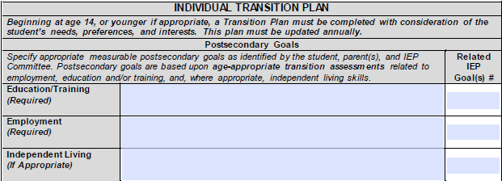
1
2

IEP Section: Age-Appropriate Transition Assessments
State Board Policy Chapter 74, Rule 74.19 requires the use of age-appropriate assessments to develop appropriate measurable postsecondary goals in education/ training, employment, and where appropriate, independent living skills. The Council for Exceptional Children’s Division on Career Development and Transition defines transition assessment as “an ongoing process of collecting data on the individual’s needs, preference, and interests as they relate to the demands of current and future working, educational, living, and personal and social environments.” Formal and/or informal age-appropriate assessments must be used to identify a student’s needs, preferences, and interests as they relate to the demands of current and future employment education, living, and personal and social environments. Examples of age-appropriate assessments that are useful for transition planning include assessments of adaptive behavior/daily living skills, aptitude tests, achievement tests, interest inventories, temperament inventories, self-determination assessments, transition planning inventories, and career maturity and employability tests. See Procedures Volume V: Secondary Transition for examples of formal and informal assessments.

Results of the age appropriate assessments used for transition planning should be included in the PLAAFP and assist the IEP Committee in prioritizing among possible postsecondary goals.
- Assessment Type: Record the assessment used to develop the student’s postsecondary goals.
- Responsible Agency/Person: Record the agency/person responsible for assessing the student.
- Date Conducted: Identify the date(s) of any assessment conducted. Assessments must be conducted before the development of appropriate measurable postsecondary goals.
- Report Attached: Place a “Y” for yes or “N” for no to indicate if a report summarizing the results of the assessment(s) is attached to the IEP. The report of the assessment should include the date(s) of the assessment(s); name, title, and qualifications of the examiner(s), informants, and observers; results of the assessment(s); and a summary of the interpretations of the assessments and implications for the student’s education/training, employment, and, where appropriate, living skills.

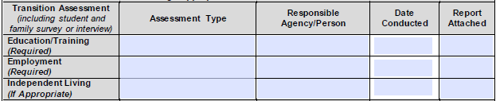
4
3
2
1

Secondary Transition Services
Secondary transition services for a student with a disability consist of a coordinated set of activities that are focused on improving the academic and functional achievement of the student to facilitate the student’s movement from school to post-school activities, including postsecondary education, vocational education, integrated employment (including supported employment); continuing and adult education; adult services; independent living; or community participation. Secondary transition services must be designed to support the student’s achievement of their individual postsecondary goals based on the student’s individual needs, strengths, preferences, and interests. Secondary transition services are grouped into six categories: (a) instruction, (b) related services, (c) community experiences, (d) development of employment and other post-school adult living objectives, (e) acquisition of daily living skills (when appropriate, and (f) functional vocational evaluation (when appropriate).
- Instruction: Specifies instruction the student needs to complete needed courses and to be successful in the general education curriculum. For example:
- Tutoring
- Self-advocacy training
- Instruction related to word processing
- Self-management instruction related to behavior
- Related services: Specifies related services the student needs to continue post-high school. For example:
- Visiting community mental health agencies in the area
- Identifying potential post-school providers for recreation therapy, occupational therapy, speech therapy, or physical therapy
- Exploring transportation options
- Applying for Supplemental Security Income (SSI)
- Community experiences: Specifies experiences the student needs to be provided outside the school campus. For example:
- Supported employment
- Job shadowing
- Tours of postsecondary institutions
- Investigating opportunities for socialization training in the community
- Investigating participation in community civic organizations or sports teams
- Development of employment and other post-school adult living objectives: Specifies additional knowledge, skills, and experiences the student needs to achieve his or her postsecondary goals. For example:
- Participating in career planning
- Registering to vote
- Participating in a community-based career exploration program
- Meeting with supported employment agencies to evaluate their services
- Learning about legislation identifying the rights of adults with disabilities (i.e., the Americans with Disabilities Act and Section 504 of the Rehabilitation Act) to appropriately self-advocate
- Meeting with a Division of Vocational Rehabilitation Services (DVRS) counselor to develop an Individualized Plan for Employment (IPE) that will determine the services to be provided after graduation
- Acquisition of daily living skills (when appropriate): Specifies daily living skills the student needs to function independently as an adult. For example:
- Learning about money management and banking
- Exploring insurance issues/concerns
- Learning about managing/maintaining/performing simple repairs at home
- Learning about ways to purchase/lease a car and maintain a vehicle
- Learning about expectations for eating in restaurants
- Functional vocational evaluation (when appropriate): Specifies any assessments needed to provide information about career interests, aptitudes, and skills.

When identifying appropriate transition services for the student, ask:
- What information and skills does/will the student need to learn to achieve his or her desired postsecondary outcomes?
- What type and amount of educational supports does/will the student need?
- What type and amount of developmental, corrective, and other supported services does/will the student need?
- What type and amount of community experiences does the student need?
- What additional information or skills does/will the student need to learn to function independently as an adult?
- What additional assessments are needed to determine the student’s career interests, aptitudes, and skills?
- Who is currently providing transition services to the student? Are additional transition service providers needed?
- Will the student be linked to the needed postsecondary services, supports, or programs before he or she leaves the school setting?

Transition services must be linked to the student’s postsecondary goals and his or her PLAAFP. At least one transition service must be identified for each measurable postsecondary goal. (See Procedures Volume V: Secondary Transition for additional information about transition)

IEP Section: Transition Services
- Instruction: List any instruction provided as a transition service by the school, student, parent, and/or outside agencies.
- Related Services: List any related services provided as a transition service by the school, student, parent, and/or outside agencies.
- Community Experiences: List any community experiences provided as a transition service by the school, student, parent, and/or outside agencies.
- Development of Employment Objectives and Functional Vocational Evaluation (when appropriate): List any additional instruction, services, experiences, or assessments provided as a transition service by the school, student, parent, and/or outside agencies to assist the student in achieving his or her postsecondary goals or determining career interests, aptitudes, and skills.
- Acquisition of Daily Living Skills and Other Post-Adult Living Objectives (when appropriate): List any instruction or experiences provided as a transition service by the school, student, parent, and/or outside agencies to assist the student in functioning independently as an adult.

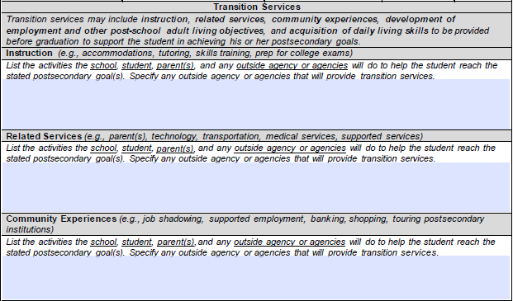
3
2
1

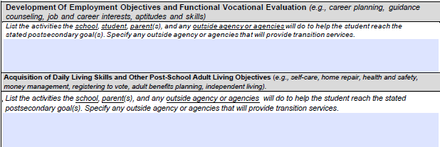
5
4

IEP Section: Course of Study
The course of study guides the IEP Committee in choosing appropriate classes for the student to achieve his or her desired exit option. The student’s general education teacher and guidance counselor must be involved in the collaborative decision-making process for determining the student’s course of study. Like the student’s desired postsecondary goals, the student’s course of study must be determined based on the student’s strengths, preferences, and interests.

When selecting the course of study for the student, the IEP Committee must consider the specific requirements for each exit option and the specific entry requirements for the postsecondary college or career selected. For example, if a student’s postsecondary goal is to attend a college or university immediately after high school, he or she must have a course of study leading to a standard high school diploma and/or complete a GED program. If a student’s postsecondary goal is to enlist in the military, he or she should have a course of study leading to a standard high school diploma as the military rarely accepts applicants with a GED without additional college coursework and/or a high Armed Services Vocational Aptitude Battery (ASVAB) score. If a student’s postsecondary goal is to become a commercial driver, the student’s course of study will depend upon both the specific exit option selected and the postsecondary training program pursued. As some commercial driver training programs require a standard high school diploma or GED while others do not, the student may be able to exit with a standard high school diploma, GED, MOD, or certificate of completion and still pursue his or her postsecondary goal depending upon the entry requirements of the commercial driver training program selected.

When selecting the student’s course of study, ask:
- What is the student’s postsecondary goal(s) in education and what course of study will appropriately prepare the student to succeed in his or her chosen postsecondary educational or training program?
- What is the student’s postsecondary goal(s) in employment and in what career cluster is the student’s desired employment?
- What course of study will appropriately prepare the student to succeed in his or her chosen postsecondary career or employment option and/or to complete any required degree, certification, or training program for the desired career?
- What classes support the student in obtaining his or her desired exit option?
- What classes are available that support the student’s efforts to achieve his or her desired postsecondary goals in education, employment, and, if applicable, independent living?
- Do the student’s projected classes for the course of study have prerequisite classes that will need to be sequenced?

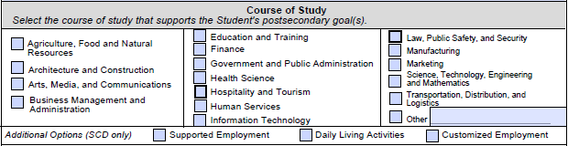

IEP Section: Exit Options
One of the most important decisions the IEP Committee will make for a student with a disability is identifying his or her exit option. The range of postsecondary education, training, and employment opportunities to which the student will be able to gain access will be greatly impacted by the exit option selected. This decision will have lifelong implications for the student as well as his or her family and community.
Mississippi currently offers the following exit options:
- Traditional High School Diploma: The traditional high school diploma is the only option leading to graduation. Students pursuing a traditional diploma must identify an endorsement prior to entering ninth grade. There are three endorsement options: career and technical, academic, and distinguished academic endorsement. See the Mississippi Public Schools Accountability Standards for more information.

- High School Equivalency (GED): The General Educational Development (GED) is a high school equivalency credential earned through successful completion of a group of subject area assessments that measure high school-level college- and career-readiness skills. Some school districts offer GED preparatory programs.

- Mississippi Occupational Diploma (MOD): This option is only available to students that entered ninth grade prior to the 2017-2018 SY. The MOD is not the equivalent of a traditional diploma. Students that exit with a MOD will have limited access to postsecondary training opportunities, will not be allowed to enroll in the military, and may have limited employment opportunities.

- Mississippi Alternate Diploma: Mississippi public schools offer an alternate course of study for students with SCDs. This course of study leads to the alternate diploma, which recognizes that a student has completed high school. The alternate diploma is not equivalent to a traditional diploma and is not recognized by postsecondary entities that require a standard high school diploma.

- Certificate: A certificate of completion is not a high school equivalency credential but rather an acknowledgement of the student’s participation in and completion of his or her IEP. (See the Mississippi Public School Accountability Standards: Appendix A-11: Graduation Requirements Standard 14 – Certificate of Completion)

When selecting the student’s exit option, ask:
- What is the student’s postsecondary goal(s) for education and what exit option is required for the student to gain entry into that type of educational program?
- What is the student’s postsecondary goal(s) for employment and what preparation and/or certification is required to gain entry into the career field?
- Is a particular exit option required to gain entry into the career field?
- Is completion of a degree, certification, or training program required for the student’s desired career or employment option?
- How many requirements for each exit option has the student currently met?
- How much time does the student have to meet the remaining requirements before turning age and aging out of eligibility for special education services?

When selecting the exit option for a student, the IEP Committee must consider the student’s postsecondary goals and the progress in the educational environment. For example, for a student who can meet high school college- and career-readiness standards but lacks sufficient credits, will soon age out of eligibility, and is at-risk of dropping out of school, a district GED option may be a viable option. For a student with a SCD, a certificate of completion is a viable option. (See the Mississippi Public School Accountability Standards: Appendix A-11: Graduation Requirements Standard 14 – Certificate of Completion)

            - Exit Option: Check the box to indicate the exit option selected.

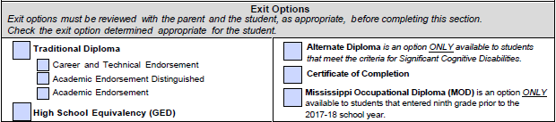

            - Parent/Guardian Signature: The parent must sign the statement. A signature is required. This signature section is located at the end of the document on the IEP signature page.
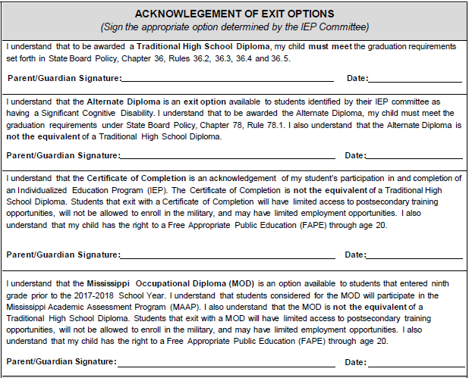

IEP Section: Student’s Invitation to the IEP Committee Meeting
The secondary transition plan should be developed based on the student’s strengths, preferences, and interests. Students with disabilities, whenever appropriate and at the discretion of their parents, should be invited to attend the IEP Committee meeting, especially when the student’s transition goals, services, exit options, and course of study are to be discussed.

Student’s Invitation: Check the box to indicate if the student was invited to attend the IEP Committee meeting when secondary transition plans were discussed.

IEP Section: Interagency Linkages
- Education/Training: List any agencies currently involved or that are likely to become involved with the student/family who can provide information or services related to education or training. Check the box if written parental consent has been obtained to invite an agency representative to the IEP Committee meeting.
- Employment: List any agencies currently involved or that are likely to become involved with the student/family who can provide information or services related to employment. Check the box if written parental consent has been obtained to invite an agency representative to the IEP Committee meeting.
- Independent Living: List any agencies currently involved or that are likely to become involved with the student/family who can provide information or services related to independent living, if applicable. Check the box if written parental consent has been obtained to invite an agency representative to the IEP Committee meeting.

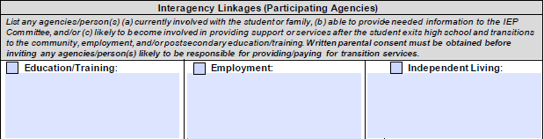
2
1
3

Interagency linkages are developed with agencies and/or their representative(s) who are currently involved with the student or family or are likely to become involved in providing support or services once the student exits high school and transitions into postsecondary education/training, employment, and the community. Representatives of these agencies may be able to provide critical information to assist the IEP Committee in planning for secondary transition and/or to provide transition services. Written parental consent must be obtained prior to inviting an agency representative to attend an IEP Committee meeting or to become an IEP Committee member.

In Mississippi, agencies commonly involved in transition planning or services include:

- Vocational Rehabilitation Agency (VR): Funded by federal and state monies, VR agencies typically operate regional and local offices and provide assistance to people with cognitive, sensory, physical, or emotional disabilities to attain employment and increased independence. VR services are available for a limited period of time based on an individual’s rehabilitation plan.
- Mental Health Agencies: Funded by federal, state, and (primarily) local monies, mental health agencies, operated out of regional offices, provide a comprehensive system of services responsive to the needs of individuals with mental illness or intellectual disabilities on a sliding payment scale.
- Independent Living Centers (ILC): Operated locally, ILCs help people with disabilities achieve and maintain self-sufficient lives within the community. Some services, such as classes, may require fees; however, other services, such as advocacy services, are typically available at no cost.
- Social Security Administration (SSA): Funded by federal monies, the SSA operates several programs that provide benefits for people of any age who are unable to do substantial work and have severe mental or physical disabilities, including Social Security Disability Insurance (SSDI), Supplemental Security Income (SSI), Plans to Achieve Self-Support (PASS), Medicaid, and Medicare.
- Department of Health: Funded by federal and state monies, health departments assist individuals with physical or mental disabilities obtain employment and live more independently through provision of counseling, medical, and psychological services, job training, and other individualized services.
- The Mississippi Council on Developmental Disabilities: Funded by the Federal Administration on Developmental Disabilities, the MSCDD supports nine area programs for students and parents of students with disabilities: child care, community supports, education and early intervention, employment, health, housing, transportation, quality assurance, and recreation.

IEP Section: Transfer of Rights
Beginning at least one year before the student reaches the age of majority under state law at age 21, the student’s IEP must include a statement that the student has been informed that his or her rights under the IDEA will transfer to the student on reaching the age of majority. (Note: This signature section is located at the end of the document on the IEP signature page.)

Signature and Date: Have the student sign and date the statement at least one year before the student reaches the age of majority under state law. A signature is required. If the public agency receives notice of the student’s legal incompetency, no transfer of rights will occur and this section of the IEP may be left blank.

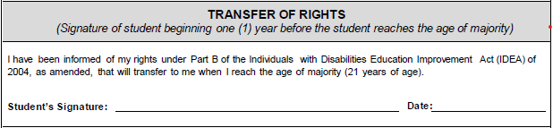

Placement Considerations and Least Restrictive Environment (LRE) Determination
Districts are required to provide a continuum of services with different placement options depending upon the needs of the students they serve. A student’s LRE is the one that allows the student to the maximum extent appropriate to be educated with students who are not disabled. Special classes, separate schooling, or other removals of students with disabilities from the regular educational environment may occur only when the nature or severity of a student’s disability is such that education in regular classes with the use of supplementary aids and services cannot be achieved satisfactory. LRE requirements apply to all students eligible for special education services, including preschool students.

At least once each year, the IEP Committee must consider the placement of the student based on:
- The student’s IEP: All decisions made during the development of the IEP (e.g., selection of standards, goals, services, accommodations, modifications, other supports, and, if applicable, transition plans) are used to help determine the student’s LRE.
- The location of the school the student would attend if he or she were not disabled: The student’s placement must be as close as possible to the student’s home and, unless the student requires other arrangements, in the school that he or she would attend if the student were not disabled.
- Any potential current or long-term harmful effects on the student: Harmful effects can include, but are not limited to, lack of opportunity for appropriate role models, stigmatization, isolation from peers, diminished access to the full range of the curriculum, decreased self-esteem, and decreased access to the instructional opportunities available in an integrated setting. For example, for a student who has been on a modified curriculum in all subjects, continue with the modified curriculum even though he or she will be unable to meet the requirements for a standard high school diploma at his or her current rate of progress. For a student who has been on a modified curriculum in all subjects, continue with the modified curriculum because the student requires small-group or one-to-one instruction using flexible repetitive teaching strategies to facilitate the development of academic skills. Due to self-esteem issues, a quiet environment away from peers is needed to allow for answering questions with confidence and provide immediate feedback during academic instruction.
- Access to age-appropriate peers who are not disabled: Students with disabilities must be educated with age-appropriate peers to the maximum extent appropriate. For every placement considered, the IEP Committee should look for ways to include students with disabilities to provide access to age-appropriate peers who are not disabled throughout the school day and across the school week. For example, a student may be placed in a self-contained class for all academic courses but participate with his peers who are not disabled in related arts classes, including physical education, music, and art.
- The provision of supplementary aids and services: Students with disabilities cannot be removed from general education settings solely because they require accommodations and/or modifications. Public agencies must demonstrate their efforts to provide supplementary aids and services to enable students with disabilities to participate in the general education setting the maximum extent in light of the student’s circumstances. In addition, the IEP Committee must determine if special transportation is a related service for the student. For example, a student may require special transportation and personnel to ensure that he or she remains seated while on the bus and is provided support if he or she becomes over stimulated in that environment.

NOTE: See Procedures Volume II: FAPE, IEP, LRE, and ESY for more information on making placement decisions.

When considering the student’s LRE, ask:
- What school would the student attend if he or she were not disabled?
- Has the student had significant difficulties (e.g., increasing academic or behavioral difficulties, etc.) in the current placement?
- If so, can the environment be changed without changing placement?
- If not, can additional supports be provided to help the student cope with the environment and be more successful?
- Has the student demonstrated significant improvement in current placement such that he or she may be placed in a less restrictive environment with supports?

IEP Section: Placement Considerations and LRE Determinations Checklist
Answer the questions to determine the appropriate LRE Determination Option, considering all placements and discussing any needs, supplementary aids and services, accommodations/modifications, assistive technology/accessible materials, and supports for school personnel. If “No” is selected, explain the IEP Committee’s decision.
- Is this placement based on the student’s educational needs documented in this IEP? 34CFR300.114
- Is the student able to be satisfactorily educated in the general education environment for the entire school day? 34CFR300.114
- If removal from the regular environment is necessary, is it based on the nature and severity of the student’s disability and not the need for modifications in the general curriculum? 34CFR300.114
- Is the educational placement as close as possible to the student’s home? 34CFR200.116(b)(3)
- Is the educational placement in the school the student would attend if the student did not have a disability? 34CFR300.116(c)
- The IEP team considered all placement options and related services in conjunction with discussing any needed supplementary aids and services, accommodations/ modifications, assistive technology and/or accessible materials, and supports for school personnel as well as potential harmful effects on the student. (300.116(d)) The IEP team also considered the potential harmful effects of the placement of the child and whether it would impede the ability of the child or other children to learn. 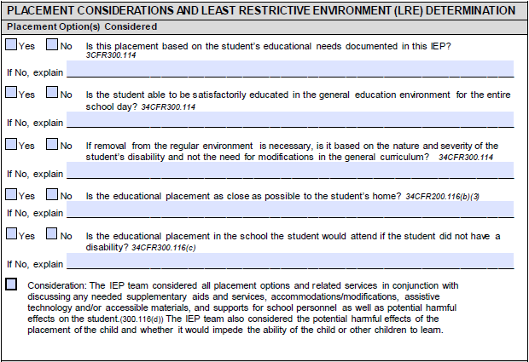
3
1
2
5
6
4
Select the correct LRE Environment to record the decision of the IEP.
- Preschool Age LRE Environment (Least restrictive to most restrictive)
(Select one for students ages 3-5)
- Early childhood setting
- Early childhood special education
- Part-time early childhood/Part-time early childhood special education
- Home
- Itinerant services outside the home
- Residential facility
- Separate school
- School Age LRE Environment (Least restrictive to most restrictive)
(Select one for students ages 6-20)
- Inside general education with no supplementary aids and services
- Inside general education with supplementary aids and services—includes itinerant instruction and resource room instructional support
- Special Classes—full- or part-time self-contained
- Separate School—residential or day treatment
- Home instruction
- Correctional facilities
- Parentally placed in private schools
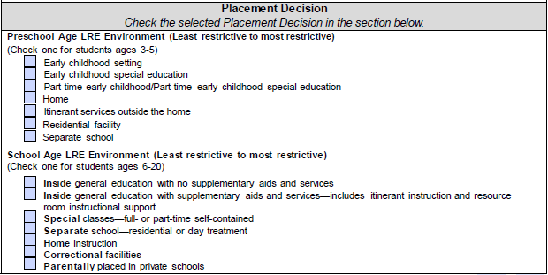
8
7

If a student’s placement changes within the year, this section should document the record of the student’s movement from one placement to another.

Special Transportation
Check the box to indicate if special transportation is required for the selected placement. Record the sources of information used to support this decision. NOTE: If special transportation is required in the LRE selected, add this related service to the Special Education and Related Services page of the IEP form.
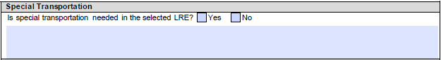

MSIS Classification for a LRE

After determining a student’s LRE, the IEP Committee must indicate the category of this placement. This information is used to assist the school and the MDE in reporting to the Office of Special Education Programs (OSEP) for Indicator 5 (LRE for 6-21-year-olds) and Indicator 6 (LRE for 3-5-year-olds) of the Annual Performance Report (APR).

IEP Section: MSIS Classification for LRE—Time Student Receives Special Education Outside the General Education Classroom
- Preschool LRE Classification (ages 3-5): Check the box that indicates the appropriate placement of the student. See the Indicator 6 Decision Tree for more information (online at https://www.mdek12.org/sites/default/files/Offices/MDE/OAE/OSE/Early-Childhood/PreS-Settings/web-indicator-6-decision-tree.pdf)
- School-age LRE Classification (ages 6-20): Check the box that indicates the appropriate placement of the student.
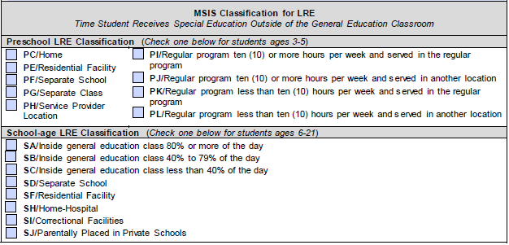
1
2

Placement Considerations for ESY
ESY services are special education and related services provided to the student beyond the normal school year, in accordance with the student’s IEP in order to provide a FAPE, and at no cost to the parent.

IEP Section: Exemption for Considering ESY Services
The IEP Committee does not need to address ESY services for students who are in 12-month programs that continue to provide services over the summer break.

- Question: Check the box if the student attends a 12-month program.
1

IEP Section: Determination of Need for ESY Services
The IEP Committee must determine on an individual basis each student’s need for ESY services considering all qualifying criteria:
- Regression-Recoupment: Refers to a student’s loss of skills addressed on the student’s IEP after at least two (2) breaks in instruction without regaining the documented level of skills within a period of time equal to the amount of time of the breaks up to a maximum of four (4) weeks.
- Critical Point of Instruction 1: Refers to a need to maintain a student’s skills to prevent a loss of general education class time or an increase in special education service time.
- Critical Point of Instruction 2: Refers to a point in the acquisition or maintenance of a critical skill during which a lengthy break in instruction would lead to a significant loss of progress.
- Extenuating Circumstances: Refers to special situations that jeopardize the student’s receipt of a FAPE unless ESY services are provided.
When considering the student’s need for ESY services, ask:
- Has the student had two or more breaks in instruction?
- If so, did the student have a loss of skills when he or she returned to school?
- How long did it take the student to regain the lost skills?
- Is a break in instruction likely to cause the student to lose skills required across a number of environments, settings, or situations?
- Is a break in instruction likely to cause the student’s development to slow?
- Would ensuring the student maintained his or her skills enable him or her to function more independently and/or spend more time in integrated environments?

- Check the “Consideration” box to indicate that the IEP Committee considered all criteria when determining the student’s eligibility for receiving ESY services.
- Check the box that corresponds to the decision for ESY services.
- Indicate the criteria that qualified the student for ESY services
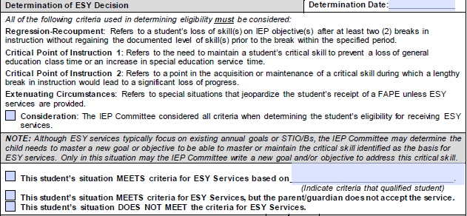
3
1
2

IEP Section: ESY Goals, STIO/Bs, and Report of Progress
Typically, existing goals or STIO/Bs will be the focus of ESY services; however, the IEP Committee may determine the student needs to master a new goal or objective to be able to master or maintain the critical skill identified as the basis for the ESY determination. Only in these instances may the IEP Committee write a new goal and/or objective to address this skill. (See the Procedures Volume II: Chapter 6: Extended School Year Services for more information)

- Measurable Annual Goals or Short-Term Instructional Objectives/Benchmarks (STIO/Bs): Write the existing measurable annual goal(s) or STIO/Bs for which the student needs ESY services and/or write a new measurable annual goal or STIO/Bs for the student to be able to master or maintain the critical skill for which the student needs ESY services. Each goal or objective must be linked to a specific service to be provided.
- Transition Activity (TA): For a student with a secondary transition plan, record a “Y” for yes or “N” for no to indicate if the measurable annual goal is a transition activity. For any student where a secondary transition plan is not appropriate, record “N/A” for not applicable. A secondary transition plan is required for every student age 14 and may be appropriate for younger students as determined by their IEP Committee.
- Method of Measurement (MOM): Write the code in (3a) for the method to be used to measure the student’s progress using the key provided in (3b).
- Current Level of Progress (CLP): Write a statement describing the student’s current level of performance on the annual goal based on progress on the STIO/Bs using the identified method of measurement.
- Progress on Annual Goal (PAG): Record the letter corresponding to the statement listed on the Measurable Annual Goal page that best describes the student’s progress on the annual goal.
- Progress Report: [6a] Record the frequency or the date after which a progress report for the student will be provided to the parent/guardian. [6b] After the progress report(s) has been provided to the parent/guardian, record the date(s).
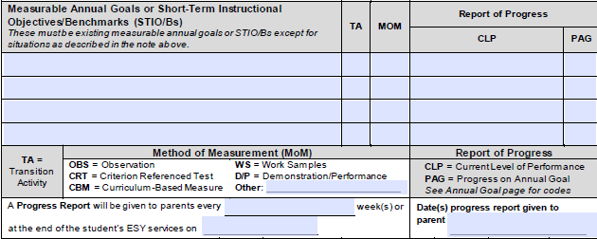
3a
3b
2
6a
6b
1
5
4
1

IEP Section: ESY Services
Complete the rest of the documentation as you would the IEP. Refer to sections on Assessing and Reporting Student Progress and Special Education and Related Services.
- Educational Services: List the special education services to be provided.
- Number (#) of Weeks: Record the total number of weeks the service will be provided.
- Duration/Frequency: Record the amount of time per day and the number of days per week the services will be provided (e.g., 30 minutes/3 times a week, etc.).
- Area: Record the area where the student will receive the services using the letter codes listed at the bottom of the Special Education and Related Services page of the IEP.
- Location: Record if the service will be located in special education or in general education classes. Any class with 50% or more students receiving special education service is considered a special education classroom.
- Start Date: Record the date on which the services will begin.
- End Date: Record the date on which the services will end.
- Related Services: List any related services to be provided. Record the number of weeks, duration/frequency, start date, and end date for the services as well as the area and location in which they will be provided. Any related services provided (except transportation) must have a corresponding measurable annual goal or STIO/Bs.
- Transportation: List any transportation services to be provided. Record the number of weeks, duration/frequency, start date, and end date for the services as well as the location in which they will be provided.
- Other: List any additional services to be provided. Record the number of weeks, duration/frequency, start date, and end date for the services as well as the area and location in which they will be provided.

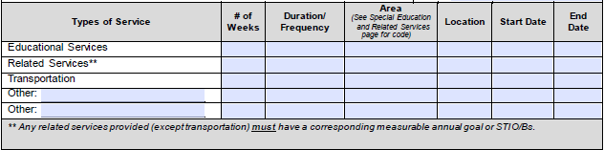

Chapter 4: Itinerant Services
Itinerant services are services provided by intervention specialists or related services personnel which occur in the setting where the student, the student and parent(s), or the student and caregiver(s) are located as opposed to services provided at a centralized location. Every district must offer itinerant services as part of the LRE continuum for preschool. Itinerant services may be provided by full- or part-time intervention specialists or related services personnel employed by school districts or educational service centers. Itinerant services may be provided directly to the student or provided to the student using a consultative model. Consultative services may include all staff involved with the preschool student with a disability. All staff involved in service delivery must contribute to planning instruction and monitoring progress. Service delivery may be done through a team teaching or transdisciplinary model in conjunction with “Head Start”, public preschools, community preschools, or childcare.

Early Childhood Special Education Services
Eligibility for special education through local education agencies can begin as early as 3 years of age. State law mandates free appropriate public educational services and equipment for exceptional students ages 3-20 for whom the regular school programs are not adequate.

Services for students ages 3-5 are referred to formally as 619 services, as this is the section in the IDEA where these services are described. In the research literature, one may see the terms 619 services, early childhood special education (ECSE) services, or preschool services. In Mississippi, the term “preschool services” is used most often.

Children in Mississippi receiving ECSE services may fall in any of the following disability categories:
- Orthopedic Impairment
- Other Health Impairment
- Developmentally Delayed
- Traumatic Brain Injury
- Intellectual Disability
- Specific Learning Disability
- Language/Speech
- Autism
- Deaf-Blind
- Hearing Impairment
- Visually Impaired
- Multiple Disabilities
- Emotional Disability

The goal of ECSE services is to enable young children to be active and successful participants in developmentally appropriate activities now and in the future in a variety of settings – in their homes, schools, and communities – resulting in positive outcomes for children and their families.

The LRE requirements in section 612(a)(5) of the IDEA apply to the placement of preschool children with disabilities. Special classes, separate schooling, or other removal of students with disabilities from the regular educational environment may occur only when the nature or severity of the disability of the student is such that education in regular classes with the use of supplementary aids and services cannot be achieved satisfactorily.

Regular Early Childhood Program Services
Programs that include a majority (at least 50%) of children who are not disabled may include, but are not limited to:
- Head Start
- Kindergartens
- Preschool classes in the public school system
- Private kindergartens or preschools
- Group child development centers or childcares

Districts without public preschool programs that can provide all the appropriate services and supports must explore alternative methods such as the following to ensure LRE:
- Provide opportunities for participation in other public preschool programs
- Enroll preschool children with disabilities in private preschool programs for children who are not disabled
- Locate classes for preschool children with disabilities in regular elementary schools
- Provide home-based services

Preschool Itinerant Services
Itinerant services can be provided in the home, in a public preschool program, or in a community-based preschool or licensed childcare program. Unless otherwise specified in the IEP, a minimum of four hours of services per month must be provided for each child by an itinerant teacher.

Itinerant special educators
- Implement their children’s IEPs
- Collaborate with caregivers (e.g., parents, preschool teachers, and childcare providers) to meet the child's needs
- Coordinate their children's educational goals with other providers and therapists

Direct Service Delivery Model
- Works with the child focused on IEP goals within the context of ongoing activities or outside of the child’s typical day
- Limits IEP-based instruction to the itinerant teacher’s visit

Indirect Service Delivery Model
- Assists educators and primary caregivers to provide specialized instruction and plans ways to address IEP goals within the course of the child’s typical day and routine activities

What happens between itinerant visits is most critical for learning.
- The consistent adults in a child’s life have the greatest influence on the child’s learning and development — not service providers or teachers.
- All families/caregivers have strengths and capabilities that can be used to help their child develop and learn.

ECSE IEP’s IDEA Requirements
- PLAAF
- Indicates how the child's disability affects the child's involvement and progress in the general education curriculum (i.e., the same curriculum as for children who are not disabled), or
- For preschool children, as appropriate, indicates how the disability affects the child's participation in appropriate activities
- Measurable Annual Goals
- Relate to the child's needs that result from the disability to enable the child to be involved in and make progress in the general education curriculum
- Meet each of the child's other educational needs that result from the child's disability
- Include benchmarks or short-term objectives where required
- Reporting Progress: A description of how progress will be measured and when progress reports will be provided
- Must include statements of:
- Special education and related services
- Supplementary aids and services
- Program modifications and supports for school personnel
- Must include the projected beginning service date, including the anticipated frequency, location, and duration
- Must include an explanation of the extent, if any, to which the child will not participate with children who are not disabled in the regular class and activities
- Must include individually appropriate accommodations necessary to measure the academic achievement and functional performance of the child on state and districtwide assessments

ECSE IEP Goals
Measurable annual goals indicate what the child needs in order to participate, access, and make progress in the general education curriculum. High quality, functional ECSE IEP goals:
- Describe how the child will demonstrate what he or she knows
- Are written in plain language and are jargon free
- Describe the child’s involvement in age-appropriate activities to address “academic and functional” areas
- Emphasize the positive
- Describe conditions in which the child will demonstrate progress
- Are measurable and observable

The Office of Curriculum and Instruction (OCI) has new Early Learning Standards for Classrooms Serving 3 and 4-year-olds for English language arts and mathematics that are aligned to the MS CCRS, physical development, social/emotional development, approaches to learning, social studies, science, and creative expression.
- districtaccess.mde.k12.ms.us/curriculumandInstruction/EarlyChildhood/3-year-old-standards.pdf
- districtaccess.mde.k12.ms.us/curriculumandInstruction/EarlyChildhood/4-year-old-standards.pdf

Appendix A: Guided Questions for Areas of Academic Achievement and Functional Performance

Guided Questions for Areas of Academic Achievement and Functional Performance

HEALTH, VISION, HEARING, AND MOTOR ABILITIES
Health, Vision, Hearing, and Motor Abilities include information regarding the student’s relevant health or physical needs, sensory abilities, and environmental access/mobility skills. This information is provided through screening information and by health care providers, including physical and occupational therapists.

Health or Medical Issues
- Does the student have a health or medical condition? If yes, describe.
- Based on available documentation, what is the student’s medical diagnosis?
- Does the student currently take medications? If so, list.
  - What is the purpose of each medication?
  - Does the medication cause side effects or adverse reactions?
  - What are the effects of the medication on the student’s educational performance?

Vision Conditions
- Does the student have a vision/eye condition? If so, describe the student’s eye condition.
- What is the student’s near and distance best-corrected acuity?
- Does the student have a color vision deficiency?
- Does the student have a visual field defect or loss?

Hearing Issues
- Does the student have a hearing defect or loss? If so, describe the nature/degree of the impairment.
- If appropriate, describe the speech awareness thresholds (SATs), speech reception thresholds (SRTs), or speech discrimination scores (if applicable).
- Does the student have a personal amplification (e.g., cochlear implant or hearing aids)? If so, describe.
  - Is the student a consistent wearer of his or her amplification system?
  - Does the student report dysfunction of his or her personal amplification system, when appropriate?
- Describe how the student’s hearing loss impacts auditory function in the educational setting.

Motor Issues
- Does the student require assistance with activities of daily living (e.g., dressing, toileting, feeding, etc.)?
- Does the student have motor issues that impact educational performance, including the ability to sit, stand, and move within the classroom, in the building, or in outdoor settings?
- Describe the student’s ability to make transfers (e.g., to and from the wheelchair, to desk chair, to toilet, etc.).
- Does the student have sensory motor challenges? If so, describe.
- Does the student have fine motor deficits? If so, describe.
- Do mobility issues require safety precautions (e.g., bus, playground, gym, etc.)?

Other
- Does the student’s medical condition limit productivity due to limited strength, vitality, or alertness?
- Does the student’s medical condition restrict activity at school or other settings?
Guided Questions for Areas of Academic Achievement and Functional Performance

COMMUNICATION STATUS
Communication Status includes performance in the areas of voice, fluency, receptive and expressive language (including pragmatics), and speech sound production and use. This includes any means (e.g., speech, sign language, augmentative communication, etc.) by which a student relates experiences, ideas, knowledge, and feelings to others.

Speech Sound Production and Use
- Is the student’s speech intelligible to adults and same-aged peers?
- Does the student participate effectively in a range of conversations with diverse partners?
- Does the student pronounce phonemes in all positions of simple words/phrases?

Receptive and Expressive Language
- How does the student communicate his or her basic wants and needs?
- What is the student’s primary mode of communication (e.g., signs, pictures, an AAC device, etc.)?
- Does the student seem to understand what is said to him or her (e.g., follows directions, etc.)?
- Does the student participate in conversational turn taking?
- Does the student’s conversation seem socially appropriate for the context?
- Does the student have purposeful verbalizations (e.g., the student makes a sound to gain attention, express displeasure, etc.)?

Voice (requires a medical diagnosis)
- Does the student have a hoarse or breathy vocal quality?
- Does the student have a hyper/hyponasal vocal quality?
- Does the student have an appropriate vocal pitch for his or her age and gender?
- Does the student exhibit vocal abuse behaviors (e.g., yelling, screaming, or speaking loudly, etc.)?

Fluency
- Does the student’s conversational speech have a normal rate and rhythm, absent of frequent dysfluencies, prolongations, blocks, etc.?
- Does the student exhibit any secondary characteristics when speaking (e.g., eye blinks, articulatory, posturing, squeezing fists, etc.)?
- Does the student seem aware of his or her dysfluencies?

Other
- Are there concerns related to feeding and swallowing?
- Does the student currently require or use assistive technology or special equipment (e.g., augmentative device or picture exchange communication system)?

Guided Questions for Areas of Academic Achievement and Functional Performance

ACADEMIC PERFORMANCE
Academic Performance describes the level of development or achievement and how the student applies his or her learning in one or more of the following areas: oral expression, listening comprehension, basic reading skills, reading fluency, reading comprehension, written expression, math calculation, and math reasoning. The description may include strategies applied in learning and preferred learning styles.

Foundational Skills—Phonological Awareness
- How well does the student:
  - Recognize rhyming words?
  - Apply phonemic awareness skills: phoneme manipulation, blending, and segmenting?
  - Chunk longer words into syllables?
  - Use syllable patterns?

Foundational Skills—Phonics and Word Recognition
- How well does the student:
  - Make words by writing letters for phoneme?
  - Convert letters or letter combinations (grapheme type) to spoken sounds (spelling)?
  - Blend sounds to form recognizable words (synthetic phonics)?
  - Use parts of word families to identify words that have similar parts to identify unfamiliar words?
  - Recognize high frequency words?
- How does the student apply phonics and word analysis skills to decode unfamiliar words?
- How well does the student decode words with multiple syllables?

Vocabulary Acquisition and Use
- How well does the student determine the meaning of vocabulary, including figurative and technical language?
- How well does the student:
  - Use context clues to clarify the meaning of unknown words, multiple meaning words, and phrases?
  - Recognize word relationships?
  - Use common inflections and affixes?
- How well does the student acquire and use:
  - Academic words in informational and literary texts?
  - Domain-specific words?

Guided Questions for Areas of Academic Achievement and Functional Performance
ACADEMIC PERFORMANCE
Academic Performance describes the level of development or achievement and how the student applies his or her learning in one or more of the following areas: oral expression, listening comprehension, basic reading skills, reading fluency, reading comprehension, written expression, math calculation, and math reasoning. The description may include strategies applied in learning and preferred learning styles.

Comprehension—Text Complexity
- How well does the student demonstrate understanding of multiple levels of meaning of literary texts?
- How well does the student demonstrate understanding of informational text where the purpose is explicitly or implicitly stated?
- How well does the student comprehend when the text is structured through ranges from low complexity to high complexity?
- How well does the student access and engage in grade-level texts?
- How well does the student acquire and use words from grade-appropriate texts?

Comprehension—Informational Text
- How well does the student determine the general meaning of academic and domain-specific words within grade-level texts?
- How does the student effectively engage in collaborative classroom discussions on grade-level topics?
- Given a grade-level text, how does the student gain information from the text to knowledgably participate in classroom discussions about the subject?

Comprehension—Literary Text
- How well does the student determine the meaning of words and phrases in a text, such as metaphors and similes?
- How well does the student compare and contrast specific details within a text?
- Does the student consistently provide textual evidence to support inferences from the text by quoting text, citing sources, and other methods?

Foundational Skills—Fluency
- Given a reading passage at the student’s instructional level, what is the student’s fluency rate during a timed reading assessment?
- What is the student’s independent level of reading?
- What is the student’s instructional level of reading?
- What is the student’s frustration level of reading?

Other
- What does the data indicate about the student’s performance when using assistive technology (e.g., adapted passages, text readers, visual supports, etc.)?

Guided Questions for Areas of Academic Achievement and Functional Performance
ACADEMIC PERFORMANCE
Academic Performance describes the level of development or achievement and how the student applies his or her learning in one or more of the following areas: oral expression, listening comprehension, basic reading skills, reading fluency, reading comprehension, written expression, math calculation, and math reasoning. The description may include strategies applied in learning and preferred learning styles.

Math Calculation and Math Reasoning
- How well does the student demonstrate understanding of mathematical progressions compared to same-aged peers in:
  - Counting and cardinality (e.g., sequencing, one-to-one correspondence, extending the counting, etc.)?
  - Operations and algebraic thinking (e.g., ratios and proportional relationships, expressions, inequalities, etc.)?
  - Number operations in Base Ten (e.g., basic operations such as addition, subtraction, multiplication, and division, decimals, etc.)?
  - Number operations in fractions (e.g., basic operations such as addition, subtraction, multiplication, and division, conversion to decimals and percentages, etc.)?
  - Measurements and data (e.g., charts, graphs, tables, etc.)?
  - Geometry (e.g., graphing on a coordinate plane, properties of figures—two- and three-dimensional, congruence, and similarity)?
  - Statistics and probability (e.g., categorical and quantitative data)?
  - Ratios and proportional relationships?
  - Number systems?
  - Expressions and equations?
  - Functions?
- How well is the student able to:
  - Make sense of problems and persevere in solving them?
  - Reason abstractly and quantitatively?
  - Construct viable arguments and critique the reasoning of others?
  - Model with mathematics?
  - Use appropriate tools strategically?
  - Attend to precision?
  - Look for and make use of structure?
  - Look for and express regularity in repeated reasoning?

Guided Questions for Areas of Academic Achievement and Functional Performance

SOCIAL, EMOTIONAL, AND BEHAVIORAL STATUS
Social and Emotional Status includes functional performance information about the student’s social skills, interpersonal behavior, personal skills, self-related behaviors, sensory self-regulation, emotional behavior, and organizational and executive skills.

Interpersonal Relationships
- How does the student interact with same-aged peers (e.g., social conversation, group activities, etc.)?
- How does the student build and maintain friendships?
- How does the student display interpersonal behaviors such as accepting authority, coping with conflict, gaining attention, making conversation, playing in organized and informal activities, engaging others, and respecting property (own or others)?

Self-Regulation
- How does the child demonstrate self-related behaviors such as accepting consequences, ethical behavior, expressing feelings, positive attitude toward self?
- Does the student employ sensory or self-regulation skills such as using a stress ball, using a bouncer or swing, taking quiet time, or walking away from a stressful situation?
- How does the student respond to challenges such as using appropriate voice tones, tolerating frustration, employing anger management strategies, curbing aggression, acting-out, withdrawing from others, using stress management strategies, and adjusting to social, school, and community environments?

Organizational and Executive Functioning
- How does the student apply organizational and executive skills such as attending to a task, sustaining attention, ignoring distractions, managing impulsive behaviors, bringing materials to class, completing homework, managing multi-step assignments or projects, employing self-advocacy/determination skills, following a schedule, asking and answering questions, participating in class discussions, following directions, completing independent work, performing before others, and following class rules and routines?

Making Transitions
- How well does the student make transitions within the classroom, school building, and school campus, including transitions from one activity to another, from one classroom to another, movement to and from the cafeteria/gym/office/playground, and traveling on a school bus?

Other
- What supports promote successful student behavior?

Guided Questions for Areas of Academic Achievement and Functional Performance

SECONDARY TRANSITION NEEDS
When the student is age 14 or earlier, if appropriate, the Secondary Transition Needs area focuses on the student’s needs related to his or her planned course of study and exit options. By age 16, the focus is also on the transition services which assist the student in reaching his or her postsecondary goals. Secondary Transition Needs must include one or more of the following areas: instruction, related service, community experience, development of employment, provision of a functional vocational evaluation, acquisition of daily living skills (if appropriate), and other post-school adult living objectives.

Transition Needs
- What transition needs must be addressed to prepare the student for living, learning, and working in the community as an adult?

Instructional Needs
- What instructional services or skills/strategies instruction does the student need to meet the postsecondary goals? Instructional services mean formal or informal imparting of knowledge or skills that a student needs to receive in specific areas to complete needed courses, succeed in the general curriculum, and gain needed skills.
- Does the student need training in a vocational school or community college?
- Does the student plan to attend a two- or four-year institution of higher learning?

Related Services Beyond High School
- What services (to be accessed after high school) does the student need to support his or her postsecondary goals?
- Who or what agency might provide the services?
- What is the process for identifying and connecting the student and parent to the service provider prior to the student’s graduation or release due to aging out?

Community Experiences
- What community experiences will enhance the student’s learning and postsecondary goals? Community experiences means activities/strategies that are generally provided outside the school building that prepare the student for participation in community life.

Guided Questions for Areas of Academic Achievement and Functional Performance
SECONDARY TRANSITION NEEDS
When the student is age 14 or earlier, if appropriate, the Secondary Transition Needs area focuses on the student’s needs related to his or her planned course of study and exit options. By age 16, the focus is also on the transition services which assist the student in reaching his or her postsecondary goals. Secondary Transition Needs must include one or more of the following areas: instruction, related service, community experience, development of employment, provision of a functional vocational evaluation, acquisition of daily living skills (if appropriate), and other post-school adult living objectives.

Functional Vocational Evaluation
- Does the student need a functional vocational evaluation? Functional vocational evaluation means an assessment process that provides information about a job or career interests, aptitudes, and skills; information may be gathered through formal or informal assessments or through situational assessments in the setting where a job is performed.

Employment
- What employment skills does the student need to meet the postsecondary goal? Employment skills means activities/strategies that focus on development of work-related behaviors, job seeking and keeping skills, career exploration, skill training, apprenticeship training, on-the-job training, and actual employment.

Daily Living Skills
- What daily living skills does the student need to meet the postsecondary goals? Daily living skills means activities that adults do most every day, such as preparing meals, budgeting, maintaining a residence, paying bills, raising a family, caring for clothing, and/or personal grooming.

Post-School Adult Living Objectives
- Does the student have or need post-school adult living objectives? Post-school living objectives means activities/strategies that focus on adult living skills such as registering to vote, filing taxes, obtaining a driver’s license, renting or buying a home, accessing medical services, obtaining and filing for insurance, and accessing community services.

Guided Questions for Areas of Academic Achievement and Functional Performance

FUNCTIONAL VISION AND LEARNING MEDIA ASSESSMENT
For a student who is blind or visually impaired, evaluate the student’s reading and writing skills, needs related to learning, and appropriate reading and writing media, including consideration of the future need for instruction in braille and the use of braille. The present levels summarize the findings of the Functional Vision Assessment and Learning Media Assessment.

Eye Condition
- Describe the student’s eye condition.
- What is the student’s best-corrected near and distance acuity?
- Does the student have a color vision deficiency?
- Does the student have a visual field defect or loss?

Functional Vision
- For students who are totally blind or function as blind, a discussion of Functional Vision may not be relevant to the student’s needs.
- How does the student use his or her vision to access the surrounding environment (e.g., classroom, hallway, cafeteria, outside, home, etc.)?
- Describe observations of near, intermediate, and distant visual tasks.
- Describe the physical appearance of eyes and note abnormalities.

Learning Media
- What is the student’s primary reading medium (e.g., regular print, print with magnification, large print, or braille, etc.)?
- What is the student’s current words-per-minute when reading texts?
- What assistive technology devices does the student use and in what capacity?
- Is the student’s handwriting legible to self and others?
- For students who are blind, can the student sign his or her name using a signature guide?
- For braille readers, does the student use Grade 1 or Grade 2 braille?
- For braille readers, does the student use the Nemeth Braille Code for Mathematics?

Others
- What does the data indicate about the student’s performance when using assistive technology?

Appendix B: Indicator 13 Checklist

Indicator 13 Checklist
Student’s Name D.O.B. Age School
 | Yes | No
- Are there appropriate measurable postsecondary goals in the areas of training, education, employment, and, where appropriate, independent living skills? | ☐ | ☐
Can the goals be counted?
Will the goals occur after the student graduates from school?
Based on the information available about the student, do the postsecondary goals seem appropriate for the student?
- If yes to all three guiding questions, then count as Yes OR if a postsecondary goal is not stated, count as No.
- Are the postsecondary goals updated annually? | ☐ | ☐
Were the postsecondary goals addressed/updated in conjunction with the development of the current IEP?
- If yes, then count as Yes OR if the postsecondary goals were not updated with the current IEP, count as No.
- Is there evidence that the measurable postsecondary goals were based on age-appropriate transition assessments? | ☐ | ☐
Is the use of transition assessments for the postsecondary goals mentioned in the IEP or evident in the student’s file?
- If yes, then count as Yes OR if no, then count as No.
- Are there transition services in the IEP that will reasonably enable the student to meet his or her postsecondary goals? | ☐ | ☐
Do the transition services listed in the student’s IEP that the student needs to reach the postsecondary goals include, as needed, instruction, related services, community experience, development of employment and other post-school adult living objectives, and if appropriate, acquisition of daily living skills and provision of a functional vocational evaluation?
- If yes, then count as Yes OR if no, then count as No.
- Do the transition services include courses of study that will reasonably enable the student to meet his or her postsecondary goals? | ☐ | ☐
Do the transition services include courses of study that align with the student’s postsecondary goals?
- If yes, then count as Yes OR if no, then count as No.
- Are there annual IEP goals related to the student’s transition services needs? | ☐ | ☐
Are annual goals included in the IEP that is/are related to the student’s transition services needs?
- If yes, then count as Yes OR if no, then count as No.
- Is there evidence that the student was invited to the IEP team meeting where transition services were discussed? | ☐ | ☐
For the current year, is there documented evidence in the IEP or cumulative folder that the student was invited to attend the IEP team meeting (e.g., a letter inviting the student to the meeting)?
- If yes, then count as Yes OR if no, then count as No.
- If appropriate, is there evidence that a representative of any participating agency was invited to the IEP team meeting with prior consent of the parent or student who has reached the age of majority? | ☐ | ☐
For the current year, is there evidence in the IEP that representatives of any of the following agencies/services were invited to participate in the IEP development, including, but not limited to, postsecondary education, vocational education, integrated employment (including supported employment), continuing and adult education, adult services, independent living, or community participation for the postsecondary goals?
Was prior consent obtained from the parent or student who has reached the age of majority?
- If yes to both, then count as Yes.
- If no invitation is evident and a participating agency is likely to be responsible for providing or paying for transition services and there was consent to invite them to the IEP meeting, then count as No.
- If it is too early to determine if the student will need outside agency involvement, or no agency is likely to provide or pay for transition services, count as Yes.
- If parent or individual student consent (when appropriate) was not provided, count as Yes.
Does the IEP meet the requirements of Indicator 13? (Circle one.)
Yes (requires a “Yes” response for each item 1-8) or No (one or more “No” response(s))
Signatures:
Teacher Transition Coordinator Date

Instructions for Completing the Indicator 13 Checklist
- Are there appropriate measurable postsecondary goals in the areas of training, education, employment, and, where appropriate, independent living skills?
  - Find the postsecondary goals for the student.
  - If there are appropriate measurable postsecondary goals that address Training after high school, Education after high school, Employment after high school, and (where appropriate) Independent Living Skills after high school and if the identified postsecondary goals for Training, Education, Employment, and (where appropriate) Independent Living Skills appear to be appropriate for the student, based on the other information regarding Present Levels of Academic and Functional Performance and/or the student’s strengths, preferences, and interests, count as Y.
  - If the student’s postsecondary goals in the areas of Training and Education address both training for a career and other education after high school (e.g., enrollment in an adult education program focused on both job and independent living skills, enrollment in a college program in preparation for a career in architecture, etc.), count as Y.
  - “It may not always be necessary for the student to have separate postsecondary goals for training and education in these instances. Based on the individual needs of the student and the student’s plans after leaving high school, it may be reasonable for an IEP team to interpret the areas of training and education as overlapping in developing postsecondary goals for a student. In these instances, an IEP team could develop a combined postsecondary goal in the areas related to training and education. Employment is a distinct activity from the areas related to training and education, and each student’s IEP must include a separate postsecondary goal in the area of employment.” For further information, see Questions and Answers on Secondary Transition, Revised September 2011, OSEP, Retrieved https://sites.ed.gov/idea/files/Transition-QA-September-2011-FINAL_topic.pdf.
  - If there are postsecondary goals that address Training after high school, Education after high school, Employment after high school, and (where appropriate) Independent Living Skills after high school, but these goals are not measurable, count as N.
  - If there is misalignment between the student’s postsecondary goals, based on the information available (e.g., present levels of performance, student strengths, student interests, student preferences, etc.), count as N.
  - If there is not a postsecondary goal that addresses Training after high school, count as N.
  - If there is not a postsecondary goal that addresses Education after high school, count as N.
  - If there is not a postsecondary goal that addresses Employment after high school, count as N.
- Are the postsecondary goals updated annually?
  - If the postsecondary goals for Training, Education, Employment, and (where appropriate) Independent Living Skills are documented in the student’s current IEP, count as Y.
  - If the postsecondary goals for Training, Education, Employment, and (where appropriate) Independent Living Skills are not documented in the student’s current IEP, count as N.
  - If this is the student’s first IEP that addresses secondary transition services because the student just turned age 16, it is considered an update for purposes of this checklist, so count as Y.

- Is there evidence that the measurable postsecondary goals were based on age-appropriate transition assessments?
  - Find where information relates to assessments and the transition component on the IEP (either in the IEP or the student’s file).
  - For each postsecondary goal, if there is evidence that at least one age-appropriate transition assessment was used to provide information on the student's needs, strengths, preferences, and interests regarding the postsecondary goals, count as Y.
  - For each postsecondary goal, if there is no evidence that age-appropriate transition assessments provided information on the student’s needs, taking into account the student’s strengths, preferences, and interests [regarding the postsecondary goals], count as N.
  - If a postsecondary goal area was addressed in item #1 but was not measurable, and if there is age-appropriate transition assessment information from one or more sources regarding the student’s needs, taking into account the student’s strengths, preferences, and interests [regarding this postsecondary goal], count as Y.
  - If a postsecondary goal area was addressed in item #1 but was not measurable, and if there is not age-appropriate transition assessment information provided on the student’s needs, taking into account the student’s strengths, preferences, and interests [regarding this postsecondary goal], count as N.
- Are there transition services in the IEP that will reasonably enable the student to meet his or her postsecondary goals?
  - Find where transition services/activities are listed on the IEP.
  - For each postsecondary goal, if there is a transition service such as instruction, related service, community experience, development of employment and other post-school adult living objectives, and, if appropriate, acquisition of daily living skills and provision of a functional vocational evaluation listed that will enable the student to meet the postsecondary goal, count as Y.
  - For each postsecondary goal, if there is no transition service that relates to a specific postsecondary goal, (a) type of instruction, (b) related service, (c) community experience, (d) development of employment and other post-school adult living objective, (e) if appropriate, acquisition of a daily living skill, or (f) if appropriate, provision of a functional vocational evaluation listed in the IEP that will enable the student to meet the postsecondary goal, count as N.
  - If a postsecondary goal area was addressed in item #1 but was not measurable, and there is a transition service that will enable the student to meet that postsecondary goal, count as Y.
  - If a postsecondary goal area was addressed in item #1 but was not measurable, and there is no transition service listed that will enable the student to meet that postsecondary goal, count as N.
- Do the transition services include courses of study that will reasonably enable the student to meet his or her postsecondary goals?
  - Locate the course of study (i.e., instructional program of study) or list of courses of study in the student’s IEP.
  - Are the courses of study a multi-year description of coursework from the student’s current to anticipated exit year that is designed to help achieve the student’s desired post-school goals? If yes, go to the next instruction bullet. If no, count as N.
  - Do the courses of study align with the student’s identified postsecondary goals? If yes, count as Y. If no, count as N.
- Are there annual IEP goals related to the student’s transition services needs?
  - Find the annual goals, or, for students working toward alternative achievement standards or states in which short-term objectives are included in the IEP, short-term objectives on the IEP.
  - For each of the postsecondary goal areas counted as Y in question #1, if there is an annual goal or short-term objective included in the IEP related to the student’s transition services needs, count as Y.
  - For each of the postsecondary goals mentioned in question #1, if there is no annual goal or short-term objective included in the IEP related to the student’s transition services needs, count as N.
  - If a postsecondary goal area was addressed in question #1 but was not measurable, and an annual goal is included in the IEP related to the student’s transition services needs, count as Y.
  - If a postsecondary goal area was addressed in question #1 but was not measurable, and there is no annual goal included in the IEP related to the student’s transition services needs, count as N.
- Is there evidence that the student was invited to the IEP team meeting where transition services were discussed?
  - Locate the evidence that the student was invited (e.g., a copy of the student’s invitation to the IEP conference). Was the student invitation signed (by the LEA) and dated prior to the date of the IEP conference? If yes, count as Y. If no, count as N.
- If appropriate, is there evidence that a representative of any participating agency (that is likely to be responsible for providing or paying for transition services) was invited to the IEP team meeting with prior consent of the parent or student who has reached the age of majority?
  - Find where persons responsible and/or agencies are listed on the IEP.
  - Are there transition services listed on the IEP that are likely to be provided or paid for by outside agencies? If yes, continue with next instruction bullet. If no, count as N/A.
  - Was parent or student consent (once the student has reached the age of majority) to invite outside agencies obtained? If yes, continue with next instruction bullet. If no, count as N/A.
  - If a postsecondary goal area was addressed in item #1 but was not measurable, and there is evidence that agencies for which the parent/student had given their consent to invite were invited to the IEP meeting to discuss transition, count as Y.
  - If a postsecondary goal area was addressed in item #1 but was not measurable, and there is no evidence that agencies for which the parent/student had given their consent to invite were invited to the IEP meeting to discuss transition, count as N.
  - If it is too early to determine if the student will need outside agency involvement, count as N/A.

Holbrook, M.D. (August 2007). Standards-Based Individualized Program examples. Retrieved from https://nceo.umn.edu/docs/Teleconferences/AAMASteleconferences/StandardsBasedIEPExamples.pdf.
Ahearn, E. (June 2010). Standards-Based IEPs: Implementation update. Retrieved from http://nasdse.org/DesktopModules/DNNspot-Store/ProductFiles/80_dd3d052a-8b03-495f-a442-50fb9b6b543b.pdf
Ahearn, E. (May 2006). Standards-Based IEPs: Implementation in selected states. Retrieved from http://nasdse.org/DesktopModules/DNNspot-Store/ProductFiles/192_e13a4e04-fd0e-43b0-b0e9-191d288002d3.pdf
National Dissemination Center for Children with Disabilities (n.d.) Present levels. Retrieved from https://www.parentcenterhub.org/present-levels
Ohio Department of Education. (n.d.). Academic content standards terminology definitions. Retrieved from http://education.ohio.gov/Topics/Learning-in-Ohio/Ohios-Learning-Standards/Ohio-Learning-Standards-Resources/Ohio-Learning-Standards-Terminology.
Konitsky, C. (March 2012). Writing IEPs that align to Common Core Standards. Presentation for Alabama CASE Spring Conference, Birmingham, AL.
Adapted from HCESC Smart Sheet, Chalfant and McGraw, 4/4002
Guided questions for special considerations were adapted and modified from the Center for Parent Information & Resources Supporting the Parent Centers Who Serve Families of Children with Disabilities.
See Mississippi’s Access for All Guide document.
Miss. Code Ann. § 37-23-1
Key Principles Underlying the IEP Process: Supporting Family Participation, Inclusive Practices and Positive Outcomes for Preschool Children with Disabilities, 2012
OSEP Dear Colleague Letter – Feb. 29, 2012
34 CFR §300.320-324

