Who We Are
District Profile:
Include information on:
- Schools
- Demographics
- Enrollment
- Teaching Units/Certification
- Per Pupil Expenditure
- Any additional information that may be needed to provide an all-encompassing profile of your district

What We Believe
Mission

Vision

What We Want to Accomplish
Goals  - Based on the data, what will you work toward accomplishing as a district? | Rationale/Evidence  - What data/evidence was used to identify and prioritize this goal?  - How will this goal impact student achievement? | Expected Outcomes  - What will you use to measure and determine success?  - How often will this be measured?
Goal 1 |  | Overarching Expected Outcome
 |  | Year 1:
 |  | Year 2:
 |  | Year 3:
Goal 2 |  | Overarching Expected Outcome
 |  | Year 1:
 |  | Year 2:
 |  | Year 3:
Goal 3 |  | Overarching Expected Outcome
 |  | Year 1:
 |  | Year 2:
 |  | Year 3:

GOAL 1
Professional Learning Initial Activity | Professional Learning Follow-up | Duration | Resources
Who, What, How? | Who, What, How? | When? | What is needed?

GOAL 2
Professional Learning Initial Activity | Professional Learning Follow-up | Duration | Resources
Who, What, How? | Who, What, How? | When? | What is needed?

GOAL 3
Professional Learning Initial Activity | Professional Learning Follow-up | Duration | Resources
Who, What, How? | Who, What, How? | When? | What is needed?

Add tables as needed

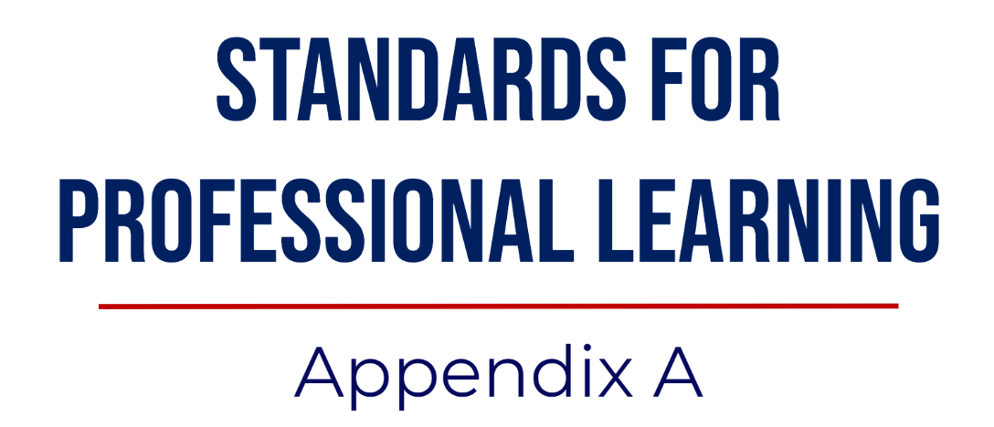

Standards for Professional Learning outline the characteristics of professional learning that leads to effective teaching practices, supportive leadership, and improved student results.
Learning Communities | Professional learning within communities requires continuous improvement, promotes collective responsibility, and supports alignment of individual, team, school, and school system goals. Learning communities convene regularly and frequently during the workday to engage in collaborative professional learning to strengthen their practice and increase student results. Learning community members are accountable to one another to achieve the shared goals of the school and school system and work in transparent, authentic settings that support their improvement.
Leadership | Leaders throughout the pre-K-12 education community recognize effective professional learning as a key strategy for supporting significant school and school system improvements to increase results for all students. Whether they lead from classrooms, schools, school systems, technical assistance agencies, professional associations, universities, or public agencies, leaders develop their own and others' capacity to learn and lead professional learning, advocate for it, provide support systems, and distribute leadership and responsibility for its effectiveness and results.
Resources | Effective professional learning requires human, fiscal, material, technology, and time resources to achieve student learning goals. How resources are allocated for professional learning can overcome inequities and achieve results for educators and students. The availability and allocation of resources for professional learning affect its quality and results. Understanding the resources associated with professional learning and actively and accurately tracking them facilitates better decisions about and increased quality and results of professional learning.
Data | Data from multiple sources enrich decisions about professional learning that leads to increased results for every student. Multiple sources include both quantitative and qualitative data, such as common formative and summative assessments, performance assessments, observations, work samples, performance metrics, portfolios, and self-reports. The use of multiple sources of data offers a balanced and more comprehensive analysis of student, educator, and system performance than any single type or source of data can. However, data alone do little to inform decision making and increase effectiveness.  Thorough analysis and ongoing use are essential for data to inform decisions about professional learning, as is support in the effective analysis and use of data.
Learning Designs | Integrating theories, research, and models of human learning into the planning and design of professional learning contributes to its effectiveness. Several factors influence decisions about learning designs, including the goals of the learning, characteristics of the learners, their comfort with the learning process and one another, their familiarity with the content, the magnitude of the expected change, educators' work environment, and resources available to support learning. The design of professional learning affects its quality and effectiveness.
Implementation | The primary goals for professional learning are changes in educator practice and increases in student learning. This is a process that occurs over time and requires support for implementation to embed the new learning into practices. Those responsible for professional learning apply findings from change process research to support long-term change in practice by extending learning over time. They integrate a variety of supports for individuals, teams, and schools. Finally, they integrate constructive feedback and reflection to support continuous improvement in practice that allows educators to move along a continuum from novice to expert through application of their professional learning.
Outcomes | For all students to learn, educators and professional learning must be held to high standards. Professional learning that increases results for all students addresses the learning outcomes and performance expectations education systems designate for students and educators. When the content of professional learning integrates student curriculum and educator performance standards, the link between educator learning and student learning becomes explicit, increasing the likelihood that professional learning contributes to increased student learning. When systems increase the stakes for students by demanding high, equitable outcomes, the stakes for professional learning increase as well.

