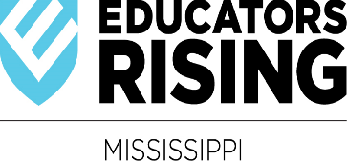 2024 State Conference T-Shirt Design
The winning graphics will be displayed on the state conference booklet and state t-shirt. Complimentary registration for State Conference.

The purpose of this contest is to provide students with an opportunity to graphically illustrate the Educators Rising theme by displaying the design on the state conference booklet and state t-shirt.
Please follow the guidelines when creating your design. All chapters are encouraged to participate.
Eligibility:
One design per registered fall conference chapter.
Design Guidelines:
All entries for the contest must comply with the following materials and specifications. Graphic must be designed for the back of a t-shirt.
Material and Specifications:
- Dimension of the art should be approximately 8” wide by 8” tall.
  - The art does not have to be square.
  - The art should not be a picture of a t-shirt.
  - The National Educators Rising logo cannot appear in the design.
- Entry must submit in no more than (3) three colors.
- Entry must include the State Organization’s Name, Current Conference Year, Current Conference Theme.
- DO NOT use images that are offensive.
The State Office reserves the right to make corrections/changes to the winning design to ensure positivity. Additionally, the State Office reserves the right to disqualify entries.
Judging:
All entries meeting guidelines criteria will be sent to registered fall conference chapters for judging. Each registered chapter will be allowed two votes.
Theme: “Discovering Your Potential”
Submitting Your Design and Deadline:
Submit electronically to State Office by October 16, 2023. In subject line, type “Ed Rising T-Shirt Design.”

