2021 Mississippi Parent of the Year

Program Nomination Guidelines

Sponsored by

Mississippi Department of Education

Office of Teaching and Leading
P.O. Box 771 - Jackson, MS 39205-0771
Phone: 601-359-3631
Website: https://www.mdek12.org/OTL/OTC/recognition

Parent of the Year Program Overview
The Mississippi Parent of the Year (MPOY) Program recognizes outstanding parents who have made a significant commitment to their local school through their dedication to students and their generous gifts of time and other resources. It is the vision of the Parent of the Year Program to elevate student success by honoring parents whose involvement and support contributes to a powerful effect on the success of schools.
The Parent of the Year (POY) candidate should be:
- Actively involved in their child’s educational life through activities/projects
- Focused on improving the school and student success
- Member of the Parent Teacher Association (PTA) and supports the association mission
- Active member of the community

Application Instructions
Please complete all parts of the application (Sections 1 – 4). Any incomplete parts on the application will result in a score reduction. All applications should be typed and not handwritten, printed one-sided not two sided. For sections two (2) and three (3), do not exceed 3 pages.
Section I – Application Form
Complete the application form and include the following signatures:
- School District Superintendent
- Applicant
Section II – Personal Involvement
Respond to this question in detail with a 12-point font, double-spaced, 1-inch margins, and a maximum of 250 words.
Section III – School Improvement Efforts and Recognition
Respond to the two (2) questions in detail with a 12-point font, double-spaced, 1-inch margins.
Section IV – Letters of Recommendation
Attach three (3) letters of recommendation that support why you should be the 2021 Mississippi Parent of the Year. Letters should not exceed one page in length and double-spaced between paragraphs, and a 12-point font size.

Submitting Applications
After completing sections 1 – 4 of the application, submit one original and four (4) stapled copies by January 29, 2021 to:

Mississippi Department of Education
Office of Teaching and Leading
P.O. Box 771
Jackson, MS 39205

2021 Mississippi Parent of the Year Program Timeline
(Tentative)

Date | Activity
November 2020 | 2021 Parent of the Year nomination application is emailed to district superintendents. The application is available on the Mississippi Department of Education, Office of Teaching and Leading webpage: https://www.mdek12.org/OTL/OTC/recognition
January 29, 2021 | Deadline for application submission. Submit one original application and four (4) stapled copies to the Mississippi Department of Education. Faxed entries will not be accepted.
February 2021 | The Selection Committee will review district applications.
March 2021 | State Selection Committee will meet and choose the congressional district finalists and the 2021 Mississippi Parent of the Year.
TBD | 2021 Parent of the Year is recognized by the State Board of Education

CONGRESSIONAL DISTRICT MAP
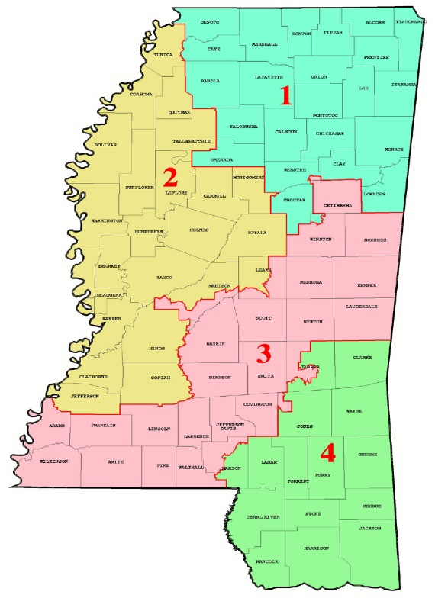

2021 Mississippi Parent of the Year
Application Form
Please Type

Section I

Candidate’s Information
Full Name:

Congressional District: ___ 1 ___ 2 ___ 3 ___ 4

School District:

School District Address:

City: State: Zip:

Home Address:

City: State: Zip:

Employment:

______________________________________________________________________________
Personal Email:

Cell Phone: Home Phone:

Twitter Handle (If applicable):
Facebook Profile (If applicable):
Instagram Profile (If applicable):
Other Social Media (If applicable):

2021 Mississippi Parent of the Year
Application Form

Section I (continued)

For Publicity Purposes Only
Spouse’s Name (If applicable):

Spouse’s Occupation (If applicable):

Children’s Name, Age, & School or Occupation:

School District Superintendent
Name:

Superintendent’s Email Address:

Telephone:

I acknowledge that the nominee submits this application with my approval.

Signature of District Superintendent Date

Parent of the Year Candidate

Signature of Candidate Date _____________

2021 Mississippi Parent of the Year Application
Section II: Personal Involvement
As a parent, explain why is it important to be actively involved in your child/children’s educational life?

2021 Mississippi Parent of the Year Application
Section III: School Improvement Efforts and Recognition
- Describe your involvement in service-oriented activities such as: funding/grant efforts, community/business involvement, student activities and projects, or other voluntary services. Include date(s) and year(s) of involvement.

- Describe in detail any awards/recognitions (current and past) you have received. For each award/recognition include the title of the award and dates of involvement.

2021 Mississippi Parent of the Year Application
Section IV: Three (3) Letters of Recommendation

2021 Mississippi Parent of the Year Application
Evaluation Rubric

Each candidate will be rated on the components of the application. The following rubric will be used to evaluate each candidate’s completed application. Incomplete applications will result in a score reduction. Each candidate may receive up to 40 points.

CRITERIA | LOW SCORE | AVERAGE SCORE | HIGH SCORE | MAX POINTS | SCORE
II. Personal Involvement ( maximum 250 words)  As a parent, explain why is it important to be actively involved in your child/children’s educational life?  - Why the parent is invovled in their child/children’s educational life | Fails to cover all required areas.  0-3  Points _____ | Provides adequate evidence in all areas.  4-7  Points _____ | Provides clear and exceptional evidence in all areas.  8-10  Points _____ | 10
III. School Improvement Efforts and Recognition  Describe your involvement in service-oriented activities such as: funding/grant efforts, community/business involvement, student activities and projects, or other voluntary services. Include date(s) and year(s) of involvement.  - Funding/grant efforts  - Community/business involvement  - Student activities/projects  - Other voluntary services | Fails to cover all required areas.  0-4  Points _____ | Provides adequate evidence in all areas.  5-9  Points _____ | Provides clear and exceptional evidence in all areas.  10-15  Points _____ | 15
III. School Improvement Efforts and Recognition  Describe in detail any awards/recognitions (current and past) you have received. For each award/recognition include the title of the the award and dates of involvement.  - Title of award/recognition in detail  - Dates of award/recognition involvement | Fails to cover all required areas.  0-3  Points _____ | Provides adequate evidence in all areas.  4-7  Points _____ | Provides clear and exceptional evidence in all areas.  8-10  Points _____ | 10
IV. Letters of Recommendation  - Includes three (3) letters  - Why the parent qualifies to become Mississippi Parent of the Year  - Letters do not exceed one page in length (double-spaced between paragraphs and 12-point font size) | Fails to cover all required areas.  0-1  Points _____ | Provides adequate evidence in all areas.  2-3  Points _____ | Provides clear and exceptional evidence in all areas.  4-5  Points _____ | 5

