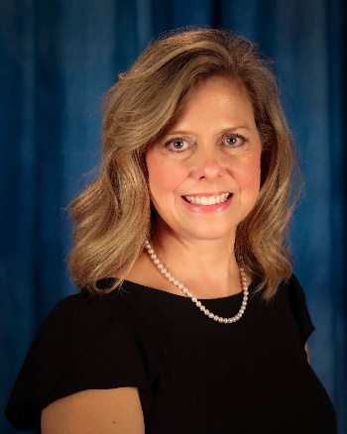
Dear Mississippi Educators,

Welcome to the 2020-2021 school year! What a difference a pandemic can make! I do not know about you, but this has been the strangest ‘beginning of the school year’ in my educational career. This year, more than ever, we will need to focus on ‘Hope,’ ‘Mind-Set,’ and ‘Grace.’ These are all things we will need to lean into to keep our sanity. This year is moving at a different speed and as we slowly figure it out, I am reminded of a quote from Confucius that states, “It does not matter how slowly you go so long as you do not stop.” I can assure you that no one has stopped, and even if slow is not your favorite speed, we must lean into it.
In 1776 Thomas Payne said, “These are the times that try men’s souls.” He was right then, and he is right today. We have been tried on many fronts, and our paths have shifted from one way to another. However, we have never lost focus on what is important - the safety and education of our students. We will continue to keep that focus as we transition into this new school year.
UNKNOWNS are the things for which we must give grace. Grace…something that is hard to give, yet something we quickly accept. “I do not at all understand the mystery of grace - only that it meets us where we are but does not leave us where it found us” (Anne Lamott). In a time where virtual learning is now a common phrase; having hybrid schedules is not an outlandish idea; and face to face learning is taking a risk, we will all need to give and receive a lot of grace. Grace to students, grace to parents, grace to teachers, and grace to each other. What we knew when we started our school year in 2019 is not going to help us in 2020. We must face all the unknowns and give grace when we do not handle these unknowns with perfection. The definition of perfection according to Dictionary.com is the action or process of improving something until it is faultless or as faultless as possible. In a world of unknown we will seek to improve how we handle these unusual times, and we will improve the process as we go.
This is going to be a different year, but I believe it will be a great year in spite of its differences. As Roy T. Bennett said, “Whenever something bad happens, keep calm, take a few deep breaths and shift the focus to something positive.” I could not agree more. This year, let us focus on our great students, parents, and teachers. All will come together, maybe not in the way we wanted but maybe, just maybe, in a way that makes us better.
“The road that is built in hope is more pleasant to the traveler than the road built in despair, even though they both lead to the same destination” (Marion Zimmer Bradley, The Fall of Atlantis). We know that this year will be like none other, just as last year was like none other. It is my hope that together we will embrace change with a growth mind-set, we will rain grace down upon one another, and we will reach our destination hand in hand. It will not be easy, but it will define our character. We are builders of citizens of excellence, and as such, we will model excellence with grace and hope. Have an adventurous 2020-2021 school year. May it open your mind to new things, fill your heart with grace and may your road be built with hope.

Sincerely,

Debra Houghton
2020 Mississippi Administrator of the Year

