2024-2025 Mississippi Parent of the Year

Program Nomination Guidelines

Sponsored by

Mississippi Department of Education

Office of Teaching and Leading
Parent of the Year Program
P.O. Box 771 - Jackson, MS 39205-0771
Phone: 601-359-3513
Website: https://www.mdek12.org/OTL/OTC/recognition

Parent of the Year Program Overview
The Mississippi Parent of the Year (MPOY) Program recognizes outstanding parents who have made a significant commitment to their local school through their dedication to students and their generous gifts of time and other resources. It is the vision of the Parent of the Year Program to elevate student success by honoring parents whose involvement and support contributes to a powerful effect on the success of schools.
The Parent of the Year (POY) candidate should be:
- Actively involved in their child’s educational life through activities/projects
- Focused on improving the school and student success
- Member of the Parent Teacher Association (PTA) and supports the association mission
- Active member of the community

Application Instructions
Please complete all sections of the application (Sections 1 – 4). Any incomplete sections on the application will result in a score reduction. All applications should be typed and not handwritten, printed one-sided not two sided. For sections two (2) and three (3), do not exceed two (2) pages.
Section I – Application Form
Complete the application form and include the following signatures:
- School District Superintendent
- Applicant
Section II – Personal Involvement
Respond to the question in detail with a 12-point font, double-spaced, 1-inch margins, maximum two (2) pages.
Section III – School Improvement Efforts and Recognition
Respond to the question in detail with a 12-point font, double-spaced, 1-inch margins, maximum two (2) pages.
Section IV – Letters of Recommendation
Attach three (3) letters of recommendation that support why you should be the 2024-2025 Mississippi Parent of the Year. Letters may be from: superintendent, principal, colleague, PTA/PTO president, teacher, student, or civic leader. Letters should not exceed one (1) page in length, double-spaced between paragraphs, and a 12-point font size. Please attach letters to the application.
Submitting Applications
After completing sections 1 – 4 of the application, submit one original and three (3) stapled copies postmarked by January 10, 2024 to:

Mississippi Department of Education
Office of Teaching and Leading
Parent of the Year Program
P.O. Box 771
Jackson, MS 39205

For questions, contact Sandra Hilliard at 601-359-3513 or by email: shilliard@mdek12.org

2024-2025 Mississippi Parent of the Year Program Timeline
(Tentative)

Date | Activity
October 2023 | 2024-2025 Parent of the Year nomination application is emailed to district superintendents. The application is available on the Mississippi Department of Education, Office of Teaching and Leading webpage: https://www.mdek12.org/OTL/OTC/recognition
January 10, 2024 | Deadline for application submission. Submit one original application and three (3) stapled copies to the Mississippi Department of Education, Office of Teaching and Leading.
February 2024 | The Selection Committee will review district applications.
March 2024 | State Selection Committee will meet and choose the congressional district finalists and the 2024-2025 Mississippi Parent of the Year.
April 26, 2024 | 2024-2025 Parent of the Year is recognized at the Administrator and Teacher of the Year Awards Program.

CONGRESSIONAL DISTRICT MAP
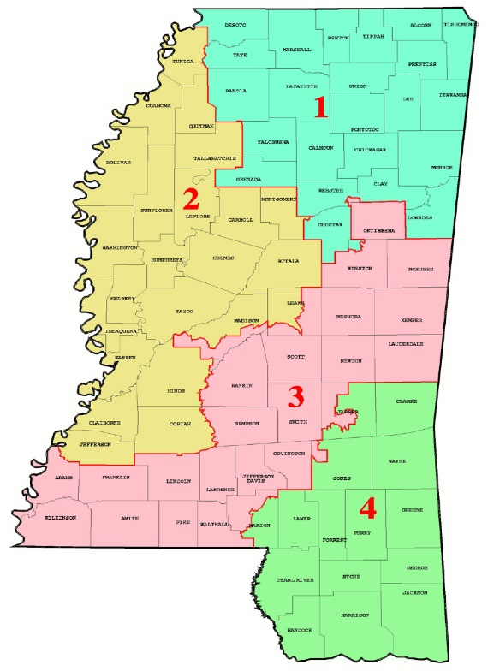

2024-2025 Mississippi Parent of the Year Application
Evaluation Rubric

Each candidate will be rated on the components of the application. Please use the following rubric as a checklist and guide when completing your application. Incomplete applications will result in a score reduction. Each candidate may receive up to 35 points.

CRITERIA | LOW SCORE | AVERAGE SCORE | HIGH SCORE | MAX POINTS | SCORE
II. Personal Involvement ( maximum two (2) pages)  As a parent, explain why is it important to be actively involved in your child/children’s educational life?  - Why the parent is involved in their child/children’s educational life | Fails to cover all required areas.  0-3  Points _____ | Provides adequate evidence in all areas.  4-7  Points _____ | Provides clear and exceptional evidence in all areas.  8-10  Points _____ | 10
III. School Improvement Efforts and Recognition (maximum two (2) pages)  Describe your involvement in service-oriented activities such as: funding/grant efforts, community/business involvement, student activities (homeroom activities, PTA, district work, athletics, etc.) and projects, or other voluntary services. Be specific in describing projects, awards, and recognitions (current and past) you have received. For each award/recognition include the title of the award and dates of involvement.  - Describe service-oriented activities such as: funding/grant efforts, community/business involvement, student activities/projects, or other voluntary services (current and past)  - Title and dates of award/recognition involvement | Fails to cover all required areas.  0-4  Points _____ | Provides adequate evidence in all areas.  5-9  Points _____ | Provides clear and exceptional evidence in all areas.  10-15  Points _____ | 15
IV. Letters of Recommendation  - Includes three (3) letters  - Why the parent qualifies to become Mississippi’s 2024-2025 Parent of the Year  Letters do not exceed one page in length (double-spaced between paragraphs and 12-point font size) | Fails to cover all required areas.  0-3  Points _____ | Provides adequate evidence in all areas.  4-7  Points _____ | Provides clear and exceptional evidence in all areas.  8-10  Points _____ | 10
 |  |  | Maximum Points | 35
Tally the points allotted in each section. This is the candidate’s final score. |  |  | Final Score

2024-2025 Mississippi Parent of the Year
Application Form
(Please Type)

Section I

Candidate’s Information
Full Name:

Congressional District: ___ 1 ___ 2 ___ 3 ___ 4

School District:

School District Address:

City: State: Zip:

Home Address:

City: State: Zip:

Employment:

_____________________________________________________________________________________
Personal Email:

Cell Phone: Home Phone:

Twitter Handle (If applicable):
Facebook Profile (If applicable):
Instagram Profile (If applicable):
Other Social Media (If applicable):

2024-2025 Mississippi Parent of the Year
Application Form

Section I (continued)

For Publicity Purposes Only
Spouse’s Name (If applicable):

Spouse’s Occupation (If applicable):

Children’s Name, Age, & School or Occupation:

School District Superintendent
Superintendent’s Name:

Superintendent’s Email Address:

Telephone:

I acknowledge that the nominee submits this application with my approval.

Signature of District Superintendent Date

Parent of the Year Candidate

Signature of Candidate Date _____________

2024-2025 Mississippi Parent of the Year Application
Section II: Personal Involvement
As a parent, explain why it is important to be actively involved in your child/children’s educational life? (Maximum two (2) pages)

2024-2025 Mississippi Parent of the Year Application
Section III: School Improvement Efforts and Recognition
Describe your involvement in service-oriented activities such as: funding/grant efforts, community/business involvement, student activities (homeroom activities, PTA, district work, athletics, etc.) and projects, or other voluntary services. Be specific in describing projects, awards, and recognitions (current and past) you have received. For each award/recognition include the title of the award and dates of involvement. (Maximum two (2) pages)

2024-2025 Mississippi Parent of the Year Application
Section IV: Three (3) Letters of Recommendation

