MS Department of Education
Office of Secondary Education
Miss. Code Ann. § 37-11-67
District Implementation Plan

Miss. Code Ann. § 37-11-67 requires
- District Superintendent appoints a suicide prevention coordinator
- MDE with Department of Mental Health (DMH) will establish a model policy
- DMH will develop the content of the training
- District must adopt a suicide prevention policy
- District must include a diverse group for policy development.
- All school staff must have training during the 2017-18 school year.
- Thereafter, only new employees are required to have training.
Statement of Best Practice
The best practice for a districts development of suicide prevention plans based on the best evidence available. The Whole Community, Whole School, Whole Child model illustrates the various areas that can be addressed through this training requirement.
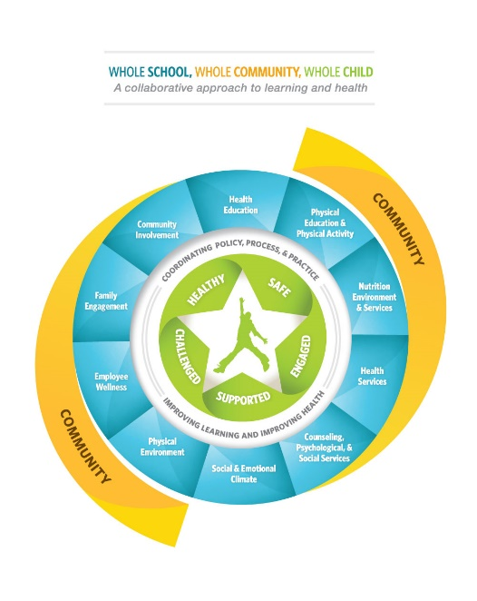
- Consider mental health data including local if available (smart track), statewide (YRBS), and national. This data can be information on student behaviors, bullying, cyberbullying, and chronic absenteeism.
- Form a group of interested community stakeholders including parents, community mental leaders, and educators to provide input on the district plan. The school health council can be the catalyst for this planning.
- Maintain transparency with parents and community regarding the development of this suicide prevention policy.
Assess your present situation
- Review available data
- Determine level of student instruction that the district will provide. There are various mental health topics throughout the current health curriculum, is this a level that is preferred in your district.
- Consider the training needs for district, department, and school level employees.
- Access MS Code 37-11-67, for other information and exact language regarding the required training.
Develop District Plan for Policy and Training Implementation
- District will develop a Suicide Prevention Policy and may use the template provided.
- Consider dissemination of policy for parent and community access.
- All District level training should include classified and certified staff even though they may not have daily student contact. Training can provided in a staff development setting or self-guided format.
- All School level training should include classified and certified staff assigned to a specific school building within the district and have daily contact with students. This group is made up of mostly teachers and specific support staff. Training can provided in a staff development setting or self-guided format.
- It is recommended the classified staff complete The Jason Foundation Curriculum.
- It is recommended the certified staff complete the Society for the Prevention of Teen Suicide curriculum.
- Some employees fit into more than one level. It is up to the district/school to determine how the training will reach all groups of employees.
- Districts must select a Suicide Prevention Coordinator to communicate and report to MDE.
- Districts may select a school specific coordinator to communicate with the District Coordinator.

Two curricula were selected by a Department of Mental Health Focus Group
- The Jason Foundation http://jasonfoundation.com/
- The Coordinator should register prior to the training
  - Go to “Get Involved”
  - Choose Educator, Youth Worker, Coach
  - Choose Professional Development Series
  - Choose Mississippi under “State” drop down menu
  - Under My Courses click Two-Hour Courses
  - Choose Module 5—Youth Suicide: “A Silent Epidemic”
  - Click View Course- there are Five Chapters with Review
- This curriculum was chosen with clerical staff in mind, and may be better viewed in groups. Because of the chapter format it can be viewed in multiple sittings.

- Society for the Prevention of Teen Suicide http://www.sptsusa.org/
  - Coordinator should register prior to training
    - Click the 2017-18 National Version—Making Educators Partners In Youth Suicide Prevention: Act on Facts
    - Go to the Educators tab
    - Choose online training
    - Left side of page choose Login or Create New Account
  - Choose Courses the 2017-18 National Version—Making Educators Partners In Youth Suicide Prevention: Act on Facts. This contains six modules to be completed.
- This curriculum was chosen with certified staff in mind. It can be viewed individually at the trainees on pace or it can be done in a staff meeting setting. If selecting the groups setting it can be viewed in multiple sittings.
Reporting and Monitoring
- District will complete the MDE survey designating the Suicide Prevention Coordinator for the district.
- District will conduct the training and maintain all documents associated with this training.
- By April 1, 2018, the District will submit the Suicide Prevention Training letter to MDE verifying training completion, to be signed by Coordinator and Superintendent.
- During any monitoring, audits, or site visits be prepared to provide the documentation of training completion.

Resources
- The Jason Foundation
http://jasonfoundation.com/

- Society for the Prevention of Teen Suicide
http://www.sptsusa.org/

- The American Foundation for Suicide Prevention
https://afsp.org/

- Mississippi Department of Mental Health http://www.dmh.ms.gov/?s=suicide+prevention

- Mississippi Department of Education --- HB263Training@mdek12.org

- Mississippi State Department of Health
http://msdh.ms.gov/msdhsite/_static/31,0,302.html

- Centers for Disease Control and Prevention
https://www.cdc.gov/healthyyouth/wscc/

